Week beginning Monday 1st June – Home Learning for Class 1

Dear Parents and Children of Class 1,

Welcome to Summer Term B - Weeks 1 and 2, of your Home Learning! We hope that you had a wonderful half term break and are all happy and well. It’s that time again where we are sending you the next fortnight worth of work and a bank of resources to access. We hope that you are managing to do some learning at home and that you are finding all of the work helpful and enjoyable. Don’t panic if you don’t manage to do everything, just have a go. Remember that the most important thing you can do at this unusual time is to read every day and continue to practise your phonics and key mathematics skills such as number bonds to 10, 20 and 100 and 2, 3, 5 and 10 times tables.

Once again, we have really enjoyed receiving photographs and messages from you to tell us all about your learning and we continue to print and stick these in a scrapbook for us to look at when we finally return to school. As always, if you have any questions at all please use the following email address - admin@branscombe.devon.sch.uk.

Certain aspects of the planning that you have become accustomed to, for example phonics, will be changing over the course of this half term, as we focus on revising key skills rather than teaching ‘new’ knowledge. In light of this, we would like all of you to focus a little more on Bug Club. It is a really useful tool for helping with reading through practising and embedding your phonics skills as the books that you have been allocated have been matched to the the skills taught prior to half term. Another part of learning to read is about understanding what you are reading, not just reading the words. That is why, at different points in each book, you will see a little bug icon like this. When you first see him, his eyes are open. If you click on him, there will be a question about the book that you have read. If you answer the question, his eyes will shut and you will be able to collect some coins. It is really important that you do this as you read the book (or afterwards if you prefer) as we can then see whether you have understood the book and it helps me to plan where to take your learning next. You are able to go back through books that you have read and complete these tasks even when you have finished reading the book. Please can you have a look this week and make sure that you have firstly, completed each of the comprehension tasks in the the books that you choose to read and secondly, rated the book at the end to tell me whether you enjoyed it or not. In light of our focus on reading we would like to challenge you to take a photo of you reading a book in an unusual or bizarre place. We will do the same and send you our photos in our next letter to you. We can’t wait to share!

Miss Harvey-Jones and Maisie enjoyed finding this pebble on one of their walks last week. Can you think of a message to decorate a pebble with? Why not make your own and leave it on one of your walks for someone else to find? Don’t forget to take a photo of it in place and send it to us though!

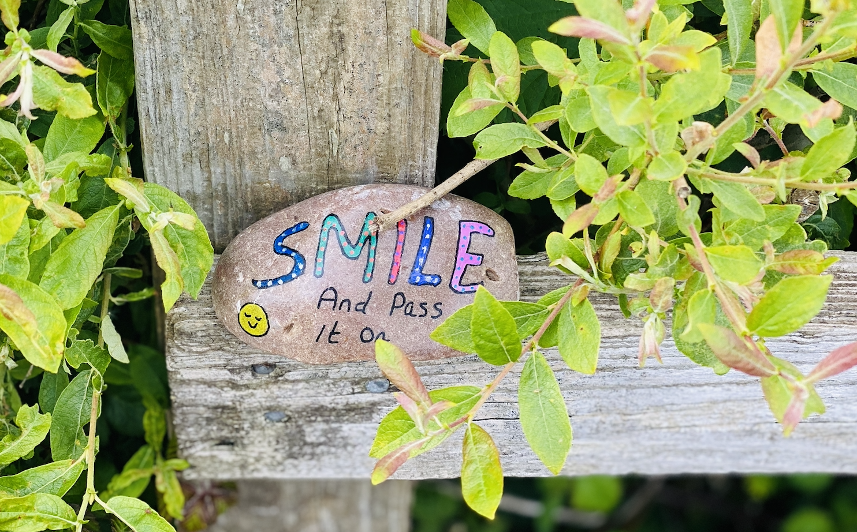

Please keep reading a book you enjoy and staying safe with your family,
Miss Harvey-Jones and Mrs Bartlett

EVERY DAY
- 20 minutes phonics: Pre-school, Reception, Y1 and Y2. Reception, Y1 and Y2 pupils please see the table below for details/activities. Remember, you could also use Phonics Play to practise reading sounds and words and also practise sounding and blending skills with the games provided on here. It is FREE at this time: https://new.phonicsplay.co.uk/. It is also app/tablet friendly. Pre-school children would benefit from spending some time to practise writing their name – ideally forename and surname (remembering the capital letters), so that they know how to spell it using correctly formed letters. They could also practise letter formation of the other letters of the alphabet. (See below for guidance).
- 20 minutes ‘Bug Club’ Reading (with comprehension ‘bug’ questions): Reception, Y1 and Y2. Bug Club books continue to be updated to suit your level.
- Choose 5 spellings from your Home Learning Books, Common Exception Words list or High Frequency Words list to learn: Reception, Y1 and Y2. (See below for these word lists).
- 15 minutes ‘Spelling Shed’, ‘SPAG.com’ OR ‘Bug Club Grammar’ games (KS1 only). As before, please do contact us if you would prefer to access paper-based work to limit screen time we can email additional SPAG documents for you to print off.
- 15 minutes ‘Times Table Rockstars’ (KS1 only) OR to limit screen time you may wish to spend this time learning 2, 3, 5 and 10 times tables to be able to recall them at speed. Reception pupils would benefit from spending a little time counting in twos e.g. count some teddies or dolls in twos.
- 20 - 30 minutes Maths: Pre-school, Reception, Y1 and Y2. See table below for a 5 minute warm ups with your parents/game, then complete any tasks set if in Reception or KS1. KS1 pupils can also continue to work in their ‘Power Maths’ Practice Books should you wish. Pre-school children may enjoy watching the videos too or could access some of the websites attached on website to play some number and shape games.
- PE/Active Time: Pre-school, Reception, Y1 and Y2. Joe Wicks (The Body Coach) has daily workout videos on YouTube (go online with your grown ups) but you do not need to feel restricted to this – get some fresh air when walking the dog, using skills developed in out of school clubs such as football/ballet or exercising in the garden instead, if you can safely do so.
- We would like children to continue their Summer Term diary: Pre-school, Reception, Y1 and Y2. Write one or two sentences a day (labels/captions scribed or written with support if necessary for pre-school children) and draw a picture. The sentence might be about something they have done, something they have seen or even what the weather is like. Some examples might be: ‘It is sunny.’ ‘It is a flower.’ ‘I went to the park’. Sentences do not need to be spelt correctly but the children should use their phonic skills to attempt to write words. KS1 children could also use the Time Capsule sheets attached on a separate link to help with ideas.
- Please keep reading/sharing a book you enjoy with your family: Pre-school, Reception, Y1 and Y2. Try to keep a log together (one or two sentences) of what you have read that day. If you are reading a fiction book, what happened or what characters did you meet? If you are reading a non-fiction book perhaps you write down something that you have found out that you didn’t know before.

Monday | Phonics – ALL with support from parents/carers (pre-school see notes above)  Reception – Phase 4 revision: Practise GPCs and Phase 4 Tricky Words - Play Flashcards using the previously attached resources or Quickwrite Graphemes (say the sound on the flashcard ask your child to write it without them seeing it). Play ‘Phase 4 Blends Blast Off’ game (see attached documentation on website).  Year 1 – Phase 6 revision: We are learning to read words with the -s ending (and revise graphemes from Phase 5a & alternative pronunciations from Phase 5b). Go through all of the GPCs with your child at a rapid pace using the attached resources (see below – pink cards to print and cut out/make your own using this template). Practise GPCs for any that your child struggled with by playing ‘Flashcards’ using just these cards or Quickwrite Graphemes (say the sound on the flashcard ask your child to write it without them seeing it). You can also play ‘Flashcards’, selecting to use these sounds on Phonics Play if you subscribe for free. Model blending to read a singular word – peacock. Then show the word peacocks and blend to read that. Explain simply that by adding the -s there is now more than one peacock and that we call this making the word plural. Repeat for crocodile/crocodiles, donkey/donkeys, dolphin/dolphins, whale, whales. Adding -s and -es. Play Countdown (how many of these plural words can you read in one minute/how many times): apricots, fields, units, headaches, herbs, ferns, pyramids, rhythms, humans, bowls, acids, boulders, chiefs, minds, shoulders, dangers. You can also play ‘Crater Creature Countdown’, selecting to use these words on Phonics Play if you subscribe for free. Hold up each of these sentences on paper. Ask your child to read the sentence you. Encourage them to discuss and figure out any words that they find difficult: Emus have fluffy feathers. The chefs forgot to peel the apricots. There are lots of dangers that unicorns can face. Now cover up the sentences so that your child can’t see them and slowly dictate each one to your child, asking them to write the sentences in their books, applying their learning from today.  Year 2 revision – The /ɜ:/ sound spelt ‘or’ after ‘w’. Use the following words: word, work, worm, world, worth, worse, worst. Show your child the images and ask them to work out what words they stand for. For each word ask them to sound it out and, as they do so, write the word underneath. They write the word and add the sound buttons. (Sound buttons are circles or spots that can be written underneath a sound to support reading. When you touch the sound button you then practice saying the sound aloud.) What do they notice about the words?  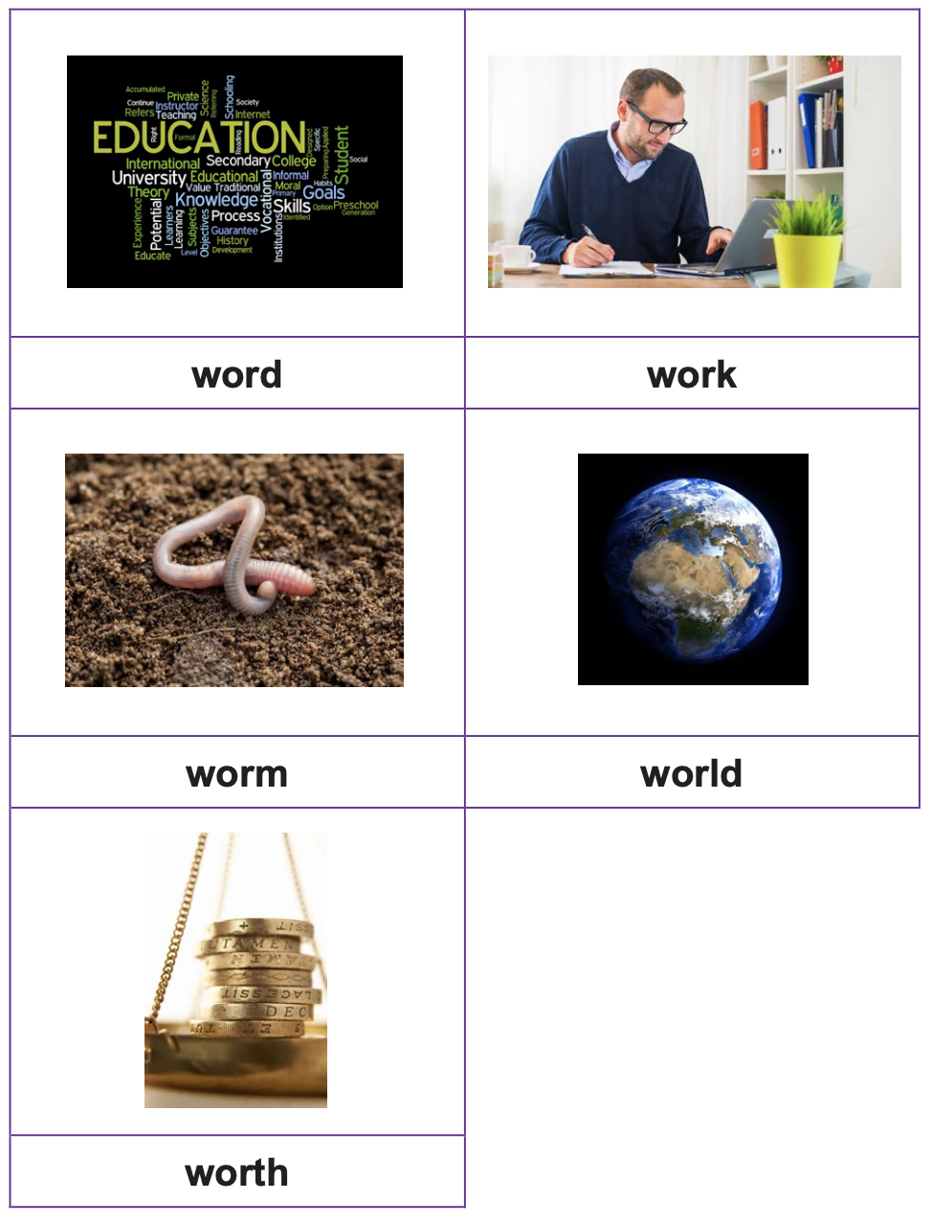  Maths  EYFS Maths Starter – Practise your number bonds to 10.  EYFS - Access the White Rose Maths website for home learning (link below).  https://whiterosemaths.com/homelearning/early-years/  Complete Summer Term Week 4 - Day 1: The very busy spider (watch the video before completing the activity).  KS1 Maths Starter  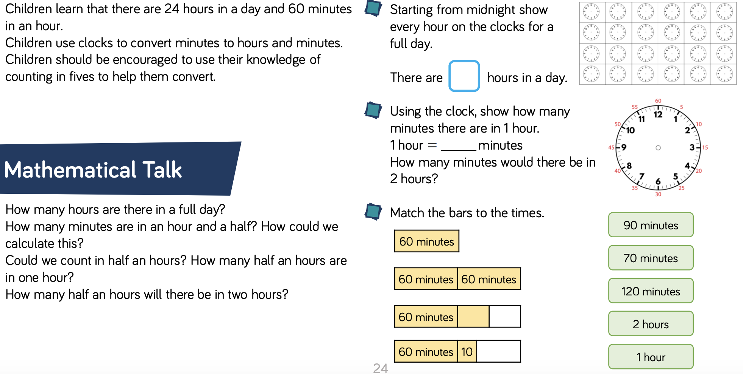  Y1 Access the White Rose Maths website for home learning (link below).  https://whiterosemaths.com/homelearning/year-1/  Complete Summer Term – Week 6 (w/c 1st June) Lesson 1: Measure Mass (watch the video before completing the activity).  Y2 Access the White Rose Maths website for home learning (link below).  https://whiterosemaths.com/homelearning/year-2/  Complete Summer Term – Week 6 (w/c 1st June) – Lesson 1: The 10 times-table (watch the video before completing the activity).  KS1 - If you do have access to a printer and want to print the White Rose sheets that go with each lesson, you can do. If you do this, you do not have to do the Power Maths pages as well.  If you do not have access to a printer, watch the White Rose video each day and then complete the Power Maths books.  Daily Project – PSHE and RE  TASK 1 - EYFS and KS1: We have been so fortunate with the fantastic weather that we have been getting lately… Mrs Bartlett and I feel so lucky to be able to enjoy spending time in our gardens in the sun. Do you know how to keep safe in the sun? Watch the story of Sammy Seagull (see separate attachment on website). Can you think of a creative way to tell people how to stay safe in the sun? Sammy made up a song - maybe you could make up a dance or actions to go with his song. Send us your ideas and stay safe in the sun.  TASK 2 – EYFS and KS1: In Class 1, we often ask questions and consider what Jesus might have looked like. Have a look at this link in which the young narrator talks about what Jesus might have looked like and how he might have lived.  https://www.bbc.co.uk/bitesize/clips/zfpvcdm
Tuesday | Phonics – ALL with support from parents/carers (pre-school see notes above)  Reception – Phase 4 revision: Practise GPCs and Phase 4 Tricky Words - Play Flashcards using the previously attached resources or Quickwrite Graphemes (say the sound on the flashcard ask your child to write it without them seeing it). Play ‘Phase 4 Snakes and Ladders’ game (see attached documentation on website).  Year 1 – Phase 6 revision: We are learning to spell words with the -s ending where no change to the root word is needed (and revise using knowledge of best guesses – introduced in Phase 5c - to choose how to spell words).  Ask your child to quickly write down all the graphemes they know for /ai/. Which is the best guess in the middle of the word? Which at the end? Which are very rare? Repeat for /ee/. Refer to best guess posters:  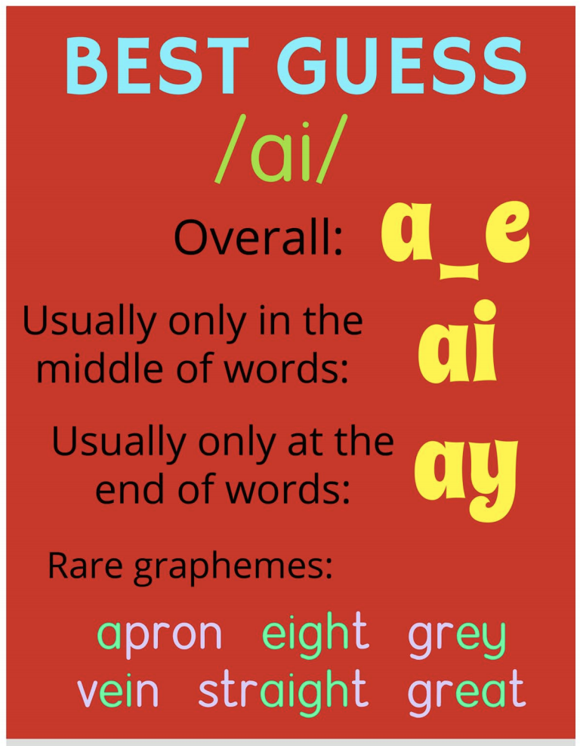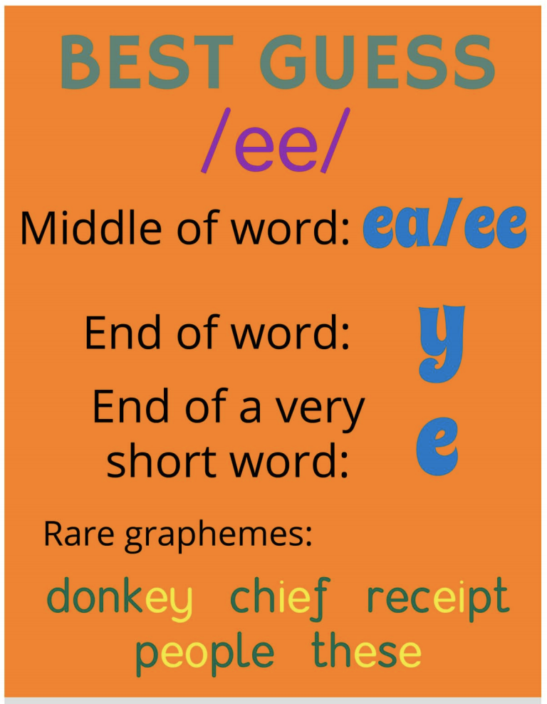  Model segmenting to spell the word snails. Model thinking about how to spell the /ai/ sound. E.g. “Let me think /s/ /n/ /ai/ /l/ /s/.” Draw sound buttons (lines under or circles around each sound) and write in the easy phonemes e.g. s, n, l, s. Now say: “The /ai/ sound is in the middle of the word snail so it is probably either the split digraph a_e or it's ai. I think that I remember that in this word it is ai.” Write the letters in ‘ai’. Repeat (segment, sound buttons, put in the easy bits, talk about the thought processes for the tricky bits, make a best guess for the tricky bits) for days and treats. Play Quickwrite (your child writes each word quickly on a piece of paper) with the words: trays, beads, planes, whales, bees, seats, knees, trees, fields. After they have written each word, they should them to you, then you give them the correct spelling whilst they mark their words. One tick for the correct number of sound buttons plus one tick for each correct letter. If children have chosen the wrong grapheme e.g. ai instead of aigh, then encourage them to correct it. Now dictate the following sentences as your child writes them: Do snails or snakes make the best pets? The bees in the trees give painful stings. Can whales book seats on planes? Reveal correctly written sentences and encourage your child to check their own spellings.  Year 2 revision – The /ɜ:/ sound spelt ‘or’ after ‘w’. P work in small groups. Give your child the cards with the images and words on (see yesterday). They choose one card, turn it face down and the whole group writes it. They then turn the card over and check that they have spelt the word correctly. If not, they rewrite the word three times after looking at the tricky part again. They repeat with another image. Dictate the following sentences: It will not be worth watching a worm as it works down into the soil. The world is full of worms that are on the path and grass. Give them the correct sentences and ask them to check their writing.  Discuss any errors.  Maths  EYFS Maths Starter:  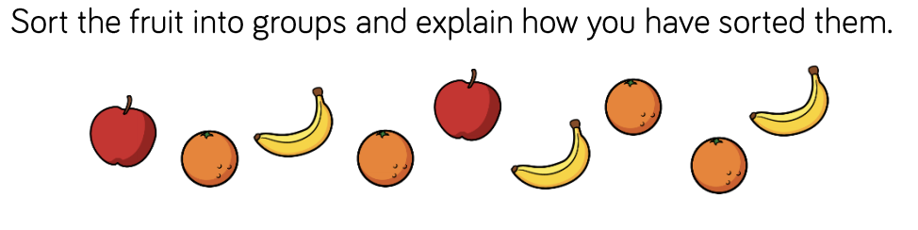  EYFS - Access the White Rose Maths website for home learning (link below).  https://whiterosemaths.com/homelearning/early-years/  Complete Summer Term Week 4 - Day 2: The very busy spider (watch the video before completing the activity).  KS1 Maths Starter:  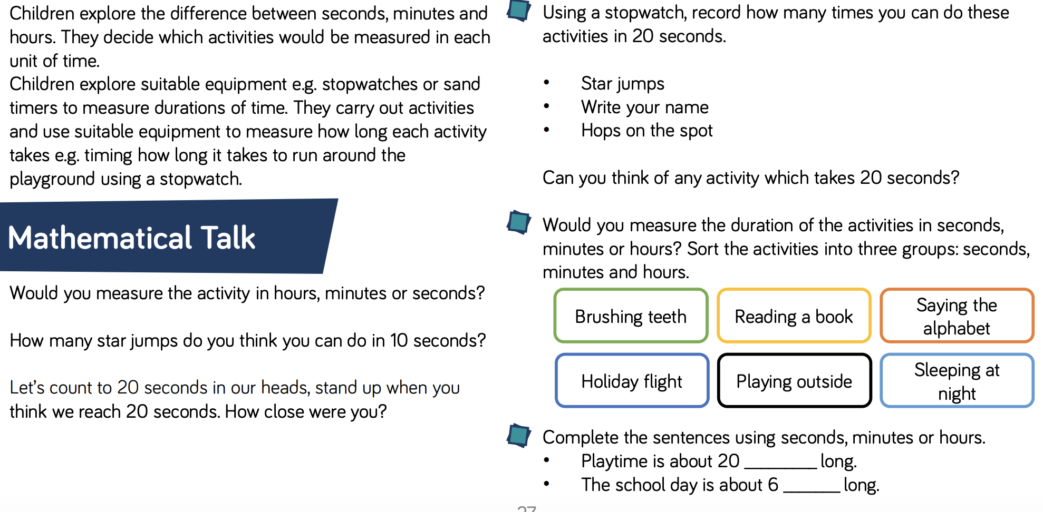  Y1 Access the White Rose Maths website for home learning (link below).  https://whiterosemaths.com/homelearning/year-1/  Complete Summer Term – Week 6 (w/c 1st June) Lesson 2: Compare Mass (watch the video before completing the activity).  Y2 Access the White Rose Maths website for home learning (link below).  https://whiterosemaths.com/homelearning/year-2/  Complete Summer Term – Week 6 (w/c 1st June) – Lesson 2: Sharing (watch the video before completing the activity).  KS1 - If you do have access to a printer and want to print the White Rose sheets that go with each lesson, you can do. If you do this, you do not have to do the Power Maths pages as well.  If you do not have access to a printer, watch the White Rose video each day and then complete the Power Maths books.  Daily Project - TOPIC  EYFS and KS1: Today you will begin to think about and describe how toys have changed over time. Take a look at the pictures that show toys ‘then’ and ‘now’ (see attached resource on website). Do your parents still have any of their old toys that you could look at and feel? Have you ever been anywhere that you have seen any other older toys that you can remember? Describe what you have seen and share your opinions about what you liked and didn’t like about toys in the past. Now look at this webpage:  https://downloads.bbc.co.uk/history/handsonhistory/victorians_games.pdf  Can you have a go at some of the Victorian games described on here?

Wednesday | Phonics – ALL with support from parents/carers (pre-school see notes above)  Reception – Phase 4 revision: Practise GPCs and Phase 4 Tricky Words - Play Flashcards using the previously attached resources or Quickwrite Graphemes (say the sound on the flashcard ask your child to write it without them seeing it). Complete Phase 4 matching activity – pictures and captions (see attached documentation on website).  Year 1 – Phase 6 revision: We are learning to read words with the -es ending.  Revise blending to read Phase 5b words (see two separate attachments on website). Look at a picture of a fox. Ask your child what is it? Show a picture of a few foxes. Ask your child to say the word now. Repeat with pictures of a coach/coaches, box/boxes, cockroach/cockroaches a church/churches. Look at the word foxes written down. Point out that e makes an /i/ sound and the s makes a /z/ sound. Model blending /f/ /o/ /x/ /i/ /z/ foxes. Repeat with churches and wishes. Play Countdown (how many of these plural words can you read in one minute/how many times): kisses, misses, arches, lashes, cockroaches, taxes, dishes, bushes, inches, dresses, crosses, bunches, torches, beaches, wrenches, launches. You can also play ‘Crater Creature Countdown’, selecting to use these words on Phonics Play if you subscribe for free. Hold up each of these sentences on paper. Ask your child to read the sentence you. Encourage them to discuss and figure out any words that they find difficult: I think that foxes may be lurking in the bushes. The boxes with crosses on them are full of cockroaches. The frog got a lot of kisses. Now cover up the sentences so that your child can’t see them and slowly dictate each one to your child, asking them to write the sentences in their books, applying their learning from today. Practise writing the sentences (dictate to your child): The frog runs away from the kisses. The cockroach bends his knees. The snake munches all the treats and sweets. Reveal correctly written sentences and encourage children to check their own spellings.  Year 2 revision – The possessive apostrophe (singular nouns). Display some words with the possessive apostrophe. Ask your child what they notice about these words. Can they remember what this is called and why it is used? Look at a sentence from below with an apostrophe missing. Ask them to spot where it should go. Display another sentence and ask them to copy it, putting in the apostrophe correctly. Dictate sentences using the possessive apostrophe. Check that they have applied it correctly. That is Anna’s coat. Please give me Hamid’s ball. This car’s lights are very dirty. Where is the girl’s book?  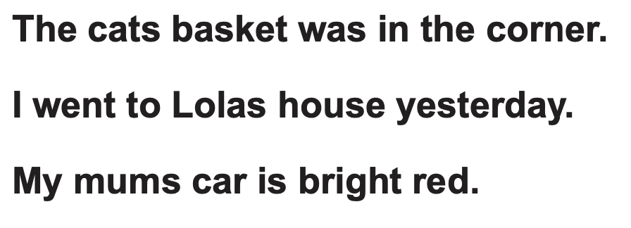  Maths  EYFS Maths Starter:  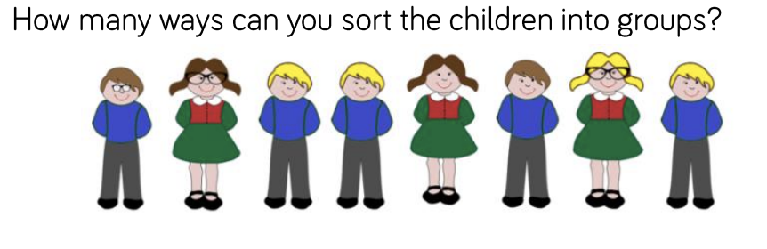  EYFS - Access the White Rose Maths website for home learning (link below).  https://whiterosemaths.com/homelearning/early-years/  Complete Summer Term Week 4 - Day 3: The very busy spider (watch the video before completing the activity).  KS1 Maths Starter:  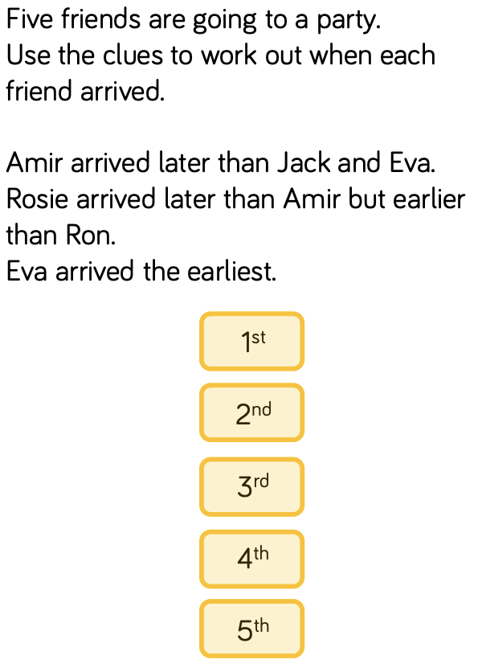  Y1 Access the White Rose Maths website for home learning (link below).  https://whiterosemaths.com/homelearning/year-1/  Complete Summer Term – Week 6 (w/c 1st June) Lesson 3: Introduce capacity and volume (watch the video before completing the activity).  Y2 Access the White Rose Maths website for home learning (link below).  https://whiterosemaths.com/homelearning/year-2/  Complete Summer Term – Week 6 (w/c 1st June) – Lesson 3: Grouping (watch the video before completing the activity).  KS1 - If you do have access to a printer and want to print the White Rose sheets that go with each lesson, you can do. If you do this, you do not have to do the Power Maths pages as well.  If you do not have access to a printer, watch the White Rose video each day and then complete the Power Maths books.  Daily Project – SCIENCE and PSHE  TASK 1 - EYFS and KS1: Today we will begin looking at the different parts of our body. Follow the link and watch the video: https://www.bbc.co.uk/bitesize/topics/z9yycdm/articles/zqhbr82. Now, have a go at the quiz using this link: https://www.bbc.co.uk/bitesize/topics/z9yycdm/articles/zqhbr82.  TASK 2 – EYFS and KS1: Begin on page 1 of the ‘Family positivity and gratitude pack.’ We will continue with a page per week throughout the rest of the term.
Thursday | Phonics – ALL with support from parents/carers (pre-school see notes above)  Reception – Phase 4 revision: Practise GPCs and Phase 4 Tricky Words - Play Flashcards using the previously attached resources or Quickwrite Graphemes (say the sound on the flashcard ask your child to write it without them seeing it). Complete Phase 4 Activity Booklet.  Year 1 – Phase 6 revision: We are learning to spell words with the -es ending where no change to the root word is needed.  Ask your child to quickly write down all the graphemes they know for /igh/. Which is the best guess in the middle of the word? Which at the end? Which are very rare? Repeat for /oa/. Refer to best guess posters:  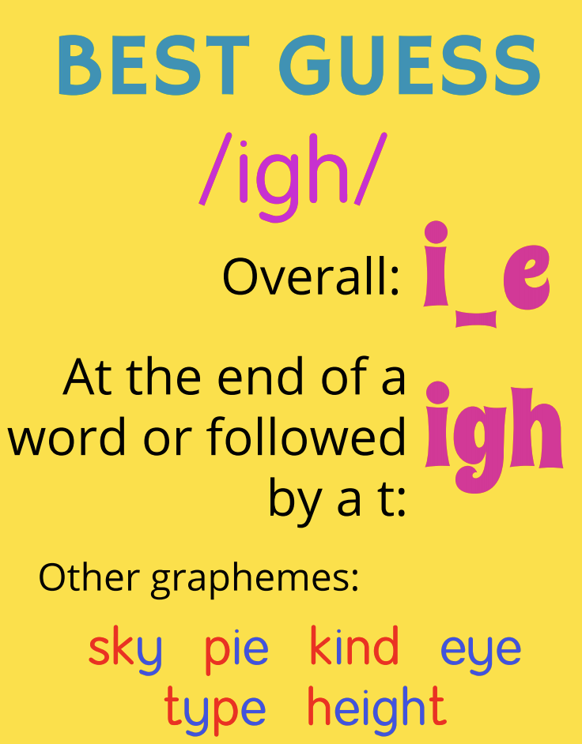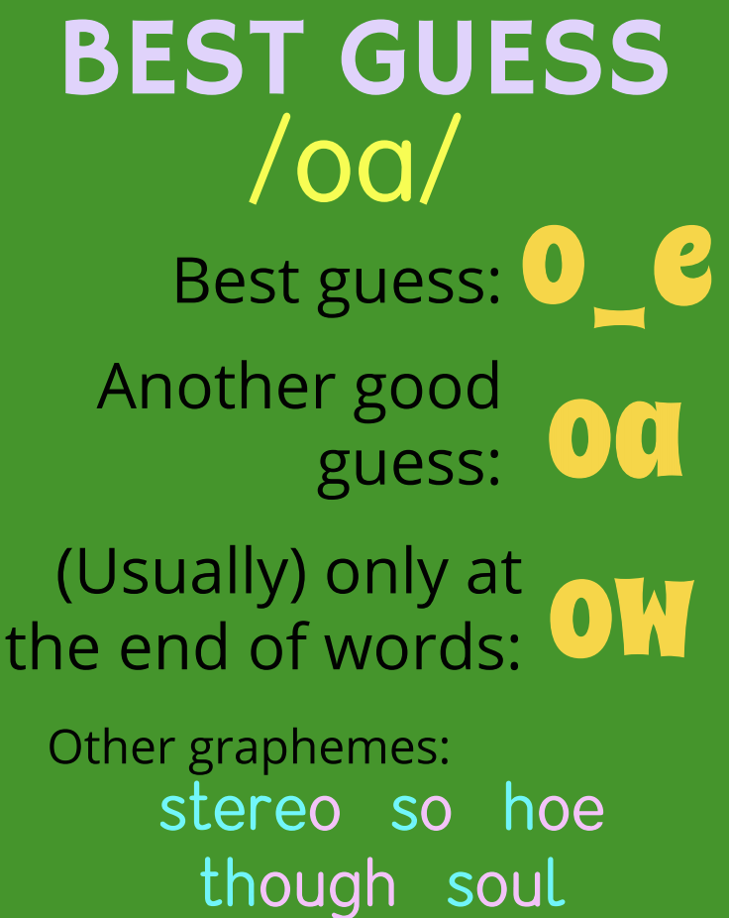  Model segmenting to spell the word boxes. Ask your child to clap out the syllables in this word. Start with the first syllable box. Remind your child that they know how to spell this root word box. Then look at the second syllable /i/z/. Ask your child if they can remember the letters that make the /i/ and /z/ sounds in this phoneme. Write boxes. Repeat with kisses and churches. Play Quickwrite with the words: lashes, foxes, bunches, torches, bushes, cockroaches. After children have written each word, show to parent, parent gives correct spelling whilst your child marks their words. One tick for the correct number of sound buttons plus one tick for each correct letter. If your child has chosen the wrong grapheme, encourage them to correct it. Look at a list of words that need to have -es added. Help your child to see that all these words end with hissing, buzzing or shushing sounds. Try saying some of these words with an /s/ added on and let the children see that it is virtually impossible to say the /s/ sound straight after a hissing, buzzing or shushing sound. This is why these words need /i/z/ spelt -es added to make them plural.  Year 2 – The /l/ or /əl/ sound spelt ‘-al’ at the end of words  (metal, pedal, capital, hospital, animal, petal; and with suffix ‘-al’, medical, magical). Remind your child about the spellings that they have already learnt for the /l/ or /əl/ sound (‘-le’ and ‘-el’). Display the words that they collected:  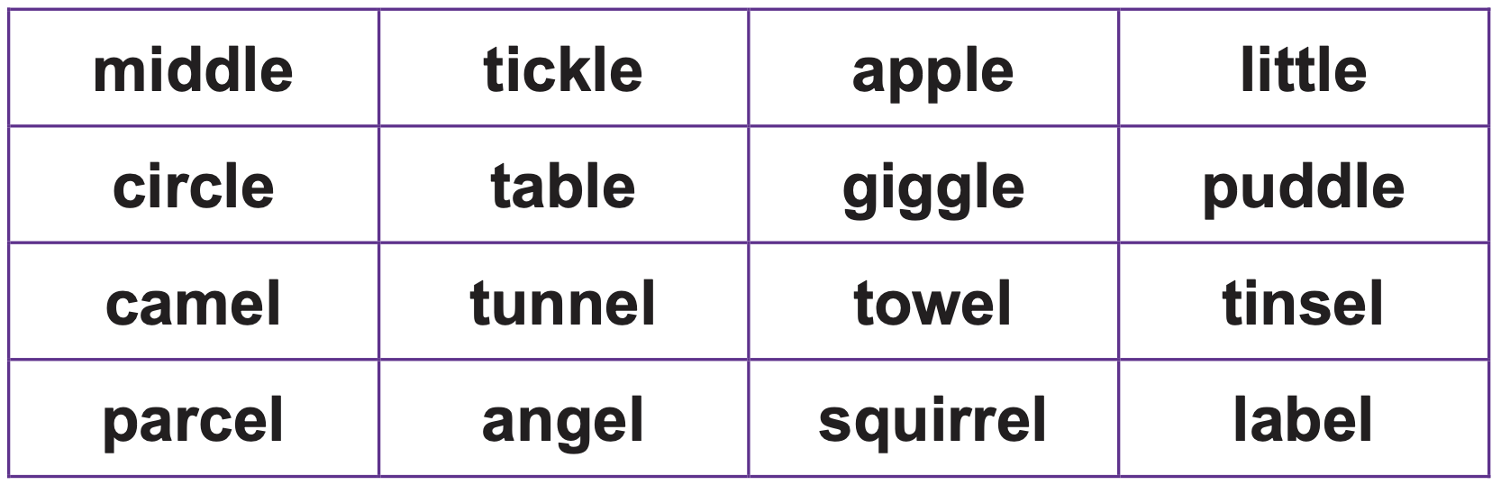  Tell the children that they are going to learn another spelling of this phoneme.  Ask them to write the words animal, petal and metal. What have they written for the final phoneme? Display the correct spelling of the words and other words with this pattern (see below). Ask them to practise writing one of the words on your back with their finger. Can you work out which word they have written?  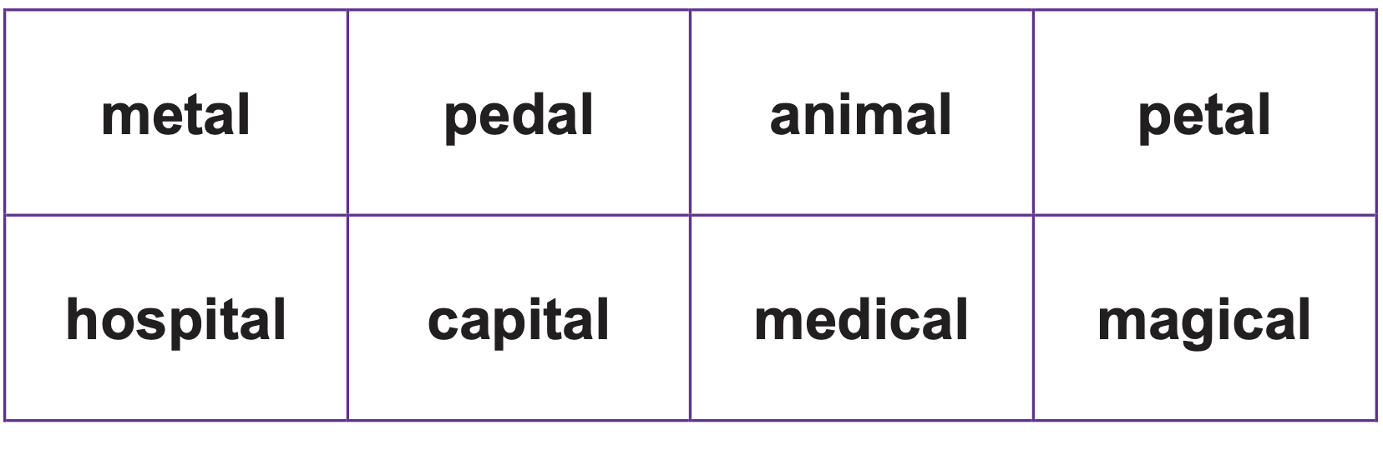  Maths  EYFS Maths Starter:  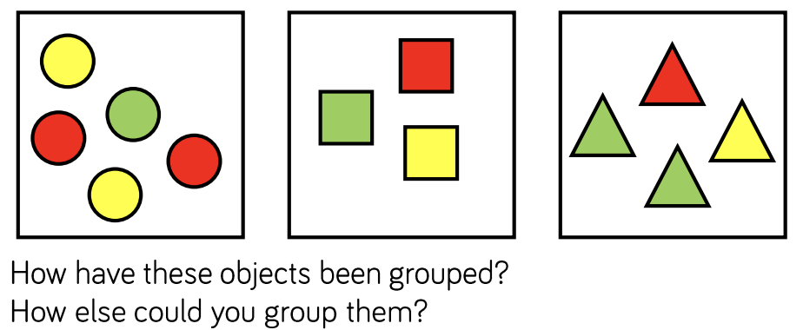  EYFS - Access the White Rose Maths website for home learning (link below).  https://whiterosemaths.com/homelearning/early-years/  Complete Summer Term Week 4 - Day 4: The very busy spider (watch the video before completing the activity).  KS1 Maths Starter:  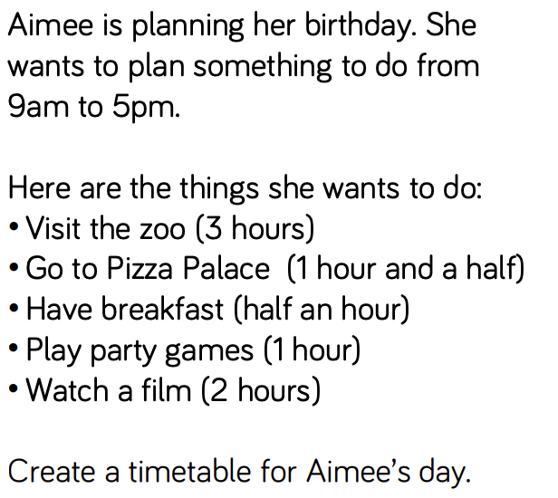  Y1 Access the White Rose Maths website for home learning (link below).  https://whiterosemaths.com/homelearning/year-1/  Complete Summer Term – Week 6 (w/c 1st June) Lesson 4: Measure Capacity (watch the video before completing the activity).  Y2 Access the White Rose Maths website for home learning (link below).  https://whiterosemaths.com/homelearning/year-2/  Complete Summer Term – Week 6 (w/c 1st June) – Lesson 4: Odd and even numbers (watch the video before completing the activity).  KS1 - If you do have access to a printer and want to print the White Rose sheets that go with each lesson, you can do. If you do this, you do not have to do the Power Maths pages as well.  If you do not have access to a printer, watch the White Rose video each day and then complete the Power Maths books.  Daily Project – R.E.  Ask your child ‘Who is important to God?’ Your child could make a mind cloud with the question in the middle of the paper and pictures and or words around it with their ideas.  Remind your child about the animal stories from the Quran that we looked at before half term. Watch the BBC bitesize clip of the stories ‘The Prophet and the ants’ and ‘The crying Camel’: https://www.bbc.co.uk/bitesize/clips/z9tqb82  Discuss how all animals great and small are important.  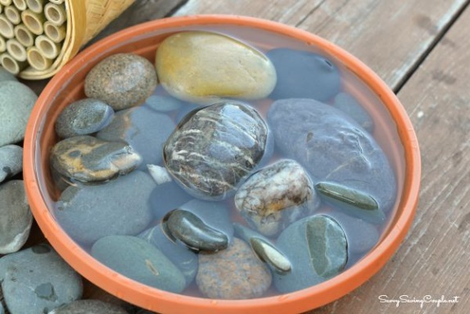  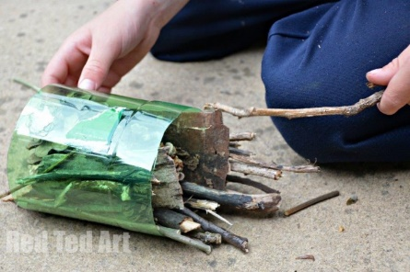  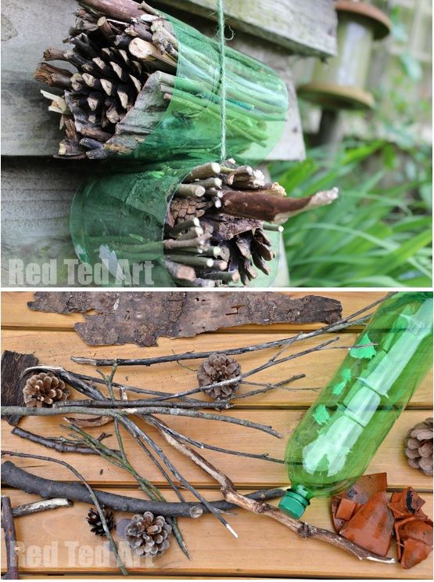  To follow on from this your child could make a bug hotel out of a plastic bottle or butterfly and bee drinking station with stones or marbles in a shallow tray to help our smallest creatures.
Friday | Phonics – ALL with support from parents/carers (pre-school see notes above)  Reception – Phase 4 revision: Watch some of these videos to revise your phonemes today https://www.bbc.co.uk/bitesize/topics/zvq9bdm. We particularly enjoy this one: https://www.bbc.co.uk/bitesize/topics/zvq9bdm/articles/zr728xs. Have a look at the games on this website: http://www.letters-and-sounds.com/phase-4-games.html and have a go at some of them to practise your phonics.  Year 1 – Phase 6 revision: We are learning to add -s and -es to the third person singular of verbs.  Briefly recap the rules for adding -s or -es. One at a time, show singular words that we have turned into plurals this week – wrench, box, beast, treat, dish, uniform, beach, mountain, bee, inch. Sort into two columns – ones that need to have -s added and ones that need to have -es added (children can show which column by pointing left or right). State that sometimes we add -s or -es to words for other reasons than making plurals (but that we can still use the same rules for choosing how to spell them, thank goodness). Child stands up. Show them I jump up high. Child blends to read then act it out (on the spot). Repeat for I stamp my feet. I munch on a carrot. Instead of I jump it needs to be he … (let children fill in the blank). Repeat for I brush my hair. I fix rockets. Quickly and simply model how these sentences need to change when you are using the third person (talking about somebody else). Model writing: jumps, stamps, brushes, munches, fixes on the board by segmenting the root word and using the rules learned earlier in the week to decide whether to add -s or -es. Ask your child to write wash. Then turn it into washes. Repeat with shout/shouts, dream/dreams, pinch/pinches, fix/fixes, float/floats.  Year 2 – The/l/ or /əl/ sound spelt ‘-al’ at the end of words. Practise handwriting using the ‘-al’ words from the previous lesson. Practise joining the ‘a’ at the bottom and making sure that the ‘l’ is the correct height. Give your child cards with ‘-le’, ‘-el’ and’-al’ on them.  Read out some words from previous sessions with the three different spellings of the /l/ or /əl/ phoneme taught so far. Ask them to have a go at writing the word. Hold up the correct grapheme card for that word. Show them the correct spelling and chant the letters together.  Maths  EYFS Maths Starter:  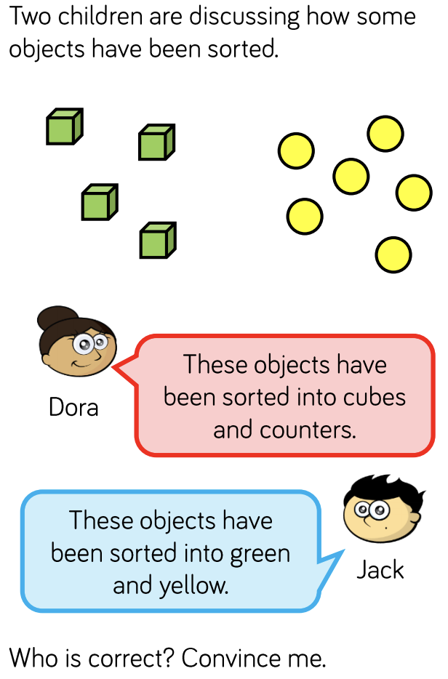  EYFS - Access the White Rose Maths website for home learning (link below).  https://whiterosemaths.com/homelearning/early-years/  Complete Summer Term Week 4 - Day 5: The very busy spider (watch the video before completing the activity).  KS1 Maths Starter:  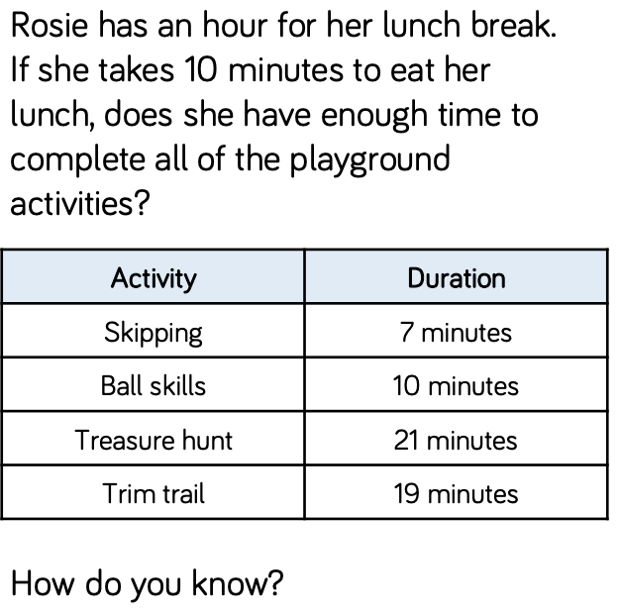  Y1 Access the White Rose Maths website for home learning (link below).  https://whiterosemaths.com/homelearning/year-1/  Complete Summer Term – Week 6 (w/c 1st June) Lesson 5: Friday Maths Challenge (watch the video before completing the activity).  Y2 Access the White Rose Maths website for home learning (link below).  https://whiterosemaths.com/homelearning/year-2/  Complete Summer Term – Week 6 (w/c 1st June) – Lesson 5: Friday Maths Challenge (watch the video before completing the activity).  KS1 If you do have access to a printer and want to print the White Rose sheets that go with each lesson, you can do. If you do this, you do not have to do the Power Maths pages as well.  If you do not have access to a printer, watch the White Rose video each day and then complete the Power Maths books.  Daily Project – SPELLING  KS1 – See attached sheets on website for revision and practise. (Please note that there is a sheet for this week and also one ready for next week).  Daily Project - Extra-Curricular Time  Did you know that it is World Environment Day today? We are so lucky to live in such a beautiful area so let’s get thinking about our local environment!  How many of these activities can you complete today and over the coming weekend?  - Go out for a walk in the garden. What bugs can you spot?  - Build a shelter outsider.  - Use recycling to make a bird feeder.  - Create a quiz about nature.  - Draw the stages of a plant growing.  - Make a wind chime.  - Plant some seeds.  - Build a house for an animal.  - Make a poster about how we can help to take care of our planet.  - Find out about how a caterpillar turns into a butterfly. Present this information in any way that you choose.  Watch this space for another 10 challenges coming your way next week!

Reception - Spellings
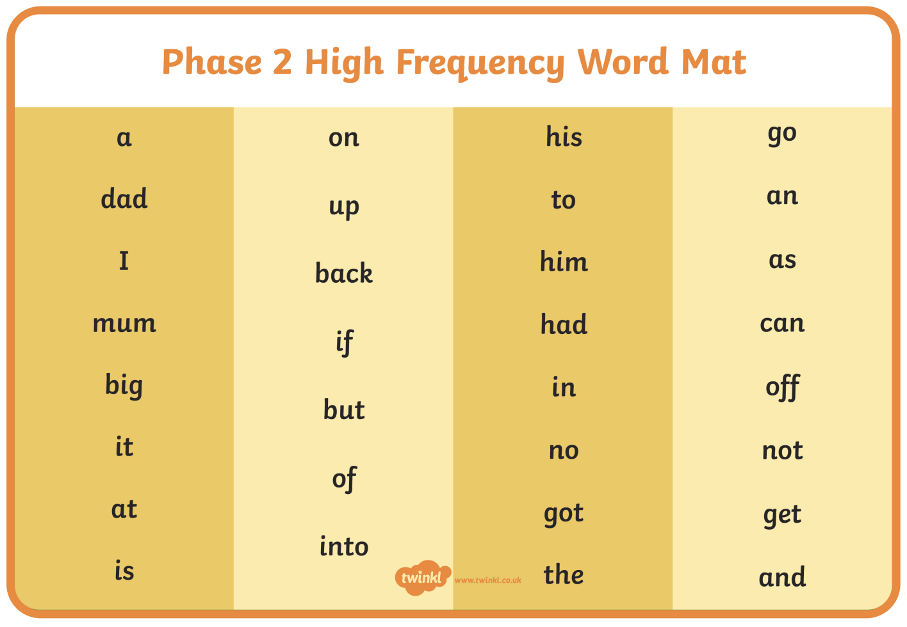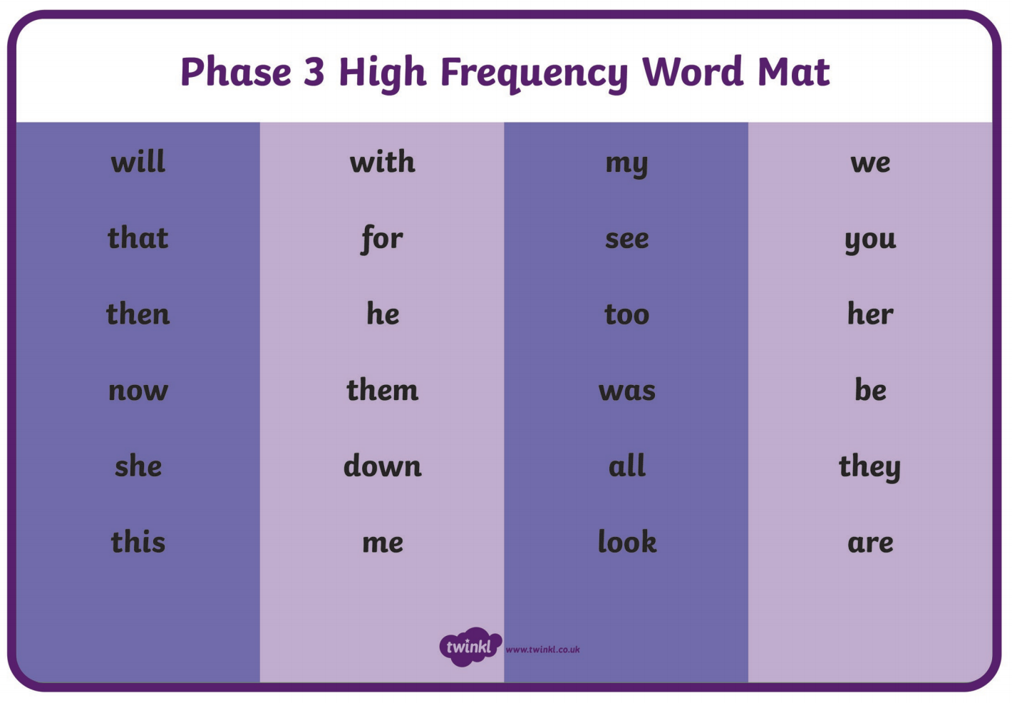

KS1 – Spellings

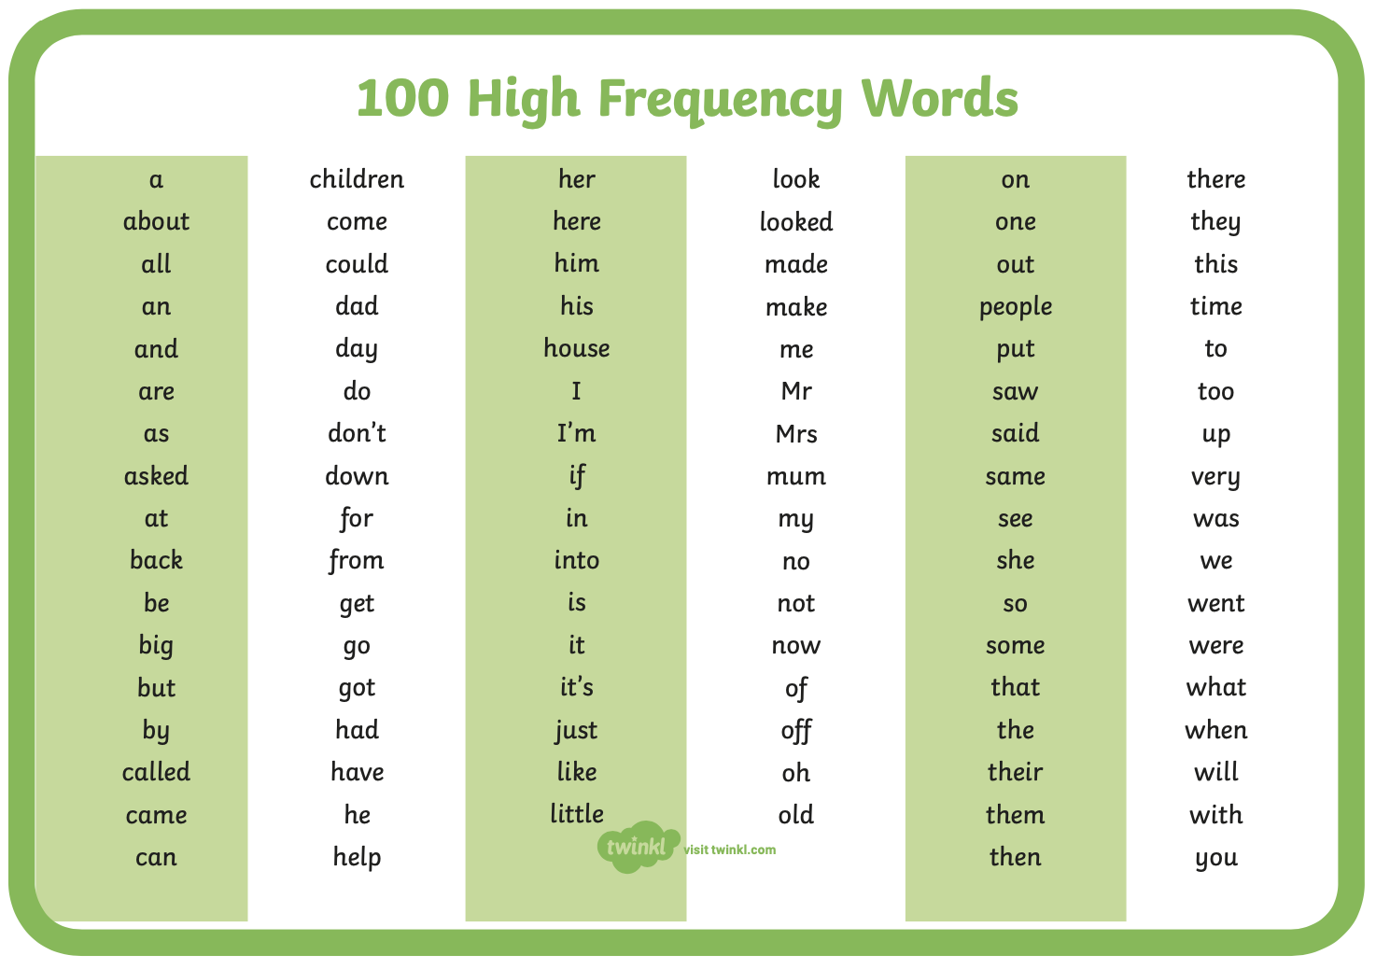
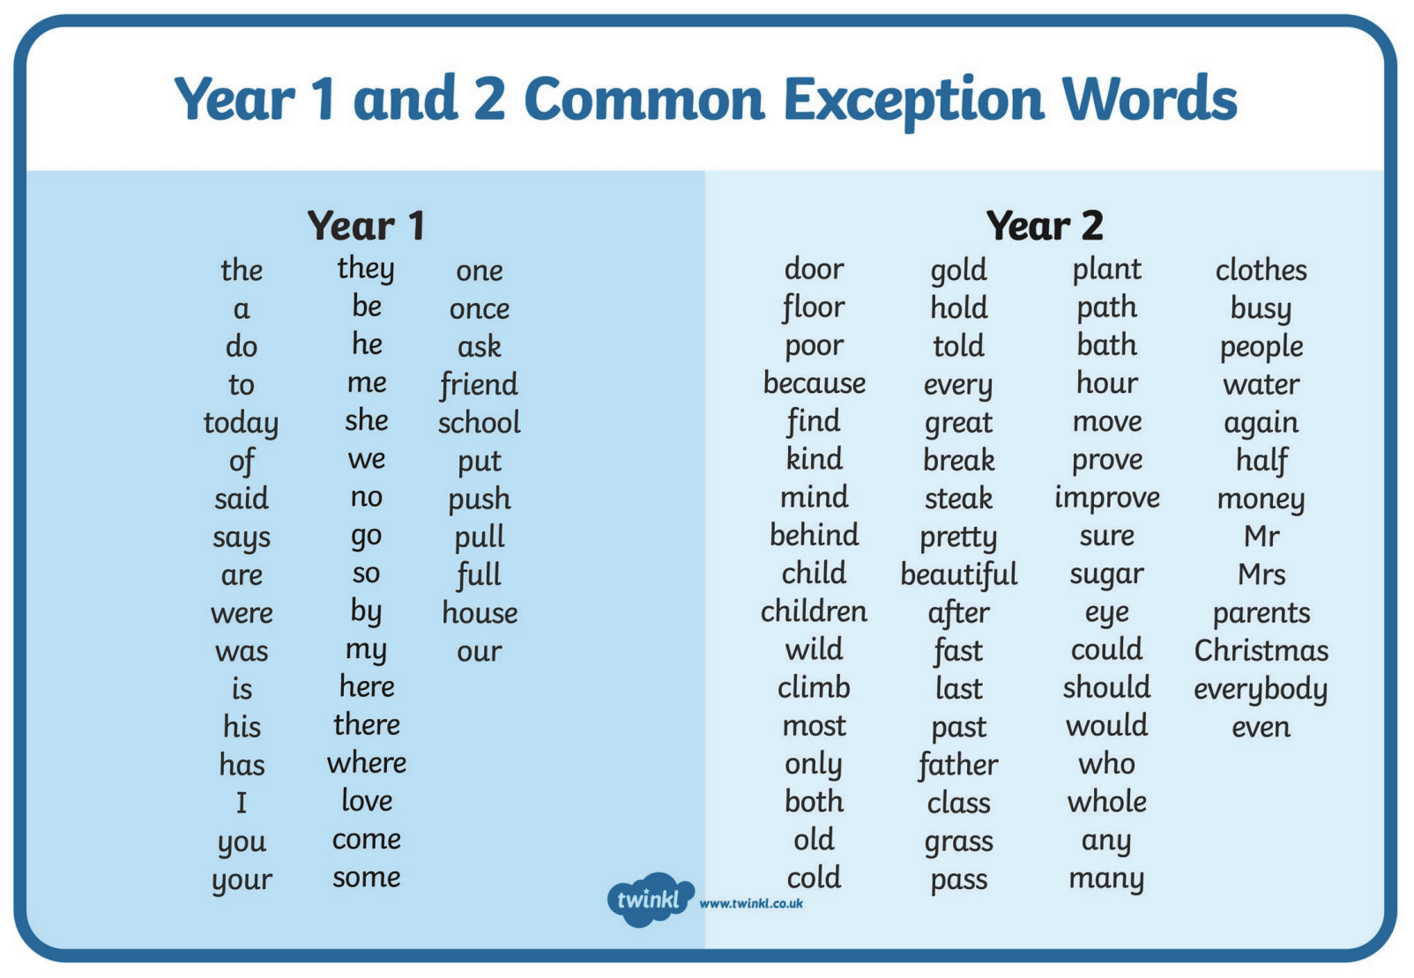

Pre-school Letter Formation Guidance
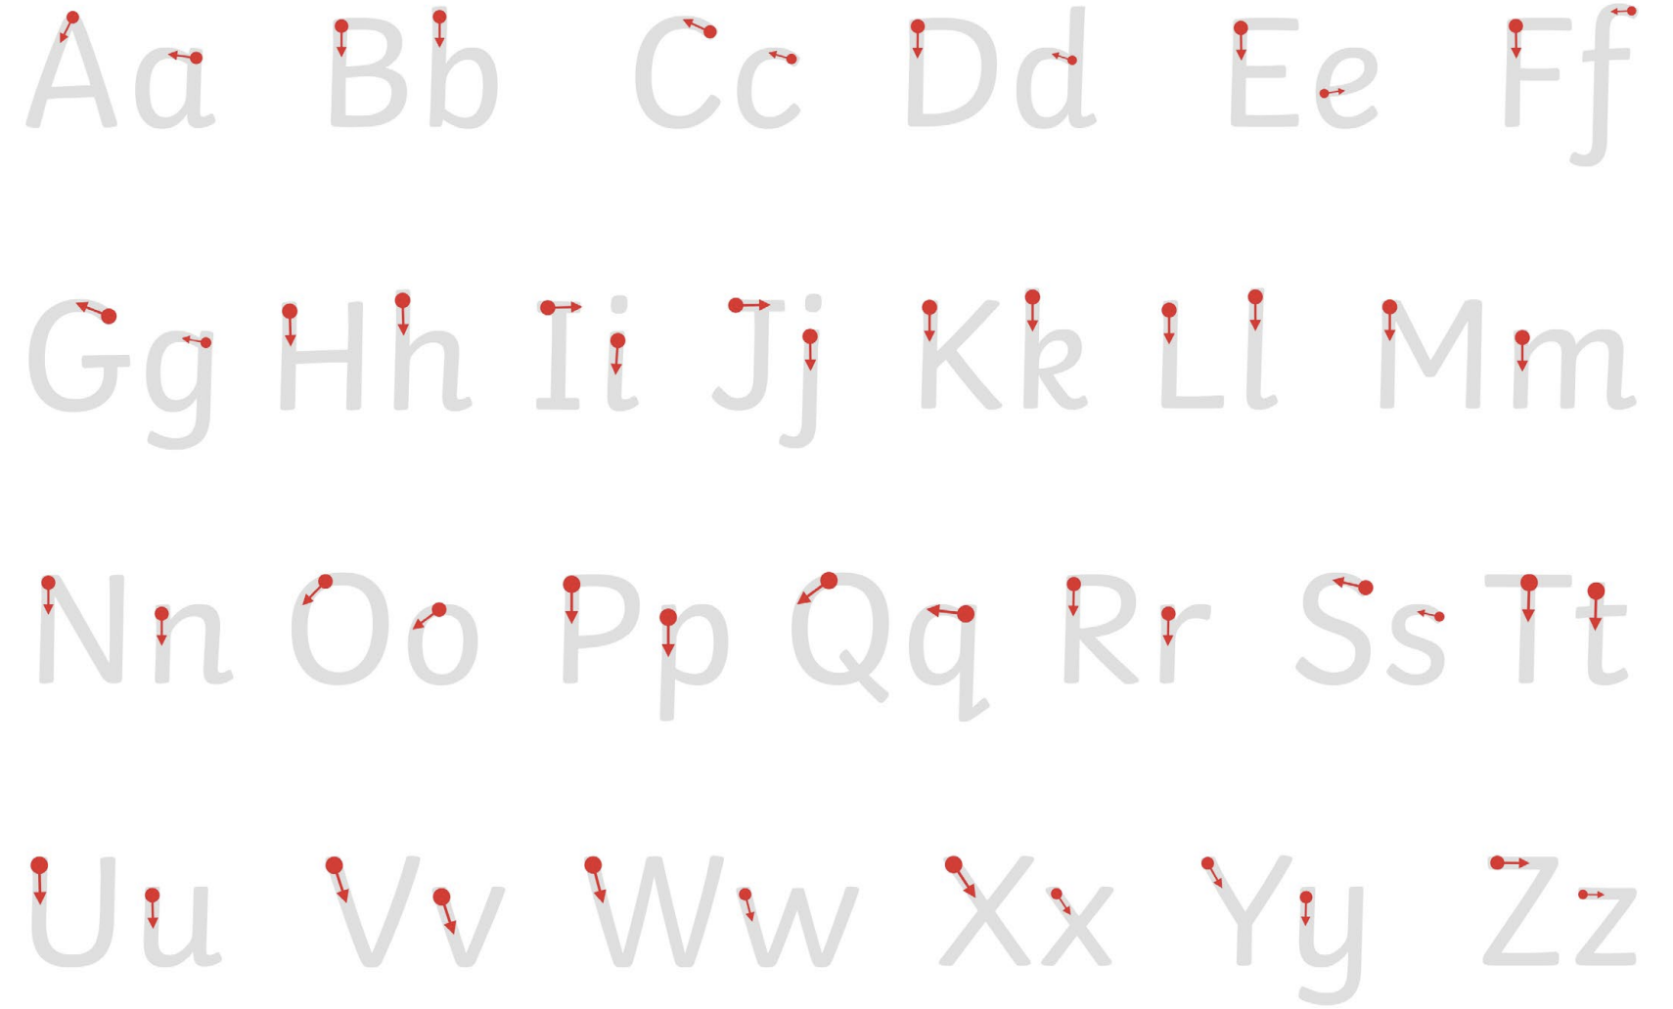
Year 1 Phonics Resources
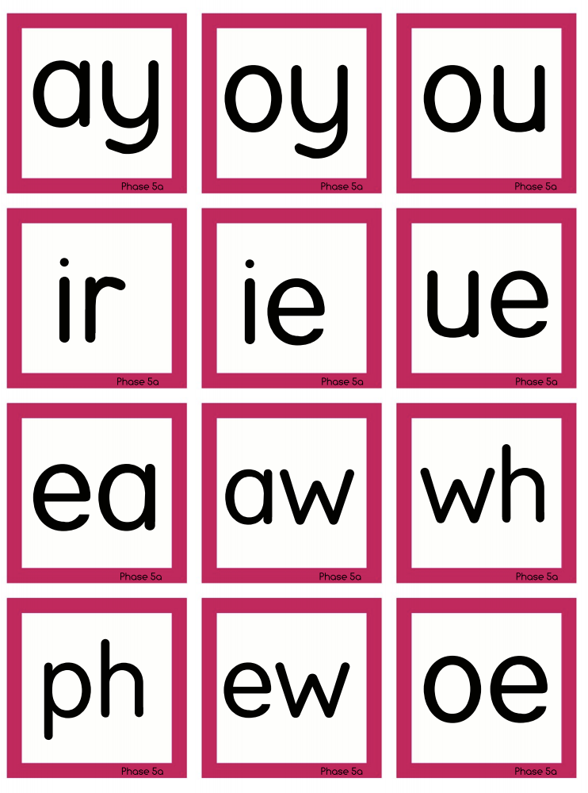

Monday | Phonics – ALL with support from parents/carers (pre-school see notes above)  Reception – Phase 4 revision: Practise GPCs - Play Flashcards using the previously attached resources or Quickwrite Graphemes. Read the list of tricky words. Practise any that your child is still finding it hard to read. SWAT activity: Lay out tricky words and ask your child to swat the correct one when you say it. The aim of today is to be secure with reading all of these words using rapid sight recognition.  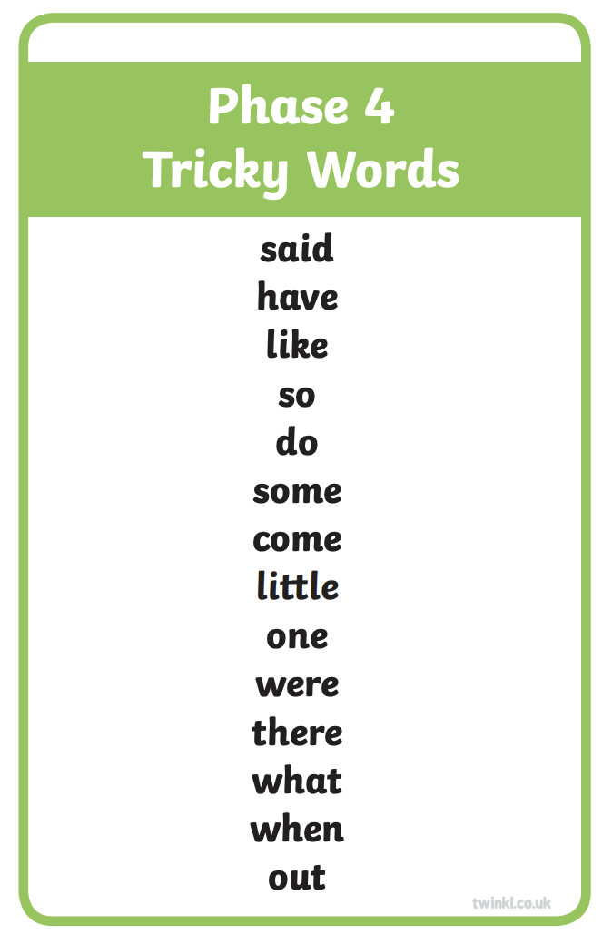  Year 1 – Phase 6 revision: We are learning to read adjectives that have the -er suffix added on: Go through all of the GPCs with your child at a rapid pace using the attached resources (see below – pink cards to print and cut out/make your own using this template). Practise GPCs for any that your child struggled with by playing ‘Flashcards’ using just these cards or Quickwrite Graphemes (say the sound on the flashcard ask your child to write it without them seeing it). You can also play ‘Flashcards’, selecting to use these sounds on Phonics Play if you subscribe for free. Practise reading the tricky words: water, where, who, again, thought, through, work, mouse, many (again you can use the Tricky Trucks on Phonics Play if you wish). Model blending to read the word kind. Talk through the thought processes involved in using the strategy. Show adding -er onto the end of kind. Briefly explain that the word kinder lets you compare how kind things are. Repeat with slow/slower and neat/neater. Play Countdown: lower, weaker, cheaper, meaner, smoother, shorter, stronger, darker, colder, wilder, older, lighter, sharper (how many of these words can you read in one minute/how many times). You can also play ‘Crater Creature Countdown’, selecting to use these words on Phonics Play. Hold up each of these sentences on paper. Ask your child to read the sentence you. Encourage them to discuss and figure out any words that they find difficult: This crocodile is kinder than that tiger. That flamingo is slower than this emu. Some people are neater than others. Now cover up the sentences so that your child can’t see them and slowly dictate each one to your child, asking them to write the sentences in their books, applying their learning from today.  Year 2 revision – Homophones: Cut up the word cards (below) and stick them around the room. Read one of the sentences below containing a homophone and ask your child to run to the correct place. Say the sentence together and chant the letters in the word.  There are 11 children in our class. They’re the best children in the school!  Their teacher is great.  I like to play spelling games. Have you got two cakes?  I like cakes too.  The sea is very choppy today. I can see huge waves.  Can you hear that dog barking? I’ll put your coat here.  It’s quite warm today. What a quiet classroom!  I saw a great big bear.  The trees are bare in the winter.  The sun shone brightly. My son is six.  He won the gold cup. We have one cat.  I want to be an explorer. That bee is buzzing loudly!  The wind blew strongly. Where is my blue hat?  At night, I go to bed.  The knight rode to the castle.  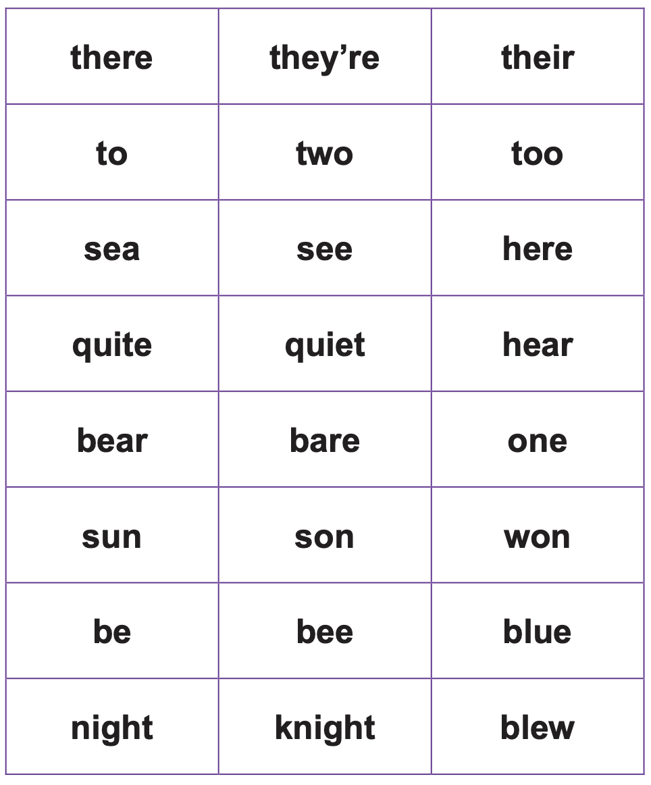  Maths  EYFS Maths Starter – Practise your number bonds to 10.  EYFS - Access the White Rose Maths website for home learning (link below).  https://whiterosemaths.com/homelearning/early-years/  Complete Summer Term Week 5 - Day 1: Superworm (watch the video before completing the activity).  KS1 Maths Starter  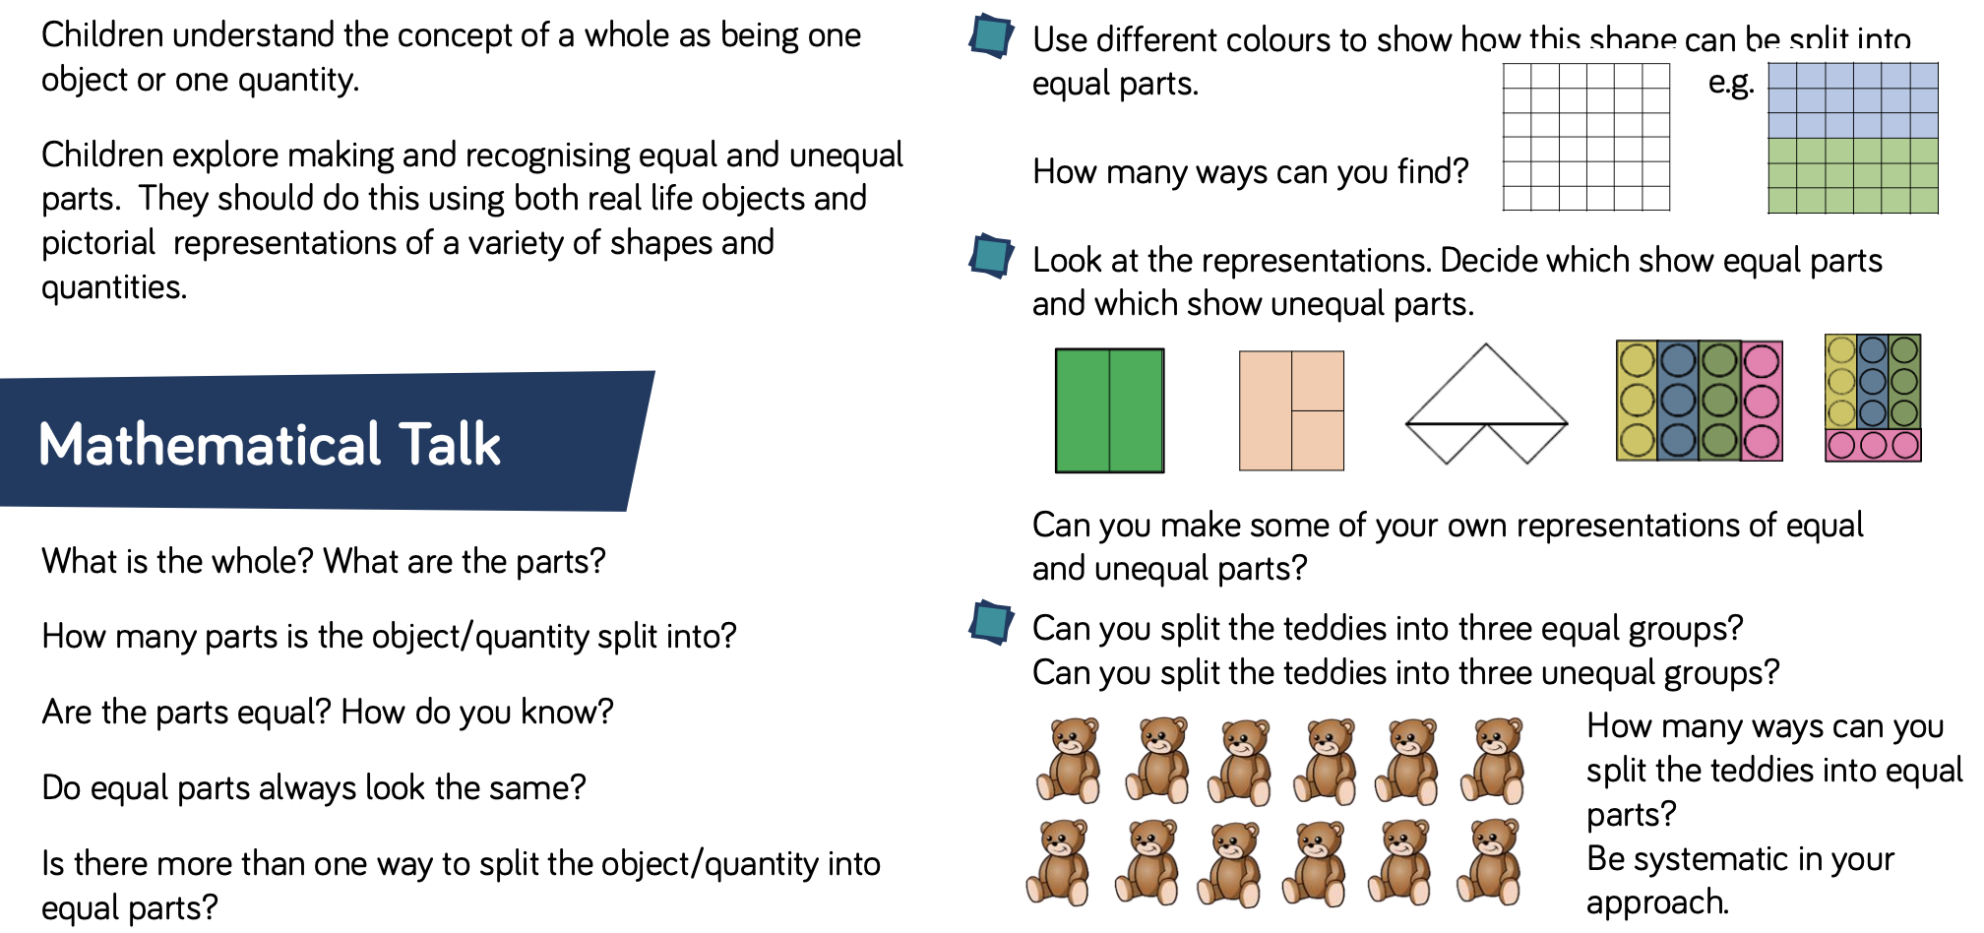  Y1 Access the White Rose Maths website for home learning (link below).  https://whiterosemaths.com/homelearning/year-1/  Complete Summer Term – Week 7 (w/c 8th June) Lesson 1 (watch the video before completing the activity).  Y2 Access the White Rose Maths website for home learning (link below).  https://whiterosemaths.com/homelearning/year-2/  Complete Summer Term – Week 7 (w/c 8th June) – Lesson 1 (watch the video before completing the activity).  KS1 - If you do have access to a printer and want to print the White Rose sheets that go with each lesson, you can do. If you do this, you do not have to do the Power Maths pages as well.  If you do not have access to a printer, watch the White Rose video each day and then complete the Power Maths books.  Daily Project – Global Citizenship  EYFS and KS1: Isn’t it wonderful to live beside the sea? Did you know that today is ‘World Oceans Day’? Look at the PowerPoint (attached on a separate document on the website) for an introduction to this event. Can you make a mini book, poster or fact file to share some information about each of the oceans on our blue planet?
Tuesday | Phonics – ALL with support from parents/carers (pre-school see notes above)  Reception – Phase 4 revision: Practise GPCs and tricky words - Play Flashcards using the previously attached resources. Practise reading - blend and read the caption: I must not tramp on the flowers. Draw a picture. Teach spelling any tricky words that your child is unsure of. Practise. The aim of today is to be secure with spelling/writing all of these words.  Year 1 – Phase 6 revision: We are learning to write adjectives that have the -er suffix added on (and revise spelling strategies using the best guesses). Ask your child to quickly write down all the graphemes they know for /ar/. Which is the best guess in the middle of the word? Which at the end? Which are very rare? Repeat for /ow/. Refer back to best guess posters:  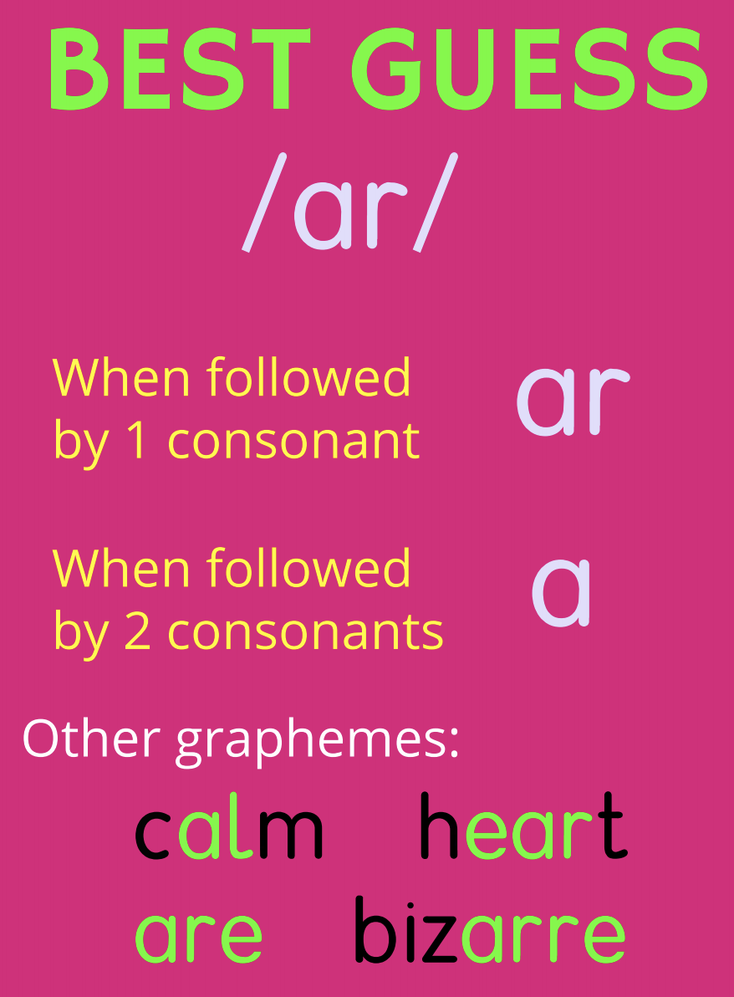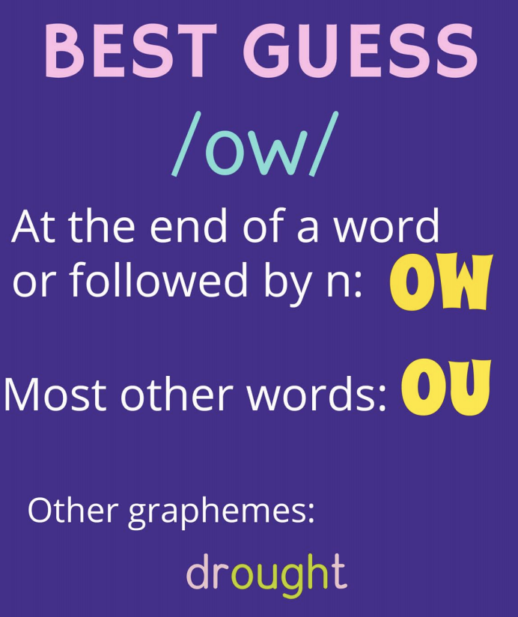  Model segmenting to spell the word louder. Model thinking about how to spell the /ow/ sound. E.g. “I'll start with the first syllable /l/ /ow/ /d/.” Draw sound buttons and write in the easy phonemes. The /ow/ sound is a tricky one but it isn't at the end of a word and it doesn't have an n after it so the best guess spelling is ou. The last syllable is /er/ (draw one more sound button) and at the end of a word, that sound is often spelt er. Write all the letters in. Repeat (segment, sound buttons, put in the easy bits, talk about the thought processes for the tricky bits, make a best guess for the tricky bits) for meaner and older. Play Quickwrite using the words: prouder, neater, colder, smoother, smarter, sharper, darker, calmer. After they have written each word, get them to show it to you, then parent gives correct spelling whilst child marks their words. One tick for the correct number of sound buttons plus one tick for each correct letter. If your child has chosen the wrong grapheme, encourage them to correct it. Now dictate the following sentences as your child writes them: I feel prouder than I have ever done before. The sky is getting darker. You had a smarter plan than I did. Reveal correctly written sentences and encourage your child to check their own spellings.  Year 2 revision – Homophones: Read the same sentences that you practised in the previous lesson. Ask your child to write down either the whole sentence or just the homophones. Check their answers and reinforce the correct spellings.  Maths  EYFS Maths Starter:  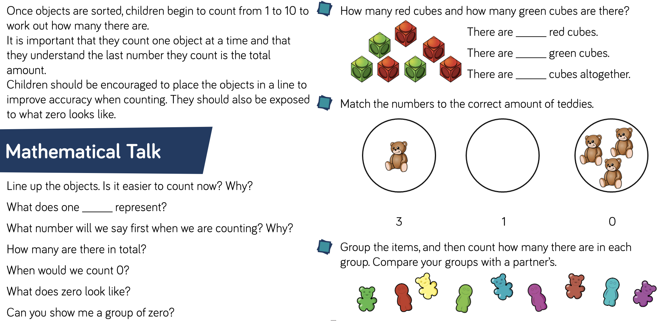  EYFS - Access the White Rose Maths website for home learning (link below).  https://whiterosemaths.com/homelearning/early-years/  Complete Summer Term Week 5 - Day 2: Superworm (watch the video before completing the activity).  KS1 Maths Starter:  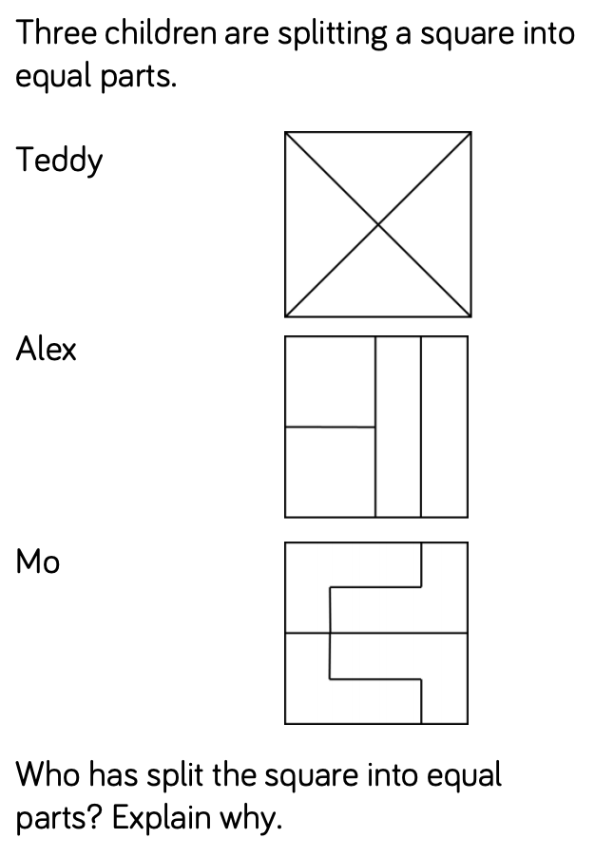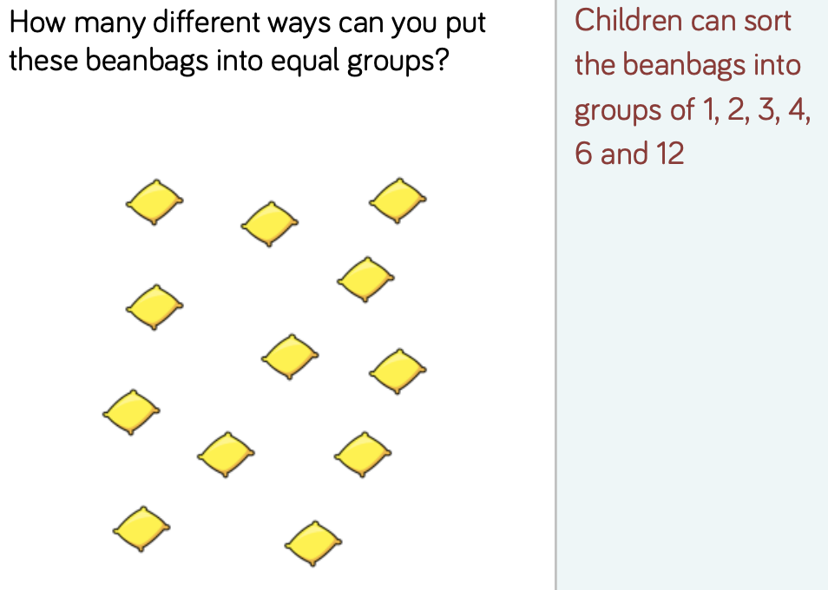  Y1 Access the White Rose Maths website for home learning (link below).  https://whiterosemaths.com/homelearning/year-1/  Complete Summer Term – Week 7 (w/c 8th June) Lesson 2 (watch the video before completing the activity).  Y2 Access the White Rose Maths website for home learning (link below).  https://whiterosemaths.com/homelearning/year-2/  Complete Summer Term – Week 7 (w/c 8th June) – Lesson 2 (watch the video before completing the activity).  KS1 - If you do have access to a printer and want to print the White Rose sheets that go with each lesson, you can do. If you do this, you do not have to do the Power Maths pages as well.  If you do not have access to a printer, watch the White Rose video each day and then complete the Power Maths books.  Daily Project - TOPIC  EYFS and KS1: Last week you began to think about and describe how toys have changed over time. Take another look at the pictures that show toys ‘then’ and ‘now’ (see attached resource on website). Choose one of these toys (or if there is one of your parents’ toys that you found or pictures online you can use these). Now compare the toy from the past with its modern equivalent. Write the best describing words you can think of on sticky notes or labels to describe what you can see and touch. Imagine you were a museum curator and make labels for your two artefacts as if they were going to be display in a museum; these should explain what the toy is, what it is made from and how it was played with.

Wednesday | Phonics – ALL with support from parents/carers (pre-school see notes above)  Reception – Phase 4 revision: Practise GPCs - Play Flashcards using the previously attached resources or Quickwrite Graphemes. Practise reading - blend and read the captions: I kept bumping into things in the dark. Milk is good for children’s teeth. Play tricky word bingo, then Quickwrite all tricky words.  Year 1 – Phase 6 revision: Revise reading the tricky words: water, where, who, again, thought, through, work, mouse. Write the words it is with each letter on a small individual square of paper and stick these up. Ask the children to read the words. Point out that we don't normally say it is. We shorten it to make it quicker to say – it's. Model taking of the piece of paper with the i on it, scrumpling it up, squishing the scrumpled piece of paper into an apostrophe shape and sticking it back where it was. Point out that the other letters need shuffling up a bit so there are no spaces because it is now one word instead of two. Now model blending to read it as one new word. Repeat with do not/don't (pointing out the pronunciation change) and I will/I'll. Stress that the apostrophe goes back in the place where the letters were (not in the gap between the words) and that the apostrophe doesn't represent any sound – just missing letters. Play Countdown (how many of these words can you read in one minute/how many times): it's, don't, I'm, didn't, can't, I'll, I'm, couldn't, I've, there's, he's, we're. Remember that you can also play ‘Crater Creature Countdown’, selecting to use these words on Phonics Play. Practise writing the sentences (dictate to your child): It's colder than it was on Sunday. I can't come to school because I've got a sore throat. I've tried but it's too hard and I can't do it. Reveal correctly written sentences and encourage children to check their own spellings.  Year 2 revision – /ʌ/ sound spelt ‘o’: Put the words from this list on display and ask your child to read them: other, mother, brother, nothing, none, Monday. Add sound buttons once they have read them. What do they notice about the words? Cover up the words, say one word and ask them to sound it out and then write it. They underline the tricky part of the word and show it. Have they got the ‘o’? Discuss any errors and why they might have happened. Ask your child to write the word again. Do this for as many of the words as you have time for.  Maths  EYFS Maths Starter:  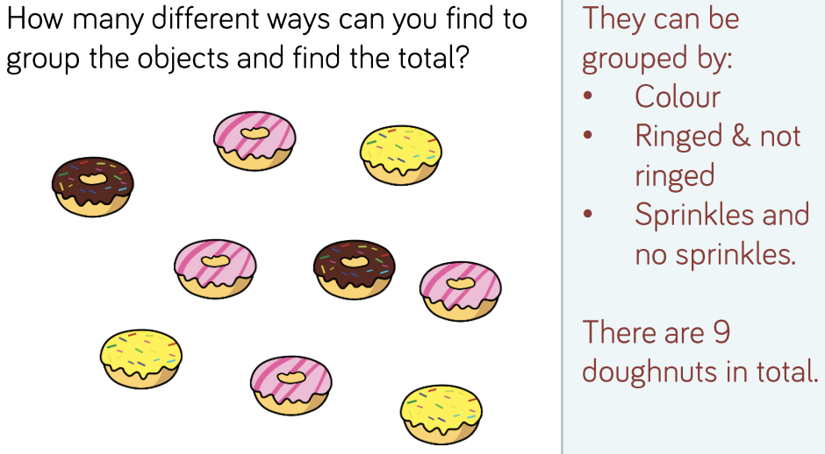  EYFS - Access the White Rose Maths website for home learning (link below).  https://whiterosemaths.com/homelearning/early-years/  Complete Summer Term Week 5 - Day 3: Superworm (watch the video before completing the activity).  KS1 Maths Starter:  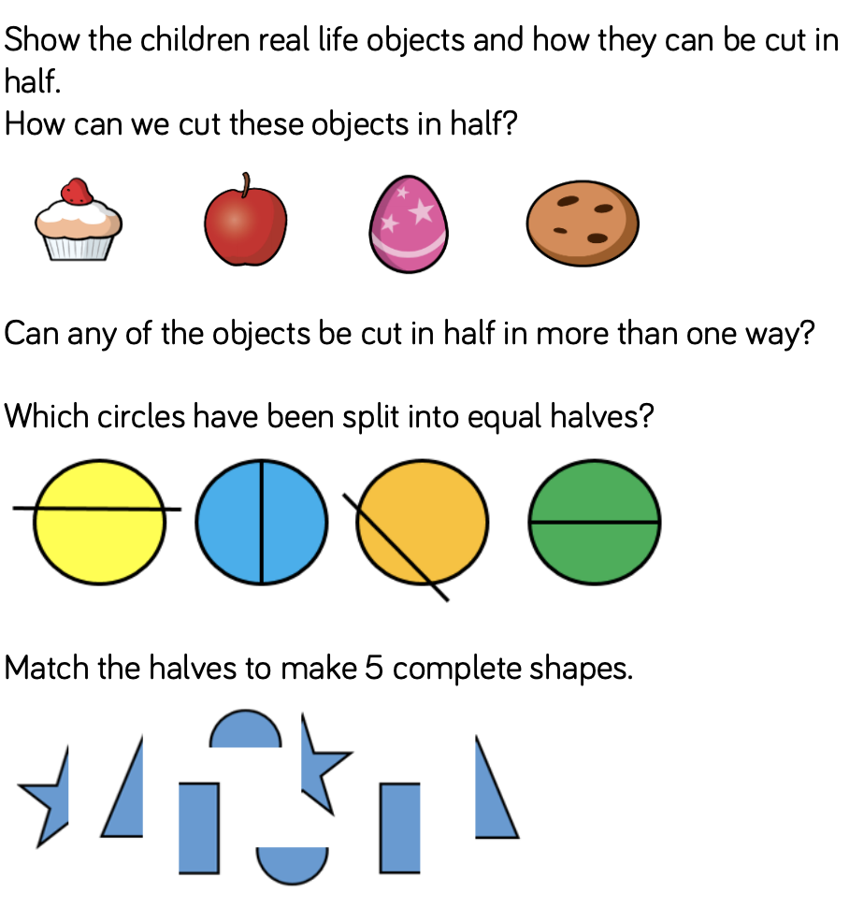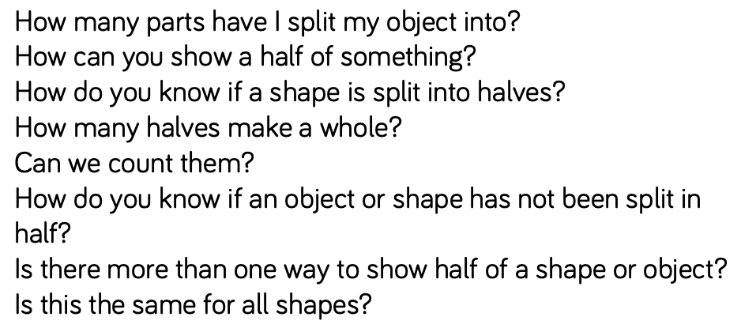  Y1 Access the White Rose Maths website for home learning (link below).  https://whiterosemaths.com/homelearning/year-1/  Complete Summer Term – Week 7 (w/c 8th June) Lesson 3 (watch the video before completing the activity).  Y2 Access the White Rose Maths website for home learning (link below).  https://whiterosemaths.com/homelearning/year-2/  Complete Summer Term – Week 7 (w/c 8th June) – Lesson 3 (watch the video before completing the activity).  KS1 - If you do have access to a printer and want to print the White Rose sheets that go with each lesson, you can do. If you do this, you do not have to do the Power Maths pages as well.  If you do not have access to a printer, watch the White Rose video each day and then complete the Power Maths books.  Daily Project – SCIENCE and PSHE  TASK 1 - EYFS and KS1: Watch the BBC Bitesize link https://www.bbc.co.uk/bitesize/clips/zmptsbk Now, look at the ‘classroom ideas’. Can you find a way to recall some of the facts and then use art straws or twigs to make artistic skeletons of humans and other animals using the same amount of sticks or straws as bones.  TASK 2 – EYFS and KS1: Complete page 2 of the ‘Family positivity and gratitude pack’ (separate document found attached on website). Remember that we will continue with a page per week throughout the rest of the term so you are not expected to complete this whole booklet now!
Thursday | Phonics – ALL with support from parents/carers (pre-school see notes above)  Reception – Phase 4 revision: Practise GPCs and tricky words – Have you got a water squirter? Perhaps you could play squirt the grapheme or word! Write the graphemes and words on labels to pin up in the garden or use chalk on a path. Ask your parent to say one of the graphemes or words, find it and squirt it! Play yes/no questions Tell a T-Rex on: https://www.ictgames.com/mobilePage/tellATRex/index.html  Year 1 – Phase 6 revision: We are learning to read words adjectives with the -est ending. Revise blending to read words and making alternative pronunciation choices for the ea grapheme. You could use Phonics Play to play Cheeky Chimps or Sneaky Squirrels if you wish.  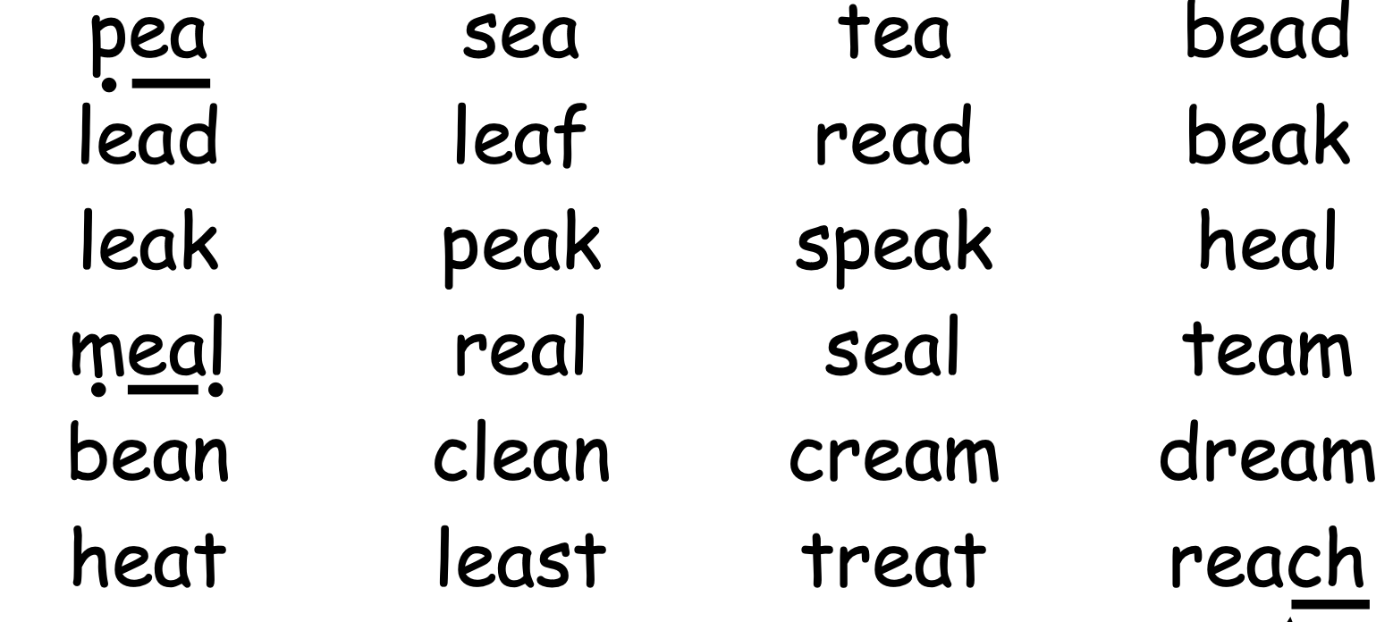  Look at the words kind, kinder and kindest. Point out that while we add -er to compare two things, we add -est to say that someone or something is the most kind. Model blending to read and show that kind/e/st doesn't sound right and that the -est ending actually sounds like /i/st. Model soundtalking to read the words oldest and darkest. Play Countdown (how many of these words can you read in one minute/how many times): proudest, neatest, coldest, smoothest, smartest, sharpest, darkest, coolest, kindest, wildest. Remember that you can also play ‘Crater Creature Countdown’, selecting to use these words on Phonics Play. Practise reading and writing the sentences (after they have read them, cover them up and dictate to your child): Which animal has the sharpest teeth? Which part of your body is the strongest? What is the coldest place you have ever been to? Reveal correctly written sentences and encourage children to check their own spellings.  Year 2 revision – /ʌ/ sound spelt ‘o’: Ask your child to read the passage with spelling errors for the focus GPC. How many errors can they spot? Ask them to rewrite the passage with the correct spellings.  PASSAGE: On Munday I went to visit my muther and my bruther. There was nothing to eat in the house so I set off to see if my uther bruther had sum cakes.  Maths  EYFS Maths Starter: (Grown up and child can play together rather than two children if necessary).  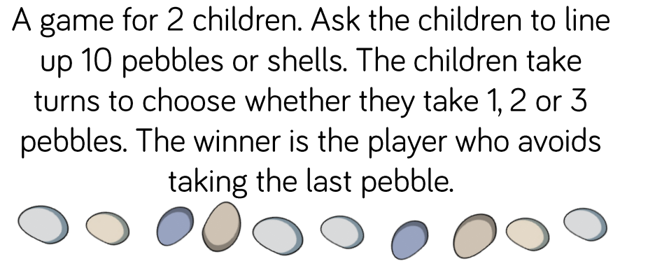  EYFS - Access the White Rose Maths website for home learning (link below).  https://whiterosemaths.com/homelearning/early-years/  Complete Summer Term Week 5 - Day 4: Superworm (watch the video before completing the activity).  KS1 Maths Starter:  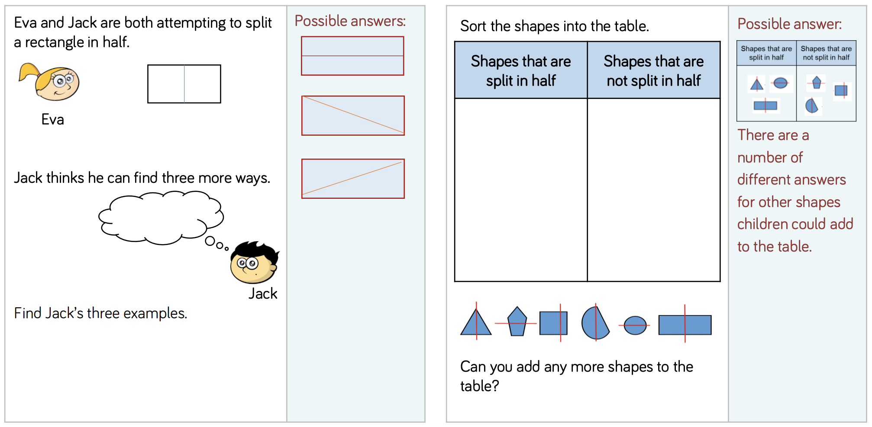  Y1 Access the White Rose Maths website for home learning (link below).  https://whiterosemaths.com/homelearning/year-1/  Complete Summer Term – Week 7 (w/c 8th June) Lesson 4 (watch the video before completing the activity).  Y2 Access the White Rose Maths website for home learning (link below).  https://whiterosemaths.com/homelearning/year-2/  Complete Summer Term – Week 7 (w/c 8th June) – Lesson 4 (watch the video before completing the activity).  KS1 - If you do have access to a printer and want to print the White Rose sheets that go with each lesson, you can do. If you do this, you do not have to do the Power Maths pages as well.  If you do not have access to a printer, watch the White Rose video each day and then complete the Power Maths books.  Daily Project – R.E.  Places of Worship: Mosque  Look at the PowerPoint with your child (attached within a separate document on the website). You might wish to look up images of famous mosques on the internet or watch some BBC bitesize video clips too. Complete the labelling sheet (also attached separately).
Friday | Phonics – ALL with support from parents/carers (pre-school see notes above)  Reception – Phase 4 revision: Quickwrite graphemes (parent say the phonemes/digraphs, child to write down what they hear).  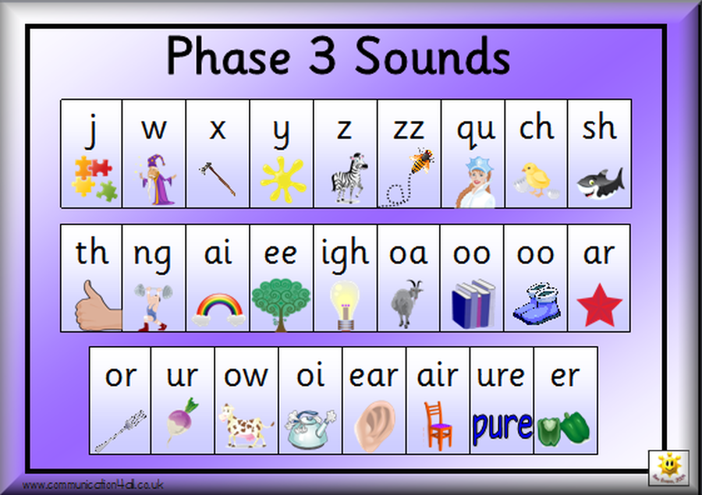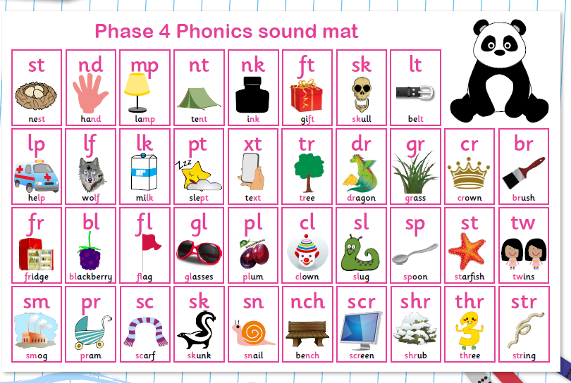  Practise reading - Blend and read caption the caption: The clown did tricks with a chimpanzee. Draw a picture. Have a look at the games on these websites: http://www.letters-and-sounds.com/phase-4-games.html and https://www.ictgames.com/mobilePage/literacy.html have a go at some of them to practise your phonics.  Year 1 – Phase 6 revision: We are learning to spell words with the -est ending where no change to the root word is needed. Ask your child to quickly write down all the graphemes they know for /oi/. Which is the best guess in the middle of the word? Which at the end? Which are very rare? Repeat for /or/. Refer to best guess posters:  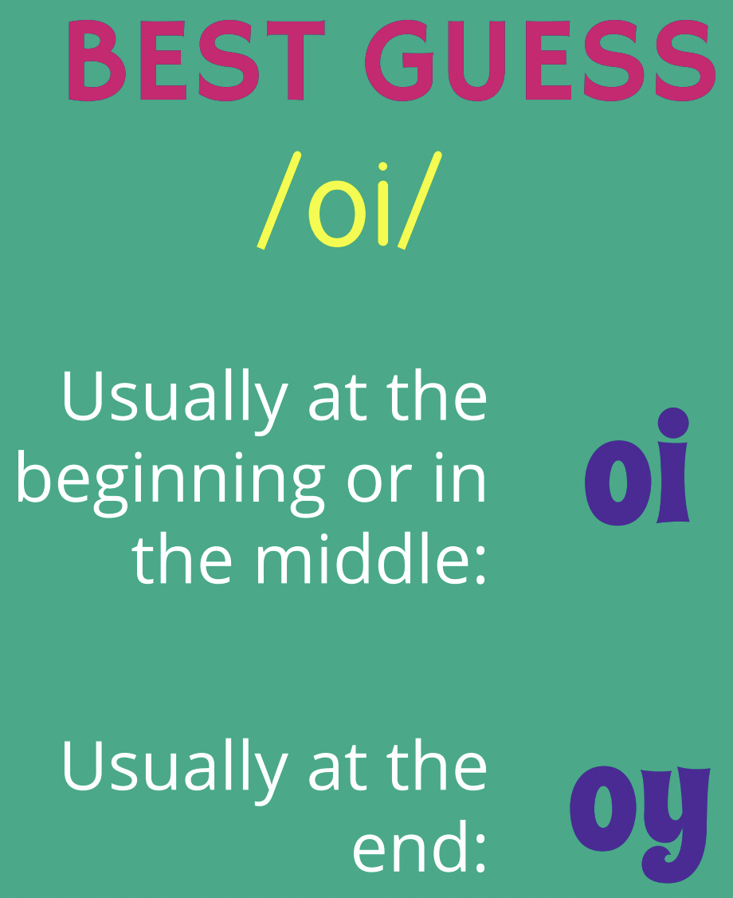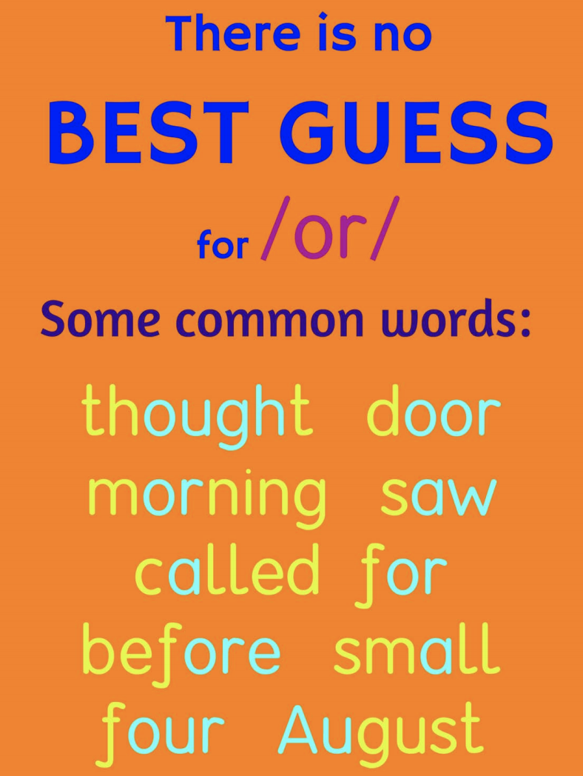  Model segmenting to spell the word lightest. Ask your child to clap out the syllables in this word. Start with the first syllable light. Remind them that they know how to spell this root word light. Then look at the second syllable /i/st. Ask the children if they can remember the letters that represent the sounds in this ending. Write lightest. Repeat with strongest and weakest. Children write a selection of words: proudest, neatest, coldest, smoothest, smartest, sharpest, darkest, calmest, coolest, kindest, wildest. Practise reading and writing the sentences (after they have read them, cover them up and dictate to your child): You have the neatest bedroom. That shark has the sharpest teeth. I don't want to go into the deepest, darkest cave. Reveal correctly written sentences and encourage children to check their own spellings.  Year 2 – revision: Ask your child to write silly sentences using any of the words revised or learnt this week. Remember best handwriting!!!  Maths  EYFS Maths Starter: Create a countdown game by chalking 10 – 0 leading towards a rocket or even a water blaster! Play on the number track with your child using a dice. Let your child roll the dice and jump from 10 to 0 according to what they have rolled. Remember to count the numbers down as you jump e.g. 10, 9, 8. Your turn next! First to reach the rocket wins and shouts blast off! If you’ve got a water blaster, perhaps the winner gets to soak the loser?! Extend learning using numbers 20 – 0.  EYFS - Access the White Rose Maths website for home learning (link below).  https://whiterosemaths.com/homelearning/early-years/  Complete Summer Term Week 5 - Day 5: Superworm (watch the video before completing the activity).  KS1 Maths Starter:  I am finding halves.  “It is hard to find half of an odd number.”  Do you agree with me? Explain your answer.  Now try this:  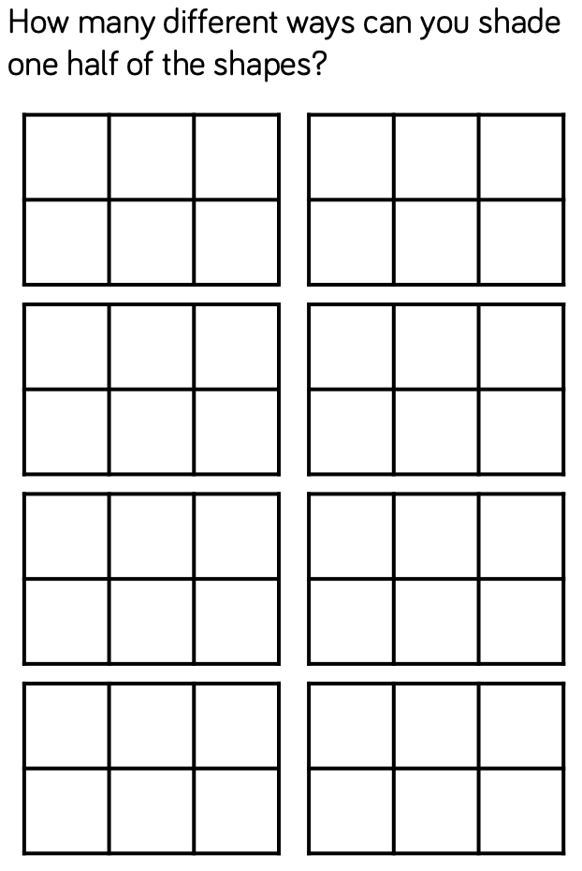  Y1 Access the White Rose Maths website for home learning (link below).  https://whiterosemaths.com/homelearning/year-1/  Complete Summer Term – Week 7 (w/c 8th June) Lesson 5: Friday Maths Challenge (watch the video before completing the activity).  Y2 Access the White Rose Maths website for home learning (link below).  https://whiterosemaths.com/homelearning/year-2/  Complete Summer Term – Week 7 (w/c 8th June) – Lesson 5: Friday Maths Challenge (watch the video before completing the activity).  KS1 If you do have access to a printer and want to print the White Rose sheets that go with each lesson, you can do. If you do this, you do not have to do the Power Maths pages as well.  If you do not have access to a printer, watch the White Rose video each day and then complete the Power Maths books.  Daily Project – SPELLING  KS1 – See attached sheets on website for revision and practise. (Please note that there was a sheet for last week, as well as one being ready for this week so scroll down for the relevant section).  Daily Project - Extra-Curricular Time  Did you remember that on Friday 5th June it was World Environment Day today? Here are your second set of 10 challenges that I promised you last week! How many of these activities can you complete today and over the coming weekend?  - Make your own garden ‘snap’ game.  - Go out for a nature walk. Draw and write what you see.  - Design your ‘dream garden’.  - Create your own weather forecast and video it.  - Make your own garden or nature word search.  - Create a nature walk map and include a key.  - Draw pictures of your favourite animals and label them with where they live.  - Make a garden in a show box.  - Can you spot some flowers in your garden? What can you find out about them from books or on the internet?  - Find out about the lifecycle of a frog. Present this information in any way that you choose.

