Grammar and Spelling Resources: Week Beginning Monday 15th June 2020
Monday: Year 3
Homophones (including heel/heal/he’ll, plain/plane, groan/grown and rain/ rein/reign)
Look at the homophones in the chart below:
heel | heal |  | he’ll
rain | rein |  | reign
plain |  | plane
groan |  | grown

Use a dictionary (eg. https://kids.wordsmyth.net/we/) to investigate the different meanings of the words. Can you draw pictures to represent each word. What strategies could you use to help you remember which spelling to use when? Try writing sentences using each of the words correctly in context.

Monday: Year 4
ly suffix with words ending in y, le and ic.
Look at the following words.
merry
bubble
magic
The word merry is an adjective that can be used to describe a person, place or thing. It can be transformed into adverbs to describe how an action is performed by adding the –ly suffix. However, when adding the –ly suffix to a word that ends in a y that has a consonant in front of it, you must first change the y to i and then add –ly. So merry becomes merrily.

The words bubble and magic are themselves nouns but the –ly suffix can also be added to each of these.
To add the –ly suffix to bubble, drop the –le at the end of the word and put –ly in its place. So bubble becomes bubbly.
To add the –ly suffix to magic, you must first add –al to turn the word into the adjective, magical. Then add –ly to make the adverb magically.
These patterns can be followed when adding –ly to a range of words that end in a similar way.
Summary
- Words ending in consonant + ‘y’: change ‘y’ to ‘i’ if the word is more than one syllable
- Words ending in ‘le’: take off ‘e’ and add ‘y’
- Words ending in ‘ic’: add ‘ally’

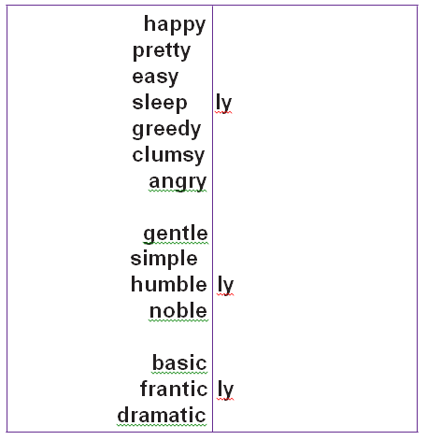
Have a go at adding the –ly suffix to words in the following matrix:

Monday: Year 5 and 6 : Tricky homophones
Review the list of tricky homophones below. Can you remember which is which in each pair of words? Write some sentences to remind yourself how to use these words.
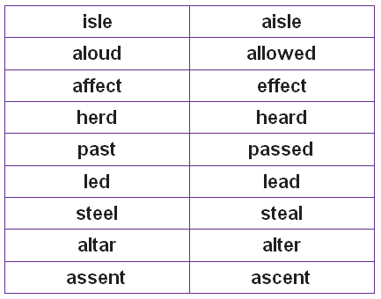

Tuesday: Years 3 and 4 – Statutory spelling words
All the following words from the Year 3 and 4 statutory list can be used as a root word using the –ly suffix. Practise spelling the root words and then add the –ly suffix. Check that you have spelt the word correctly with the suffix, then practise using ‘Look, say, cover, write, check’ and try using the words correctly in a sentence.
accident
occasion
actual
popular
regular
recent

Tuesday: Years 5 and 6 - Statutory spelling words
All of the words on the list below use the letter y as a vowel. Listen carefully to how the letter y sounds in these words. Which is the odd one out and why?
symbol
system
rhyme
rhythm
physical
Below is a further list of words to practise that all use the letter y as a vowel, with some activities to help you practise them.

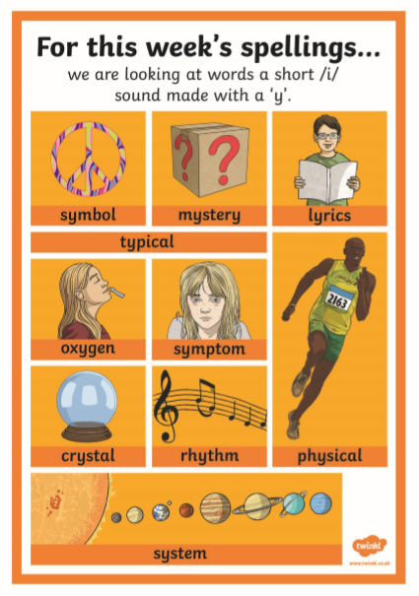
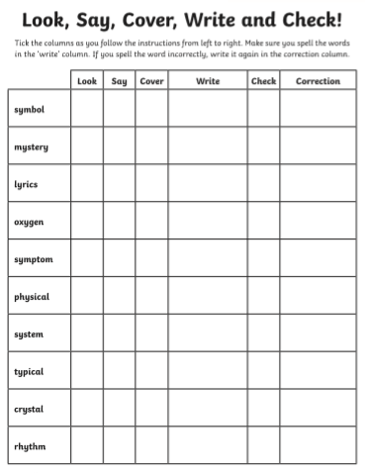

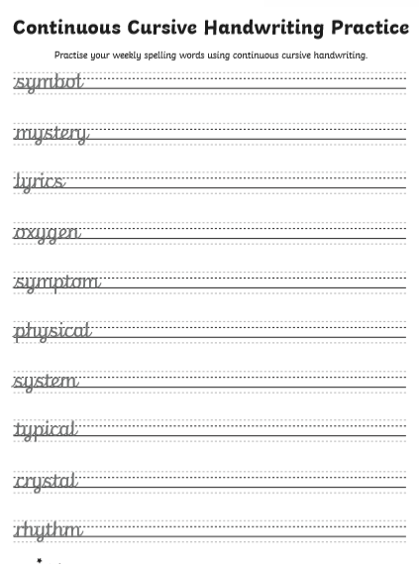

Wednesday – Year 3
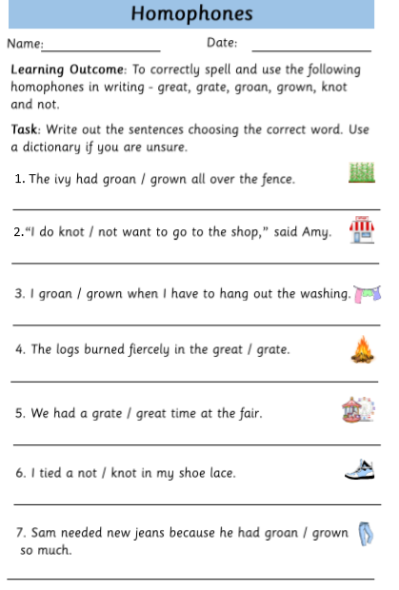

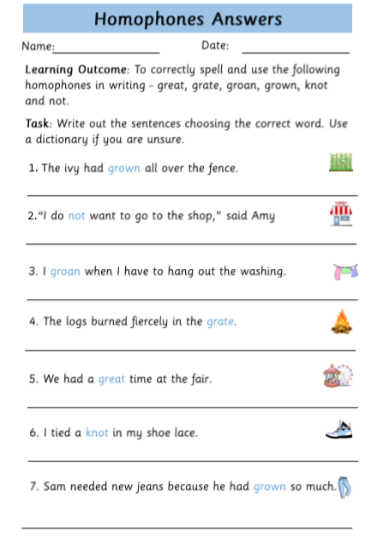

Wednesday: Year 4 – ly suffix
Practise making adverbs using the –ly suffix and using them in sentences, using the following activities:
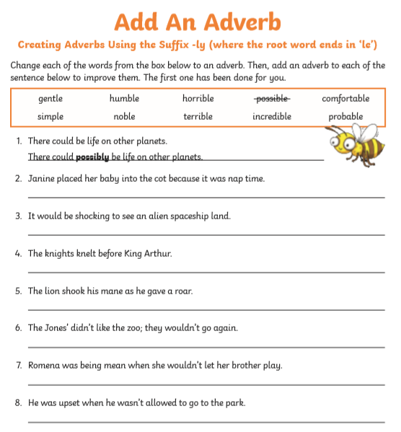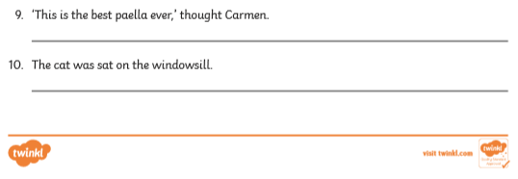
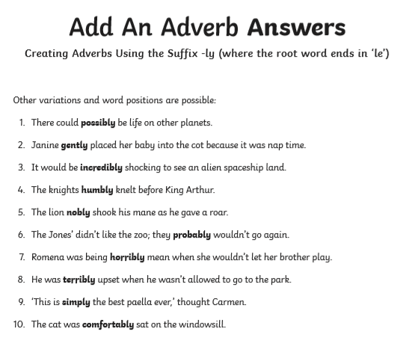
Notes about the next activity for parents:
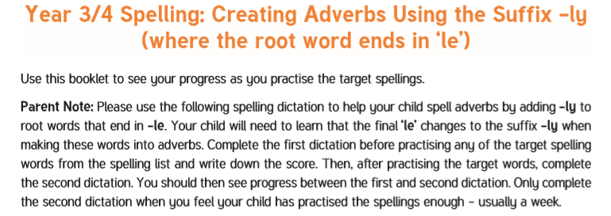

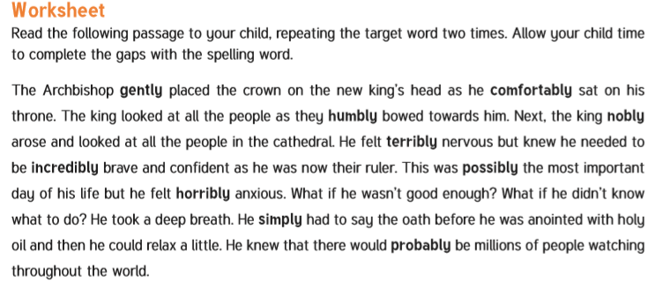
Children – if your parent is not available to help you, try reading the above dictation and recording yourself reading it, then some time later, listen to your recording and write down the missing words. Can you remember the correct spelling?

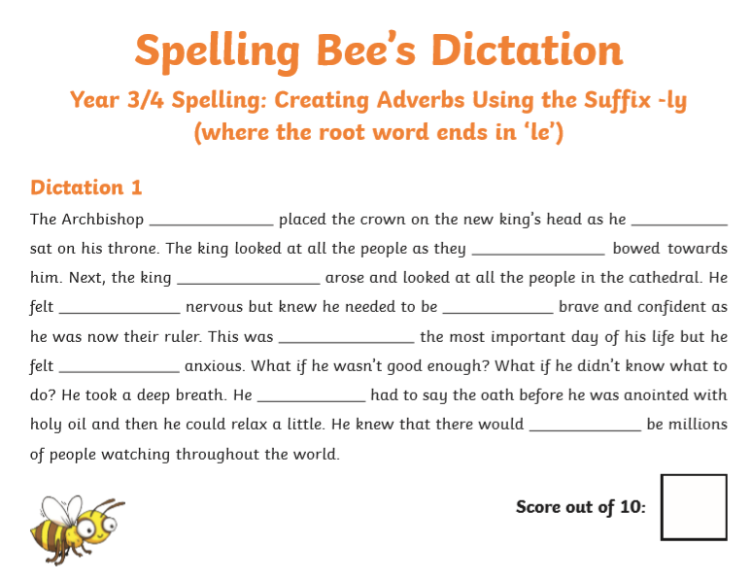

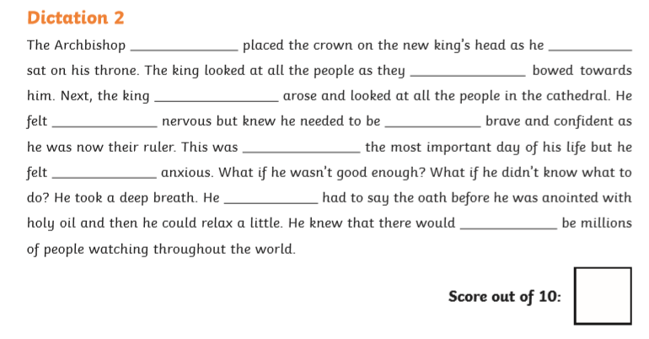

Wednesday – Year 5 and 6 – ‘y as a vowel’ revision practice including statutory words
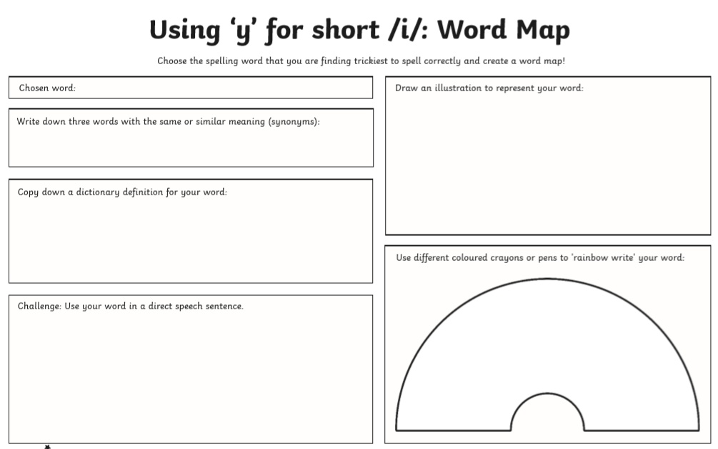

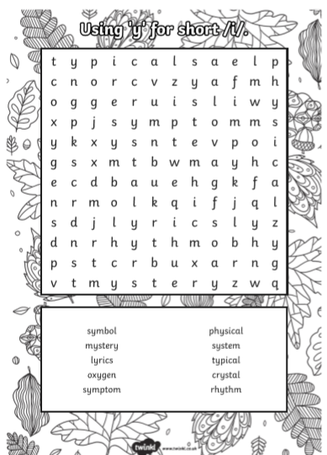

Thursday – Year 3 - homophones
Review the homophones practised this week by completing the following sentences.

heel | heal |  | he’ll
reign | rein |  | rain
plane |  | plain
groan |  | grown
knot |  | not
great |  | grate

- “I had a day today!” Lucy told her mum as they walked away from school.
- Paul hurt his when landing from a jump and found it hurt when he was walking for the rest of the day. He found himself wanting to every time he put his foot down.
“It will take a few days to ,” the doctor told his mum, but be able to walk on it if he is careful.
- The of our current monarch is now the longest in British history.
- “Do you prefer the t-shirt or the stripy one?” Mum asked.
- “Could you some cheese for me?” Dad asked Sam, as he was putting the lasagne together.
- The gardeners were all thankful when it finally began to after several very dry weeks.
- The took off exactly two hours after the family arrived at the airport and they were thankful to have a chance to sit and relax.
- His shoelaces were in such a tight that even Scott’s teacher could not untie them.
- Paul had so much taller in the past year that he now found it much easier to put a halter and on his pony.

Thursday – Year 4 – adverbs with –ly suffix
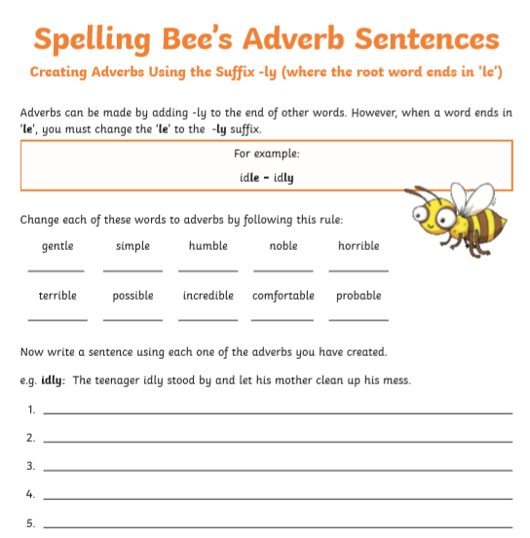

Thursday – Year 5 – tricky homophones
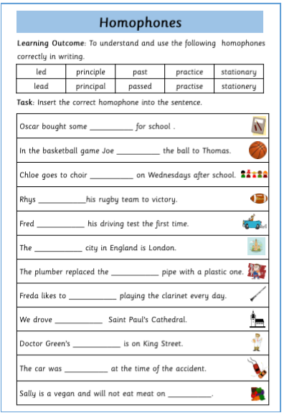
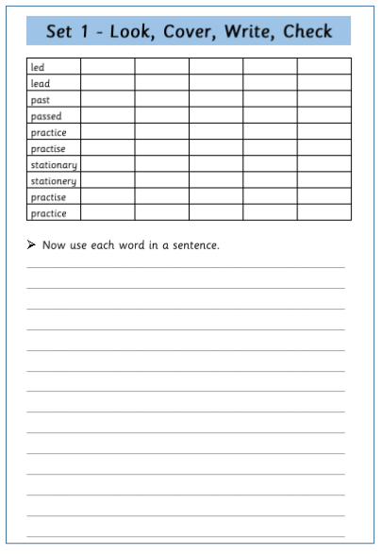
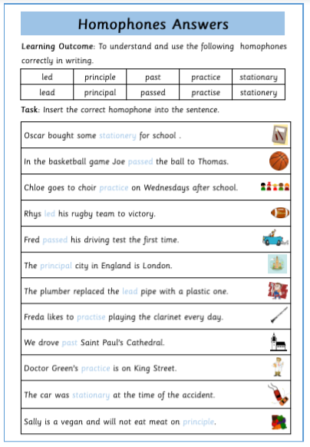

Friday – all year groups
Review the words you practised this week. Make a list of these words. If possible, ask someone to test you on this spelling list, to check you can spell all the words independently. Choose few tricky word to practise again.
Use the template below to make your own word search puzzle. Write in it the words you want to practise, writing them in the chart underneath also. Remember just one letter per square. Then fill in the blank spaces with other letters. Put your word search to one side to practise these words again next week.
