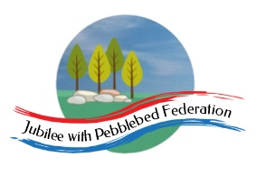

Class 2, Branscombe C of E Primary School

Dear Parents and Members of Class 2,

I do hope you managed to have bit of a half-term holiday last week. This week, we are off on holiday safari as part of our virtual world tour. Unlike previous weeks, this week’s visit is not linked to a particular festival or celebration. However, we realised that we have not yet visited any of the continent of Africa’s 54 countries. So we are off to Kenya to explore. Along the way, we will be considering themes linked to World Environment Day which takes place on 5th June and this year’s theme of ‘Biodiversity’ links well to some of the things we will learn on safari and should follow on well from the Science work completed during our visit to Russia.

Mr Williams, who teaches PE at Sidmouth College, has made a series of ‘Primary Challenge’ videos. As part of our PE this week, I have added links to these challenges. We would love to see some pictures and hear news of how you get on with them!

Also, Active Games and the School Games Organisers are organising #Devon Virtual Games tournament between 18th May and 13th July. There are 6 different events to enter and we will feature one or two of these each week for the next few weeks. You can find out more at www.activedevon.org, where new challenges will be posted every Monday in June and where you can submit entries to the competition.

Happy learning! Hope to see many of you again before too long,

Miss Moss

The most important thing you can do to support your child’s learning whilst schools are closed is to ensure that they read every day and they continue to practise their number bonds and times tables.

Don’t forget to keep using the accounts you have through our school to practise basic skills, such as reading, reading comprehension (Bug Club), Times tables (Times Table Rock Stars) and Spelling (Spelling Shed). I have set work on TTRS each week and I shall be checking these sites regularly to keep an eye on what you’re doing. Feel free to challenge me (Dot McRock) to a Rockslam competition!

Week beginning Monday 1st June

Monday | Core activities |  | Suggestions for additional activities.
9.00 – 9.30 | Daily Dashboard:  Quelle est la date aujourd’hui?  C’est lundi le premier juin 2020.  Can you write the number date in Roman numerals?  On 1st June 2019 was the first World Reef Day, which was set up as a day for consumers, businesses and organisations to reflect on the delicate ecosystem of the world’s oceans’ coral reefs and how they might make simple changes to protect them. See http://www.worldreefday.org/ Why not investigate some of the flora and fauna (plants and animals) that live on a coral reef and some of the things that threaten those food chains?  Today, we are travelling to Kenya. It was on 1st June 1964 that Kenya became a republic, with Jomo Kenyatta as its first president. Prior to that date, it had been a British colony since 1895. Why not see what else you can find out about the history of Kenya? https://www.ducksters.com/geography/country.php?country=Kenya  (Portuguese explorer Vasco de Gama was the first European to arrive in Kenya in 1498 when he was on his way to India, where he arrived on 20th May.) |  |  |  |  | It was on 1st June 1533 that Anne Boleyn, Henry VIII’s second wife was crowned queen.  What can you remember of what you learned last term about the events leading up to and following her coronation?
9.30-10.00 | Grammar – see additional Grammar resources  Pronouns |  | Use your spelling shed login to practise by playing spelling games.
10.00- 10.30 | Time for some PE –  Have a go at Mr Williams’ squat challenge: https://youtu.be/Dix4P1OY77o  When the song says ‘Sally up’ stand up and when it says ‘Sally down’ squat down, as low as you can. Can you keep going through the whole song?  Why not check out the new ‘Pentathlon’ challenge as part of the #Devon Virtual Games competition at www.activedevon.org
10.30-11.30 | Maths – follow the links to find online lessons for each year group:  Year 3: https://www.thenational.academy/year-3/maths/to-identify-perpendicular-lines-year-3-wk5-1  Year 4: https://www.thenational.academy/year-4/maths/area-part-1-estimating-year-4-wk2-1  Year 5: https://www.thenational.academy/year-5/maths/to-identify-and-describe-reflections-year-5-wk2-1  Year 6: https://www.thenational.academy/year-6/maths/to-describe-coordinate-positions-on-a-grid-year-6-wk4-1 |  |  |  | Don’t forget to keep logging on to Times Table Rock Stars to practise your times tables. A few minutes practice every day will soon improve your recall of key facts!
11.30-12.00 | Have a break and play a game or do another activity that you enjoy. | Keep active in mind and body – why not do a puzzle or other activity today that will help to stretch your brain and keep your mind active?
12.00- 1.00pm | Lunch break. Eat a healthy lunch and, if you are able, try to get outside for some fresh air!
1.00pm – 1.30pm | Reading - Complete some reading and research to complete the fact file sheet about Kenya below.  The fact file below is a good starting place, or there is some further information to read in the ‘Additional Information Kenya’.  https://www.natgeokids.com/uk/discover/geography/countries/country-fact-file-kenya/ |  |  | Keep reading online and completing Bug Club Comprehension questions  Or  Read a chapter or two of your latest reading book.
1.30pm – 3.00pm | Have a look at https://www.3dgeography.co.uk/kenya-geography to learn more about Kenya. This site contains lots of relevant information. Scroll down to watch videos, including a video of a safari where you will be able to join some tourists watching animals on a safari. Be warned – some parts are fairly brutal!  There are links to more videos and on the ‘Worksheets’ tab you will find a range of other activities as well as the fact file sheet I have copied below: https://www.3dgeography.co.uk/kenya-worksheets  Why not have a go at reading and interpreting climate graphs to compare the climate in Nairobi, Kenya’s capital with that in London? You could also revise 4-figure grid references or compare British and Kenyan homes. |  | You could sketch your own illustrated map of Kenya showing some of the places you would like to visit.  Or complete the ‘My Journey Around Kenya’ activity you will find in ‘Additional Information Kenya’.  (This activity was designed for Year 2, but you could consider how you might extend it to make it more of a challenge in Key Stage 2).

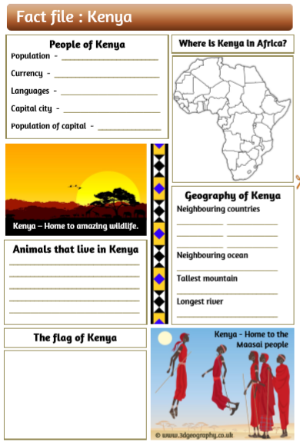

Tuesday | Core activities |  |  | Suggestions for additional activities.
9.00 – 9.30 | Daily Dashboard:  Quelle est la date aujourd’hui?  C’est mardi deux juin 2020.  Can you write the number date in Roman numerals?  On 2nd June 1875, Alexander Graham Bell made his first transmission of sound. It was only a year later that he inventor the world’s first telephone. On 2nd June 1896 Gugliemo Marconi applied for a patent of his invention – a radio. Which of these inventions do you consider to be most important and why? |  |  |  |  |  | What is happening in the world? Have a look at https://www.bbc.co.uk/newsround or https://www.dogonews.com/ to see what is going on in the world. Choose a news article or two to read.
9.30-10.00 | Grammar – see additional Grammar resources |  | Use your spelling shed login to practise by playing spelling games.
10.00- 10.30 | Time for some Physical activity.  Have a go at Mr Williams’ plank challenge. Be warned – the timing of this can be quite tricky!  https://youtu.be/bA4fFzhbHJw  If that’s not enough, try to 60-second ball challenge: https://www.youthsporttrust.org/sites/default/files/Figure%20of%208%20Challenge.pdf
10.30-11.30 | Maths – follow the links to find online lessons for each year group:  Year 3: https://www.thenational.academy/year-3/maths/to-draw-perpendicular-lines-year-3-wk5-2  Year 4: https://www.thenational.academy/year-4/maths/area-part-2-calculating-year-4-wk2-2  Year 5: https://www.thenational.academy/year-5/maths/to-describe-reflections-using-coordinates-year-5-wk2-2  Year 6: https://www.thenational.academy/year-6/maths/to-translate-simple-shapes-year-6-wk4-2 |  |  |  |  | Alternatively, you could try out the new BBC Bitesize daily lessons.
11.30-12.00 | Have a break and play a game or do another activity that you enjoy. | Ask for help – Is there something you have been finding confusing or difficult in your learning – or in life? Who could you talk to today to ask for help?
12.00- 1.00pm | Lunch break. Eat a healthy lunch and, if you are able, try to get outside for some fresh air!
1.00pm – 2.00pm | Literacy –  Imagine you have travelled to Kenya on holiday to go on a safari adventure. Watch the video at https://www.youtube.com/watch?v=p2CqXWw8izM and see how many of the animals you can identify. (You could use the information at https://www.3dgeography.co.uk/kenyan-animals?lightbox=imagenlz to help with this.) Write a diary entry or letter in role as a traveller in Kenya, describing what you saw as vividly as you can. How will you make your writing exciting to read? The video at https://www.youtube.com/watch?v=gTEXJsw62iU will give you some other ideas of things you may see on a trip to Kenya to help you write further diary entries or letters.  Alternatively, you could write a poem entitled ‘Kenya’, composed entirely of rich, descriptive vocabulary to evoke the atmosphere of this exciting country.
2.00pm – 3.00pm | Art  Create a beautiful African silhouette picture like these:  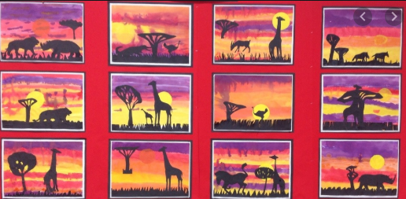  Adult guidance and animal silhouettes are provided below. |  |  |  | Alternatively, have a go at the ‘Safari in a Shoebox’ activity you will find in ‘Additional Information Kenya’.  You can print and colour the animals – or make your own!

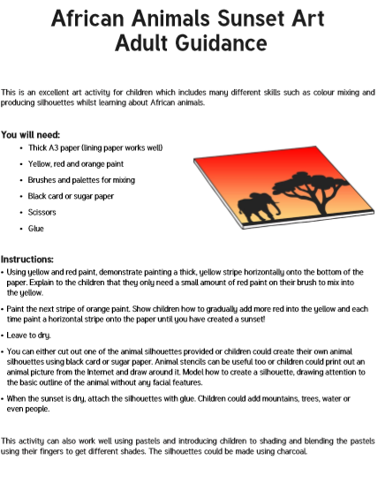

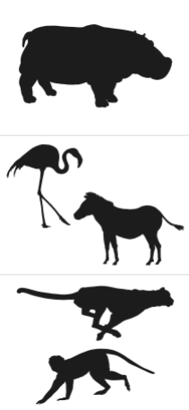

Wednesday | Core activities |  | Suggestions for additional activities.
9.00 – 9.30 | Daily Dashboard:  Quelle est la date aujourd’hui?  C’est mercredi trois mai, 2020.  Can you write the number date in Roman numerals?  What is happening in the world? Have a look at https://www.bbc.co.uk/newsround or https://www.dogonews.com/ to see what is going on in the world. Choose a news article or two to read. |  | The United Nations have delared 3rd June to be ‘World Bicycle Day’ (see https://www.un.org/en/observances/bicycle-day). Why not create a poster or write a persuasive speech encouraging people to use their bicycles and persuading them of the many benefits to health and to the environment of this form of transport?  Others around the world are celebrating ‘Global Running Day’ today – see https://globalrunningday.org/  Which do you prefer – running or bike riding? Why?
9.30-10.00 | Grammar – see grammar resources
10.00- 10.30 | Time for some physical exercise –  Today, Mr Williams’ challenge involves skipping: https://youtu.be/3ttPXJdIm_8  Or try the England Athletics Bear Crawl Challenge: https://www.youtube.com/watch?v=-z6cY2PM11s&feature=youtu.be
10.30-11.30 | Maths – follow the links to find online lessons for each year group:  Year 3: https://www.thenational.academy/year-3/maths/to-identify-and-explain-parallel-lines-year-3-wk5-3  Year 4: https://www.thenational.academy/year-4/maths/area-part-3-cm2-year-4-wk2-3  Year 5: https://www.thenational.academy/year-5/maths/to-reflect-shapes-along-axes-year-5-wk2-3  Year 6: https://www.thenational.academy/year-6/maths/to-reflect-simple-shapes-year-6-wk4-3 |  |  |  |  | How about a warm-up using Times Table Rock Stars? A little each day can really help to improve your scores!
11.30-12.00 | Have a break and play a game or do another activity that you enjoy. | Drink lots – in hot weather, it is really important to stay well hydrated. Did you know that sometimes, when your body tells you it is feeling hungry, it is actually telling you that you need a drink of water?
12.00- 1.00pm | Lunch break. Eat a healthy lunch and, if you are able, try to get outside for some fresh air!
1.00pm – 1.30pm | Reading – Complete the reading comprehension below about the famous naturalist, Jane Goodall from the ‘Additional Information Kenya’.  Note: there are three levels – one star is the easiest and three stars is the most challenging. Choose your level! |  |  | Keep reading online and completing Bug Club Comprehension questions  Or  Read a chapter or two of your latest reading book.
1.30pm – 3.00pm | Complete the Art activity you began yesterday afternoon – or have a go at another…  Create your own safari:  If it is a sunny say, you could try painting animal silhouettes on a wall, paving stones or concrete, using water. If you want to keep them, take a photo!  Look at the pictures by Kenyan artist Gakonga (below). What do you think about his work? Look at his use of colour whether it is bright or subtle does it set a mood in the picture?  Task – Copy the picture of the 3 African men. Use pastels or crayons to colour the picture.  Using the Gakonga pieces as inspiration, you might want to plan your own piece of work with an African theme. Think about the materials or colours you may use to make your piece of work come alive. |  |  |  | PSHE  If you haven’t already done so, why not have a go at making a Covid-19 time capsule? The following resource should help you with some ideas:  https://mcusercontent.com/57437507f4a3aad76843b6d9e/files/8f1f5677-a6a6-4dc8-be34-cefa3d2d38c3/Covid_19_time_capsule_final.pdf  Alternatively, here is a link to a useful PSHE lesson on the subject of ‘Worry’ which may help to support your mental health at this challenging time:  https://us8.campaign-archive.com/?u=57437507f4a3aad76843b6d9e&id=a68b2710c2&e=b9859c0018
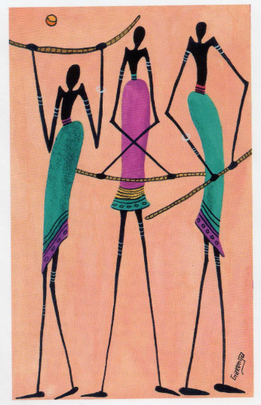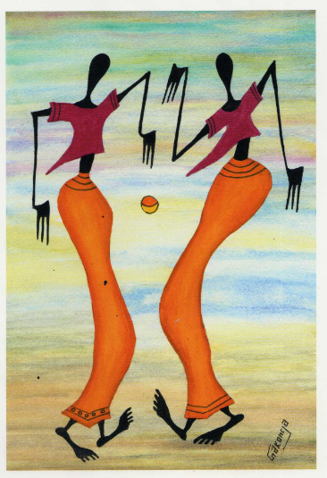
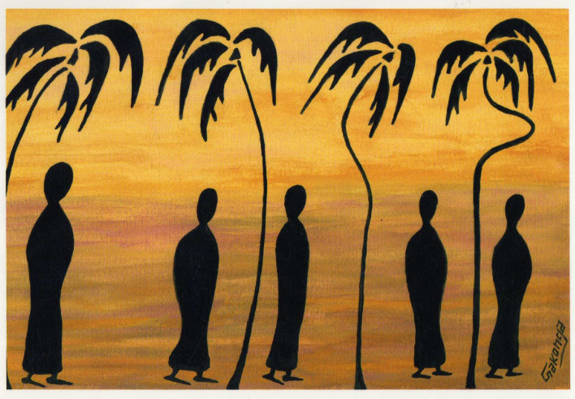

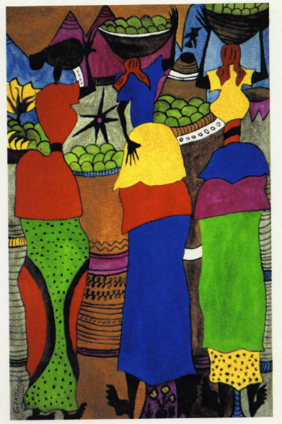
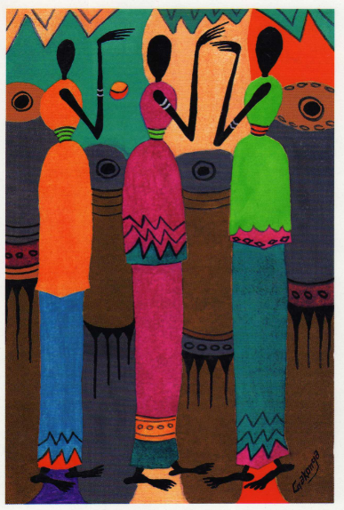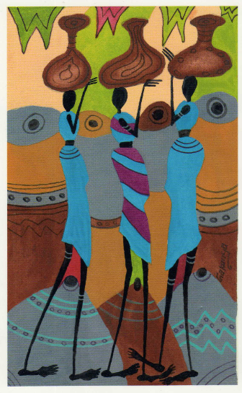

Thursday | Core activities | Suggestions for additional activities.
9.00 – 9.30 | Daily Dashboard:  Quelle est la date aujourd’hui?  C’est jeudi quatre juin 2020.  Can you write the number date in Roman numerals?  What is happening in the world? Have a look at https://www.bbc.co.uk/newsround or https://www.dogonews.com/ to see what is going on in the world. Choose a news article or two to read. | On 4th June 1940, the prime minister Winston Churchill made one of his most famous speeches. Read about this event and listen to part of this speech here: https://www.youtube.com/watch?v=nCPBnEGbL7g  When Churchill made this speech, combined attack by forces from Britain, Canada and the USA on German forces occupying France, known as ‘Operation Overlord’, was about to take place. This operation took place on 6th June, which became known as ‘D-day’. Some of you will remember learning about this when we visited the airfield at Smeatharpe, from where some of the American troops involved in the rescue set off. Look at one of the following videos to learn more:  https://www.youtube.com/watch?v=Ix2svIEqU2w (90 seconds)  https://www.youtube.com/watch?v=7f2lUwGvW3A (4 minutes)
9.30-10.00 | Grammar – see Grammar resources
10.00- 10.30 | Time for some physical activity.  Mr Williams’ challenge today involves balancing on a ball or tennis racquet. If you don’t have either of those, you might need to adapt and find something else. It might be wise to get a parent to check… https://youtu.be/3ttPXJdIm_8  And/or have a go at the ‘This is PE’ Reaction wall lesson https://www.youtube.com/watch?v=D_KaDUryDes&list=PLYGRaluWWTojV3An2WEgsQ4qGFy_91jDL&index=19 Can you find some other ways to vary or extend this activity?
10.30-11.30 | Maths – follow the links to find online lessons for each year group:  Year 3: https://www.thenational.academy/year-3/maths/to-revise-parallel-and-perpendicular-lines-year-3-wk5-4  Year 4: https://www.thenational.academy/year-4/maths/area-part-4-m2-year-4-wk2-4  Year 5: https://www.thenational.academy/year-5/maths/to-reason-about-reflection-year-5-wk2-4  Year 6: https://www.thenational.academy/year-6/maths/to-solve-practical-coordinate-problems-year-6-wk4-4 |  |  |  |  | How about a warm-up using Times Table Rock Stars or else play a Maths game to help practise core number facts?  Why not visit https://nrich.maths.org/9803 and have a go at one of the Maths investigations there. Be warned – these will really make you think!
11.30-12.00 | Have a break and play a game or do another activity that you enjoy. |  | Care for others – what little job around the house could you do today to show care for someone in your family?
12.00- 1.00pm | Lunch break. Eat a healthy lunch and, if you are able, try to get outside for some fresh air!
1.00pm – 1.30pm | Complete the Reading Comprehension about the tribal tale from africa, ‘Stealing the Sun’ which you can find in ‘Additional Information Kenya’. The story is told in three parts, with questions following each part. |  |  | Keep reading online and completing Bug Club Comprehension questions  Or  Read a chapter or two of your latest reading book.
1.30pm – 3.00pm | Human Geography – the Maasai Tribe  See what you can find out about one of Kenya’s main tribes - the Maasai. Try to collect facts you find interesting, checking more than one website for accuracy. You can learn by reading the text but also by carefully observing photographs and videos. Make some notes and then use these to write a short non-chronological report using the bordered paper below. Your report should contain an introduction and two or three other paragraphs. Here are some useful web links to help you with your research:  https://kids.kiddle.co/Maasai  https://kids.britannica.com/kids/article/Maasai/602114  Here are some useful videos:  https://www.bbc.co.uk/bitesize/clips/zgfr87h  and  https://www.compassion.ca/blog/a-day-in-the-life-of-a-maasai-boy/  You could even collect some sticks and mud and have a go at making a model of a Maasai house! |  |  |  | You could imagine that you were able to accompany some travellers on a visit to a Maasai village.  Then write another letter or diary entry, in role as a visitor to Kenya, to describe the experience and what you observed about the life of the Maasai people.  The Maasai people are known for their jumping competitions. Why not organise a family jumping competition? Who in your family can jump the highest? (Don’t forget to warm up!)  You can find out more about the Maasai jumping dance here:  https://www.youtube.com/watch?v=2wVZkJCAmC8 and you can watch some Maasai tribesmen performing the jumping dance here: https://www.youtube.com/watch?v=_MO9B2jLOgw

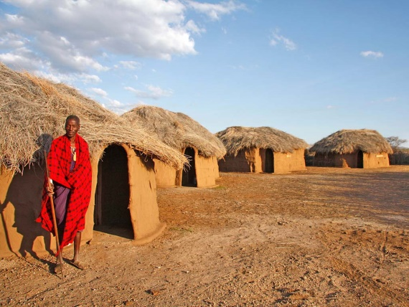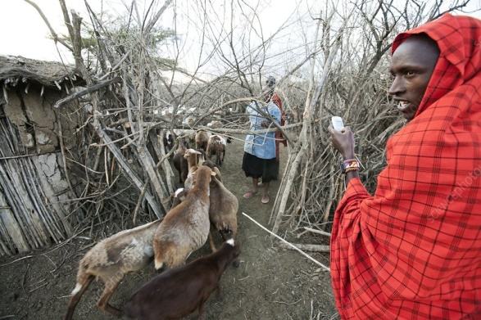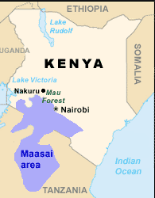

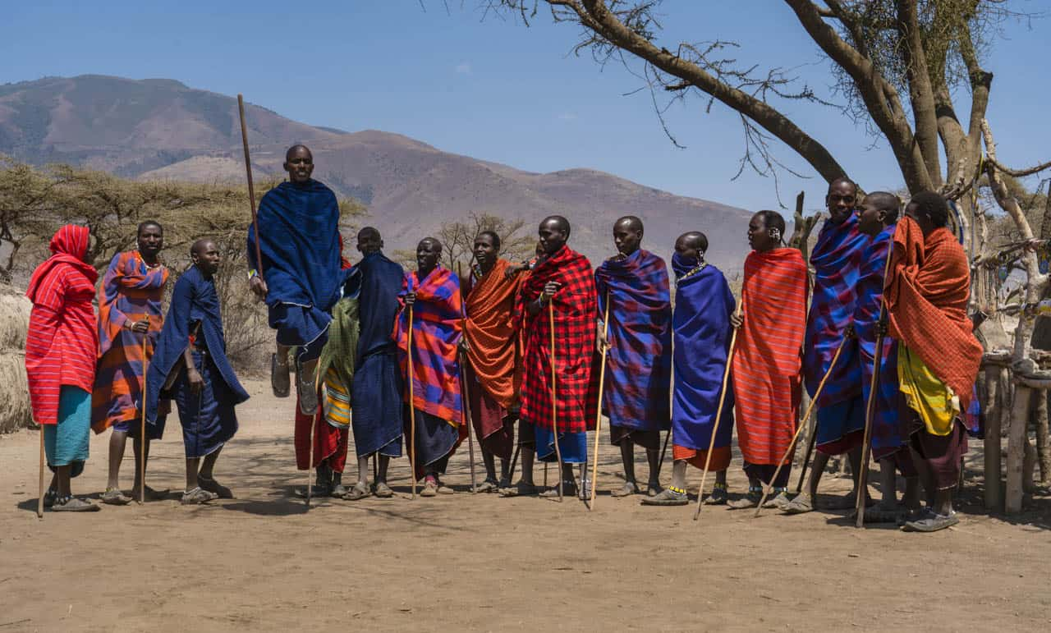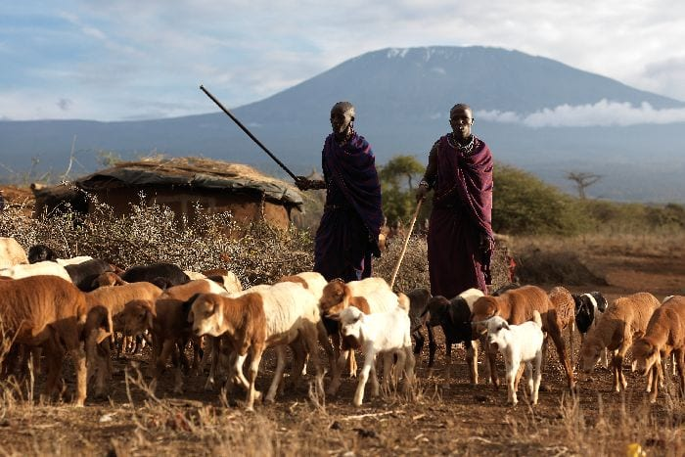

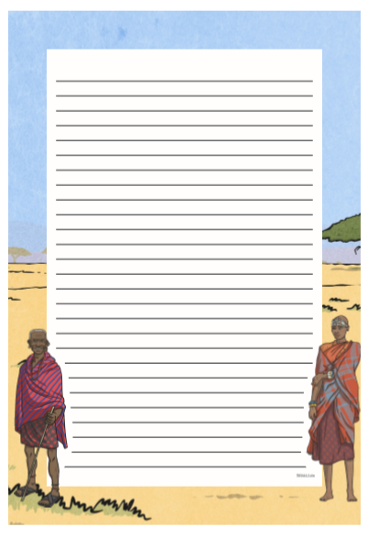

Friday | Core activities |  | Suggestions for additional activities.
9.00 – 9.30 | Daily Dashboard:  Quelle est la date aujourd’hui?  C’est vendredi cinq juin, 2020.  Can you write the number date in Roman numerals?  What is happening in the world? Have a look at https://www.bbc.co.uk/newsround or https://www.dogonews.com/ to see what is going on in the world. Choose a news article or two to read.  Today is World Environment Day. Read more about this event and watch a video made to celebrate World Environment Day 2019 at https://www.themightyearth.com/world-environment-day-2020/  This year’s theme for World Environment day is ‘Biodiversity’. You could also watch a brief video explaining what biodiversity is… https://www.youtube.com/watch?v=_bk2nnDI68g |  | Overnight tonight there is due to be a penumbral lunar eclipse. A penumbral lunar eclipse takes place when the Moon moves through the faint, outer part of Earth's shadow. This type of eclipse is often mistaken for a normal Full Moon.  You can find out about this on the following web page: https://www.timeanddate.com/eclipse/lunar/2020-june-5
9.30-10.00 | Grammar – see separte Grammar resources
10.00- 10.30 | Time for some physical activity.  Follow this link to find a game of ‘Find the Rainbow’ : https://www.getset4pe.co.uk/resourcebank/viewresourcefile?id=11651  Or have a go at the ‘This is PE’ throwing techniques lesson: https://www.youtube.com/watch?v=tQO0kwC-mmI&list=PLYGRaluWWTojV3An2WEgsQ4qGFy_91jDL&index=21
10.30-11.30 | Maths – follow the links to find online lessons for each year group:  Year 3: https://www.thenational.academy/year-3/maths/to-identify-rectangles-including-squares-year-3-wk5-5  Year 4: https://www.thenational.academy/year-4/maths/area-part-5-application-year-4-wk2-5  Year 5: https://www.thenational.academy/year-5/maths/to-make-links-between-reflections-and-translations-year-5-wk2-5  Year 6: https://www.thenational.academy/year-6/maths/to-solve-practical-coordinate-problems-year-6-wk4-5 |  |  | Why not try a BBC Supermovers Maths video to help warm up your Maths brain while getting in a bit of movement?  https://www.bbc.co.uk/teach/supermovers/ks2-maths-collection/z7frpg8
11.30-11.45 | Have a break and play a game or do another activity that you enjoy. | Be proud of your very being! What have you done well this week? Why not award yourself another certificate!
11.45 – 12.00
12.00- 1.00pm | Lunch break. Eat a healthy lunch and, if you are able, try to get outside for some fresh air!
1.00pm – 1.30pm | Reading –  Today, on World Environment Day, we are thinking about biodiversity – the range of plant and animal species in the world.  Our world’s biodiversity needs to be protected. Sadly, on 19 March 2018, Sudan, the world's last known male northern white rhinoceros, died in Kenya. Read more about White Rhinos facing extinction in the information you will find in ‘Additional Information Kenya’. There are three levels of difficulty, from one star (easiest) to 3 stars (most challenging). There are no comprehension questions to accompany this text, but perhaps you could invent a few of your own? |  |  |  | You could read another chapter of your current book.
1.30pm – 3.00pm | Science  Watch this video to learn more about why biiodiversity is important: https://www.bbc.co.uk/bitesize/clips/zjm2tfr  Read the slides below to check the vocabulary you need to understand: biodiversity, ecosystem and biome. Can you write a brief explanation of what each of these words means?  Look at the sheet entitled ‘Africa’s Natural Vegetation and Climate’. Can you match each biome to its description? All four of these landscapes are found within the African continent. Have a go at inventing a new creature for each of these different habitats. Make sure your creatures are adapted to suit their environments! Draw and write about your ideas.  Below, you will also find descriptions of some endangered species from Africa. You could create a leaflet or poster explaining to people why so many species are endangered and urging them to help to protect these from further harm. |  | Alternatively, you could investigate African music and instruments. Follow the link for an African drumming lesson… https://www.youtube.com/watch?v=q5U8md4rZS8  You may not have a drum, but what could you use to make some different rhythms?  Or follow these links for an African dance lesson: https://www.youtube.com/watch?v=VvXSbuEwd1M  and  https://www.youtube.com/watch?v=Ewqq-3xJFdI
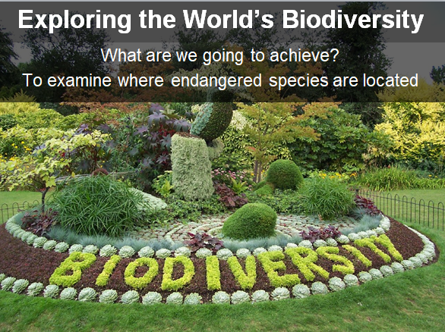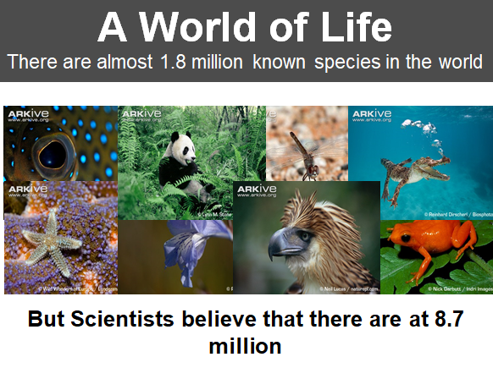
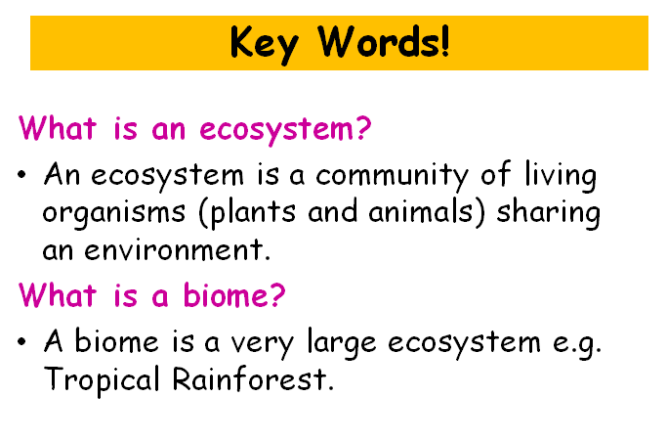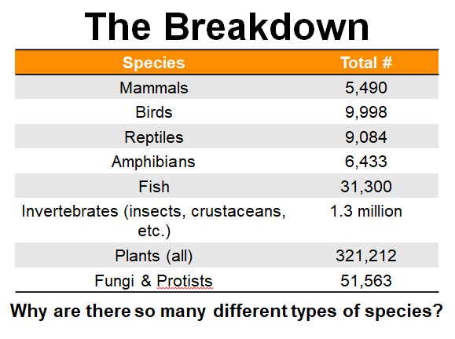

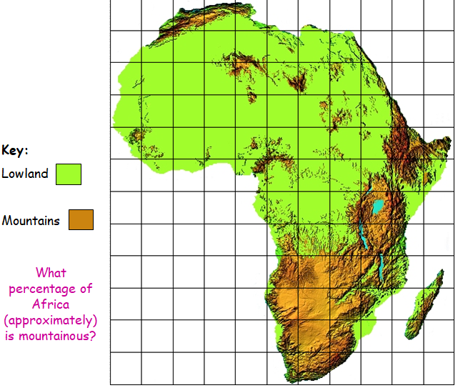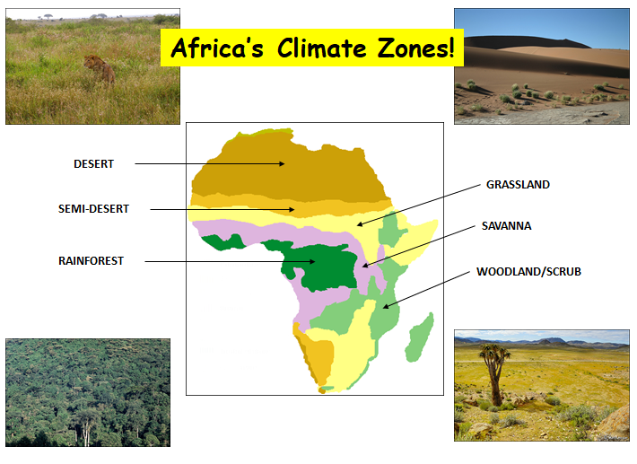

Africa’s Natural Vegetation and Climate
Savannah
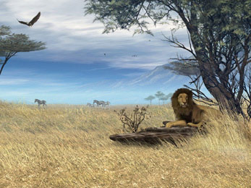
Match the picture to the description.
These are areas of both desert and grassland. Individual spaced out trees are characteristic of these areas. There are distinct wet and dry seasons, dry in winter and wet in summer. They are normally found between a tropical rainforest and a desert.

Savannah!

Tropical Rainforest!

Rainforest
The climate here is very hot and dry all year round with little rainfall, temperatures drop at night time. The animals have to adapt to the weather so that they can live in such dry conditions. There is very little vegetation because the precipitation is too low to sustain plant life.

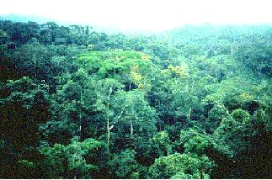

Mediterranean Shrubland
The climate here is very hot and very wet. They are close to the equator therefore there is a lot of evaporation due to the amount of sunlight. Because of this evaporation there is lots of rainfall. They have the largest range of plants and animals out of any other climate zone in the world.

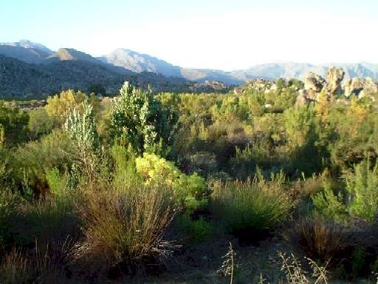

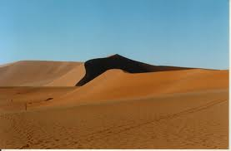
This is a natural environment with lots of evergreen small trees. They are normally found near the coast and are windy, salty areas so the vegetation has to adapt to live here. The climate is temperate. They are usually found surrounding deserts and grasslands. The wet season is in winter.

Desert

