Weeks beginning Monday 13th July/Monday 20th July – Home Learning in Class 1

Hello Class 1 Children and Parents,

Welcome to Summer Term B - Weeks 7 and 8 of your Home Learning! Off we go with your final tranche of learning: Here is the last fortnight worth of work for this academic year and a bank of resources for you to access. The children in school will continue to follow this work as well, so let us know how you get on. We’d love to see some more pictures of what you have been up to – there are some particularly exciting challenges that, if you complete, you could email over to us!

For now we would like to say a huge ‘Well Done!’ for all of your hard work during this strange time. We really hope that you have a really lovely summer holiday – you deserve a big break!

We really have missed you all so much and so look forward to welcoming you back in September.

Miss Harvey-Jones and Mrs Bartlett

EVERY DAY
- Phonics: Pre-school, Reception, Y1 and Y2. Reception, Y1 and Y2 pupils please see the table below for details/activities. Remember, you could also use Phonics Play to practise reading sounds and words and also practise sounding and blending skills with the games provided on here. Pre-school children will continue to benefit from spending some time to practise writing their name – ideally forename and surname (remembering the capital letters), so that they know how to spell it using correctly formed letters. They could also practise letter formation of the other letters of the alphabet. (See below for guidance). This does not have to be limited to using pencil and paper; the children might like to use water on the ground, write using their finger in sand or foam, or using paint for example.
- 20 minutes ‘Bug Club’ Reading (with comprehension ‘bug’ questions): Reception, Y1 and Y2. Bug Club books have been updated to suit your level – any issues please get in touch.
- Choose 5 spellings from your Home Learning Books, Common Exception Words list or High Frequency Words list to learn: Reception, Y1 and Y2. (See below for these word lists).
- 15 minutes ‘Spelling Shed’, ‘SPAG.com’ OR ‘Bug Club Grammar’ games (KS1 only).
- 15 minutes ‘Times Table Rockstars’ (KS1 only) OR to limit screen time you may wish to spend this time learning 2, 3, 5 and 10 times tables to be able to recall them at speed. Reception pupils would benefit from spending a little time counting in twos e.g. count some teddies or dolls in twos.
- 20 - 30 minutes Maths: Pre-school, Reception, Y1 and Y2. See table below for a 5 minute warm ups with your parents/game, then complete any tasks set if in Reception or KS1. KS1 pupils can also continue to work in their ‘Power Maths’ Practice Books should you wish. Pre-school children may enjoy watching the videos too or could access some of the websites attached on website to play some number and shape games.
- PE/Active Time: Pre-school, Reception, Y1 and Y2. Joe Wicks (The Body Coach) has daily workout videos on YouTube (go online with your grown-ups) but, as ever, you do not need to feel restricted to this.
- As before, continue. your Summer Term diary: Pre-school, Reception, Y1 and Y2.
- Please keep reading/sharing a book you enjoy with your family: Pre-school, Reception, Y1 and Y2. Remember to keep a log together (one or two sentences) of what you have read that day.

Monday | Phonics/Literacy  Preschool – see notes above.  Reception – Phase 4 revision: Practise GPCs and Phase 4 Tricky Words – You can continue to play ‘Flashcards’ using the previously attached resources and ‘Quickwrite Graphemes’ (say the sound on the flashcard ask your child to write it without them seeing it), or alternatively if any of the activities that have been set previously were particularly successful in helping your child to learn their tricky words you could incorporate these for a change. Complete a part of the Reception Phonics Phase 4 booklet each day (Book-6).  Year 1 – Continue revision of all of the GPCs phase 2 – 5 with your child at a rapid pace (continue to use previously suggested activities) + complete a page of the Year 1 Phase 5 Tricky Words booklet + work through ‘Talk for Creative Writing’ unit.  Year 2 - Continue revision of spelling all Common Exception Words using suggestions from Summer Term B Week 3 + see Bug Club Grammar for allocated games + work through ‘Talk for Creative Writing’ unit.  Talk for Creative Writing  We hope that you have been enjoying the creative writing units and have found that completing them is helping you to see that your writing is improving. We have attached the new units for your year group, but if you have not finished the last ones and would like to, then do that before moving on. If you think you would like a new story, then move on to the new texts below. As usual, work on one activity each day. Send us pictures of some of your writing - we would love to see!  Reception - ‘Brian Bear’s Picnic’: We think you will love this story and it is such fun to have a picnic. Your grown-ups can help you with the reading but we think that you could have a go at some more of the writing now - you don’t have to do it all - maybe your grown-ups could do some of the writing and you could watch how they do it. Take turns!  Year 1 – ‘Brian Bear’s Picnic’: A lovely story about a bear who decides to invite his friends to a picnic. His friends set off with some lovely food, but the things that happen along the way, mean that they arrive at the picnic empty- handed. What will they do?  Year 2 - ‘The Elves and the Shoemaker’: A lovely traditional tale - some of you may know it already. There are lots of lovely writing activities to complete. Remember, you are nearly Year 3 now, so you will need to write answers to questions, descriptions and opinions in full sentences using conjunctions such as ‘because’.  Maths  EYFS Maths Starter – Continue to practise number bonds to 10 and 20. Complete one page of the EY Maths Activity Daily Starter Mat.  EYFS - Access the White Rose Maths website for home learning (link below).  https://whiterosemaths.com/homelearning/early-years/  Complete Summer Term Week 8 (w/c 29th June) - Day 1: Oliver’s Vegetables (watch the video before following the links to complete suggested activities).  KS1 Maths Starter – short mental workout  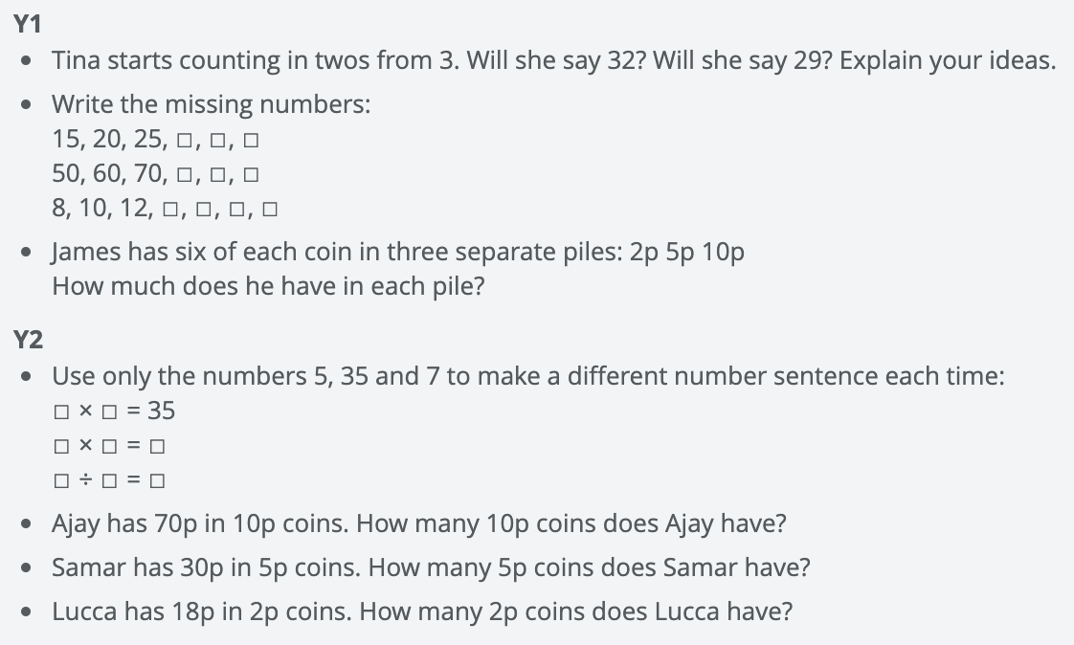  Y1 Access the White Rose Maths website for home learning (link below).  https://whiterosemaths.com/homelearning/year-1/  Complete Summer Term – Week 12 (w/c 13th July) Lesson 1 (watch the video before following the links to complete suggested activities).  Y2 Access the White Rose Maths website for home learning (link below).  https://whiterosemaths.com/homelearning/year-2/  Complete Summer Term – Week 12 (w/c 13th July) Lesson 1 (watch the video before following the links to complete suggested activities).  KS1 - If you do have access to a printer and want to print the linked sheets that go with each lesson, you can do. If you do this, you do not have to do the Power Maths pages as well. If you do not have access to a printer, watch the White Rose video each day and then complete work in your Power Maths books.  Daily Project – Mental Health/PSHE/RE  TASK 1 - EYFS and KS1: Continue with the penultimate page of your ‘Family positivity and gratitude pack’ (see resources attached on the website from week 1).  TASK 2 – EYFS and KS1: RE – see attached below (to be completed over two weeks).  TASK 3 – EYFS and KS1: This month is ‘Transition Month’. Let’s get prepared for your transition to the next year group during this time. You will need to reflect on the last year and share some of your happiest or most fun memories, as well as what you have learned. You can present this in any way you wish, however we have attached some ideas that you can use if you prefer.
Tuesday | Phonics/Literacy  Preschool – see notes above.  Reception – Phase 4 revision: Practise GPCs and Phase 4 Tricky Words – You can continue to play ‘Flashcards’ using the previously attached resources and ‘Quickwrite Graphemes’ (say the sound on the flashcard ask your child to write it without them seeing it), or alternatively if any of the activities that have been set previously were particularly successful in helping your child to learn their tricky words you could incorporate these for a change. Complete a part of the Reception Phonics Phase 4 booklet each day (Book-6).  Year 1 – Continue revision of all of the GPCs phase 2 – 5 with your child at a rapid pace (continue to use previously suggested activities) + complete a page of the Year 1 Phase 5 Tricky Words booklet + work through ‘Talk for Creative Writing’ unit.  Year 2 - Continue revision of spelling all Common Exception Words using suggestions from Summer Term B Week 3 + see Bug Club Grammar for allocated games + work through ‘Talk for Creative Writing’ unit.  Talk for Creative Writing  We hope that you have been enjoying the creative writing units and have found that completing them is helping you to see that your writing is improving. We have attached the new units for your year group, but if you have not finished the last ones and would like to, then do that before moving on. If you think you would like a new story, then move on to the new texts below. As usual, work on one activity each day. Send us pictures of some of your writing - we would love to see!  Reception - ‘Brian Bear’s Picnic’: We think you will love this story and it is such fun to have a picnic. Your grown-ups can help you with the reading but we think that you could have a go at some more of the writing now - you don’t have to do it all - maybe your grown-ups could do some of the writing and you could watch how they do it. Take turns!  Year 1 – ‘Brian Bear’s Picnic’: A lovely story about a bear who decides to invite his friends to a picnic. His friends set off with some lovely food, but the things that happen along the way, mean that they arrive at the picnic empty- handed. What will they do?  Year 2 - ‘The Elves and the Shoemaker’: A lovely traditional tale - some of you may know it already. There are lots of lovely writing activities to complete. Remember, you are nearly Year 3 now, so you will need to write answers to questions, descriptions and opinions in full sentences using conjunctions such as ‘because’.  Maths  EYFS Maths Starter – Continue to practise number bonds to 10 and 20. Complete one page of the EY Maths Activity Daily Starter Mat.  EYFS - Access the White Rose Maths website for home learning (link below).  https://whiterosemaths.com/homelearning/early-years/  Complete Summer Term Week 8 (w/c 29th June) - Day 2: Oliver’s Vegetables (watch the video before following the links to complete suggested activities).  KS1 Maths Starter – short mental workout  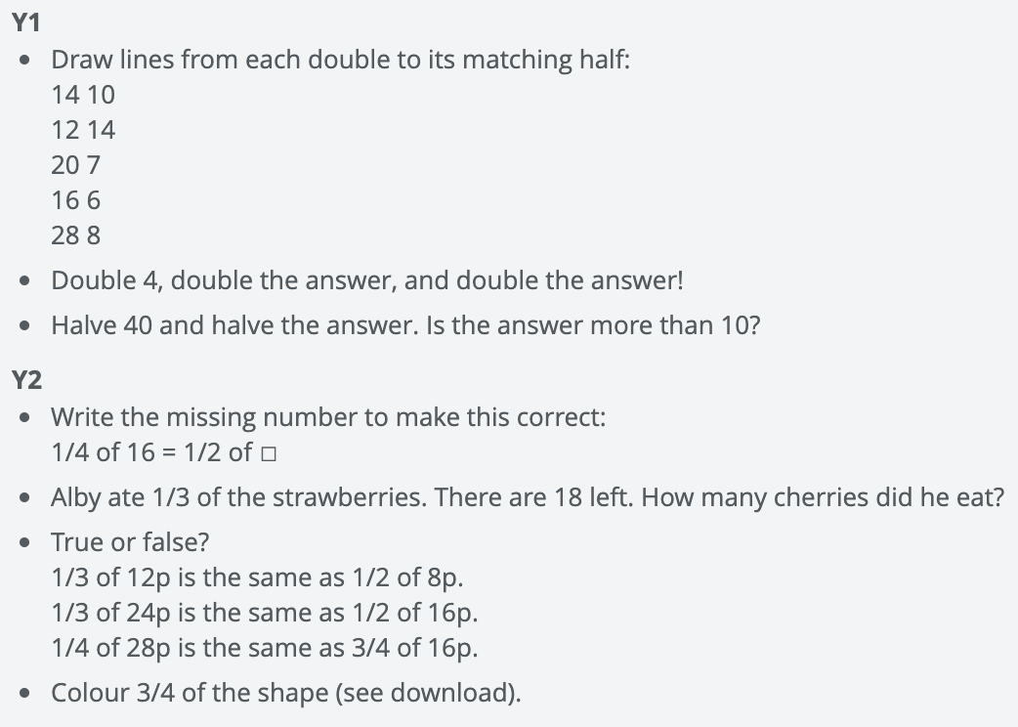  Y1 Access the White Rose Maths website for home learning (link below).  https://whiterosemaths.com/homelearning/year-1/  Complete Summer Term – Week 12 (w/c 13th July) Lesson 2 (watch the video before following the links to complete suggested activities).  Y2 Access the White Rose Maths website for home learning (link below).  https://whiterosemaths.com/homelearning/year-2/  Complete Summer Term – Week 12 (w/c 13th July) Lesson 2 (watch the video before following the links to complete suggested activities).  KS1 - If you do have access to a printer and want to print the White Rose sheets that go with each lesson, you can do. If you do this, you do not have to do the Power Maths pages as well.  If you do not have access to a printer, watch the White Rose video each day and then complete the Power Maths books.  Daily Project – PSHE/Mental Health - Growth Mindset  EYFS and KS1: You can be anything that you want to be! Have a chat with your grown-up about what you aspire to be when you grow up. Can you write a sign to tell us, take a picture of you holding your sign and ask your grown-up to email it to us in school? We will make a wonderful display of your aspirations and put it on the website for you to see.  What is happening in the world? Have a look at https://www.bbc.co.uk/newsround or https://www.dogonews.com/ to see what is going on in the world. Choose a news article or two to read.

Wednesday | Phonics/Literacy  Preschool – see notes above.  Reception – Phase 4 revision: Practise GPCs and Phase 4 Tricky Words – You can continue to play ‘Flashcards’ using the previously attached resources and ‘Quickwrite Graphemes’ (say the sound on the flashcard ask your child to write it without them seeing it), or alternatively if any of the activities that have been set previously were particularly successful in helping your child to learn their tricky words you could incorporate these for a change. Complete a part of the Reception Phonics Phase 4 booklet each day (Book-6).  Year 1 – Continue revision of all of the GPCs phase 2 – 5 with your child at a rapid pace (continue to use previously suggested activities) + complete a page of the Year 1 Phase 5 Tricky Words booklet + work through ‘Talk for Creative Writing’ unit.  Year 2 - Continue revision of spelling all Common Exception Words using suggestions from Summer Term B Week 3 + see Bug Club Grammar for allocated games + work through ‘Talk for Creative Writing’ unit.  Talk for Creative Writing  We hope that you have been enjoying the creative writing units and have found that completing them is helping you to see that your writing is improving. We have attached the new units for your year group, but if you have not finished the last ones and would like to, then do that before moving on. If you think you would like a new story, then move on to the new texts below. As usual, work on one activity each day. Send us pictures of some of your writing - we would love to see!  Reception - ‘Brian Bear’s Picnic’: We think you will love this story and it is such fun to have a picnic. Your grown-ups can help you with the reading but we think that you could have a go at some more of the writing now - you don’t have to do it all - maybe your grown-ups could do some of the writing and you could watch how they do it. Take turns!  Year 1 – ‘Brian Bear’s Picnic’: A lovely story about a bear who decides to invite his friends to a picnic. His friends set off with some lovely food, but the things that happen along the way, mean that they arrive at the picnic empty- handed. What will they do?  Year 2 - ‘The Elves and the Shoemaker’: A lovely traditional tale - some of you may know it already. There are lots of lovely writing activities to complete. Remember, you are nearly Year 3 now, so you will need to write answers to questions, descriptions and opinions in full sentences using conjunctions such as ‘because’.  Maths  EYFS Maths Starter – Continue to practise number bonds to 10 and 20. Complete one page of the EY Maths Activity Daily Starter Mat.  EYFS - Access the White Rose Maths website for home learning (link below).  https://whiterosemaths.com/homelearning/early-years/  Complete Summer Term Week 8 (w/c 29th June) - Day 3: Oliver’s Vegetables (watch the video before following the links to complete suggested activities).  KS1 Maths Starter – short mental workout  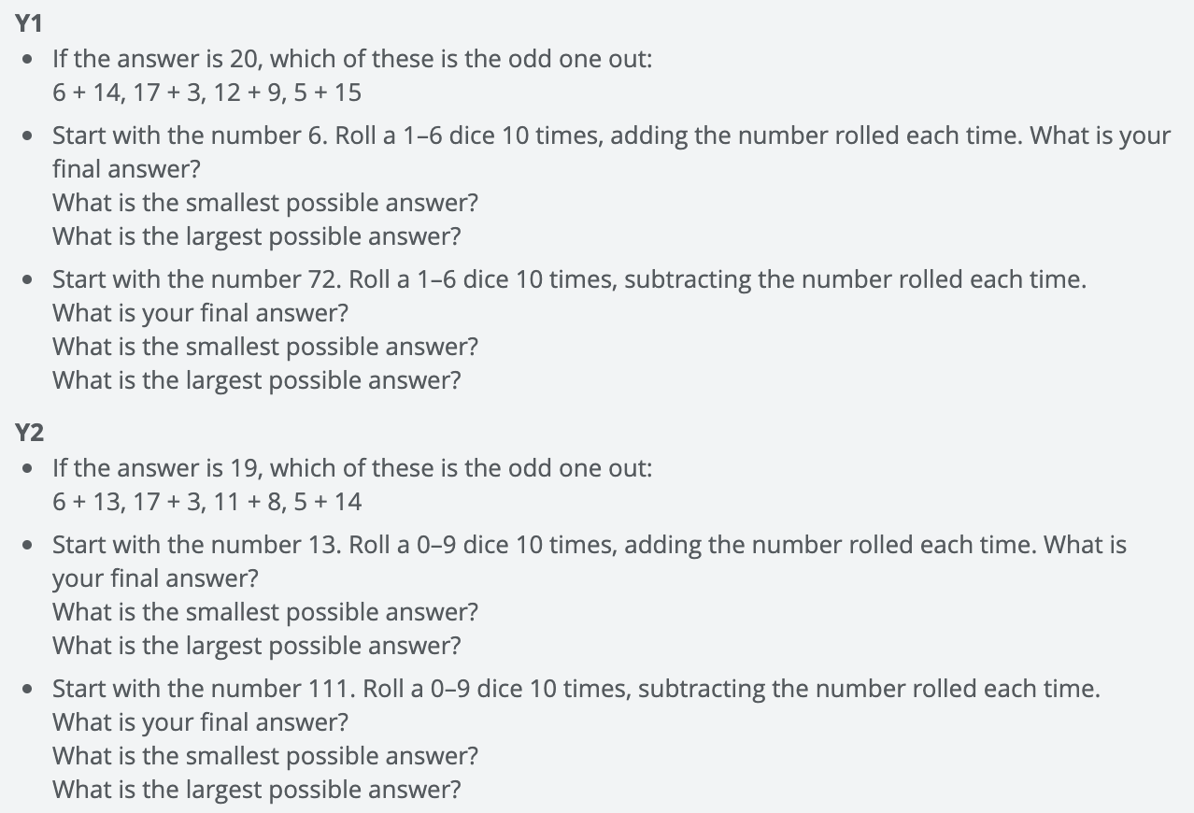  Y1 Access the White Rose Maths website for home learning (link below).  https://whiterosemaths.com/homelearning/year-1/  Complete Summer Term – Week 12 (w/c 13th July) Lesson 3 (watch the video before following the links to complete suggested activities).  Y2 Access the White Rose Maths website for home learning (link below).  https://whiterosemaths.com/homelearning/year-2/  Complete Summer Term – Week 12 (w/c 13th July) Lesson 3 (watch the video before following the links to complete suggested activities).  KS1 - If you do have access to a printer and want to print the White Rose sheets that go with each lesson, you can do. If you do this, you do not have to do the Power Maths pages as well.  If you do not have access to a printer, watch the White Rose video each day and then complete the Power Maths books.  Daily Project – Music Challenge!  1. Compare music from 2020, 2010 and 2000. Find your favourite song from each decade, sing along to them and write about the artist who performed it.  2. Tap the rhythm to different songs. Use different things in the house to create sounds (e.g. ripping velcro, bubble wrap, clapping.  3. Practice and perform a dance for your family.  Looking for something else to do? You could spend a little more time on your Talk for Writing booklet, or look back at the challenges set last Friday… could you complete any more of them?
Thursday | Phonics/Literacy  Preschool – see notes above.  Reception – Phase 4 revision: Practise GPCs and Phase 4 Tricky Words – You can continue to play ‘Flashcards’ using the previously attached resources and ‘Quickwrite Graphemes’ (say the sound on the flashcard ask your child to write it without them seeing it), or alternatively if any of the activities that have been set previously were particularly successful in helping your child to learn their tricky words you could incorporate these for a change. Complete a part of the Reception Phonics Phase 4 booklet each day (Book-6).  Year 1 – Continue revision of all of the GPCs phase 2 – 5 with your child at a rapid pace (continue to use previously suggested activities) + complete a page of the Year 1 Phase 5 Tricky Words booklet + work through ‘Talk for Creative Writing’ unit.  Year 2 - Continue revision of spelling all Common Exception Words using suggestions from Summer Term B Week 3 + see Bug Club Grammar for allocated games + work through ‘Talk for Creative Writing’ unit.  Talk for Creative Writing  We hope that you have been enjoying the creative writing units and have found that completing them is helping you to see that your writing is improving. We have attached the new units for your year group, but if you have not finished the last ones and would like to, then do that before moving on. If you think you would like a new story, then move on to the new texts below. As usual, work on one activity each day. Send us pictures of some of your writing - we would love to see!  Reception - ‘Brian Bear’s Picnic’: We think you will love this story and it is such fun to have a picnic. Your grown-ups can help you with the reading but we think that you could have a go at some more of the writing now - you don’t have to do it all - maybe your grown-ups could do some of the writing and you could watch how they do it. Take turns!  Year 1 – ‘Brian Bear’s Picnic’: A lovely story about a bear who decides to invite his friends to a picnic. His friends set off with some lovely food, but the things that happen along the way, mean that they arrive at the picnic empty- handed. What will they do?  Year 2 - ‘The Elves and the Shoemaker’: A lovely traditional tale - some of you may know it already. There are lots of lovely writing activities to complete. Remember, you are nearly Year 3 now, so you will need to write answers to questions, descriptions and opinions in full sentences using conjunctions such as ‘because’.  Maths  EYFS Maths Starter – Continue to practise number bonds to 10 and 20. Complete one page of the EY Maths Activity Daily Starter Mat.  EYFS - Access the White Rose Maths website for home learning (link below).  https://whiterosemaths.com/homelearning/early-years/  Complete Summer Term Week 8 (w/c 29th June) - Day 4: Oliver’s Vegetables (watch the video before following the links to complete suggested activities).  KS1 Maths Starter – short mental workout  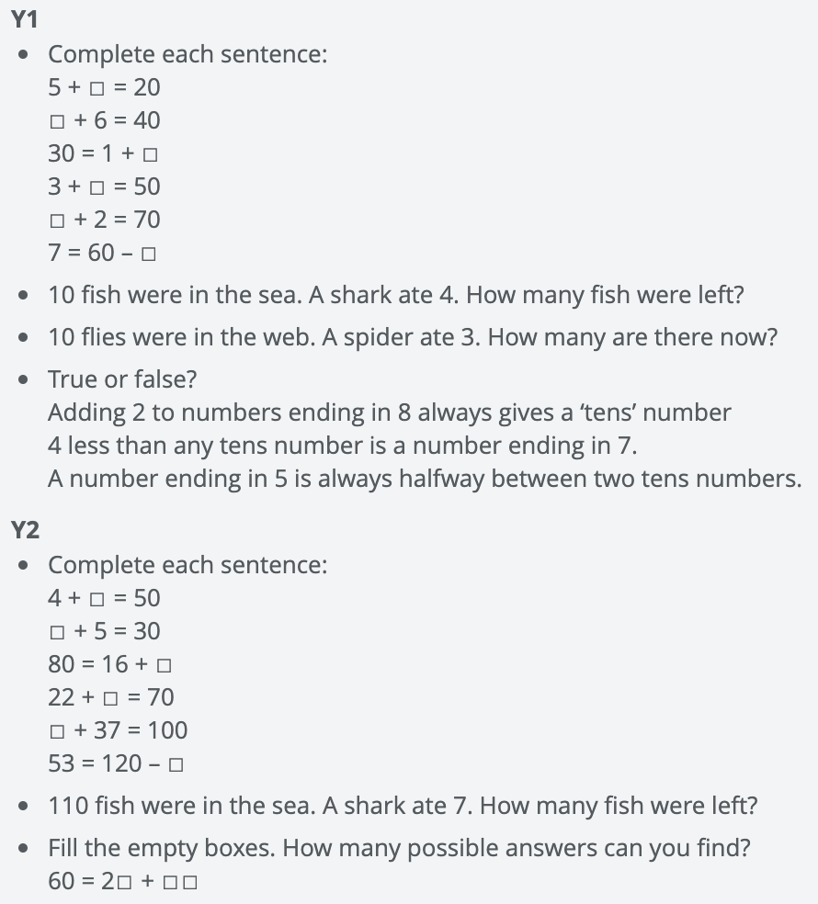  Y1 Access the White Rose Maths website for home learning (link below).  https://whiterosemaths.com/homelearning/year-1/  Complete Summer Term – Week 12 (w/c 13th July) Lesson 4 (watch the video before following the links to complete suggested activities).  Y2 Access the White Rose Maths website for home learning (link below).  https://whiterosemaths.com/homelearning/year-2/  Complete Summer Term – Week 12 (w/c 13th July) Lesson 4 (watch the video before following the links to complete suggested activities).  KS1 - If you do have access to a printer and want to print the White Rose sheets that go with each lesson, you can do. If you do this, you do not have to do the Power Maths pages as well.  If you do not have access to a printer, watch the White Rose video each day and then complete the Power Maths books.  Daily Project – Science Challenge!  Have a go at some of these fun experiments to do at home (we’d love to see some photos of them so don’t forget to email us):  - https://www.businessinsider.com/8-awesomely-simple-science-experiments-you-can-do-at-home-2016-7?r=US&IR=T  - Collect leaves from the garden. Use the internet to find out what kind of leaves these are.  - Dissect a flower into its different parts. Stick them on a piece of paper and label each part.  - Put a flower into some diluted food colouring. Write about what happens.  - Plant leftover fruit or vegetables. Water them daily and see how they grow.  - Press flowers and make a piece of art from them.  - How many birds can you spot in your garden? Use the attached spotter guide from the RSPB and look at the online guide too. There are some fun and other nature activities too for you to enjoy.  https://www.rspb.org.uk/fun-and-learning/for-families/family-wild-challenge/activities/go-birdwatching/  https://www.rspb.org.uk/fun-and-learning/for-kids/games-and-activities/
Friday | Phonics/Literacy  Preschool – see notes above.  Reception – Phase 4 revision: Practise GPCs and Phase 4 Tricky Words – You can continue to play ‘Flashcards’ using the previously attached resources and ‘Quickwrite Graphemes’ (say the sound on the flashcard ask your child to write it without them seeing it), or alternatively if any of the activities that have been set previously were particularly successful in helping your child to learn their tricky words you could incorporate these for a change. Complete a part of the Reception Phonics Phase 4 booklet each day (Book-6).  Year 1 – Continue revision of all of the GPCs phase 2 – 5 with your child at a rapid pace (continue to use previously suggested activities) + complete a page of the Year 1 Phase 5 Tricky Words booklet + work through ‘Talk for Creative Writing’ unit.  Year 2 - Continue revision of spelling all Common Exception Words using suggestions from Summer Term B Week 3 + see Bug Club Grammar for allocated games + work through ‘Talk for Creative Writing’ unit.  Talk for Creative Writing  We hope that you have been enjoying the creative writing units and have found that completing them is helping you to see that your writing is improving. We have attached the new units for your year group, but if you have not finished the last ones and would like to, then do that before moving on. If you think you would like a new story, then move on to the new texts below. As usual, work on one activity each day. Send us pictures of some of your writing - we would love to see!  Reception - ‘Brian Bear’s Picnic’: We think you will love this story and it is such fun to have a picnic. Your grown-ups can help you with the reading but we think that you could have a go at some more of the writing now - you don’t have to do it all - maybe your grown-ups could do some of the writing and you could watch how they do it. Take turns!  Year 1 – ‘Brian Bear’s Picnic’: A lovely story about a bear who decides to invite his friends to a picnic. His friends set off with some lovely food, but the things that happen along the way, mean that they arrive at the picnic empty- handed. What will they do?  Year 2 - ‘The Elves and the Shoemaker’: A lovely traditional tale - some of you may know it already. There are lots of lovely writing activities to complete. Remember, you are nearly Year 3 now, so you will need to write answers to questions, descriptions and opinions in full sentences using conjunctions such as ‘because’.  Maths  EYFS Maths Starter – Continue to practise number bonds to 10 and 20. Complete one page of the EY Maths Activity Daily Starter Mat.  EYFS - Access the White Rose Maths website for home learning (link below).  https://whiterosemaths.com/homelearning/early-years/  Complete Summer Term Week 8 (w/c 29th June) - Day 5: Oliver’s Vegetables (watch the video before following the links to complete suggested activities).  KS1 Maths Starter – short mental workout  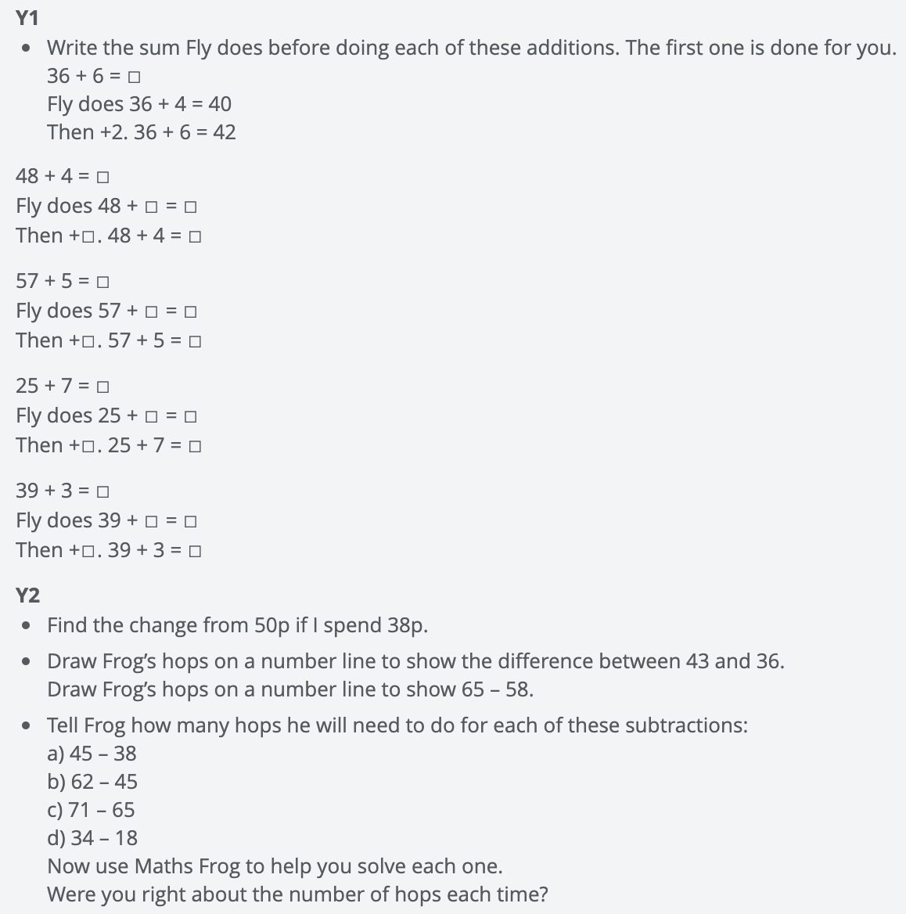  Y1 Access the White Rose Maths website for home learning (link below).  https://whiterosemaths.com/homelearning/year-1/  Complete Summer Term – Week 12 (w/c 13th July) Lesson 5 (watch the video before following the links to complete suggested activities).  Y2 Access the White Rose Maths website for home learning (link below).  https://whiterosemaths.com/homelearning/year-2/  Complete Summer Term – Week 12 (w/c 13th July) Lesson 5 (watch the video before following the links to complete suggested activities).  KS1 If you do have access to a printer and want to print the White Rose sheets that go with each lesson, you can do. If you do this, you do not have to do the Power Maths pages as well.  If you do not have access to a printer, watch the White Rose video each day and then complete the Power Maths books.  Daily Project – SPELLING  KS1 – See sheets attached below for revision and practise. (Please note that there is a sheet for this week and also one ready for next week).  Daily Project - TOPIC/HISTORY/PSHE  KS1 – On July 18th it is Mandela Day. Mandela Day is an annual event named after Nelson Mandela and is designed to encourage everyone to take action against poverty. A United Nations (UN) international event held every year on Nelson Mandela's birthday, Mandela Day was founded on the principle that we can all give a little bit of our time to have a positive effect on the life of someone else. We can all make a difference in our community and help change the world for the better!  When is Mandela Day 2020?  Mandela Day takes place every year on 18th July. In 2020 the aim is to encourage people, governments, businesses and society to focus on 5 key areas:  - Education and literacy  - Food and nutrition  - Shelter  - Sanitation  - Active citizenship  Who was Nelson Mandela?  Nelson Mandela was an anti-apartheid activist who believed that everyone should have the same rights. He was imprisoned for 27 years for fighting for his beliefs, but was released in 1990. In 1993 he was awarded the Nobel Peace Prize. In 1994 he became the first black president of South Africa.  Complete the attached Reading Comprehension.  Did you manage to complete any of these challenges last Friday? If not, why not spend some time taking a look at them now?

RE Weeks 7 and 8
We have looked at many religious buildings together this year: Church, Mosque, Gurdwara, Mandir and Synagogue. We have learnt about the different important features both inside and out. Using the knowledge you have gained and pictures you have seen, can you design your own place of worship for the future? You can be as creative as you like to make your design come to life. Use junk modelling or lego to build a 3D model. You could paint or draw your design. You could even make a colourful scratch art picture by using different colours to make a rainbow background (make sure you press hard and leave no white bits!) Then mix black paint with a little washing up liquid and paint over your crayon masterpiece. Once it is dry use a cocktail stick to scratch away your design to reveal the rainbow crayon underneath. Once you have made it, evaluate your design. Has it turned out how you imagined? What do you like about it? What can you do to improve it?
Don’t forget to send your photos into school so we can stick them into our home learning scrap book!

My Place of Worship for the future
Draw and label your building

Materials needed:
_______________________________________________________________
_______________________________________________________________
_______________________________________________________________
______________________________________________________________________________________________________________________________
_______________________________________________________________

Important features:
_______________________________________________________________
_______________________________________________________________
_______________________________________________________________
_______________________________________________________________
_______________________________________________________________
_______________________________________________________________

Reception spellings
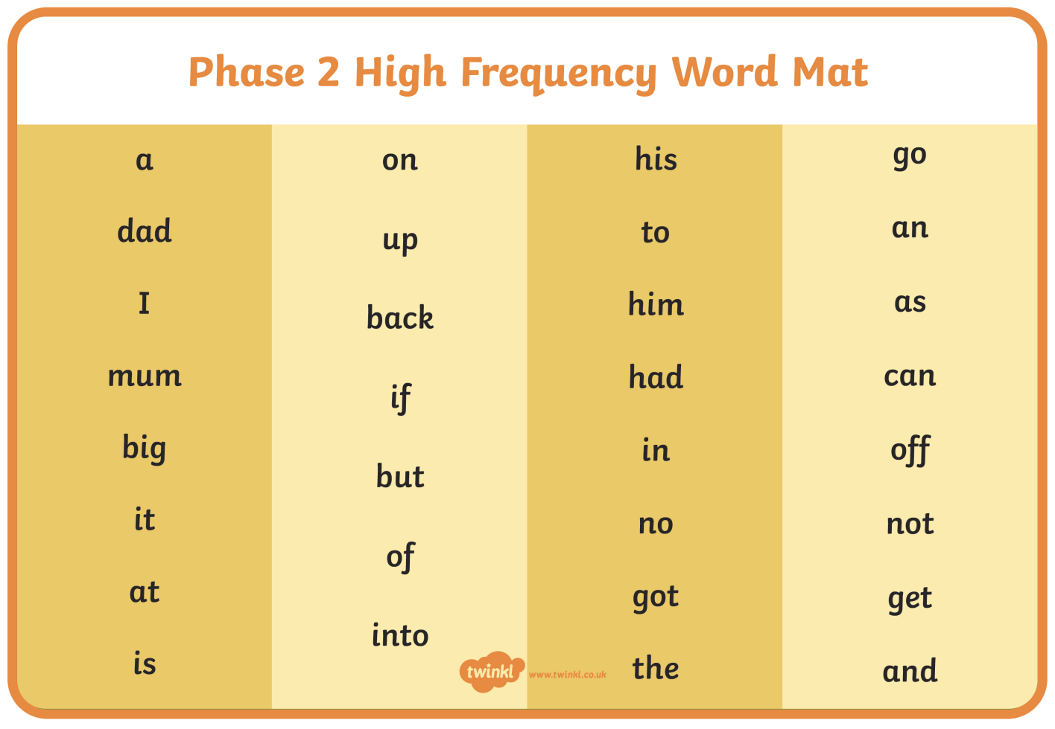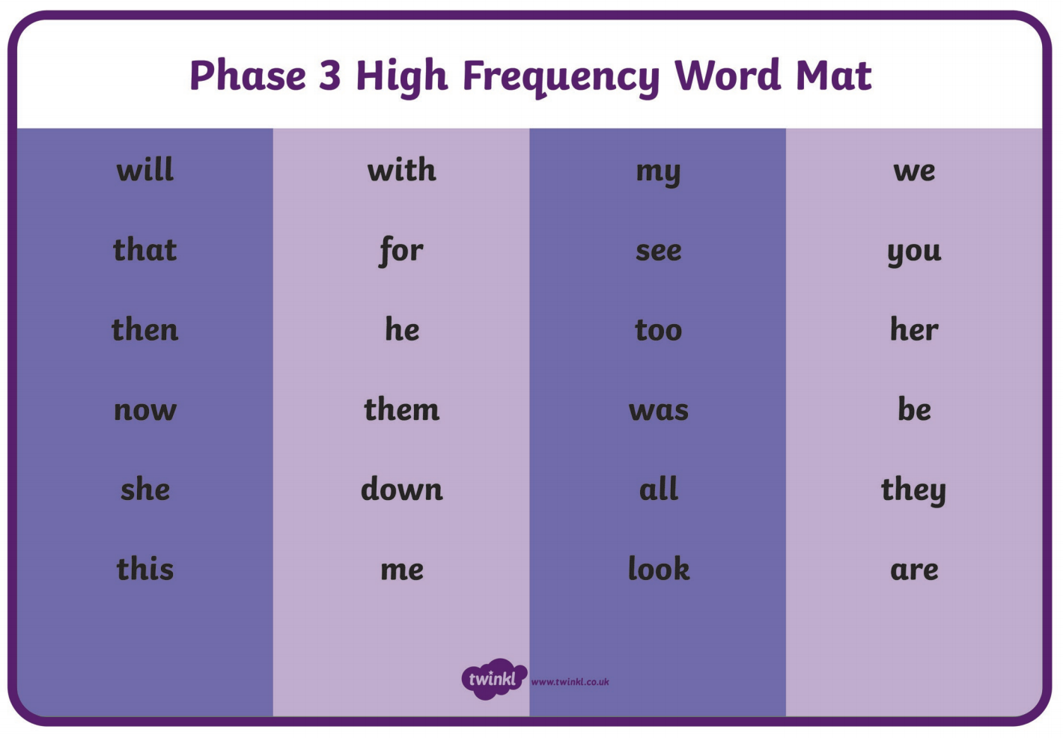

KS1 – Spellings
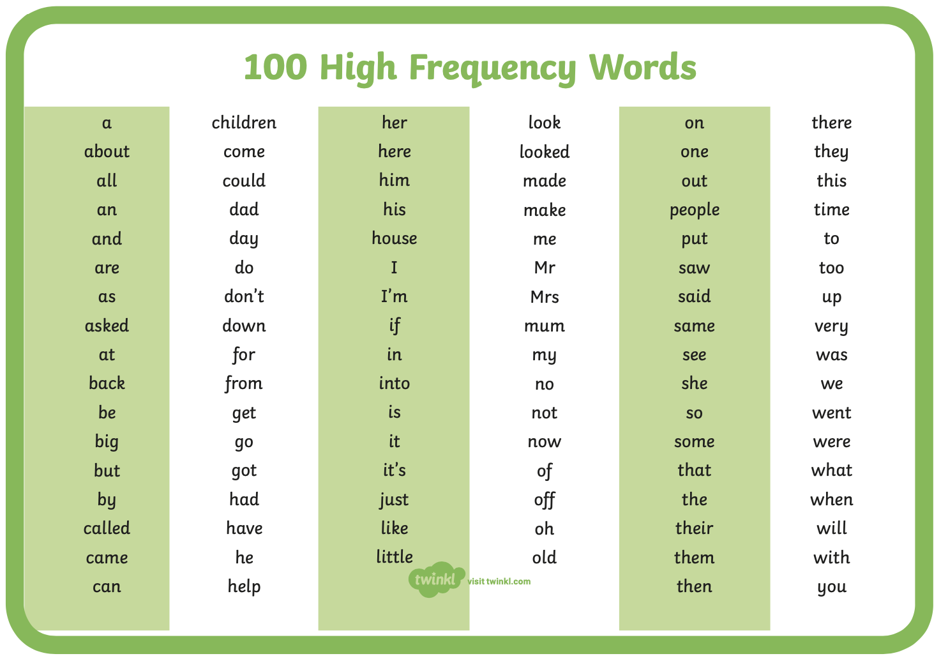
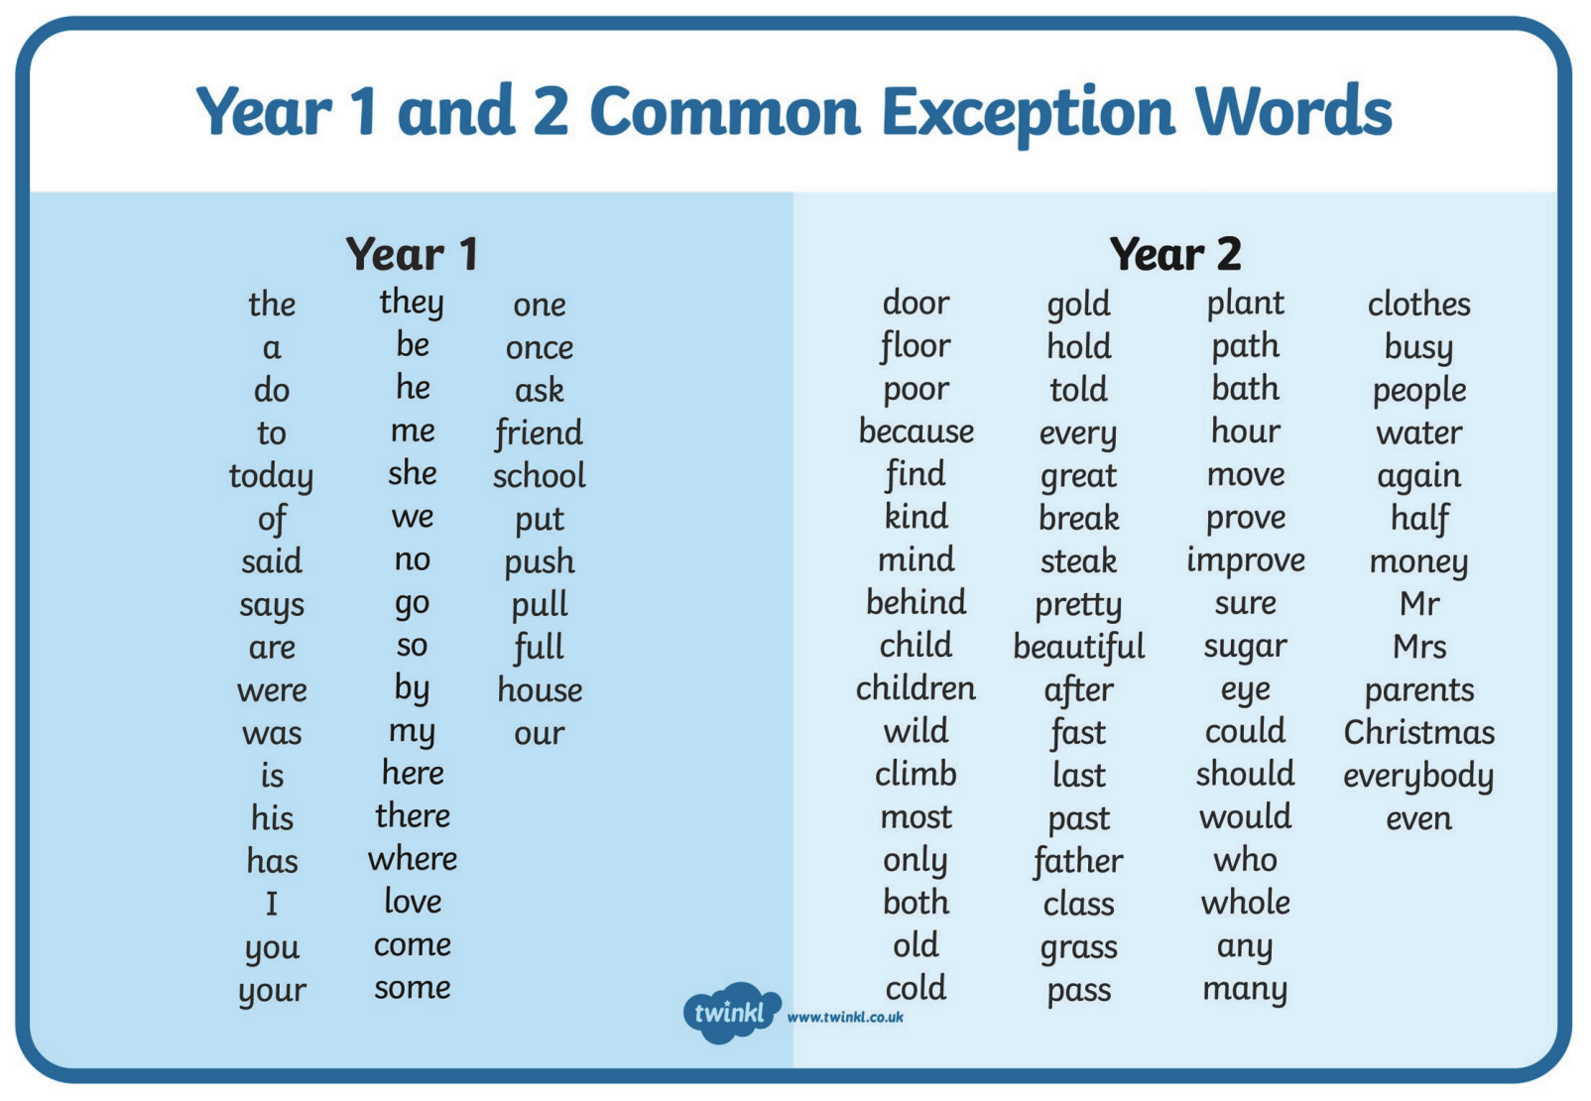
Pre-school Letter Formation Guidance
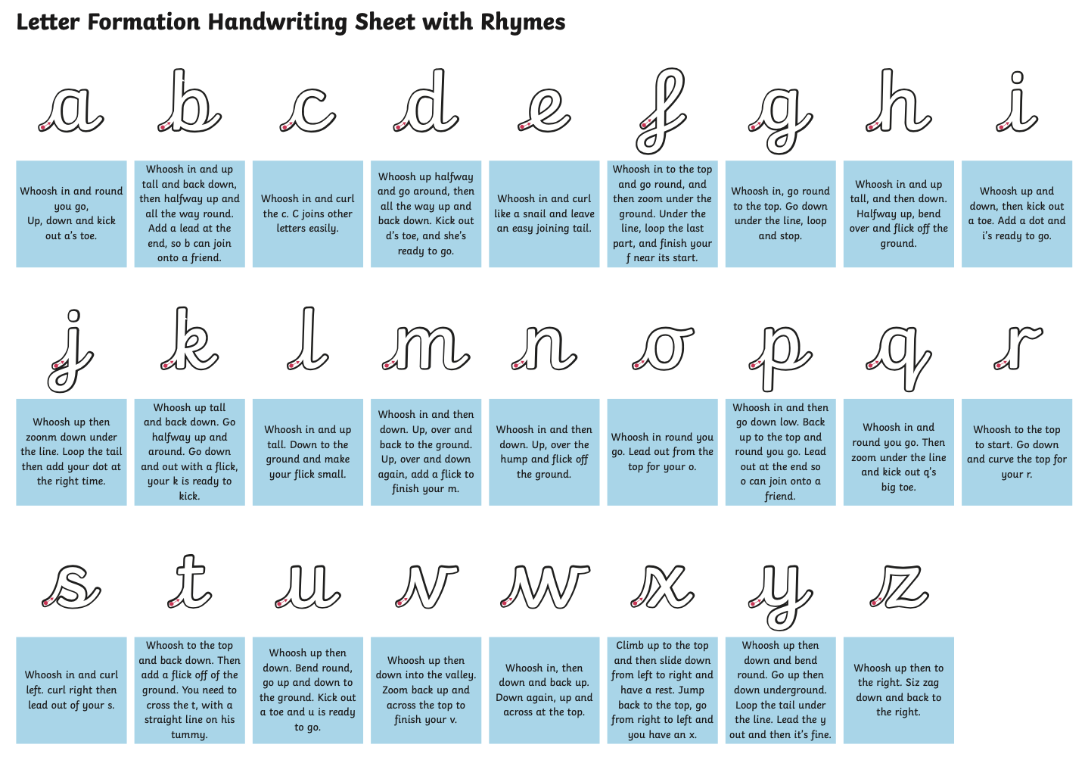

Monday | Phonics/Literacy – PLEASE NOTE THAT THIS PLANNING REMAINS FOR THE REST OF THE WEEK.  Preschool – see notes above.  Reception – Phase 4 revision: Practise GPCs and Phase 4 Tricky Words – You can continue to play ‘Flashcards’ using the previously attached resources and ‘Quickwrite Graphemes’ (say the sound on the flashcard ask your child to write it without them seeing it), or alternatively if any of the activities that have been set previously were particularly successful in helping your child to learn their tricky words you could incorporate these for a change. Complete a part of the Reception Phonics Phase 4 booklet each day (Book-7).  Year 1 – Continue revision of all of the GPCs phase 2 – 5 with your child at a rapid pace (continue to use previously suggested activities) + please play the games this week for Phase 5 assessment for real words and pseudo words (we have allocated them to you on Bug Club Phonics - please play each day so that we can have a look and see how you are getting on) + work through ‘Talk for Creative Writing’ unit.  Year 2 - Continue revision of spelling all Common Exception Words using suggestions from Summer Term B Week 3 + see Bug Club Grammar for allocated games + work through ‘Talk for Creative Writing’ unit.  Talk for Creative Writing  We hope that you have been enjoying the creative writing units and have found that completing them is helping you to see that your writing is improving. We have attached the new units for your year group, but if you have not finished the last ones and would like to, then do that before moving on. If you think you would like a new story, then move on to the new texts below. As usual, work on one activity each day. Send us pictures of some of your writing - we would love to see!  Reception - ‘Brian Bear’s Picnic’: We think you will love this story and it is such fun to have a picnic. Your grown-ups can help you with the reading but we think that you could have a go at some more of the writing now - you don’t have to do it all - maybe your grown-ups could do some of the writing and you could watch how they do it. Take turns!  Year 1 – ‘Brian Bear’s Picnic’: A lovely story about a bear who decides to invite his friends to a picnic. His friends set off with some lovely food, but the things that happen along the way, mean that they arrive at the picnic empty- handed. What will they do?  Year 2 - ‘The Elves and the Shoemaker’: A lovely traditional tale - some of you may know it already. There are lots of lovely writing activities to complete. Remember, you are nearly Year 3 now, so you will need to write answers to questions, descriptions and opinions in full sentences using conjunctions such as ‘because’.  Maths  EYFS Maths Starter – Continue to practise number bonds to 10 and 20. Have a go at EY Maths Story Time activity.  EYFS - Access the White Rose Maths website for home learning (link below).  https://whiterosemaths.com/homelearning/early-years/  Complete Summer Term Week 8 (w/c 6th July) - Day 1: The Dinosaur that pooped a planet (watch the video before following the links to complete suggested activities).  KS1 Maths Starter – short mental workout  - How many minutes from...?  (a) 10:30 to 11 o’clock?  (b) 3 o’clock to half past 3?  (c) 12:30 to 1 o’clock?  - Write this mixture of analogue and digital times in order, starting at 1 o’clock:  7:30, half past two, 1:00, 8 o’clock, 3:00  - What time is half an hour later than:  2:30 seven o’clock 11:00 half past 6?  - What time is half an hour earlier than:  5:30 ten o’clock 1:00 half past 2  Y1 Access the White Rose Maths website for home learning (link below).  https://whiterosemaths.com/homelearning/year-1/  Complete Summer Term – Week 13 (w/c 20th July) Lesson 1 (watch the video before following the links to complete suggested activities).  Y2 Access the White Rose Maths website for home learning (link below).  https://whiterosemaths.com/homelearning/year-2/  Complete Summer Term – Week 13 (w/c 20th July) Lesson 1 (watch the video before following the links to complete suggested activities).  KS1 - If you do have access to a printer and want to print the White Rose sheets that go with each lesson, you can do. If you do this, you do not have to do the Power Maths pages as well.  If you do not have access to a printer, watch the White Rose video each day and then complete the Power Maths books.  Daily Project – SPELLING  KS1 – See sheets attached below for revision and practise.  Daily Project – Mental Health/PSHE/Celebrating Self/RE  TASK 1 - EYFS and KS1: Continue and complete the final page of your ‘Family positivity and gratitude pack’ (see resources attached on the website from week 1).  TASK 2 – EYFS and KS1: RE – see attached (to be completed over two weeks).  TASK 3 - EYFS and KS1: https://www.youtube.com/watch?v=aqpaTT6EcXM&app=desktop  Watch this lovely video of Ray Charles practising a new song on the piano using Braille.  Fine the sheet called ‘Words that describe me’. Draw yourself in the middle and then use words to describe how amazing you are!
Tuesday | Phonics/Literacy – PLEASE REFER TO MONDAY PLANNING  Maths  EYFS Maths Starter – Continue to practise number bonds to 10 and 20. Now:  - Place 6, 19, 16 and 9 on a washing line in the correct order  - How many numbers come between 10 and 15?  - Which numbers are in the wrong place on this line?  13 17 15 14 16  EYFS - Access the White Rose Maths website for home learning (link below).  https://whiterosemaths.com/homelearning/early-years/  Complete Summer Term Week 8 (w/c 6th July) - Day 2: The Dinosaur that pooped a planet (watch the video before following the links to complete suggested activities).  KS1 Maths Starter – short mental workout  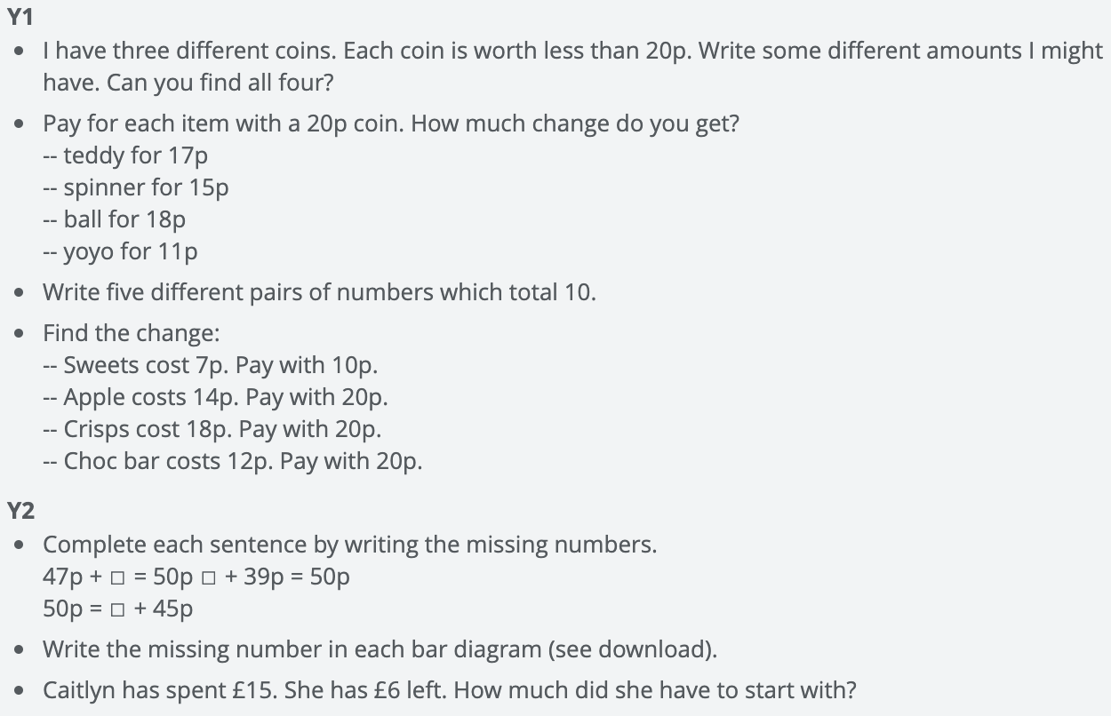  Y1 Access the White Rose Maths website for home learning (link below).  https://whiterosemaths.com/homelearning/year-1/  Complete Summer Term – Week 13 (w/c 20th July) Lesson 2 (watch the video before following the links to complete suggested activities).  Y2 Access the White Rose Maths website for home learning (link below).  https://whiterosemaths.com/homelearning/year-2/  Complete Summer Term – Week 13 (w/c 20th July) Lesson 2 (watch the video before following the links to complete suggested activities).  KS1 - If you do have access to a printer and want to print the White Rose sheets that go with each lesson, you can do. If you do this, you do not have to do the Power Maths pages as well.  If you do not have access to a printer, watch the White Rose video each day and then complete the Power Maths books.  Daily Project - EYFS and KS1 – Sports Day!  Your task this week is to design, promote, and take part in your very own Sports Day for you and your family!  Step 1 – Plan!  Pick your Sports Day activities.  Take a look at this resource for some ideas: https://www.youthsporttrust.org/system/files/resources/documents/YST_NSSW_Activities.pdf or design your own!  Pick as many as you wish.  Try a couple of the activities to find your favourite.  Design a poster to promote your day.

Wednesday | Phonics/Literacy – PLEASE REFER TO MONDAY PLANNING  Maths  EYFS Maths Starter – Continue to practise number bonds to 10 and 20. Now:  Write the missing numbers.  5 + ☐ = 10  ☐ + 7 = 10  10 – 4 = ☐  2 + ☐ = 10  10 – 1 = ☐  Which is your favourite addition to 10? Why?  EYFS - Access the White Rose Maths website for home learning (link below).  https://whiterosemaths.com/homelearning/early-years/  Complete Summer Term Week 8 (w/c 6th July) - Day 3: The Dinosaur that pooped a planet (watch the video before following the links to complete suggested activities).  KS1 Maths Starter – short mental workout  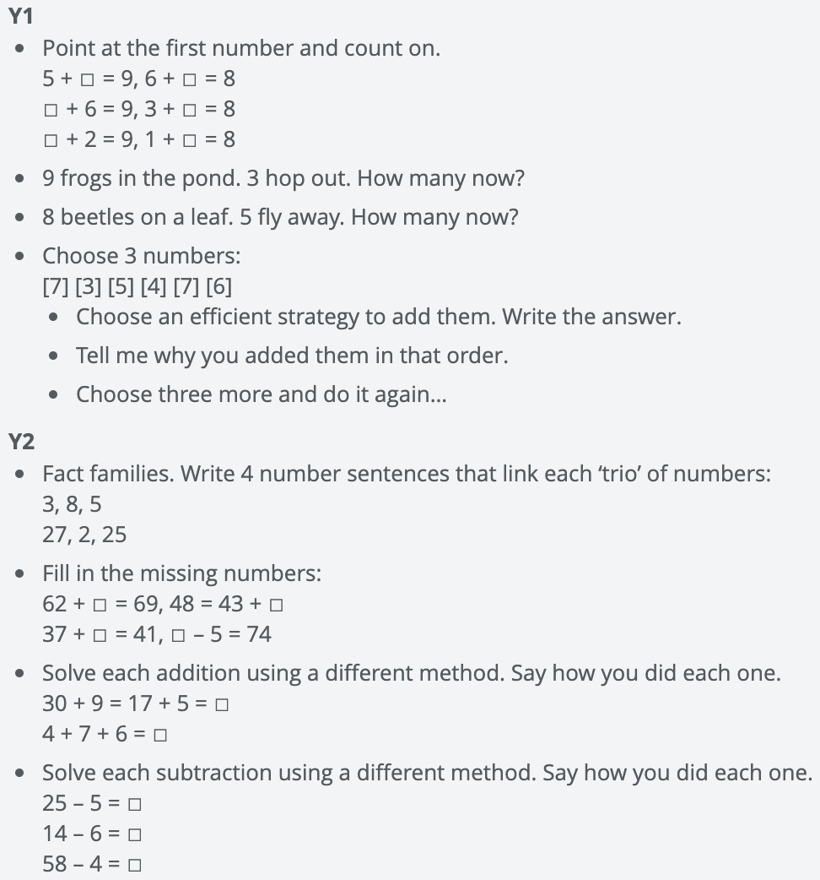  Y1 Access the White Rose Maths website for home learning (link below).  https://whiterosemaths.com/homelearning/year-1/  Complete Summer Term – Week 13 (w/c 20th July) Lesson 3 (watch the video before following the links to complete suggested activities).  Y2 Access the White Rose Maths website for home learning (link below).  https://whiterosemaths.com/homelearning/year-2/  Complete Summer Term – Week 13 (w/c 20th July) Lesson 3 (watch the video before following the links to complete suggested activities).  KS1 - If you do have access to a printer and want to print the White Rose sheets that go with each lesson, you can do. If you do this, you do not have to do the Power Maths pages as well.  If you do not have access to a printer, watch the White Rose video each day and then complete the Power Maths books.  Daily Project - EYFS and KS1 – Sports Day!  Step 2 – Prepare!  Practise all of your Sports Day activities.  Gather all of the equipment you need. Ensure you are in a safe environment and are wearing appropriate clothing.  Design your own scorecard for the activities e.g.  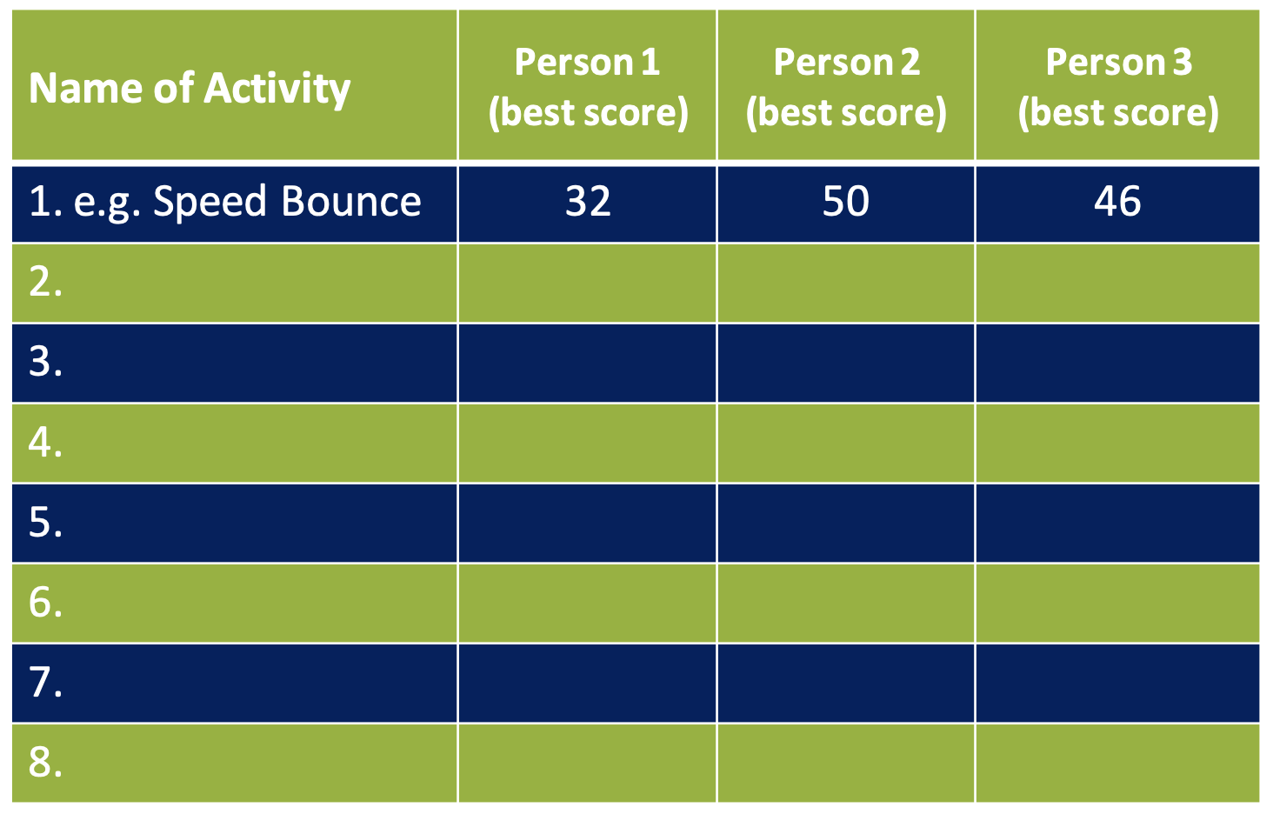  Step 3 – Promote!  Demonstrate your chosen activities to a family member.  Design some bunting to showcase your day and decorate!
Thursday | Phonics/Literacy – PLEASE REFER TO MONDAY PLANNING  Maths  EYFS Maths Starter – Continue to practise number bonds to 10 and 20. Now:  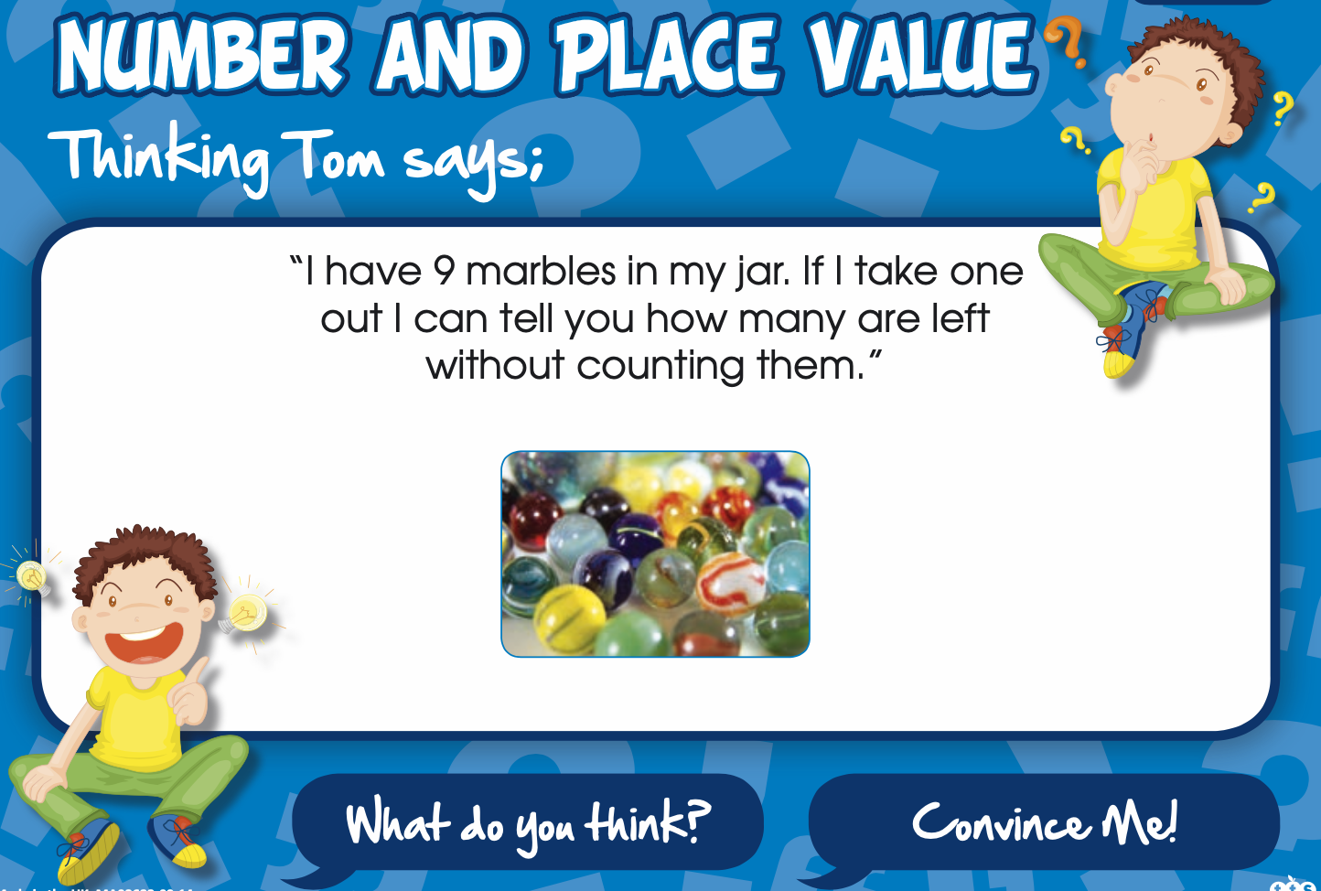  EYFS - Access the White Rose Maths website for home learning (link below).  https://whiterosemaths.com/homelearning/early-years/  Complete Summer Term Week 8 (w/c 6th July) - Day 4: The Dinosaur that pooped a planet (watch the video before following the links to complete suggested activities).  KS1 Maths Starter – short mental workout  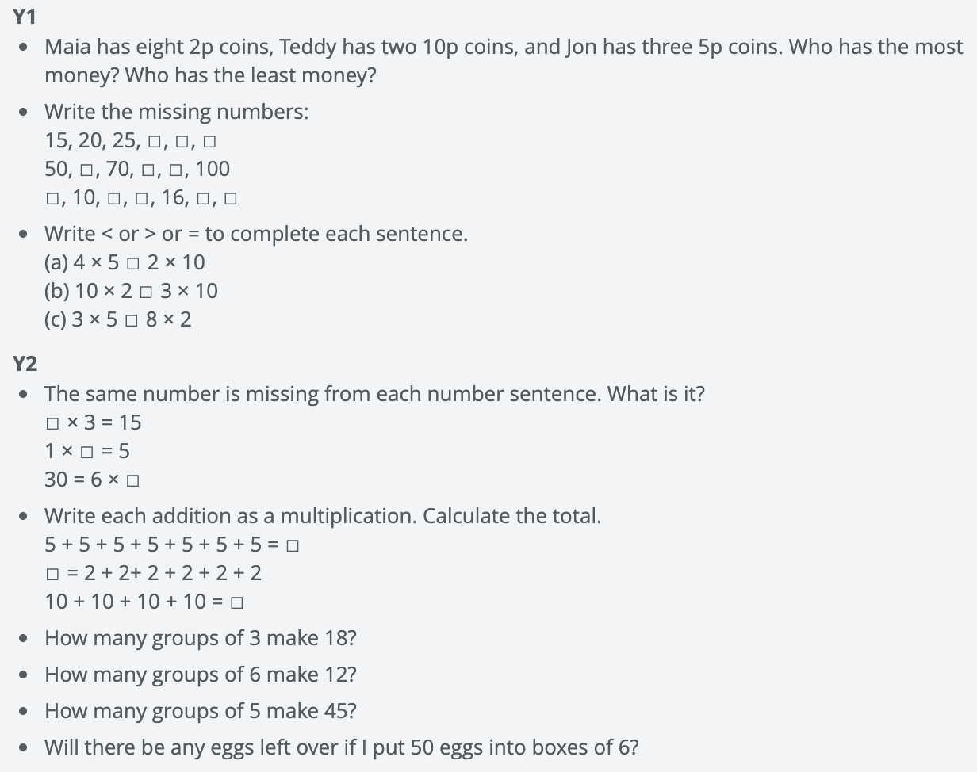  Y1 Access the White Rose Maths website for home learning (link below).  https://whiterosemaths.com/homelearning/year-1/  Complete Summer Term – Week 13 (w/c 20th July) Lesson 4 (watch the video before following the links to complete suggested activities).  Y2 Access the White Rose Maths website for home learning (link below).  https://whiterosemaths.com/homelearning/year-2/  Complete Summer Term – Week 13 (w/c 20th July) Lesson 4 (watch the video before following the links to complete suggested activities).  KS1 - If you do have access to a printer and want to print the White Rose sheets that go with each lesson, you can do. If you do this, you do not have to do the Power Maths pages as well.  If you do not have access to a printer, watch the White Rose video each day and then complete the Power Maths books.  Daily Project - EYFS and KS1 – Sports Day!  Step 4 – Celebrate!  Run through all of your chosen activities.  Make sure everyone is ready for Sports Day.  Design a medal and certificates for everyone who takes part. Can you prepare copies of these?  Step 5 – Ready, Steady, Go!  Deliver your Sports Day, making sure everyone tries their best and enjoys themselves.  Write an opening or closing speech for your Sports Day and celebrate everyone’s achievements!  Additional - Finishing off any incomplete work. Well done for all of your hard work this term!

