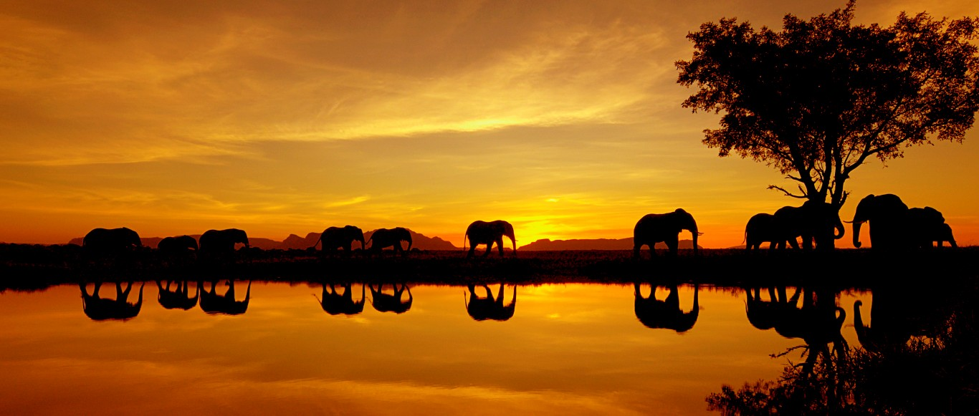

**VISIT**

Visit from a vet

**Communication, Language and Literacy**

(Speaking, listening, reading, writing, MFL)

We will be exploring fiction and non-fiction texts as readers and writers. We will continue to learn to apply phonic strategies and develop understanding of content and meaning. The children will learn how to punctuate their writing using capital letters, full stops, commas, exclamation marks and question marks. They will think about making good word choices and will try to vary how they start their sentences, adding detail to make their writing more interesting. They will develop the skill of reading and improving their writing style through learning the skills of editing it to make improvements.

MFL – Learning the name of body parts and clothes in French.

**Possible Activities**

The role play corner is set up as a ticket office at a zoo and later as a travel agents and veterinary surgery. The children will be dressing up as different animals. They will have the opportunity to ask visitors including a vet questions and will listen to the information that they share. They will be exposed to poetry about wild animals and will specifically be looking at rhyming texts. They will have the opportunity to learn and write tongue twisters and riddles. Instructional texts, reports. They will complete their own research from topic books and the Internet. Children will be making their our own non-fiction books.

**Mathematical Development/Activities across the Age Range**

Number Sense, Additive Reasoning

Ordering, comparing and counting numbers to 100, forwards and backwards. Recognising place value – tens and units. Adding and subtracting pairs to 10, 20, 100. Writing numbers to 100 in numerals and words. Multiplying and dividing – 2, 5, 10 and counting in 2s, 3s, 5s and 10s. Recognising 2D and 3D shape – naming and identifying properties of these. Finding lines of symmetry. Describing position, direction and movement – clockwise, anticlockwise, north, south, east and west. Measuring - height, length, capacity and weight. Learning to tell time and know sequences of days and months. Apply mental methods to achieve mastery in simple problem solving.

**Possible Activities**

**Science**: We will be looking at different animals and their habitats including those living in the rainforest, African Savannah and Australia. We will be making our own habitats e.g. ‘Savannah in a shoe-box’. The children will be sorting wild life into groups – comparing and contrasting to understand more about how they survive. We will look at African animal food chains and predator/prey relationships, thinking about animal’s use of camouflage for protection. Animal’s use of senses for protection. We will be completing surveys in which children are required to Notice how trees change dependent upon the season.

**History:** We will be investigating the lifestyle of tribes living in the rainforest. We will question how life changed for them over time and why? We will ask ourselves what are the threats to this way of life?

**Geography**: The children will be using the map/atlas/globe to name and locate the 7 continents before identifying the Amazon Rainforest and African Savannah. They will learning about the physical geography of these locations, comparing life in African villages to life in the UK. They will be looking at and comparing the animals that live in these locations and will study the physical features of Australian beaches, as well as marine and coastal birds of Australia.

**Topic Themed Activities**

Our first key focus is revising place value to secure understanding of tens and ones using dienes. Children will be playing games and completing activities such as number bingo, organising Numicon, arranging the animals on the number line and placing spots on the lady bird to enable them to learn and use number facts such as their number bonds to 10, 20 and 100.

The children will be solving word problems relating to zoo and travel agents; they will be thinking about feeding amounts, times and money spent in the gift shop.

The children will be sorting and comparing numbers and amounts, as well as thinking measurement by completing our table: Are you as tall as a …? We will also think about the wingspan of birds and the length and weight of animals. Using this information children will be learning to handle data – they will collect information and represent statistics using tables and bar charts such as grouping animals in the rainforest/Savannah.

**PRESENTATION**

African Savannah including watering hole; children’s drawings/paintings of safari animals and also inspired by Henri Rousseau. Moving animals made by pneumatics and paper plate animals. The different layers of the rainforest. The role-play will change throughout the term; it will be a zoo, travel agents and veterinary practice.

**A Carnival of Animals**

**Possible Activities**

RE:

We will be introduced to Tessa and Tom who will lead us through our RE investigations and we will be thinking about God and the story of the creation – asking questions and finding out about important festivals in the Jewish faith. We will of course be discussing and planning Harvest and Christmas.

PSHE:

We will be developing guidelines for our class to follow as well as being introduced to DD our class friend who will help guide us through our many questions. Our main discussions this term will be about being responsible as well as computer and fire safety.

We will be reading The Huge Bag of Worries by Virginia Ironside and Jesus’ Important Message.

**Personal, Social and Emotional Development\**

(RE, PSHE, Citizenship, SEAL)

SEAL programme of study:

New beginnings, Getting on and falling out.

PSHE:

Good Samaritan Award

Being responsible

Computer Safety and Fire Safety

PSHE in Topic - Conservation/Zoos – good or bad?

RE – Why is the word ‘God’ so important to Christians?

Judaism, Christianity

Christmas, Harvest

(Brackets) refer to Early Years Foundation Stage Areas of Learning

**Understanding of faiths, beliefs and cultures**

Worship values –

Service

Responsibility

**Knowledge and Understanding of the World**

(Geography, History, Science)

**Science**: Habitats - All living things and their habitats. Identify that most living things live in habitats to which they are suited and describe how different habitats provide for the basic needs of different kinds of animals. Seasons – Observe changes across the four seasons, observe and describe weather associated with the seasons.

**History**: Researching tribes living in the rainforest, their way of life and threats to them over time. Learn about the Aboriginal people of Australia. Finding out about Mary Anning.

**Geography**: Looking at the 7 continents and the 5 oceans before focussing on The African Savannah and Amazon Rainforest. Comparing and contrasting the local coastline with Australian beaches.

**ICT Activities**

E-Safety – using computers safely. Checking with grown ups about which internet sites are safe for us to use as well as looking at other technology available to us. Practising keyboard and mouse skills. Using paint packages to create and save pictures of safari animals. Using National Gallery website to create Rousseau pictures (KU) (EAD). Using the internet to collect images and research information about the African Savannah, the Amazon rainforest and Water Aid. Creating, organising and saving documents: Using the information gathered to make PowerPoint presentations and posters. Representing information graphically on a computer: Create block graphs to present findings, word processing reports on zebras.

**Possible Activities**

Music: The children will listen to ‘Carnival of Animals’ by Saint-Saens. They will compose and perform individual and group pieces in response to this. They will be learning about instruments of the orchestra. The children will be exploring pulse and rhythm *(African drums)*. They will learn a variety of songs - Walking in the jungle, The Elephant, Hippopotamus’ song.

Art/DT: The children will: Plan and make an animal mask, make a moving animal using pneumatics, make bird feeders/boxes or hedgehog homes, make a clay fossil. The children will experiment with Aboriginal dot painting of an Australian animal, developing this by having a go at using batik in this style. They will be exploring colour, shape and form through painting a safari animal. They will be refining skills and honing technique through drawing a bird step-by-step and observational drawings of leaves and feathers. We will be reviewing the paintings of Rousseau, creating own pieces in response to this using mixed media.

**Creative Development**

(Art, D&T, Music, Dance, Role Play)

Music: Children are asked to listen with concentration and understanding to a range of high quality live and recorded music. They will experiment with, create, select and combine sounds. They will be given the opportunity to play tuned and untuned instruments.

**Art/DT:** Children will learn about the work of a range of artists. They will select tools and equipment to perform practical tasks. They will use drawing, painting and sculptures to develop and share ideas (EAD). They will generate, develop, model and communicate their ideas through talking, drawing templates, mock-ups and, where appropriate, information and communication technology.

**Physical Development**

Leap into Life – Reception and

Year 2 Autumn Units.

**Possible Activities**

Gymnastics – Balance and movement to perform like animals, linking this to the story of The Lion King. Dance - Jungle Fever, traditional African dances.

**Texts that teach**

‘What do you do with a tail like this?’ by Robin Page and Steve Jenkins – Explanation text, children to write a book about special clothing.

‘Lord of the Forest’ by Caroline Pitcher and Jackie Morris – Narrative, children to write their own story.

‘What I like! Poems for the very young’ by Gervaise Phinn – Writing poems based on the senses.

Unfortunately by Durant and Rickerty and The Fishing Trip by Beatrice Rodriquez – Writing stories using predictable and patterned language.