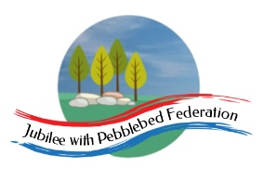

Class 2, Branscombe C of E Primary School

Dear Parents and Members of Class 2,

This week’s leg of our virtual world travels takes us to St. Petersburg in Russia, for the ‘White Nights Festival’ that usually takes place there at around this time. For a period of two months this former Russian capital comes alive with a calendar of events that provides visitors with a unique opportunity to immerse themselves in the city's cultural richness against a backdrop of a never-setting sun. The 2020 festival, which was due to have begun on 22nd May, will have to be adapted due to the Coronavirus. Most of the concerts and events that were due to take place over this period will have had to be cancelled or delayed. Nevertheless, we thought we would take advantage of the opportunity to learn more about one of the world’ largest countries and the phenomenon of ‘White Nights’.

As you will possibly have noticed already, the White Rose Home Learning website that we have been recommending for the children’s daily Maths at home is no longer providing activity sheets for free. You can continue to use the videos and we can let you have the children’s ‘Power Maths’ activity books to use for follow up work, if you would like to arrange to collect these from school. Alternatively, use a different online resource, such as the BBC Bitesize daily lessons (https://www.bbc.co.uk/bitesize/dailylessons) or the Oak National Academy (https://www.thenational.academy/online-classroom). For those who are unable to access these online resources, we have also uploaded a separate file of Maths resources that you can print. Again, if you wish to collect a printed set of these from school, let us know and we can leave a pack out for you.

Happy learning! Hope to see many of you again before too long,

Miss Moss

The most important thing you can do to support your child’s learning whilst schools are closed is to ensure that they read every day and they continue to practise their number bonds and times tables.

Don’t forget to keep using the accounts you have through our school to practise basic skills, such as reading, reading comprehension (Bug Club), Times tables (Times Table Rock Stars) and Spelling (Spelling Shed). I have set work on TTRS each week and I shall be checking these sites regularly to keep an eye on what you’re doing. Feel free to challenge me (Dot McRock) to a Rockslam competition!

Week beginning Monday 18th May

Monday | Core activities |  | Suggestions for additional activities.
9.00 – 9.30 | Daily Dashboard:  Quelle est la date aujourd’hui?  C’est lundi le dix-huit mai 2020.  Can you write the number date in Roman numerals?  Today, the Buddhist festival of Purnima/ Vesak is celebrated in India. This festival celebrates the birth, enlightenment and death of Gautama Buddha. Spend a few minutes revisiting what you know or can remember from our learning in our ‘Thailand week’ about the Buddhist religion.  This week, we are heading to Russia for the White Nights Festival in St. Petersburg. The term 'white nights' refers to a natural phenomenon more commonly known as the midnight sun. It occurs during the summer months around both poles, north of the Arctic Circle and south of the Antarctic Circle. Due to the extreme latitude of these regions, the sun does not fully set for roughly a two month period around the summer solstice. On the night of summer solstice the sun remains visible all night long.  Countries where this phenomenon occurs include Russia, Finland, Greenland, Iceland, Norway, Canada and the USA (Alaska). Look at where these countries are on a map or a globe. Many of these destinations will celebrate the summer solstice in their own way but the city of St. Petersburg goes one step further and honours the entire white night period with its own festival. Watch the following video clip about the ‘midnight sun’ in these countries: https://youtu.be/eUsWUiVCq5U |  |  | Today is Independence day in Somalia. Can you find Somalia on a map of the world? Try to find out a few facts about this East African country.  What is the climate like? What sort of landscapes are found in the country? What is the capital city? What countries does Somalia share borders with? What is the main religion and the principal profession?
9.30-10.00 | Grammar – see additional Grammar resources |  | Use your spelling shed login to practise by playing spelling games.
10.00- 10.30 | Time for some PE – Here is a link to a golf rolling activity designed for home PE: https://www.youthsporttrust.org/sites/default/files/Home%20PE%20Golf%20Rolling.pdf  Or try another- ‘Climb the ladder’:  https://www.youthsporttrust.org/sites/default/files/Home%20PE%20Climb%20the%20Ladder.pdf
10.30-11.30 | Maths - See the separate resource pack for your year group or log on to the Oak National Academy as follows:  Year 3: https://www.thenational.academy/year-3/maths/to-identify-and-recognise-angles-year-3-wk4-1  Year 4: https://www.thenational.academy/year-4/maths/area-and-perimeter-year-4-wk1-1  Year 5: https://www.thenational.academy/year-5/maths/an-introduction-to-translation-year-5-wk1-1  Year 6: https://www.thenational.academy/year-6/maths/find-the-value-of-missing-angles-year-6-wk3-1  Challenge Question:  Today, we are travelling from Vienna in Austria to St. Petersburg in Russia. The flight left Vienna at 7.15 am in the morning, local time and arrived in St. Petersburg at 10.43 am, local time. However, the time in St. Petersburg is 1 hour ahead of the time in Vienna. So how long did the flight take altogether? (Explain your reasoning fully.) The time in the UK is 3 hours behind the time in St. Petersburg, Russia. Can you work out the current time in St. Petersburg? However, the time in Vladivostok, in the East of Russia, is 7 hours ahead of that in Moscow and St. Petersburg. So what is the current time in Vladivostok?  You could have a look at a map of Russia that shows the time zones and work out the current time in different parts of the country… |  |  |  | Don’t forget to keep logging on to Times Table Rock Stars to practise your times tables. A few minutes practice every day will soon improve your recall of key facts!
11.30-12.00 | Have a break and play a game or do another activity that you enjoy. | Keep active in mind and body – why not do a puzzle or other activity today that will help to stretch your brain and keep your mind active?
12.00- 1.00pm | Lunch break. Eat a healthy lunch and, if you are able, try to get outside for some fresh air!
1.00pm – 1.30pm | Reading - Complete the Reading comprehension below to find out more about Russia. There are 4 levels of difficulty – roughly aimed at the 4 year groups in Key Stage 2, but choose the one that suits you best. | Keep reading online and completing Bug Club Comprehension questions  Or  Read a chapter or two of your latest reading book.
1.30pm – 3.00pm | Watch the video to learn more about Russia:  https://www.youtube.com/watch?v=6PucIvOn964  Read further facts on the following pages:  https://www.kids-world-travel-guide.com/russia-facts.html  and https://kids.kiddle.co/Russia and complete the Russia fact file sheet below or, alternatively, make your own!  Why not research and create your own “All About Russia” quiz. You could practise using Powerpoint to put the quiz together and add hyperlinks to the answers… |  | Use the map from the ‘Additional Resources Russia’ to research the names and locations of different Russian cities  Read through the slides in ‘Additional Resources Russia’ to find our more about the human geography and key points in the history of the world’s largest country.  Then, complete the history activity sheet by filling the gaps on the sheet and then cutting and pasting to put the events in order.  .

Year 3
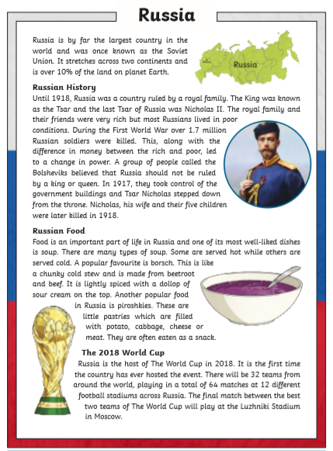
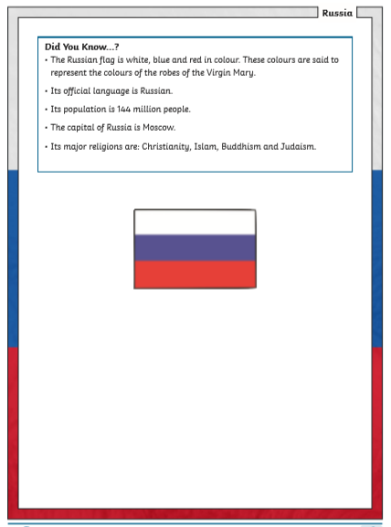

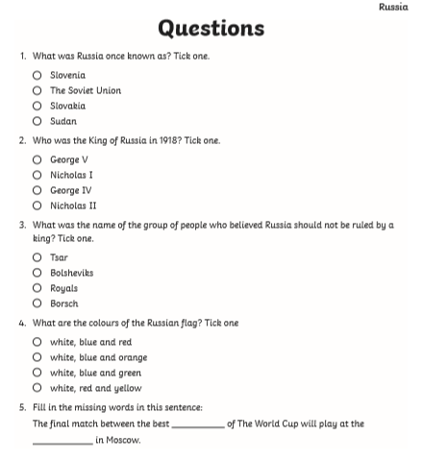
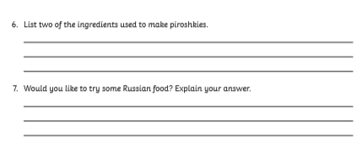

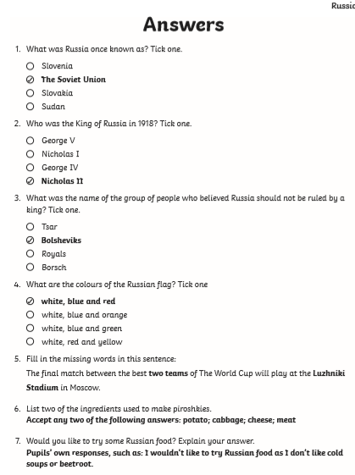

Year 4

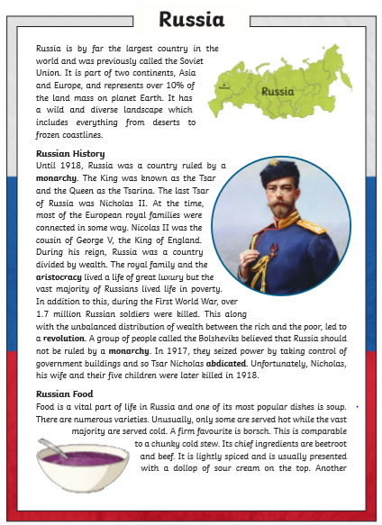

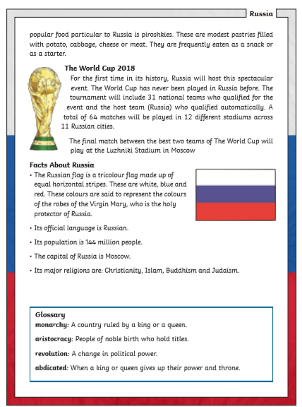

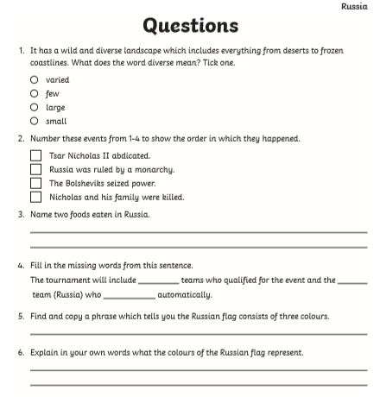
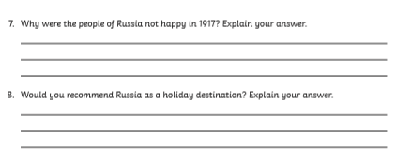
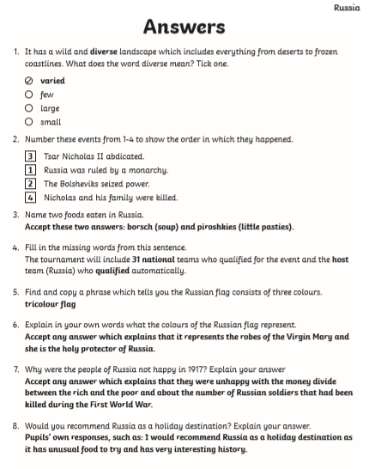

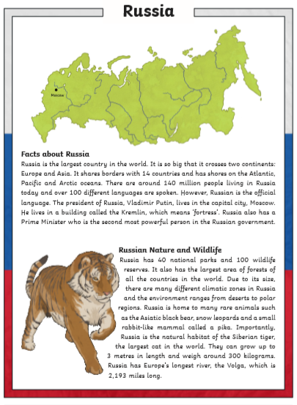
Year 5

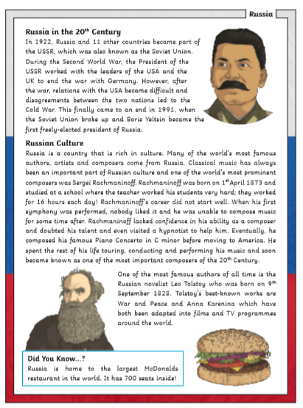
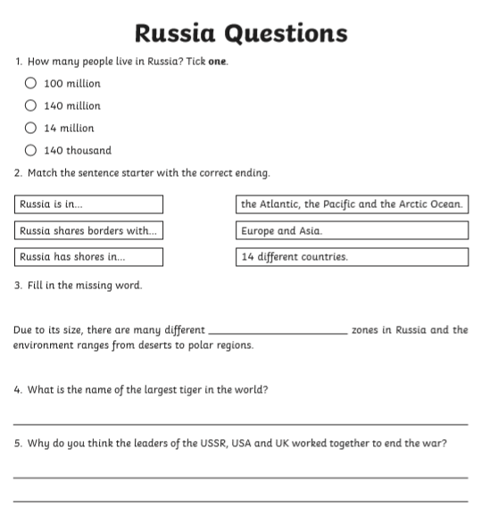
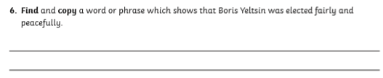
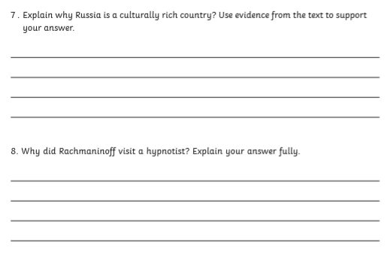

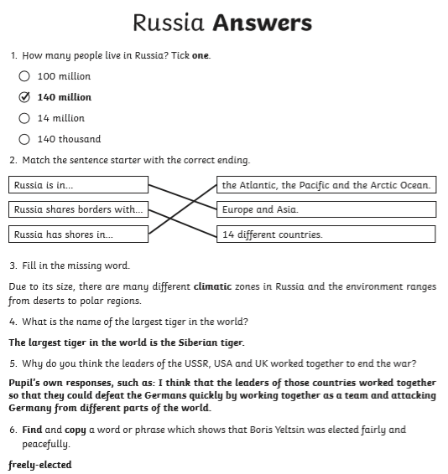
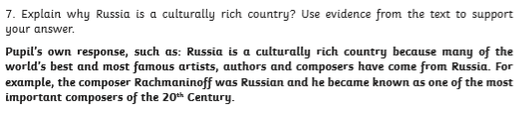
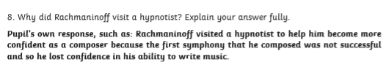
Year 6
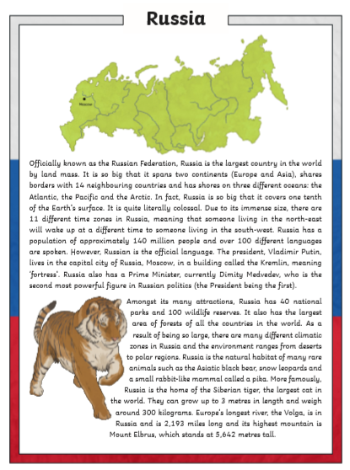

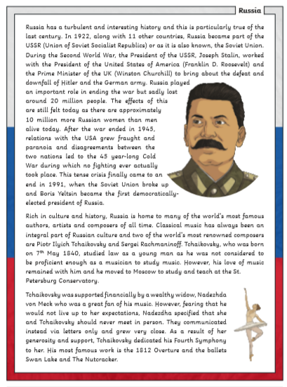

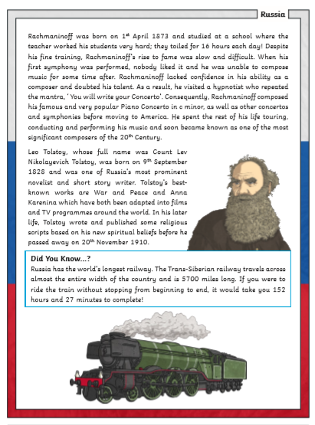

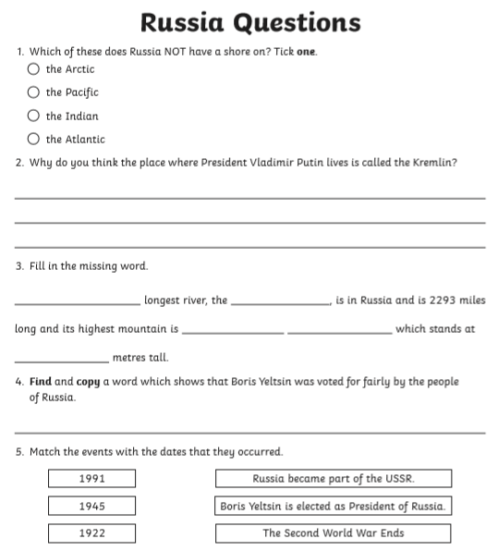
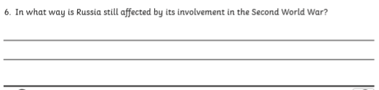

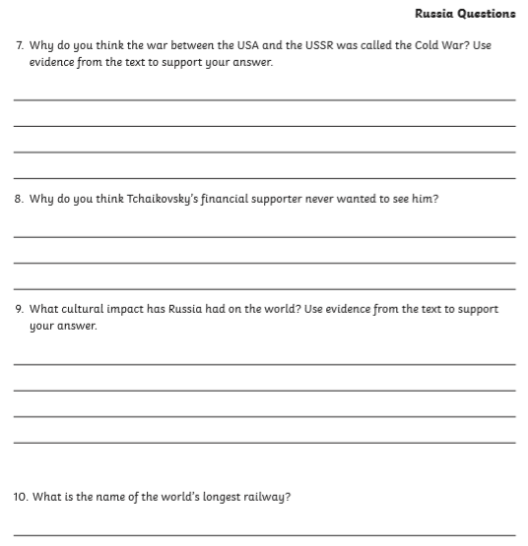
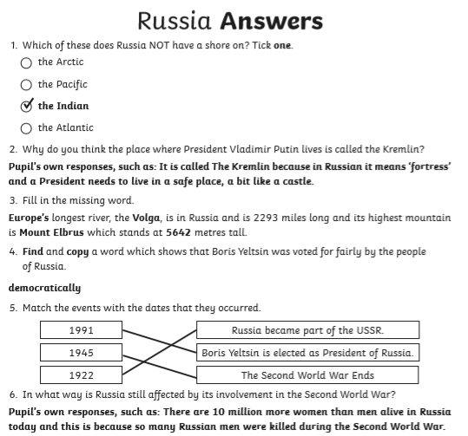
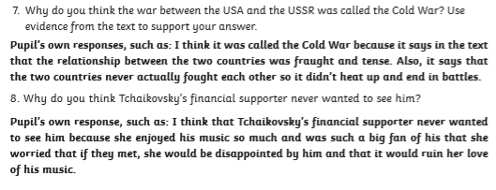
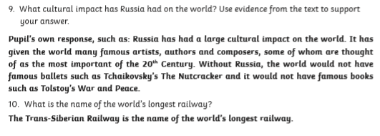

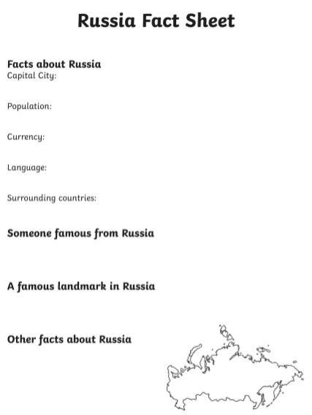

Tuesday | Core activities |  |  | Suggestions for additional activities.
9.00 – 9.30 | Daily Dashboard:  Quelle est la date aujourd’hui?  C’est mardi le dix-neuf mai 2020.  Can you write the number date in Roman numerals?  This year, 19th May is the date on which Muslims will remember an event called the ‘Night of Power’ as they celebrate Laylatul Qadr. This is the day on which they recall the night on which Allah revealed the holy Qur’an to the prophet Muhammad (peace be upon him). It is considered by many Muslims to be the holiest day of the year. You can learn more about the Night of Power by watching the following clip https://www.bbc.co.uk/bitesize/clips/z9b9jxs or you can read more about this special night and how it might be marked by Muslims here: https://www.muslimaid.org/what-we-do/religious-dues/the-night-of-power-laylat-ul-qadr/ |  |  |  |  | What is happening in the world? Have a look at https://www.bbc.co.uk/newsround or https://www.dogonews.com/ to see what is going on in the world. Choose a news article or two to read.
9.30-10.00 | Grammar – see additional Grammar resources |  | Use your spelling shed login to practise by playing spelling games.
10.00- 10.30 | Time for some Physical activity. How about an active game of Bingo?  https://www.yourschoolgames.com/sgo/south-east-devon/home-bingo-picture-template-record-sheet-1/
10.30-11.30 | Maths - See the separate resource pack for your year group or go to the Oak National Academy lessons as follows:  Year 3: https://www.thenational.academy/year-3/maths/to-identify-angles-inside-2-d-shapes-year-3-wk4-2  Year 4: https://www.thenational.academy/year-4/maths/area-and-perimeter-year-4-wk1-2  Year 5: https://www.thenational.academy/year-5/maths/describing-translations-year-5-wk1-2  Year 6: https://www.thenational.academy/year-6/maths/compare-and-classify-triangles-year-6-wk3-2 |  |  |  |  |  | Alternatively, you could try out the new BBC Bitesize daily lessons.
11.30-12.00 | Have a break and play a game or do another activity that you enjoy. | Ask for help – Is there something you have been finding confusing or difficult in your learning – or in life? Who could you talk to today to ask for help?
12.00- 1.00pm | Lunch break. Eat a healthy lunch and, if you are able, try to get outside for some fresh air!
1.00pm – 2.00pm | Reading – The Devon Schools Library Service are running a bookmark competition – see the poster below. Why not make a bookmark to enter the competition? You could win a £10 book token!
2.00pm – 3.00pm | Theme/Geography/Science  What are biomes? Find out here https://www.bbc.co.uk/bitesize/topics/z849q6f/articles/zvsp92p  Russia is pretty special because it has 4 biomes. Today we’re going to find out more about them and the animals found there. Explore the interactive map here - More information about biomes from blueplanetbiomes.org I spent ages here and learnt loads.  Remember food chains, where there’s a producer and a consumer? Consumers - sometimes they’re prey, sometimes they’re predators, sometimes they’re both!  In additional resources, you’ll find photos of Russia’s four biomes and animals you might find there. Choose a biome photo and write a few sentences about what you can see and what you might find there. You might include some of the information you learnt from the website above.  Then look at the related sheet of producers and consumers. Can you work out the food chains between them?  Feeling arty? I’ve included instructions for producing a food chain mobile below. |  |  |  | Weblink to a google map of Russia and surrounding countries: compare the size of the UK to Norway/Sweden/Denmark. Look at the size of Russia. Think about how cold Scotland is then trace East from its Northern-most tip…  Satellite View and Map of Russia from nationsonline.org  Want to know more about Russia itself in a one-stop-shop? Check out this website: it’s bursting with easy-to-read information.  https://www.coolkidfacts.com/russia-facts/  Or try this interactive map, where you identify the cities. Use your geographic language to describe why the cities are built where they are after learning about biomes today! https://online.seterra.com/en/vgp/3114
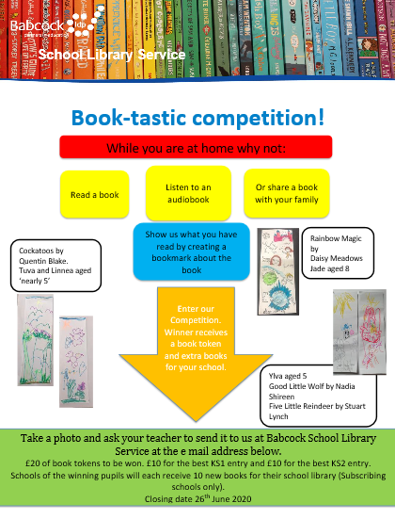

The Food Chain

Sample food chain

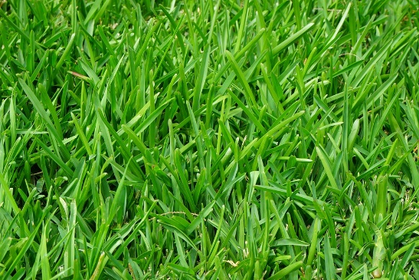
Grass Producer

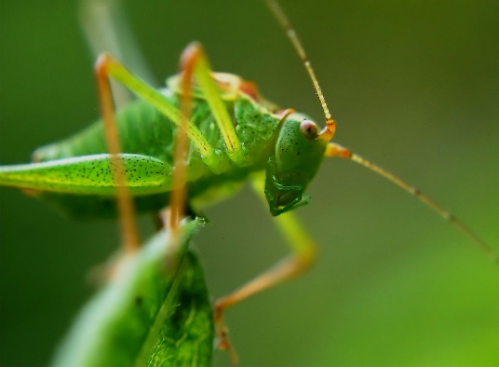

Grasshopper Primary consumer
(prey)

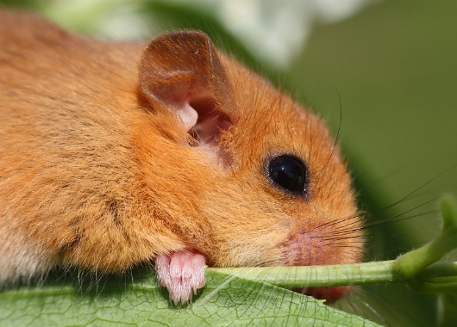

Mouse Secondary consumer
(predator/prey)

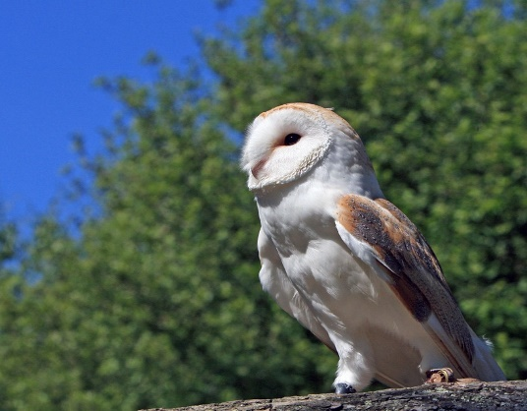

Owl Secondary consumer
(predator)

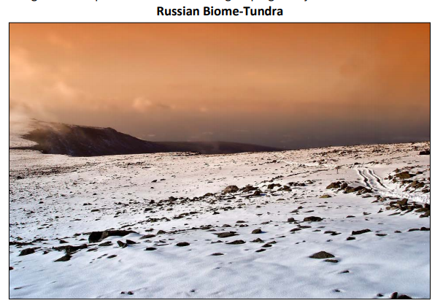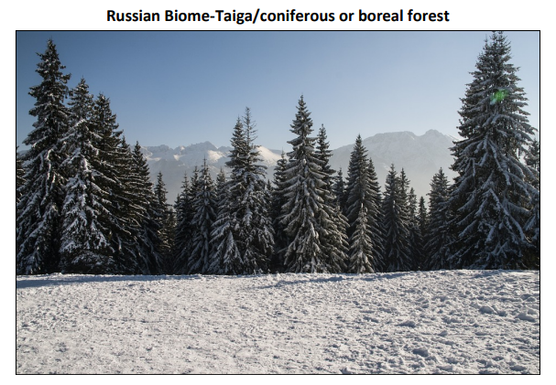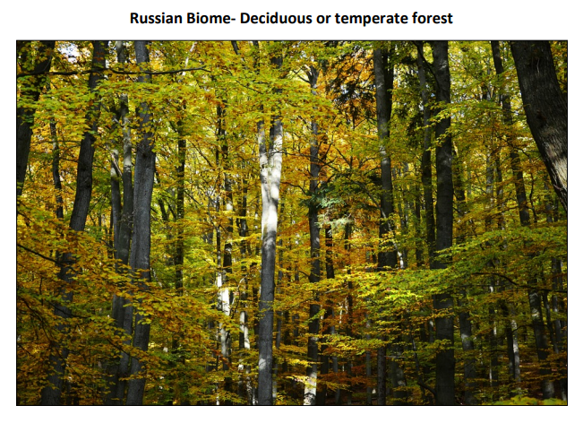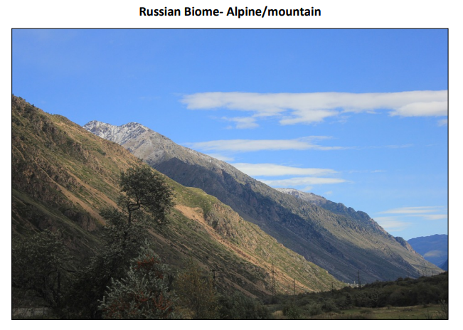

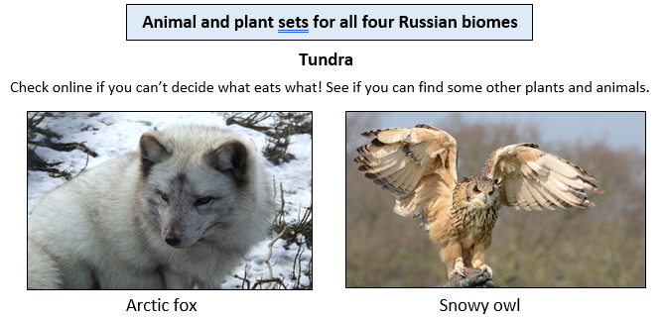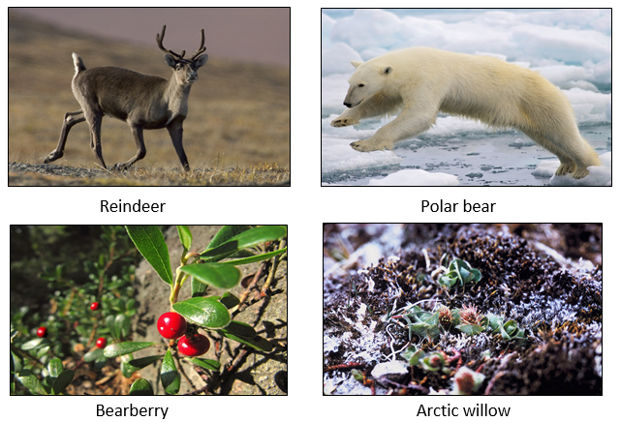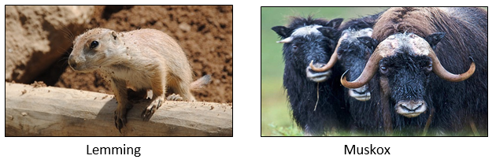

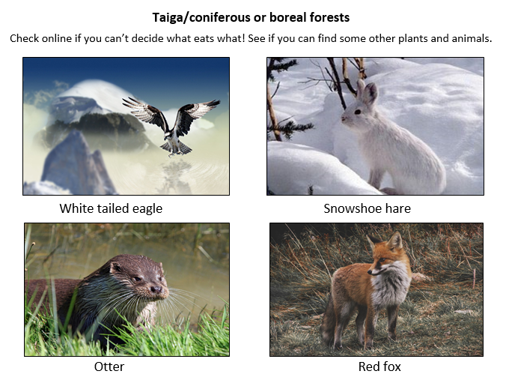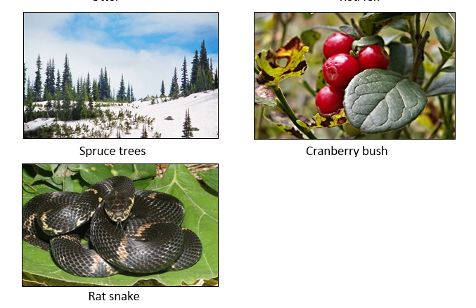

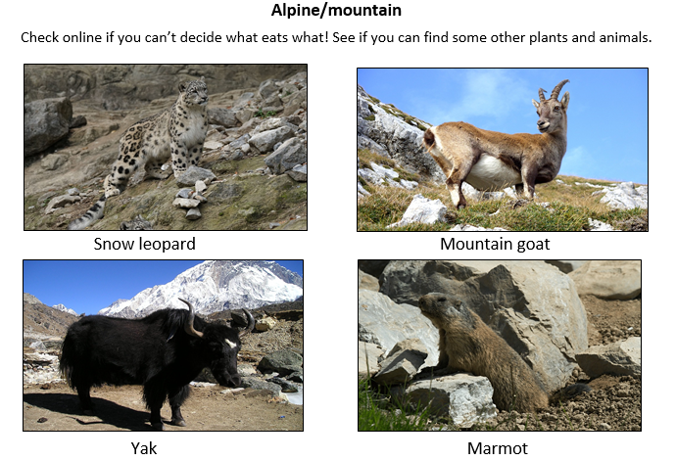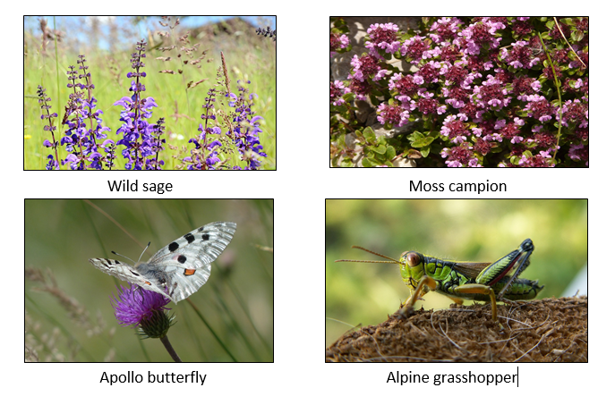

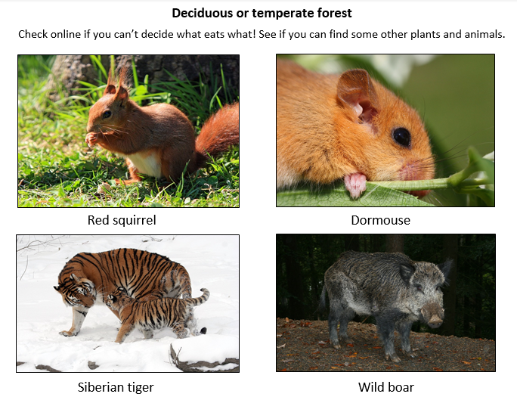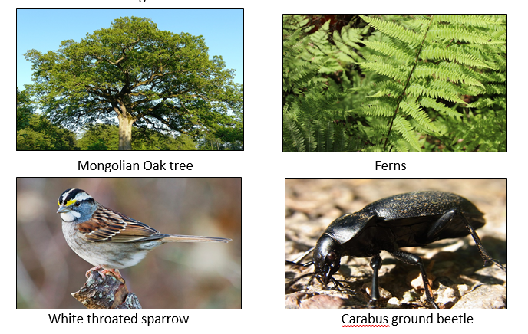

Instructions for producing a food chain mobile

You will need:

- A hanger
- About 12 strips of string or wool
- Strips of thin card with pre-punched holes
- Images of plants and animals
- Blue and red pens

How to make your mobile:

- Cut out your chosen animal and plant pictures and lay out your food chain. Make sure that you have a producer and three consumers that are different from the rest of your team

- Stick your pictures onto the strips of card and knot a piece of string or wool through the holes, ready to hang

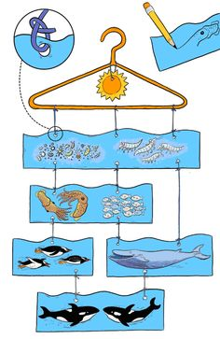
- Tie your producers to the bottom of your hanger,
then your primary consumers to your producers.
Continue tying on each stage of the food chain
until it is complete (see picture below)

- Now add a red dot to each animal strip to show
if it is a predator, and a blue dot if it is prey or
one of each, if it is both

- Add a sun in at the top of the hangar to show the
initial source of energy (remember the energy
flows from producer to primary consumer to
secondary consumers)

Wednesday | Core activities |  | Suggestions for additional activities.
9.00 – 9.30 | Daily Dashboard:  Quelle est la date aujourd’hui?  C’est mercredi le vingt mai, 2020.  Can you write the number date in Roman numerals?  What is happening in the world? Have a look at https://www.bbc.co.uk/newsround or https://www.dogonews.com/ to see what is going on in the world. Choose a news article or two to read. |  | On 20th May 1498, the Portuguese explorer Vasco de Gama arrived in India, becoming the first European known to navigate to India by sea. Can you track this journey on a globe or map of the world?  The funeral of the British King Edward VII was held on 20th May 1910. His funeral was notable for the enormous assemblage of foreign royalty. In a mere four years, the picture would be antiquated for another reason: it would be the last great gathering of royals before the outbreak of World War I, where many of the nations represented would be at war with each other.  https://www.onthisday.com/photos/nine-kings-in-one-room
9.30-10.00 | Grammar – see grammar resources
10.00- 10.30 | Time for some physical exercise – you will find a whole range of ’60 second challenges’ to try on the following web page, from keeping a balloon in the air for 60 seconds, to passing a ball (or cuddly toy) around your waist as many times as you can in 60 seconds, speed bouncing (2feet to 2feet jumps across a line) for 60 seconds or holding a plank position for as long as you can… Can you think of some other 60 second challenges?  https://www.youthsporttrust.org/60-second-physical-activity-challenges
10.30-11.30 | Maths - See the separate resource pack for your year group or go to the Oak National Academy as follows…  Year 3: https://www.thenational.academy/year-3/maths/to-recognise-right-angles-year-3-wk4-3  Year 4: https://www.thenational.academy/year-4/maths/area-and-perimeter-year-4-wk1-3  Year 5: https://www.thenational.academy/year-5/maths/describing-positions-and-coordinates-year-5-wk1-3  Year 6: https://www.thenational.academy/year-6/maths/compare-and-classify-quadrilaterals-year-6-wk3-3 |  |  |  |  | How about a warm-up using Times Table Rock Stars or else play a Maths game to help practise core number facts?
11.30-12.00 | Have a break and play a game or do another activity that you enjoy. | Eat well –Check out the nutrients contained in your favourite snacks. Are they providing your body with useful nutrients, or do they contain excessive amounts of sugar, fat or salt? If so, why not research some healthy alternatives?
12.00- 1.00pm | Lunch break. Eat a healthy lunch and, if you are able, try to get outside for some fresh air!
1.00pm – 1.30pm | Please visit Bug Club if you haven’t recently – there’s lots of new books on your shelf, untouched! |  |  | Read a chapter or two of your personal book.
1.30pm – 3.00pm | Theme/Science  Today we’re going to learn about adaptation. This is when an animal has features that mean it can survive and thrive in its environment. Learn more about adaptation here  https://www.bbc.co.uk/bitesize/clips/zbp6n39  Which animals did you see? Choose one and write about it’s adaptation – I’ve added 2 examples of ways to present the information at the end of today. One is called a concept cartoon and the other is a fold up example – both would look great on display in our classroom!  For more ideas of animals showing off their adaptation to their environment, here’s another bbc clip to watch:-https://www.bbc.co.uk/bitesize/clips/z9gvr82  My favourite is the flying fox. |  |  |  | For lots of quick facts about the worlds largest country, visit  https://www.theschoolrun.com/homework-help/russia  How many maths facts can you record from this page?  Why not take some time to admire the photos in their gallery at the bottom of the page. What images would you expect to see if it was a page about England? Or Scotland?  Do this quiz to find out more about adaptation in different biomes.

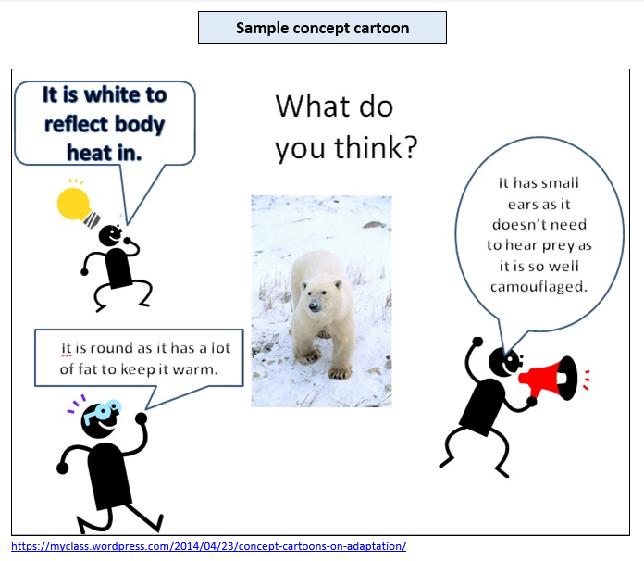

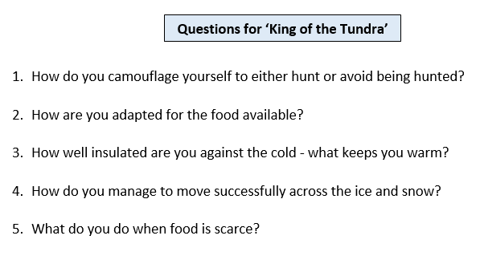

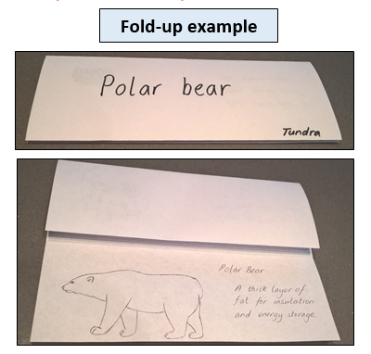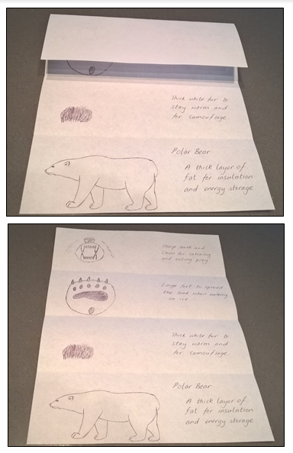

Thursday | Core activities |  |  | Suggestions for additional activities.
9.00 – 9.30 | Daily Dashboard:  Quelle est la date aujourd’hui?  C’est jeudi le vingt-et-un mai, 2020.  Can you write the number date in Roman numerals?  What is happening in the world? Have a look at https://www.bbc.co.uk/newsround or https://www.dogonews.com/ to see what is going on in the world. Choose a news article or two to read.  On May 21st 1927, Charles Lindbergh landed in Paris after the first solo crossing of the Atlantic in a plane. Exactly 5 years later, on May 21st 1932, Amelia Earhart landed in Londonderry in Ireland after a 17 hour flight, becoming the first woman to fly across the Atlantic. |  | Today is Ascension Day. This is a date in the Christian calendar, 40 days after Easter Sunday, when Christians remember Jesus’ return to heaven after he was resurrected. You can read the Bible story inMatthew 28, verses 16 to 28 or Luke 24, verses 50 to 53. Ascension Day is one of the earliest Christian festivals dating back to the year 68 CE. According to the New Testament in the Bible, Jesus Christ met several times with his disciples during the 40 days after his resurrection to instruct them on how to carry out his teachings. It is believed that on the 40th day he took them to the Mount of Olives, where they watched as he ascended to heaven.
9.30-10.00 | Grammar – see Grammar resources
10.00- 10.30 | Time for some physical activity. Here is a link to a ‘Race to 100’ game you can play with other members of your family: https://www.yourschoolgames.com/sgo/south-east-devon/race-to-100-activity-game/  Alternatively, you could play a game of ‘Treasure Chest’: Place 10 treasure items (eg. socks, shoes, small toys) at one end of the room (pr garden), known as the treasure chest. Run and collect an item and return it back to the start as quickly as possible. How many items can you collect in 60 seconds? Can you race against someone else to see who can collect the most items?
10.30-11.30 | Maths – see the separate resource pack for your year group or go to the Oak National Accademy as follows:  Year 3: https://www.thenational.academy/year-3/maths/to-recognise-obtuse-and-acute-angles-year-3-wk4-4  Year 4: https://www.thenational.academy/year-4/maths/area-and-perimeter-year-4-wk1-4  Year 5: https://www.thenational.academy/year-5/maths/describe-position-after-translation-year-5-wk1-4  Year 6: https://www.thenational.academy/year-6/maths/find-unknown-angles-in-triangles-year-6-wk3-4 |  |  |  |  | How about a warm-up using Times Table Rock Stars or else play a Maths game to help practise core number facts?  Why not visit https://nrich.maths.org/9803 and have a go at one of the Maths investigations there. Be warned – these will really make you think!
11.30-12.00 | Have a break and play a game or do another activity that you enjoy. | Care for others – what little job around the house could you do today to show care for someone in your family?
12.00- 1.00pm | Lunch break. Eat a healthy lunch and, if you are able, try to get outside for some fresh air!
1.00pm – 1.30pm | Time to read – but remember reading is not just story books. Although story books (fiction) give us a chance to escape into another world, understand another life and think about experiences that are like or unlike our own, non-fiction writing can open the world, can explain how it works or how it compares to others, to give us a different experience. What non-fiction books do you have at home? In the kitchen? In the car? What non-fiction does your family consume through phones and screens? |  |  |  | Why not read this blog  https://inspirationlaboratories.com/ideas-to-practice-classification-for-kids/  to find fun ideas for practising your classification skills around the house – it’s not just for animals and plants in science lessons!
1.30pm – 3.00pm | Topic/Science  Find out about classification here  https://www.bbc.co.uk/bitesize/topics/z6wwxnb  Watch the video, read the information then don’t forget to do the quiz!  Another video about the five kingdoms all living things can be sorted into. This helps scientists to understand the similarities and differences between living things.  http://studyjams.scholastic.com/studyjams/jams/science/animals/kingdoms-of-life.htm  Lots of practical activities involving classification can be found at Stem.org  https://www.stem.org.uk/news-and-views/opinions/ideas-teaching-identification-and-classification-primary-classroom |  |  |  |  |  | Check out this classification key – can you follow the step to the polar region? Could you make a classification key like this for a different biome?  https://simonhaughton.typepad.com/.a/6a0120a530561e970b01287697be33970c-pi  I’ve included a picture below that shows the change in land features from Taiga Forest to Tundra. Find the South marker, then think about the question.  You could do this quiz to show off how much you’ve learnt about Russia. Do you know which global sporting event was held here in 2018? https://www.bbc.co.uk/cbbc/quizzes/newsround-what-do-you-know-about-russia-quiz

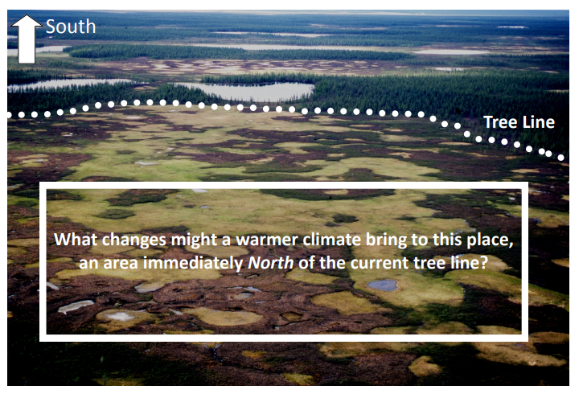

Friday | Core activities |  | Suggestions for additional activities.
9.00 – 9.30 | Daily Dashboard:  Quelle est la date aujourd’hui?  C’est vendredi le vingt-deux mai, 2020.  Can you write the number date in Roman numerals?  What is happening in the world? Have a look at https://www.bbc.co.uk/newsround or https://www.dogonews.com/ to see what is going on in the world. Choose a news article or two to read.  Today should have marked the beginning of the White Nights Festival in St. Petersburg. What can you find out about this historic Russian city? Read the information on https://wiki.kidzsearch.com/wiki/Saint_Petersburg  What different names has this city been called by in the last 120 years?  Watch the video tour and make some notes about what you discover: http://www.bbc.com/travel/video/my-city/20121031-st-petersburg |  | On 22nd May 1977 was the last scheduled run of the famously luxurious Orient Express train service, after 94 years of service. In 1883 the route began in Paris and ended in Istanbul, passing through Vienna and Munich. Can you trace this route on a map?  Over the years the route changed many times and was famed for the luxury of its sleeping and dining cars.  From the 1960s its service was gradually reduced and finished completely in 1977. The railway journey features often in literature and film; one of its most famous in the Agatha Christie novel "Murder on the Orient Express" was not actually set on the original Orient Express but a parallel service called the Simplon Orient Express.
9.30-10.00 | Grammar – see resources
10.00- 10.30 | Time for some physical activity. Why not have a look at https://thedailymile.co.uk/at-home/ for some fun challenges to try while going for a ‘daily mile’ walk or run.
10.30-11.30 | Maths – see the separate resource pack for your year group or go to the Oak National Academy lessons as follows...  Year 3: https://www.thenational.academy/year-3/maths/to-revise-angles-year-3-wk4-5  Year 4: https://www.thenational.academy/year-4/maths/area-and-perimeter-year-4-wk1-5  Year 5: https://www.thenational.academy/year-5/maths/describe-position-after-translation-year-5-wk1-5  Year 6: https://www.thenational.academy/year-6/maths/calculate-unknown-angles-in-quadrilaterals-year-6-wk3-5 |  |  |  | Why not try a BBC Supermovers Maths video to help warm up your Maths brain while getting in a bit of movement?  https://www.bbc.co.uk/teach/supermovers/ks2-maths-collection/z7frpg8
11.30-11.45 | Have a break and play a game or do another activity that you enjoy. | Be proud of your very being! What have you done well this week? Why not award yourself another certificate!
11.45 – 12.00 | Why not join in with the act of Collective Worship that you will find on the school website. Take time to think about how you can use your own creativity to make life a little brighter or easier for someone else.
12.00- 1.00pm | Lunch break. Eat a healthy lunch and, if you are able, try to get outside for some fresh air!
1.00pm – 1.30pm | Reading - Complete the Reading Comprehension exercise below, ‘The Old Man and the Turnip’, a Russian folktale. |  |  | You could read another chapter of your current book.
1.30pm – 3.00pm | Art  Complete the Matroyshka dolls craft activity below or design and make your own Matroyshka dolls.  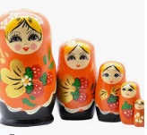  See https://www.youtube.com/watch?v=Wj1QZAVDu1I or https://www.youtube.com/watch?v=jfuWzegRKbs for a couple of suggestions of how to make your own simple set of nesting dolls (I recommend muting the sound!) |  |  | Alternatively, you could have a go at creating a picture or model of one of Moscow’s most famous and recognizable landmarks, St. Basil’s Cathedral:  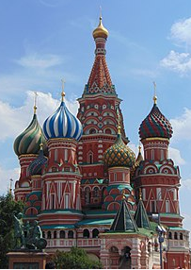  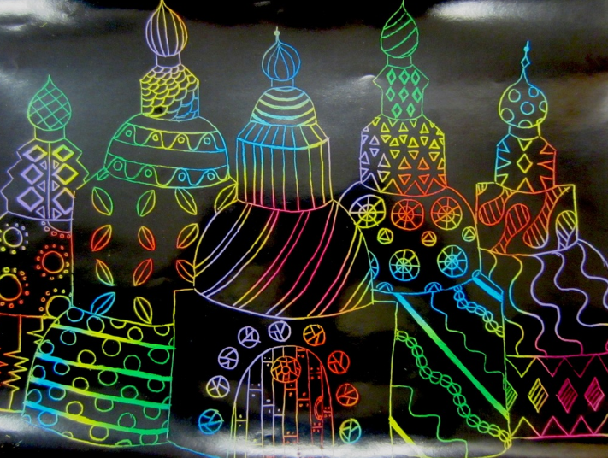  This type of picture is made using wax crayons, painting over with black paint and then scratching away the picture.

