Year 3 Maths Home Learning – Week beginning 18th May 2020

Monday: Revise 2D shapes and learn 3D shapes…
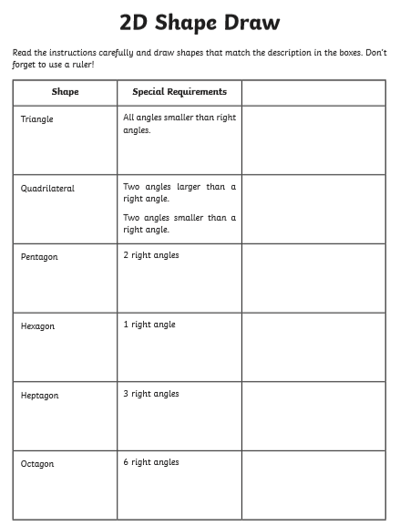

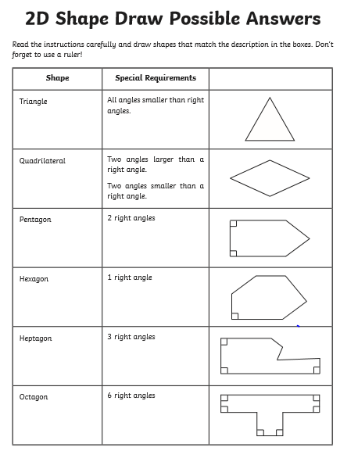
Note: There are other possibilities for some of these shapes. Check the criteria carefully.
Name the 3D shapes - what objects can you find that have these shapes? Have a look at the video at https://www.youtube.com/watch?v=3-QwWFkz5hw to help. Can you identify how many faces, edges and vertices (corners) each shape has?
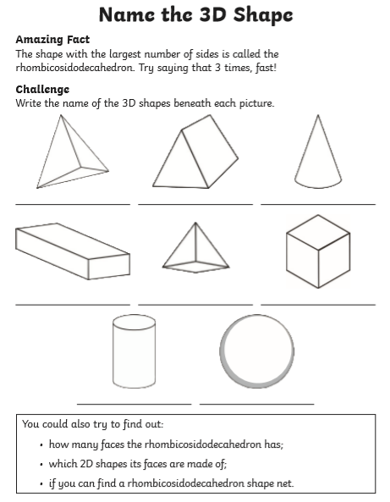
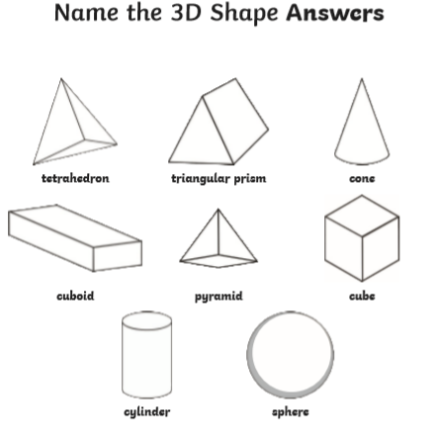

Keep practising as the week goes on to check that you can accurately name all the 3D shapes!

Tuesday: Angles of turn – clockwise and anti-clockwise
First watch the teaching video on https://www.youtube.com/watch?v=G9W2kTa_BH0

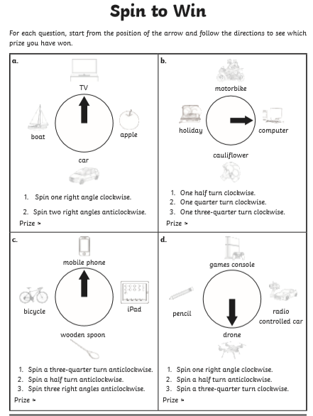

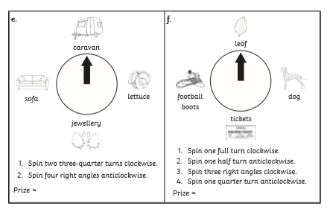

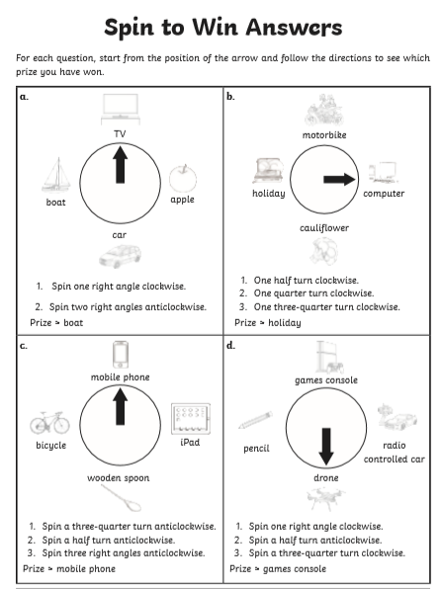
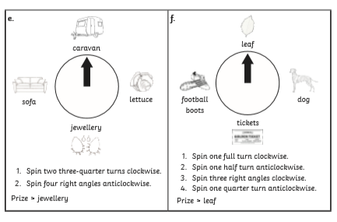

Wednesday: Recognise angles as a property of a shape and as a description of a turn…
Watch the video at https://www.youtube.com/watch?v=9PakNIwDin4 to introduce/ remind about right angles. You might also enjoy the angles song at https://www.youtube.com/watch?v=NVuMULQjb3o
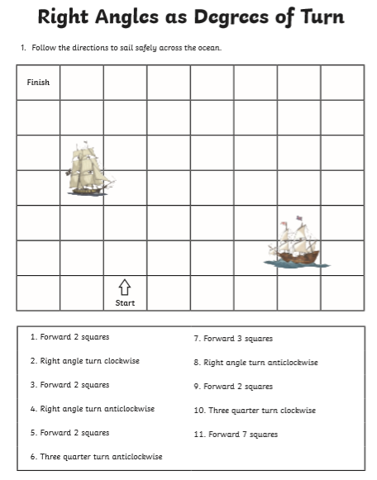
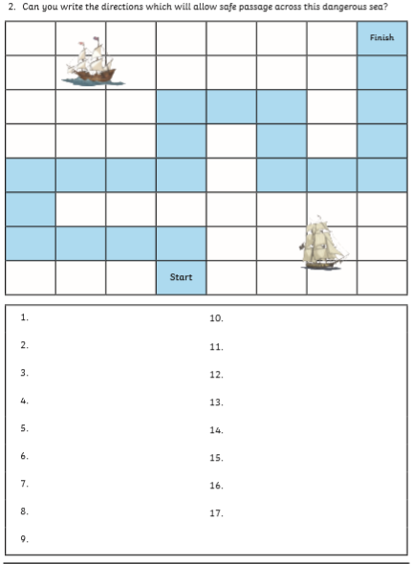

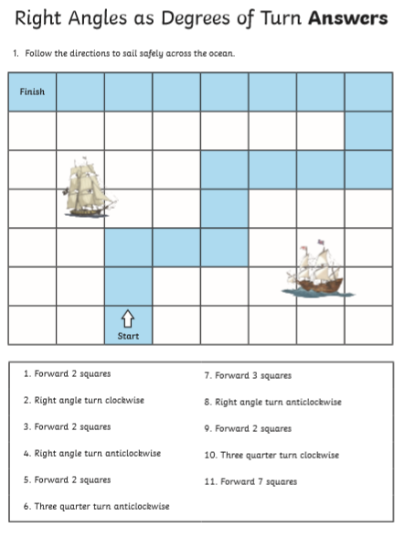
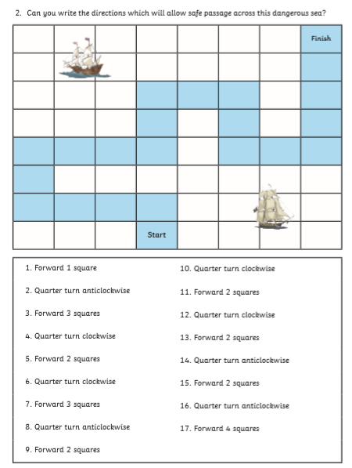
Thursday: Recognising angles that are less than or greater than right angles…
You may wish to start by reviewing the videos suggested in yesterday’s lesson about acute, right and obtuse angles. Can you find examples of these angles around your house? (see https://vimeo.com/61057513 for examples). Then label the angles below:
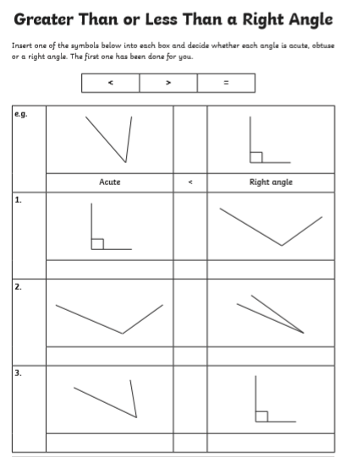

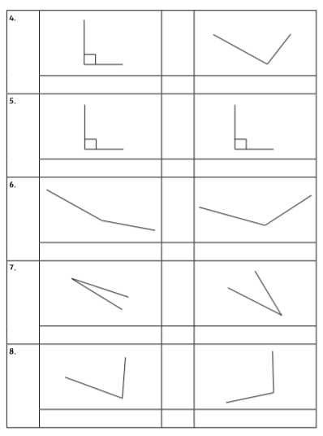

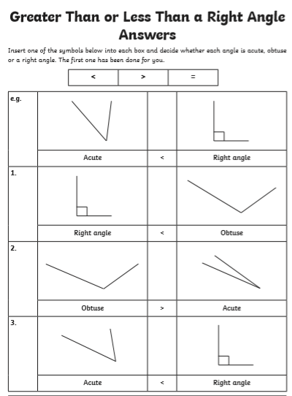
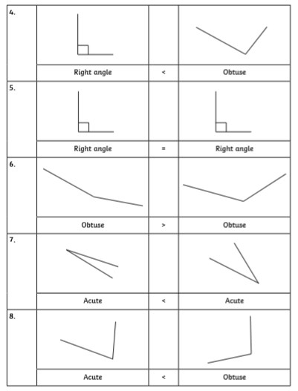
Friday: Recognising angles that are less than or greater than right angles…
Watch the video to ensure you understand what parallel and perpendicular lines are:
https://www.youtube.com/watch?time_continue=11&v=dSE2lTU1sAc&feature=emb_logo
or https://www.bbc.co.uk/bitesize/topics/zb6tyrd/articles/zp327hv
What sets of parallel or perpendicular lines can you find around the room you are in?

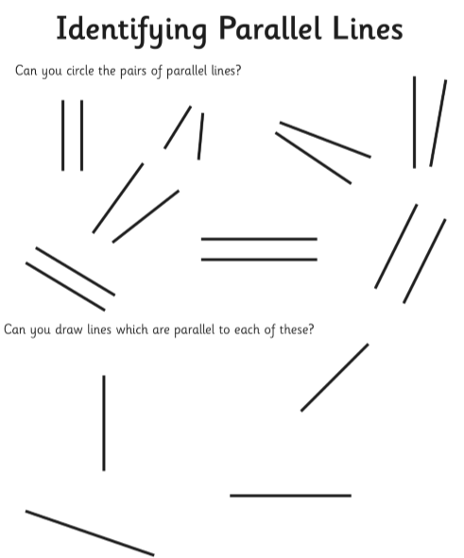

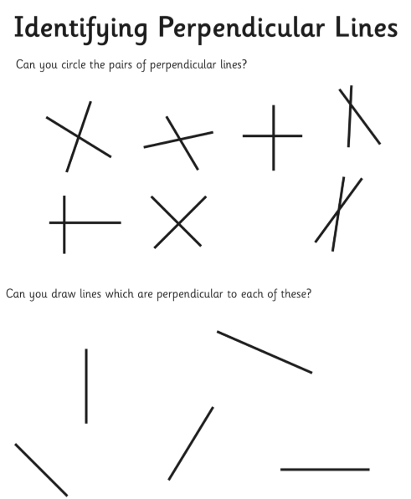

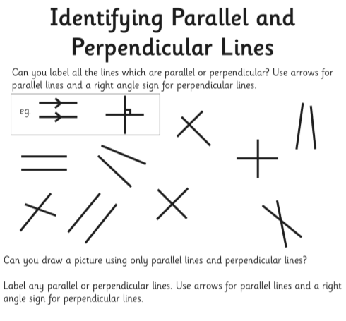
There is a fun song at https://www.youtube.com/watch?v=P3AOoLbA3us to help you remember these terms.

