Week beginning Tuesday 14th April 2020

Welcome back to your home learning following the Easter Holidays - we hope that you had a lovely Easter with your family! Here is your timetable/the work set for the next four days. Don’t forget that you can still access the variety of safe educational websites listed and the non-screen activities suggested on the Class 1 ideas for children to do at home document previously posted on the website. These are appropriate for Pre-School, Reception, Year 1 and Year 2 children. The children may also want to follow their own interests/projects or something that you as a family are particularly interested in which is also great. Perhaps you could keep a scrapbook to collect these!

These are tricky times, so it is important to try not to get anxious or worried about this home learning. Although we will continue to set work regularly, you may do more on one day than another and it is fine to be flexible. Do what you can and keep sessions short, 15-20 minutes maximum, repeated throughout the day, as it is quite intense for the children (and you!) when working one-to-one. If they want to keep going a little longer that is fine, but we want you to feel able to take regular breaks and get fresh air and exercise if you can safely. Just do your best and enjoy this precious time with your children. They are a fantastic class whom we have loved teaching and hope to do so again as soon as is possible.

If you have any questions or you would like to email a picture of some lovely work you have been doing, please email admin@branscombe.devon.sch.uk. We are missing you all and would love to hear what you have been getting up to.
Stay safe,
Miss Harvey-Jones and Mrs Bartlett

EVERY DAY
- 20 minutes phonics (Bug Club) (Reception and Y1). See table below for details of which lesson/resources to access. Y2 see below for separate phonics activities. A note to all: You could also use Phonics Play to practise reading sounds and words and also practise sounding and blending skills. They can also read sentences. It is FREE at this time: https://new.phonicsplay.co.uk/. App/tablet friendly.
- 20 minutes ‘Bug Club’ Reading (with comprehension ‘bug’ questions). Bug Club books continue to be updated to suit your level.
- 15 minutes ‘Spelling Shed’, ‘SPAG.com’ OR ‘Bug Club Grammar’ games (KS1 only). Please do contact us if you have any issues with passwords.
- 15 minutes ‘Times Table Rockstars’ (KS1 only).
- Choose 5 spellings from your Home Learning Books to learn.
- 20 - 30 minutes Maths: KS1 – see below for a 5 minute warm up with your parents/game, then work in your ‘Power Maths’ Practice Books. Complete pages in your Autumn Term books including place value and number, addition and subtraction, 2D and 3D shapes (Y1), money (Y2), multiplication and division (Y2).
Reception/Pre-School – see activities detailed below.
- PE/Active Time - Joe Wicks (The Body Coach) has daily workout videos on YouTube (go online with your grown ups) but you do not need to feel restricted to this – get some fresh air when walking the dog, using skills developed in out of school clubs such as football/ballet or exercising in the garden instead, if you can safely do so.
- Please keep reading/sharing a book you enjoy with your family. Try to keep a log together (one or two sentences) of what you have read that day. If you are reading a fiction book, what happened or what characters did you meet? If you are reading a non-fiction book perhaps you write down something that you have found out that you didn’t know before.

Tuesday | Phonics - ALL  Year 1 - Target phoneme /j/ written as 'g(e)', 'g(i)', 'g(y)'  Year 2 - Practise spelling move, prove, improve, should, would, could, most, both, only.  EYFS - Adjacent consonants (cvcc)  Maths  EYFS - Use sticks to create 2D shapes (triangles, squares etc.) Can you make a circle using sticks? What might be better? What other natural items can you find in the garden to make 2D shapes?  KS1 - Counting in twos, fives and tens. Show your child how to clap to fit with 4/4 time as follows: slap hand on thighs twice (one, two) then clap hands together (three), then rest (four) and repeat. When this is secure, count in tens, fitting the count with the hand claps: slap, slap, zero, rest; slap, slap, ten, rest; slap, slap, twenty, rest …. Count forwards from zero to 100. Listen carefully to how they are saying the numbers (encourage ‘tys’ to be clear for example, sixty). Now move on to ‘Power Maths’ book.  Daily Project - ALL  Writing (KS1) - Before Easter, we were learning about instructions. Watch an adult cook a meal or bake a cake. Write down the instructions so that someone else could make this food.  OR  Writing (KS1) - Choose a favourite character from a book and tell me all about it. Look at the questions to help.  What does your character look like? Where does it live? What adjectives would describe the type of character you have chosen? Would you like to meet this character? If you did, how would feel?  Remember to write in sentences using capital letters and full stops. Don’t forget to leave finger spaces and take care with your handwriting. Use your phonics but check the word – does it look right?
Wednesday | Phonics - ALL  Year 1 - Target phoneme /j/ written as 'dge'  Year 2 - Write the following words, sound them out and read them: want, watch, wander, squash and quantity, quality, quarrel. What do you notice about the words? Look at the first letter(s) and the sound the ‘a’ makes. Which of the words can you already spell? Which need more work? Look, cover, check to practise these.  EYFS - Language session 1 - After: cvcc words  Maths  EYFS - As yesterday, use natural materials to create 2D shapes (triangles, squares etc. Can you make some pictures using 2D shapes? Label the shapes that you have made. Take some photos if you can.  KS1 - Remind your child of the clapping rhythm from yesterday: slap hand on thighs twice (one, two) then clap hands together (three), then rest (four) and repeat.  Count forwards in tens as before, from zero to 100. Then count backwards from 100 to zero. Repeat this several times. Listen carefully to how they are saying the numbers (encourage ‘tys’ to be clear for example, sixty). Now move on to ‘Power Maths’ book.  Daily Project - ALL  PSHE - What makes me special?  Draw a picture of yourself in the middle of a page in your home learning book. Around the outside of the picture, write 10 things that make you special.  OR  Draw a picture of a time when you were sad and draw a picture of a time when you were really happy. Write a paragraph to explain your pictures.
Thursday | Phonics - ALL  Year 1 – Language session – After: alternatives for /j/  Year 2 – Parents, please dictate the following sentences and ask your child to write them down. We want to squash into the car without a quarrel to visit the beach. Watching us do this is always fun. We want to wander along the cliffs when we get to the seaside. Which spellings did you get right? Which ones need more practise? Look, cover, check to practise these.  EYFS - Language session 2 - After: ccvc words  Maths  EYFS - Do you have any playdough? If so, press 2 and 3D shapes into it (you can use anything you have to hand). Which shapes are the easiest to make? Why do you think this is?  KS1 - Practise putting numbers in order: https://www.topmarks.co.uk/ordering-and-sequencing/caterpillar-ordering  It is easier to start with sequencing first but please try both.  - Start with numbers within 10  - Try numbers within 20  - Can they do the above going backwards?  - If you are confident with the above, extend to numbers within 100.  Now move on to ‘Power Maths’ book.  Daily Project - ALL  Science (KS1) – Before Easter we were learning about materials. See below for work to complete.  Music (EYFS) - Follow the link below to sing the song.  Go to https://bbc.in/2IFMH4L and play “One Tomato Two Tomatoes”  Art (EYFS) - Free choice to draw or paint a picture.  Ask your child to tell you what their picture is about. Talk about the colours they have used.
Friday | Phonics - ALL  Year 1 - Unit 25 Assessment Activities  Year 2 – Some words are really hard to remember but we use them a lot, for example, because. Remembering a special sentence (mnemonic sentence) can help to spell the word. For example: Big elephants can always understand small elephants. Can you draw a picture and write the word below to help you to remember this spelling? Now cover up the picture and word. Say the mnemonic sentence slowly and write the word 3 times without peeking. Have you got it right?  EYFS – Adjacent consonants (ccvcc/cccvc/cccvcc)  Maths  EYFS – Use household objects (boxes, tins etc.) to create your own model. Think about which shapes work best at the bottom and at the top and see if you can say why.  KS1 – Use these websites to practise maths skills:  https://www.topmarks.co.uk/maths-games/5-7-years/  https://www.topmarks.co.uk/learning-to-count/place-value-basketball  Remember to count the ten/s first and then count the ones. Now move on to ‘Power Maths’ book.  Daily Project - ALL  Today we would normally have extra-curricular time. Have a go at building a ‘Blanket Fort’. Maybe drape a sheet or blanket over some chairs and then snuggle in with your favourite book or some drawing or colouring. We would love to see some photos of what you have made. Email them in at admin@branscombe.devon.sch.uk

KS1 Science: Find the following objects around your home. For each object, write what material it is made from, and one property of that material which makes it suitable for this object. You will find the words you need on the key vocabulary page.

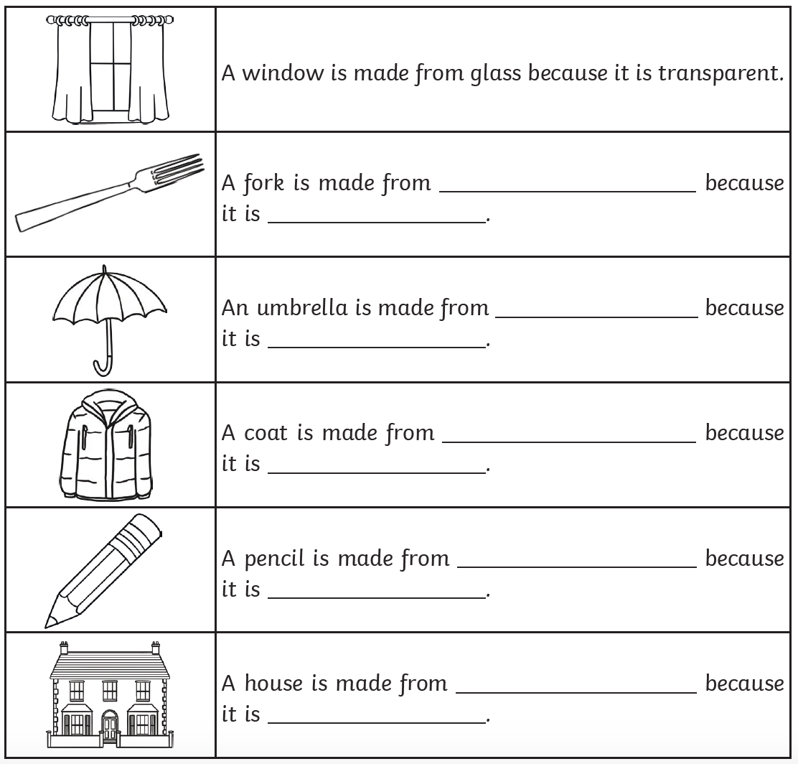

Next Step - Challenges:

- Think of another property for each of these materials. For example, ‘A window is made from glass because it is waterproof.
- Now find six new objects. Describe two properties of the material each one is made of and see if your parent can guess which object you describing.
- Treasure hunt: Can you find examples of the same material having different properties, for example rigid/flexible, transparent/opaque? Hint: try metal, plastic and glass.
