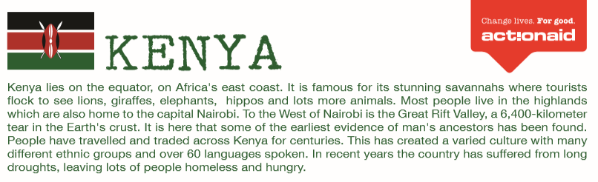
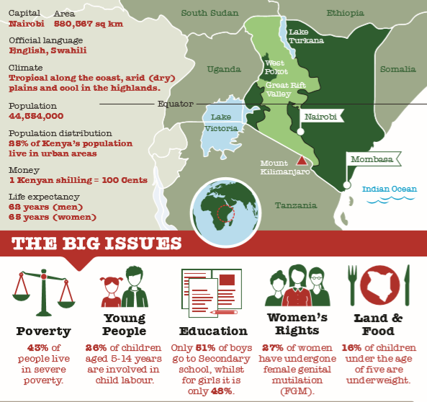
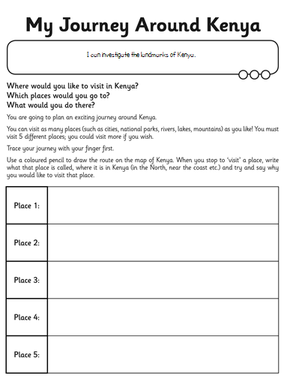

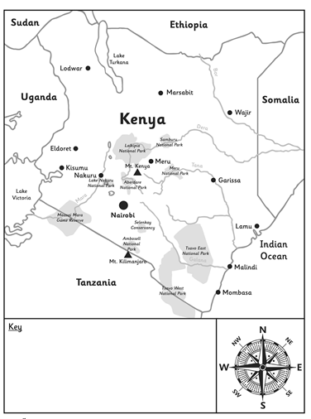

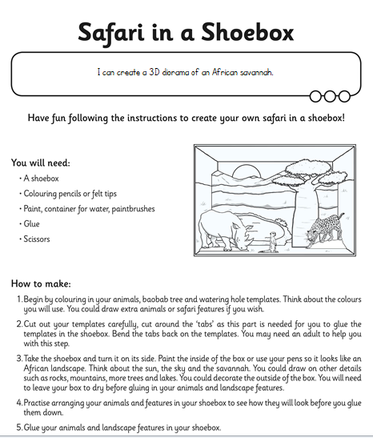

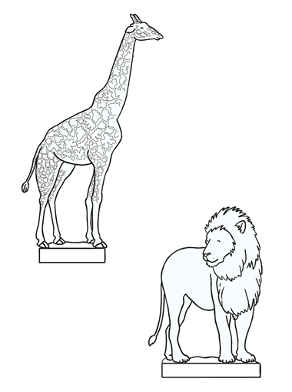

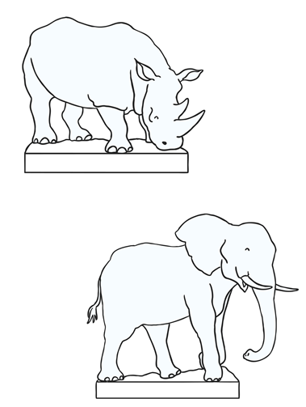

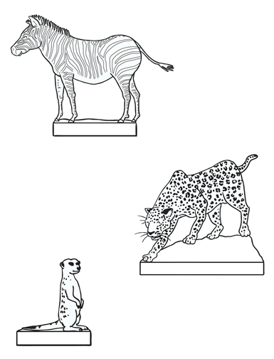

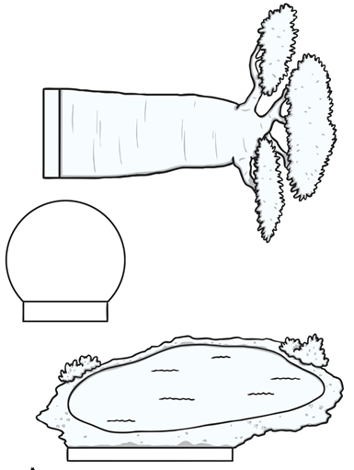

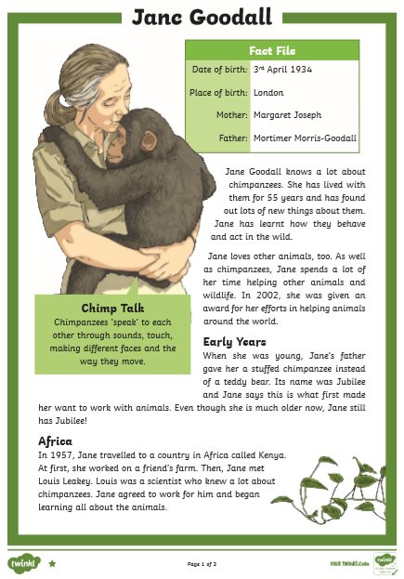
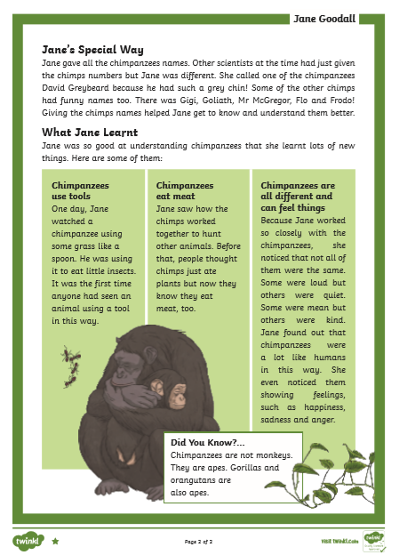

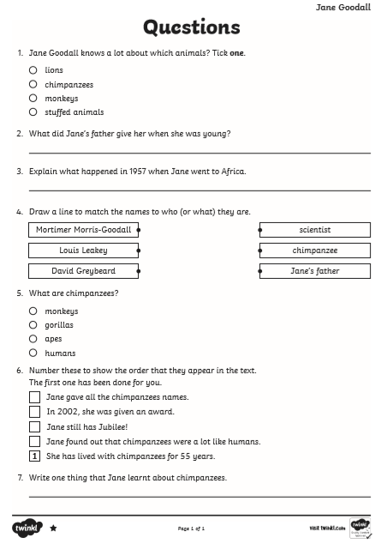
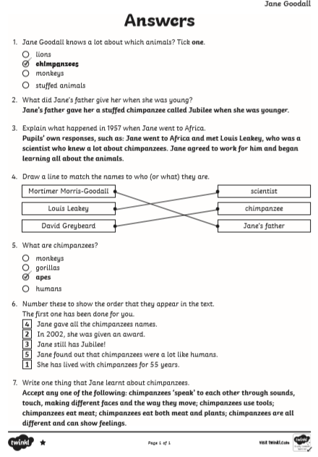
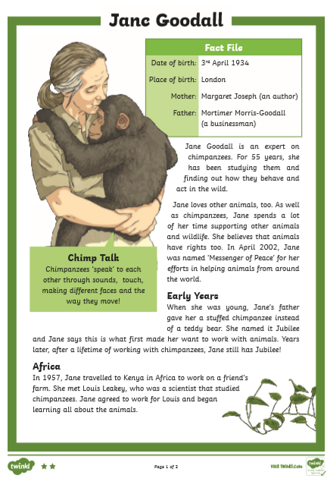
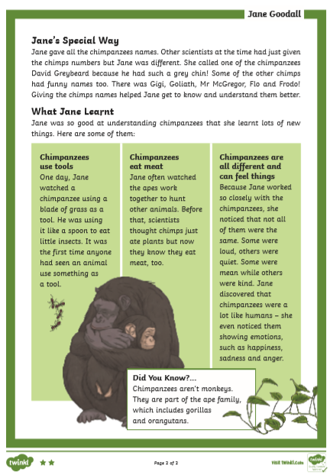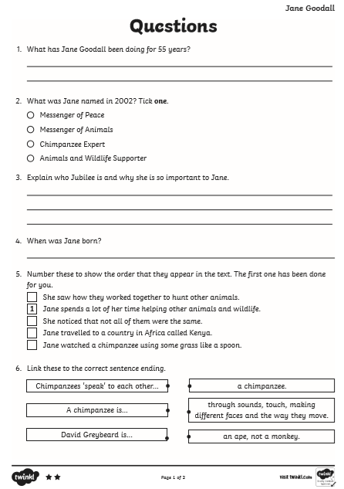

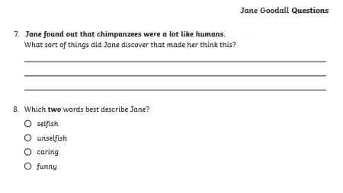

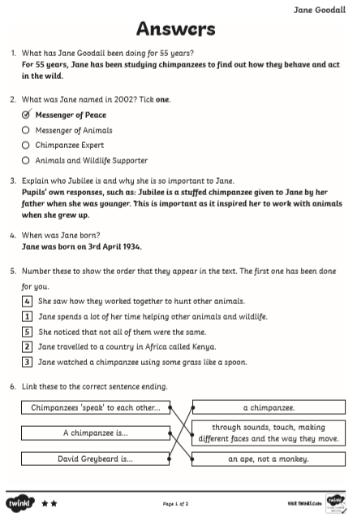
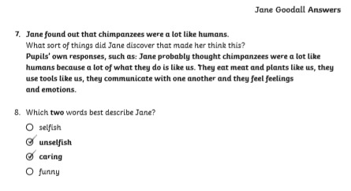

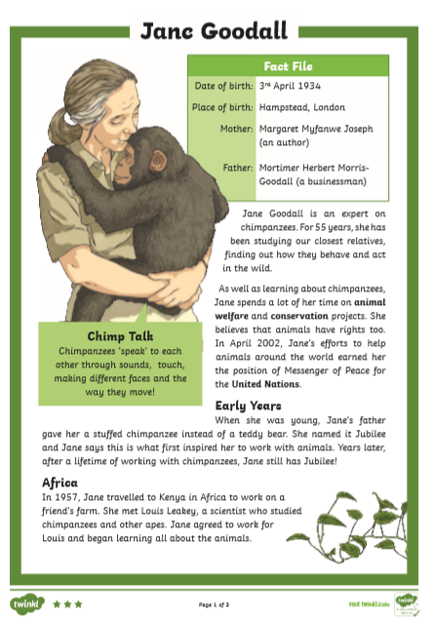
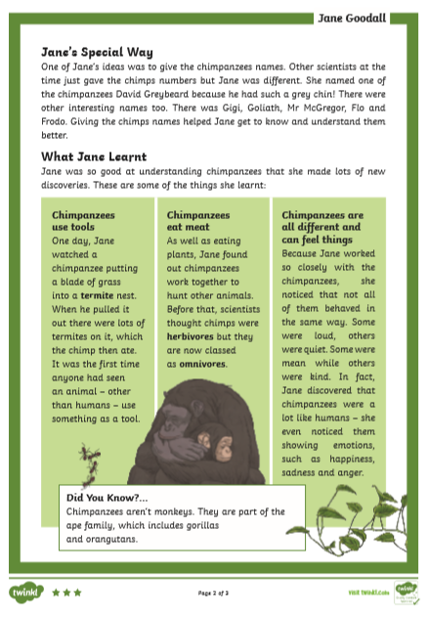
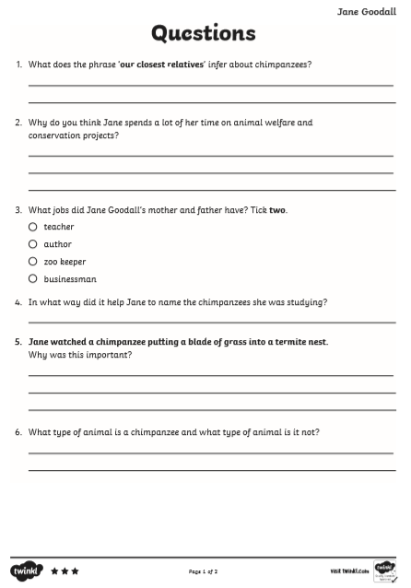
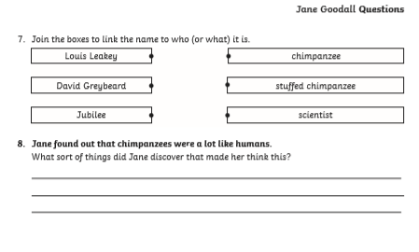

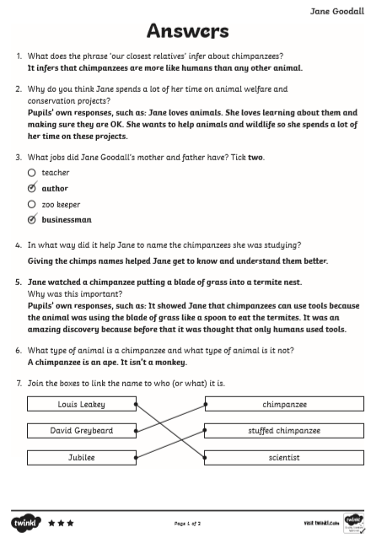
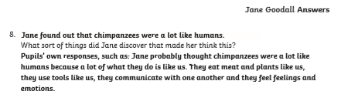

Stealing the Sun, part 1
A STORY FROM AFRICA
Chief Wai lived near Lake Tumba with his wives and many servants. He had a tall, handsome young son, named Mokele. At that time there was no sun, only dull, overcast skies all day and the bright moon at night. One day, Mokele asked his father, “Why doesn’t the sun shine here?”
Chief Wai looked sad. “It was stolen away a very long time ago.”
“I’ll go and get the sun back for you,” said Mokele.
Mokele cut down a huge tree and hollowed it out to make a canoe. When the canoe was ready, wild animals came out of the forest and begged Mokele to take them with him. “We’ll help you get the sun. If the owner won’t sell it, we’ll sting him,” buzzed the wasps.
“I can find the sun even if it’s been hidden,” grunted the tortoise.
“I can see better than anyone and I could fly away with the sun for you,” whistled the kite.
“Welcome aboard,” cried Mokele, and all the animals crowded into the canoe until there was only just enough room for him.

Answer these questions in your exercise books. Write your answers in full sentences. The answers have been started for you, but remember to copy out the whole sentence into your book. Remember capital letters and full stops.
- What was the name of Chief Wai’s son?

Chief Wai’s son’s name was ...............................

- What question did Mokele ask his father?

The question Mokele asked his father was “.............................?”

- Which animals spoke to Mokele?

A ................, a .................. and the ................. spoke to Mokele.

- How is Mokele planning to travel through the forest?

Mokele is planning to travel through the forest using a .................

Now draw a picture of Mokele and the animals about to set off down the river.

Stealing the Sun, part 2
A STORY FROM AFRICA
For days, Mokele paddled along the rovers through the forests until, at last, he came to the land of Chief Mokulaka, who had hidden the sun! Mokele asked him, very politely, “Please may I buy the sun from you?” Chief Mokulaka didn’t want to sell the sun, but when he saw a fierce leopard, a huge baboon, and all the other animals that were in the canoe, he knew it would be difficult to keep it.
“Very well,” he said, “but I’ll have to talk to my son to decide on a fair price. Why not go and rest for a while?” Mokele agreed, and sat down under a tree. Chief Mokulaka hurried to his daughter. “Molumba,” he whispered, “I want to kill this man. Brew up some poison for him.” The Chief didn’t notice the wasp that was hovering near them. The wasp flew to Mokele, and warned him what the Chief was planning.
When the Chief invited Mokele into Molumba’s hut, Mokele pretended he knew nothing of the poison. He talked to Molumba, and she so liked this handsome young man, she secretly poured the poison away.
When they were talking, the tortoise found the sun hidden in a cave. It dragged it out and held it tightly. The kite gripped the tortoise in its claws, and lifted it up. For the first time, the sun rose up in the sky.

Answer these questions in your exercise book. Write your answers in full sentences. The answers have been started for you, but remember to copy out the whole sentence into your book. Remember capital letters and full stops.
- How far away was the land of Chief Mokulaka?

The land of Chief Mokulaka...............................

- Why did Chief Mokulaka agree to sell the sun?

Chief Mokulaka agreed to sell the sun because................

- Why did Chief Mokulaka say he needed to talk to his son?

Chief Mokulaka said he needed to talk to his son because.......

- How did Mokele know that Chief Mokulaka wanted to kill him?

Mokele knew that Chief Mokulaka wanted to kill him because...................

Now draw a picture of Chief Mokulaka talking to Molumba. Include speech bubbles showing what they say.

Stealing the Sun, part 3
A STORY FROM AFRICA
When Mokele and the animals saw the sun shining over the forest, they rushed to the canoe, and Molumba went with them. Mokele paddled as fast as he could away down the river. Shouting with rage, Chief Mokulaka and his warriors chased after them, but a huge swarm of wasps stung them until they ran away.
Mokele paddled his canoe back to his village. “Father,” he shouted, “I’ve brought the sun for you.” His father and all the people cheered. They were delighted the sun was going to rise again every morning, lighting up the forest and making the days bright.
Mokele married Molumba and they were very happy. Mokele told the story of his adventure over and over again. He told his children, and his grandchildren, and the people who live in the forest are still telling the story of how Mokele brought back the sun.

Answer these questions in your draft books. Write your answers in full sentences. The answers have been started for you, but remember to copy out the whole sentence into your book. Remember capital letters and full stops.
- Why was Chief Mokulaka so angry with Mokele? Think of two reasons.

Chief Mokulaka was so angry with Mokele because ...............................

- Why were Mokele’s father and all the people happy?

Mokele’s father and all the people were happy because ...............

- Mokele is the hero in the story. What do we know about Mokele that tells us he is the hero?

We know Mokele is the hero of the story because.......

- Imagine you are one of Mokele’s grandchildren. Do you think you would enjoy listening to your grandpa tell this story?

I think I would/wouldn’t enjoy listening to this story because ...................

Now draw a comic strip showing all of the events in the story.

