Grammar and Spelling Resources: Week Beginning Monday 13th July 2020 Year 3 and 4
This week we will be completing some revision activities to consolidate your learning and ensure you can remember what you have been learning this term. Repetition is important for building neural pathways in your brain! We will also complete some assessment activities. If you complete these and you are able to send them to Miss Moss at school, it would be really helpful to know how you are getting on!
Monday:
Today, please log in to spag.com and complete the end of term assessment that is set for you there.
If you do not have your username and password, call Miss Moss at school or email admin@branscombe.devon.sch.uk to ask for it and swap today’s work with Tuesday or Wednesday while you await a response.
Tuesday: Spelling and Handwriting
Practise spelling the following words from the Year 3 and 4 statutory list. What is the theme this week? Can you tell? (Clue: these words are linked through their meaning, rather than by their spellings.)
Can you include these words in sentences?

Wednesday: Statutory Spelling list for Year 3 and 4
Look at the list of words below that you have practised so far this term. If you can, ask someone to give you a spelling test. If you have a recording device, you could do this yourself by recording yourself reading the words and then listening and writing them down as you listen to the recording played back
accident/ accidentally
actual/ actually
answer
appear
arrive
believe
bicycle
breath
breathe
build
busy
business
century
circle
complete
decide
describe
difficult
disappear
early
Earth
eight/ eighth
exercise
experiment
famous
February
grammar
guard
guide
increase
island
learn
length
medicine
mention
minute
naughty
notice
occasion/ occasionally
ordinary
particular
peculiar
popular
probably
quarter
question
recent
regular
special
suppose
surprise
weight

Keep hold of this list so that next week, you can practise spelling the words you still cannot remember.

Thursday: a or an and Prepositions
Complete the assessment activity to check that you can select and use these determiners correctly:
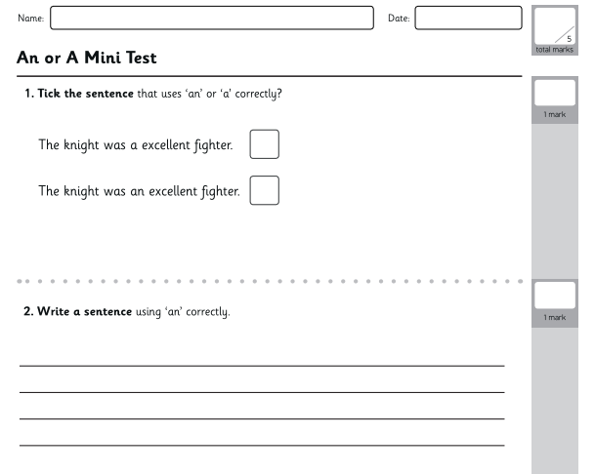
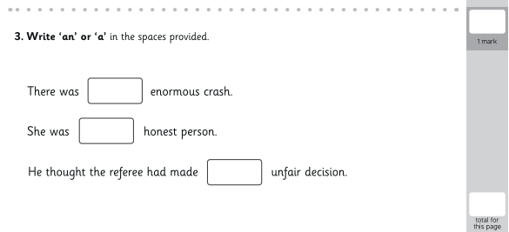

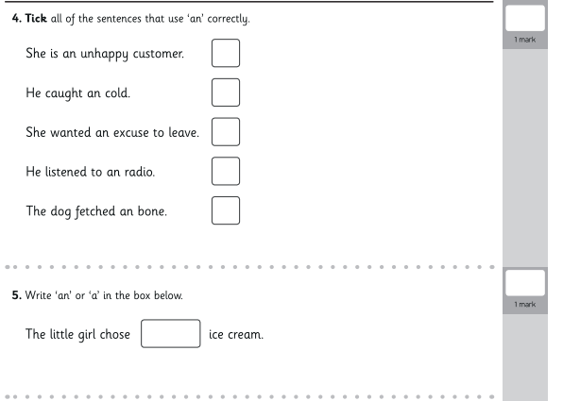
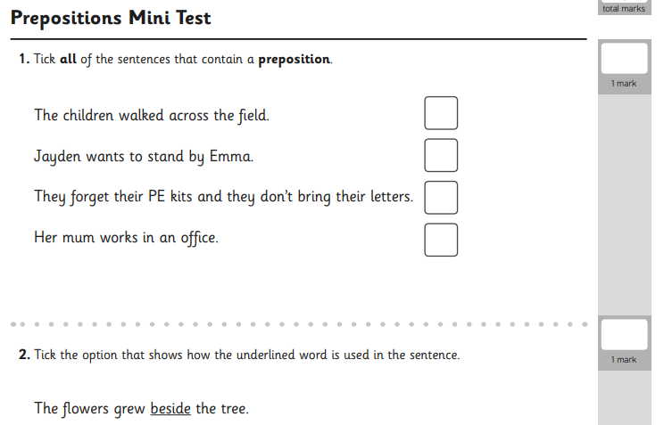

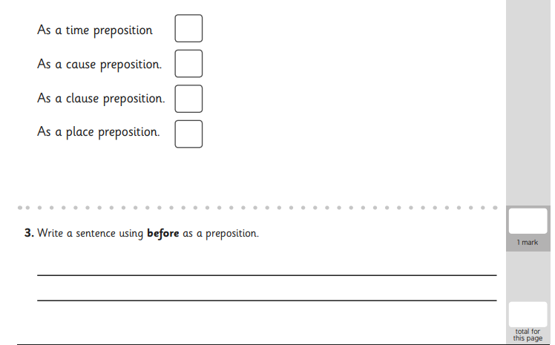
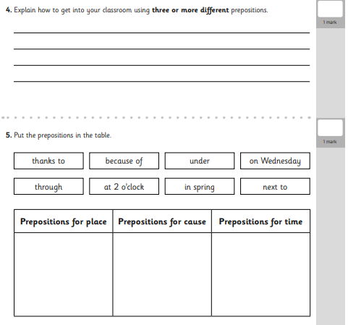

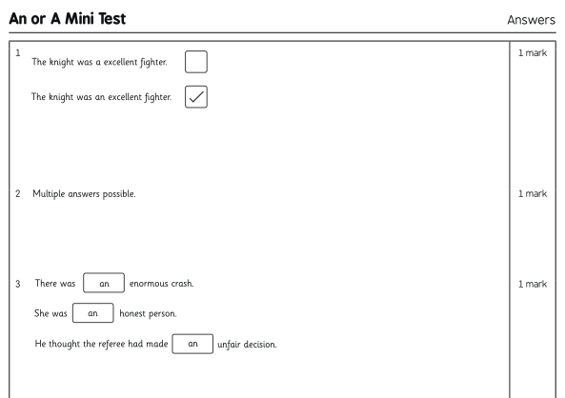
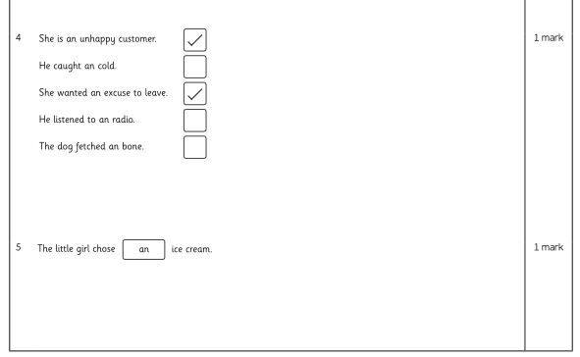

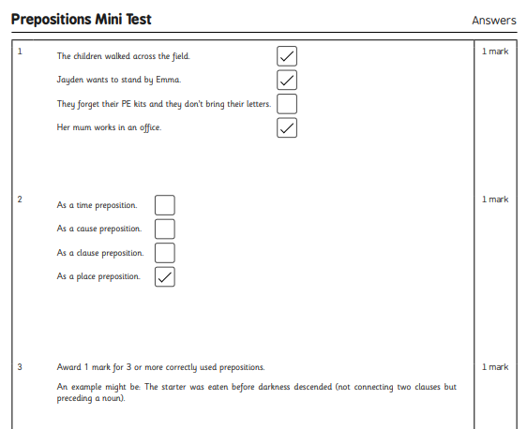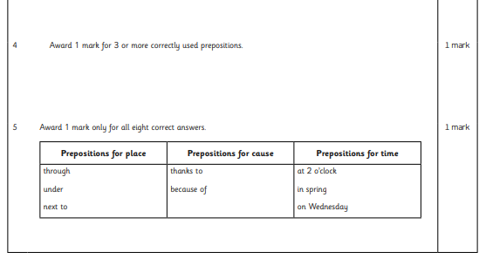

Friday: Inverted commas and Present Perfect tense revision
