Week beginning Monday 20th April 2020 – Home Learning for Class 1

Dear Parents and Children of Class 1,

We wonder how you are getting on with your Summer Term homeschooling? Have any of you been completing the Time capsule or Mental Health activities? Or have you found other ways to be creative in your learning? Don’t forget you can email via the school admin address if you would like to share what you have been up to or seek any help or advice. We would be so happy to hear from you!

So, once again, this very long piece of writing sets out your learning over the next week. As last time, we have included them in a suggested timetable structure for those who would find it helpful, which includes the maths online videos as well as phonics lessons and your weekly projects to complete. Our new theme for this whole term is called ‘Memory Box’. These are intended to be a resource for parents to draw upon, rather than a pressure for you to keep up. One of the main advantages of home-schooling is the freedom to learn at your own pace and explore the things that interest and excite you in more depth. We hope that all of you will enjoy the freedom to develop your own learning in new and exciting ways. Here are some ideas of what we might be thinking about over the next few weeks and we will try to guide you to the right resources in your pack for each project.

Can you remember being small? Being a baby and learning to crawl? Do you recall a favourite toy, maybe a teddy bear or a favourite book? Look back at family photos of special occasions; perhaps holiday snapshots or a birthday or two. Remember a wedding or a christening and find a funny photo of your grown ups when they were young. Learn how to write a diary of days gone by and find out about the days before you were born: it’s called history and it’s all about the past. Then make a special box, a memory box, to keep special things safe. In years to come, you can revisit them and remember how you looked when you were young. Memories are special. Let’s make some more.
The most important thing you can do to support your child’s learning whilst schools are closed is to ensure that they read every day and that they continue to practise their phonics and key mathematics skills.

As always, if you have any questions at all or you would like to email a picture of some lovely work you have been doing, please use the following email address - admin@branscombe.devon.sch.uk. Thank you to those of you who have already sent photographs of your learning - it really does make us smile to see what you have been getting up to at home.

Have a good week and as always stay safe,

Miss Harvey-Jones and Mrs Bartlett

EVERY DAY
- 20 minutes phonics (Bug Club) (Reception and Y1). See table below for details of which lesson/resources to access. Y2 see below for separate phonics activities. A note to all: You could also use Phonics Play to practise reading sounds and words and also practise sounding and blending skills. They can also read sentences. It is FREE at this time: https://new.phonicsplay.co.uk/. App/tablet friendly.
- 20 minutes ‘Bug Club’ Reading (with comprehension ‘bug’ questions). Bug Club books continue to be updated to suit your level.
- 15 minutes ‘Spelling Shed’, ‘SPAG.com’ OR ‘Bug Club Grammar’ games (KS1 only). Please do contact us if you have any issues with passwords. If you would prefer to access paper-based work to limit screen time we can email SPAG documents for you to print off.
- 15 minutes ‘Times Table Rockstars’ (KS1 only) OR to limit screen time you may wish to spend this time learning 2, 3, 5 and 10 times tables to be able to recall them at speed.
- Choose 5 spellings from your Home Learning Books to learn.
- 20 - 30 minutes Maths: KS1 – see below for a 5 minute warm ups with your parents/game, then complete any tasks set. On days when work is not set you can work in your ‘Power Maths’ Practice Books (you should complete pages in your Autumn Term books including place value and number, addition and subtraction, 2D and 3D shapes (Y1), money (Y2), multiplication and division (Y2) to finish these books).
Reception/Pre-School – see activities detailed below.
- PE/Active Time - Joe Wicks (The Body Coach) has daily workout videos on YouTube (go online with your grown ups) but you do not need to feel restricted to this – get some fresh air when walking the dog, using skills developed in out of school clubs such as football/ballet or exercising in the garden instead, if you can safely do so.
- We would like children to continue their Summer Term diary and write one or two sentences a day (with support if necessary for younger pupils) and draw a picture. The sentence might be about something they have done, something they have seen or even what the weather is like. Some examples might be: ‘It is sunny.’ ‘It is a flower.’ ‘I went to the park’. Sentences do not need to be spelt correctly but the children should use their phonic skills to attempt to write words. KS1 children could also use the Time Capsule sheets attached on a separate link to help with ideas.
- Please keep reading/sharing a book you enjoy with your family. Try to keep a log together (one or two sentences) of what you have read that day. If you are reading a fiction book, what happened or what characters did you meet? If you are reading a non-fiction book perhaps you write down something that you have found out that you didn’t know before.

Monday | Phonics - ALL  Year 1 - Target phoneme /l/ written as 'le'  Year 2 - Ask your child to clap out the syllables in the word treasure. Draw a box for each syllable. Put a line through the word to divide the syllables and look carefully at the way ‘trea’ is spelt. Then look at ‘sure’ and discuss how it sounds and is spelt. Cover up the word and ask your child to segment the first syllable and write it in the box. Then do the same with the second syllable. Check back to make sure that you have the words spelt correctly. Have a go at writing treasure. Do the same for the word usual.  EYFS - Adjacent consonants (ccvcc/cccvc/cccvcc)  Maths  EYFS  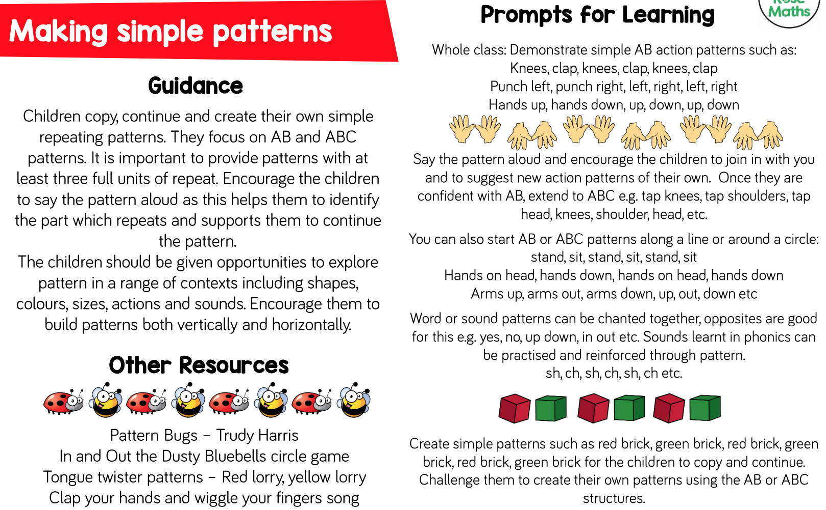  KS1 Begin by playing a game – odds and evens. Draw a noughts and crosses grid. One player/team has odd numbers, one player/team has even numbers. The aim is to complete a row or column with a total of 15. Now try other totals.  Y1 Access the White Rose Maths website for home learning (link below).  https://whiterosemaths.com/homelearning/year-1/  Complete Summer Term – Week 1 - Lesson 1 – Make Doubles (watch the video before completing the activity).  Y2 Access the White Rose Maths website for home learning (link below).  https://whiterosemaths.com/homelearning/year-2/  Complete Summer Term – Week 1 – Lesson 1 – Find three quarters (watch the video before completing the activity).  If you do have access to a printer and want to print the White Rose sheets that go with each lesson, you can do. If you do this, you do not have to do the Power Maths pages as well.  If you do not have access to a printer, watch the White Rose video each day and then complete the Power Maths pages specified.  Daily Project  EYFS - Expressive Arts/D&T - Use boxes and other recyclable materials to make models, write a label for their model. Words do not need to be spelt correctly but the children should use their phonic skills to attempt to write words where possible.  KS1 - Task 1 RE – See separate documentation. Task 2 - Mental Health/PSHE - Draw a self-portrait of yourself in the mirror below. Write positive affirmations that describe some things that you like about yourself/you are good at around the mirror.
Tuesday | Phonics - ALL  Year 1 - Target phoneme /m/ written as 'mb'  Year 2 - Practise spelling treasure and usual.  EYFS - Language session 3 - After: ccvcc, cccvc and cccvcc words  (Reception ONLY to follow this planning, Pre-School children could spend some time saying clearly the sounds and writing the letters of their names).  Maths  EYFS - Do you have any playdough? If so, use 3-D shapes to press patterns into the dough. Can you tell your family which shapes you used and copy the patterns? You could also make patterns on the dough using shells, stones, beads etc.  KS1 - Draw the triangle below. Arrange the numbers 1 to 6 in each set of circles below. The sum of each side of the triangle should equal the number in the centre of the triangular shape. Now try it with 10 in the middle, then 11 and finally, 12. What ideas did you have to solve the problem?  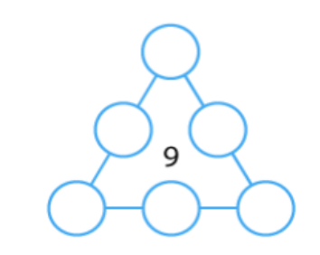  Y1 Access the White Rose Maths website for home learning (link below).  https://whiterosemaths.com/homelearning/year-1/  Complete Summer Term – Week 1 - Lesson 2 – Make equal groups (grouping) (watch the video before completing the activity).  Y2 Access the White Rose Maths website for home learning (link below).  https://whiterosemaths.com/homelearning/year-2/  Complete Summer Term – Week 1 – Lesson 2 – Count in fractions (watch the video before completing the activity).  If you do have access to a printer and want to print the White Rose sheets that go with each lesson, you can do. If you do this, you do not have to do the Power Maths pages as well.  If you do not have access to a printer, watch the White Rose video each day and then complete the Power Maths pages specified.  Daily Project  EYFS - Physical Development - Throwing and catching a ball. Play catch. Count how many times you can throw a ball to each other gradually getting further apart from each other. Ask your grown up to model writing the total number of catches onto a piece of paper. Try to beat the last score. Grown ups please emphasise the importance of looking at the ball all of the time and holding their hands out ready to catch. Children, can you start to write the score down?  KS1 - Today is The Queen’s birthday. Can you find out a little about her to make an informative poster with what you consider to be the most interesting facts? Remember to include pictures and present your poster clearly and attractively.
Wednesday | Phonics - ALL  Year 1 - Target phoneme /n/ written as 'kn' and ‘gn’  Year 2 – Homophones – new/knew - Discuss the meanings of the words new and knew and write them to display. You can include these optional words: no/know; night/knight; not/knot. Talk about things that they have that are new and what they knew. Read the first five sentences and ask pupils to hold up the correct card for the missing word. For the next five sentences pupils write the sentences out and put the correct word in.  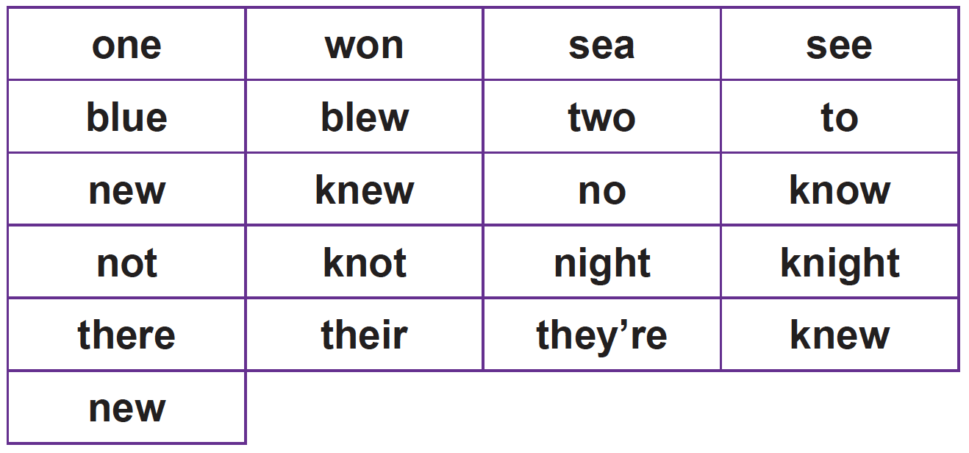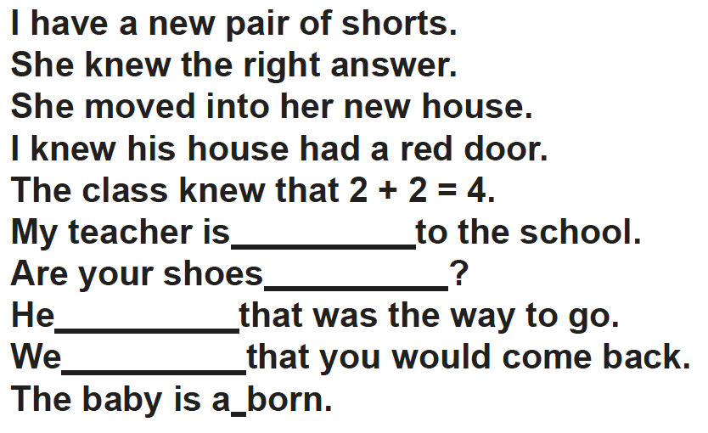  EYFS – Unit 12 Assessment  Maths  EYFS  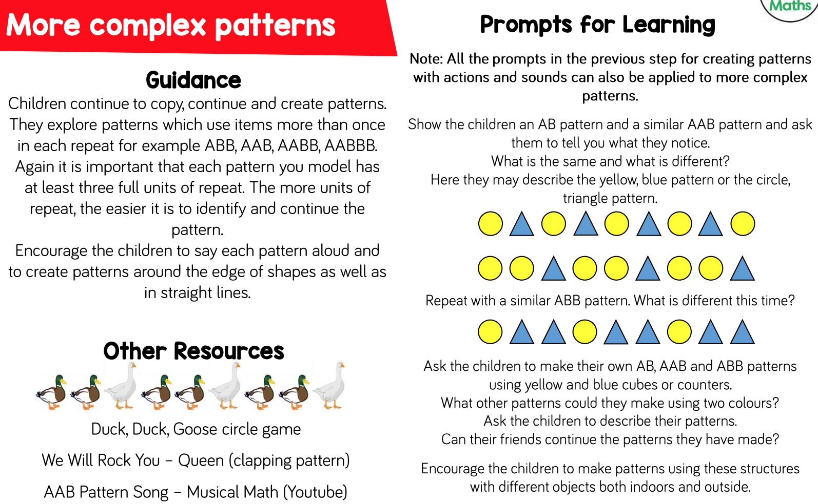  KS1 Begin with this challenge.  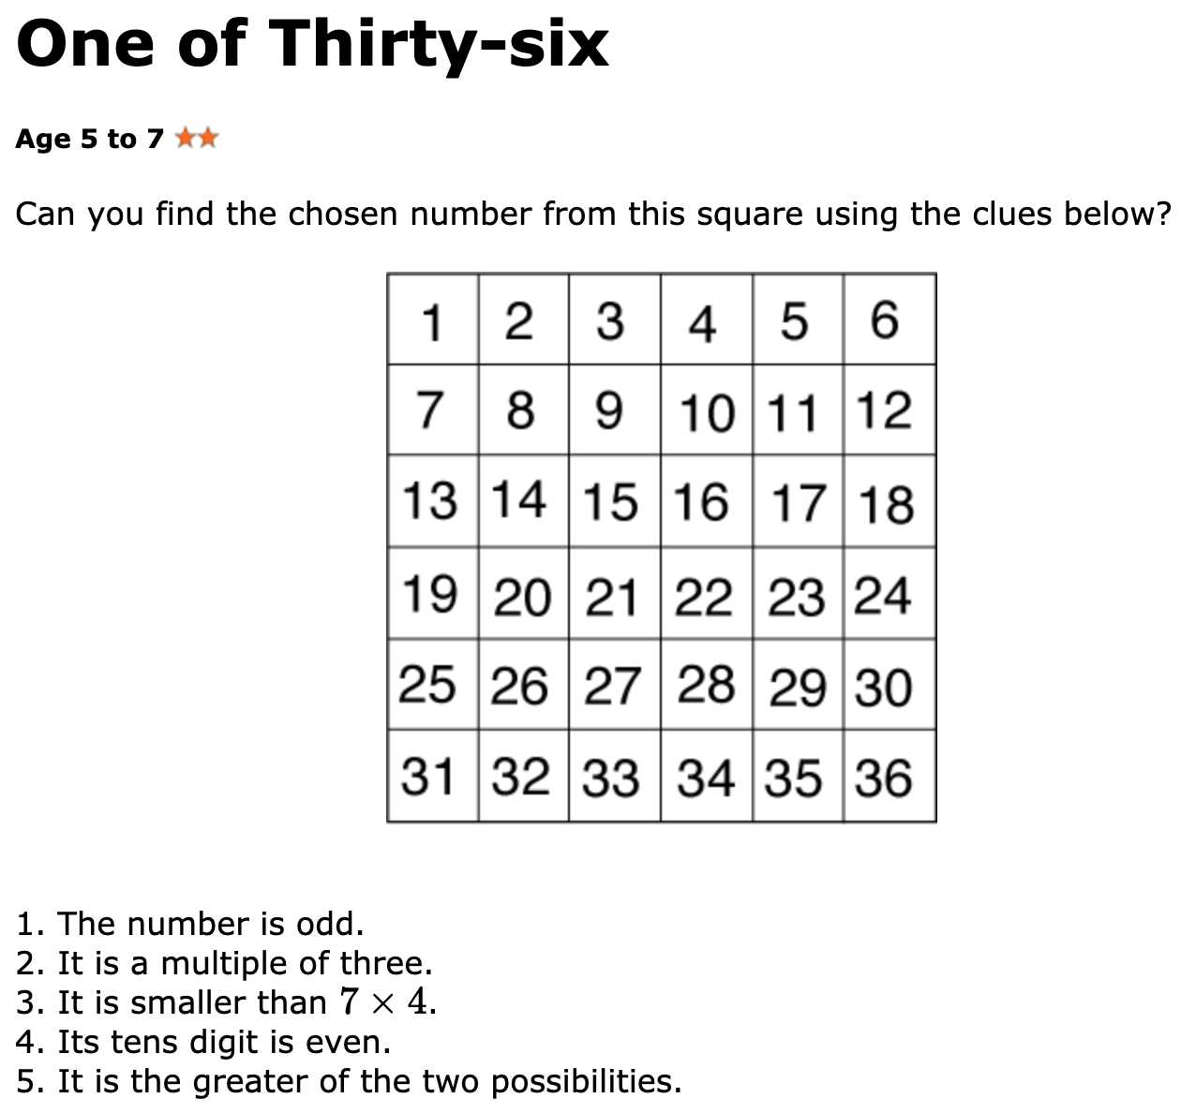  Y1 Access the White Rose Maths website for home learning (link below).  https://whiterosemaths.com/homelearning/year-1/  Complete Summer Term – Week 1 - Lesson 3 – Make equal groups (sharing) (watch the video before completing the activity).  Y2 Access the White Rose Maths website for home learning (link below).  https://whiterosemaths.com/homelearning/year-2/  Complete Summer Term – Week 1 – Lesson 3 – Measure length (cm) (watch the video before completing the activity).  If you do have access to a printer and want to print the White Rose sheets that go with each lesson, you can do. If you do this, you do not have to do the Power Maths pages as well.  If you do not have access to a printer, watch the White Rose video each day and then complete the Power Maths pages specified.  Daily Project  EYFS - Expressive Arts/Music - Make a musical instrument using empty containers and different materials to put inside for example pasta, stones. Ask your child to predict what will happen to the sound if you put more/less in. Play your instrument whilst singing your favourite song.  KS1 - PSHE/Science - Talk with your grown ups about the physical and developmental differences between babies, toddlers, children and adults. Use sticky notes to make charts with four sections: ‘Babies can…’, ‘Toddlers can…’, ‘Children can…’ and ‘Adults can…’. Think about the human body and how a person changes as they grow from a baby to an elderly person. The children can compare themselves to babies, toddlers and adults regarding how they eat, sleep, move and play. Look at the sheets attached – what can babies do, what can toddlers do, what can adults do. Complete the What can I do sheet. Think about the things that a baby or toddler needs from its parents or carers to be happy and healthy. Make a list of essentials that a parent must provide to keep their baby happy and healthy.
Thursday | Phonics - ALL  Year 1 - Target phoneme /r/ written as 'wr'  Year 2 – Homophones (there, their, thry’re) - Show your child some sentences with there, their and they’re. Discuss the different meanings of the words and the contraction they’re for they are. Give them word cards with there, their and they’re on them. Read the following sentences and ask your child to hold up the correct card.  There are three cakes in the tin. They’re going to eat those cakes! Their cakes are delicious!  Their house is down this road. There is a big dog by that gate. They’re going swimming tonight. Their home learning is very hard. Are there any apples left?  They’re escaping out of the window!  Practise other previously taught homophones as in the previous session. If different homophones have been taught, use those instead of the ones below.  I ate two cakes. I see my friend every day. One of the cats was blue. I blew out the candles.  He ran very fast and won the race. I went to the sea.  EYFS – Phase 4 Assessment Materials  Maths  EYFS - Snack - Use a selection of fruit in small pieces such as grapes, banana slices, apple chunks etc. to design your own fruit kebabs in patterns. What patterns can your family members make?  Music – Use some different instruments to play patterns. Use this to play a game – First ask your grown up to face the other way whilst you play your pattern. Then ask your grown up to work out which instruments were used and to replicate the pattern!  KS1 –Choose a game to play from the following link: https://www.topmarks.co.uk/maths-games/5-7-years/measures  Y1 Access the White Rose Maths website for home learning (link below).  https://whiterosemaths.com/homelearning/year-1/  Complete Summer Term – Week 1 - Lesson 4 – Find a half (watch the video before completing the activity).  Y2 Access the White Rose Maths website for home learning (link below).  https://whiterosemaths.com/homelearning/year-2/  Complete Summer Term – Week 1 – Lesson 4 – Measure length (m) (watch the video before completing the activity).  If you do have access to a printer and want to print the White Rose sheets that go with each lesson, you can do. If you do this, you do not have to do the Power Maths pages as well.  If you do not have access to a printer, watch the White Rose video each day and then complete the Power Maths pages specified.  Daily Project - ALL  EYFS - Communication and language - Play hide the toy. Count to ten or twenty whilst the toy is being hidden. When it is the child’s turn to find the toy encourage them to say where they found it, on/under/next to the to encourage the use of appropriate Mathematical vocabulary.  KS1 - D&T - Tomorrow you will be holding a teddy bears’ picnic. Decide what types of food would be good for the teddy bears’ picnic, make a shopping list. If your grown ups agree, tomorrow you can make some simple, healthy sandwiches for your guests, creating a balance of sweet and savoury fillings. Remember to wash your hands before making their sandwiches. What would you need to provide if young babies came to your picnic? They have specific food and drink that they can consume - find out what these are.
Friday | Phonics - ALL  Year 1 – Language Session and Unit 26 Assessment Activities  Year 2 – Adding ‘-es’ to verbs and nouns ending in ‘y’ - Show your child the chart provided below and work out together how it operates. Ask them to say he flies and write it down. What do they notice has happened to the word? How do they think carries might be spelt? Discuss and then have a go at writing it and showing their spellings. Do the same with one or two plurals. Ask what they notice about the spelling of these words.  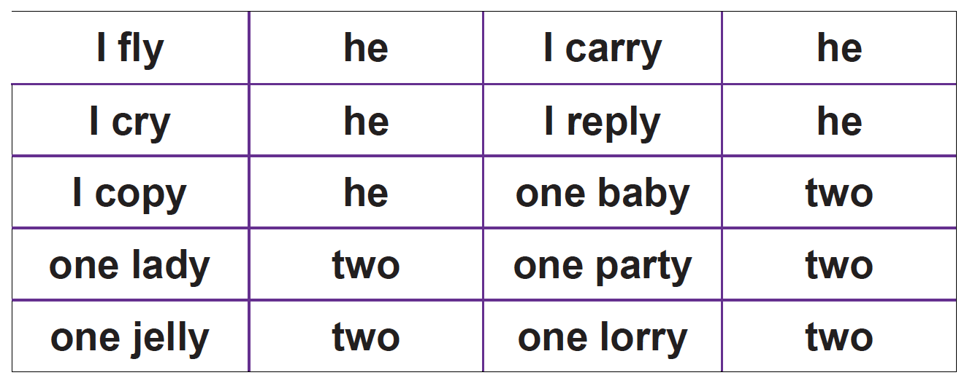  EYFS – Repeat Phase 4 Assessment Materials  Maths  EYFS  - Create some repeating patterns using different colours  2. Now can you create some patterns using different shapes?  3. Lastly can you create a pattern using colours and shapes?  KS1 Begin with the following investigation: You may want to create your own 'picnic' consisting of empty boxes and cartons, or the real thing. Alternatively, the problem could be introduced by displaying the photo.  Key questions  How many/much of these/this is there altogether?  How would we share that fairly between two?  Possible extension  What would happen if the picnic was split between four children instead of two? Are there other numbers of children that it would be easy to split the picnic for?  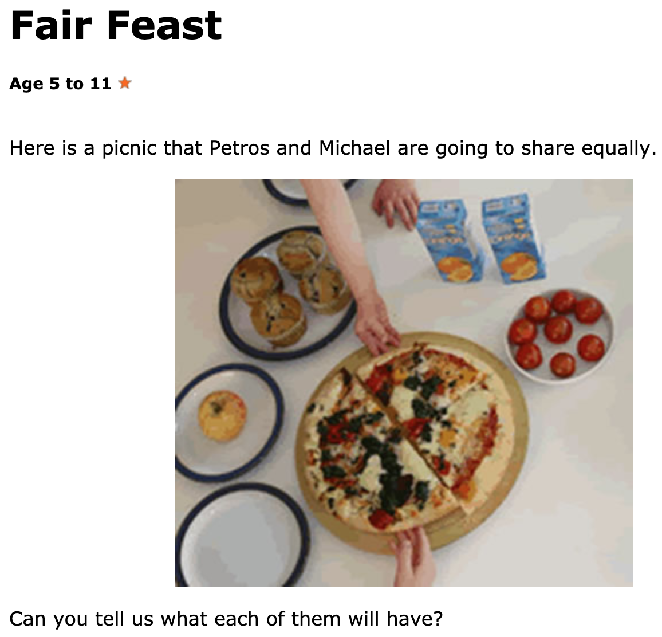  Y1 Access the White Rose Maths website for home learning (link below).  https://whiterosemaths.com/homelearning/year-1/  Complete Summer Term – Week 1 - Lesson 5 –Find a half (2) (watch the video before completing the activity).  Y2 Access the White Rose Maths website for home learning (link below).  https://whiterosemaths.com/homelearning/year-2/  Complete Summer Term – Week 1 – Lesson 5 – Compare length (watch the video before completing the activity).  If you do have access to a printer and want to print the White Rose sheets that go with each lesson, you can do. If you do this, you do not have to do the Power Maths pages as well.  If you do not have access to a printer, watch the White Rose video each day and then complete the Power Maths pages specified.  Daily Project  EYFS - Today we would normally have extra-curricular time again. Have another go at building a ‘Blanket Fort’ like last week. What could you do differently this time? Snuggle in and tell your favourite toy a story.  KS1 - Speaking and Listening - Today we would normally have extra-curricular time again. Have another go at building a ‘Blanket Fort’ like last week. What could you do differently this time? Invite your family to a teddy bears’ picnic. Design and make cards for parents and family members inviting them to the teddy bears’ picnic. Write a simple sentence or sentences that outline where and when the picnic will take place. Read your sentences aloud to check that they make sense, then illustrate your invitations. At the picnic talk to your parents about what younger children might need at different ages if they were to be invited (think about how they play, move, eat and drink). Now snuggle in and tell your favourite toy a story.  Remember, we would love to see some photos of what you have made. Email them in at admin@branscombe.devon.sch.uk

