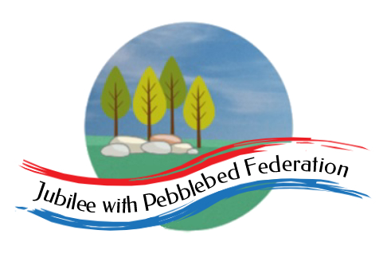
The Jubilee Hub of The Jubilee with Pebblebed Federation
Subject Intent Statement for Religious Education
Our Vision
‘Be who God meant you to be and you will set the world on fire.’
St Catherine of Siena
Intent
As a Federation of Church of England primary schools, in the Jubilee Hub of the Jubilee with Pebblebed Federation, RE is regarded as a core subject. The founding principle behind its teaching is that a deepening understanding of Christianity, as well as those of other faiths, will enable the children to better understand themselves and also the world in which they live, enabling them to live out the school vision statement ‘Be who God meant you to be and you will set the world on fire’.

In keeping with the intention to celebrate the local culture, environment and community, the children’s learning about Christianity is placed within the context of their own explorations about beliefs. Links are made to the children’s own experiences and those of other members of the community are drawn upon, through visits and visitors wherever possible. In addition, so that the children might better understand the world beyond their immediate horizons, they are introduced to the beliefs and practices of Jews, Muslims, Hindus and Humanists, as well as any other religions represented within the class. Wherever possible, this study will draw on the experiences of real people, as well as on appropriate texts, artefacts and sources.
Implementation
RE teaching is based on the Devon and Torbay Agreed Syllabus 2019-2024, incorporating Understanding Christianity. In Key Stage 1, children study Christianity every term and Judaism and Islam as other religions. In Key Stage 2, children study Christianity every term, as well as deepening their understanding of Judaism and Islam. In addition, they are introduced to Hinduism and Humanism. Reference may be made to other religions according to the children’s interests and backgrounds, but these form the core of teaching. Most sequences of work will include some reference to Humanist ideas and as the children get older, there will be more explicit teaching of the basis for these ideas, making use of resources from the Humanist society or Understanding Humanism.

According to Understanding Christianity, teaching of Christianity centres on the Big Frieze, which is displayed in every classroom and referenced in each Christianity unit of work. The units of work in the Agreed Syllabus are planned into an RE Topic plan, which is designed to support links between teaching and learning in RE and in other subject areas taught through topics, wherever possible. Links may also be made with the ongoing programme of Collective Worship in the schools. Each sequence of work will revolve around exploration of a key question, which will be displayed in the classroom. Children will be encouraged to explore their own and others’ responses to this question. Each sequence will involve, in varying degrees, each of the three core elements of the scheme: making sense of the text, understanding the impact and making connections.

At the start of each sequence of learning, children will complete an ‘Elicitation’ assessment to ascertain their existing understanding and knowledge. This may be completed by individuals, in groups or as a whole class. At the end of each sequence, a similar assessment will be completed in order to support teachers in identifying how children’s knowledge, thinking and ideas have progressed.

Teaching in RE will include a range of activities designed to support children in developing their knowledge about the beliefs and practices of major religions as well as their ability to think deeply and express their own developing thoughts, ideas and beliefs. In planning RE lessons, teachers will make reference to Bloom’s Taxonomy to ensure that activities are included that promote higher order thinking skills such as analysis, synthesis and evaluation, as well as understanding, remembering and creating. Children will be encouraged to express their thoughts through creative activities, such as drama, writing poetry or creating art, as well as discussing their views with others in ‘Philosophy for Children’ style enquiries and class discussions.

Wherever possible, children’s learning about religion will be enhanced through visits to places of worship or through visitors who will be invited to take part in RE lessons. Alternatively, where this is not possible, second-hand sources such as videos, interviews or diaries may be used to introduce children to the religious experiences, practices and views of a range of individuals from around the UK and also the wider world. Religious artefacts will be used to support children’s knowledge and engagement in the subject. Teachers will model and explain to the children how to treat these with appropriate care and respect (eg. by keeping the Qur’an in a high place and only touching it after washing hands thoroughly).

Intended Impact
- Pupils will develop an understanding of the key stories, celebrations and practices of Christianity and other major world religions.
- Pupils will develop an awareness of the core concepts at the heart of mainstream Christian belief: God, Creation and Fall, the People of God, Incarnation, Gospel, Salvation and the People of God.
- Pupils will develop a respectful and tolerant attitude towards the beliefs and practices of those whose religion and culture is different to their own.
- Pupils will be able to identify and ask ‘big questions’ about life, death and meaning and to talk articulately about their own developing ideas, thoughts and beliefs in response to these.
- Pupils will develop an appropriate vocabulary of religious terms that will enable them to make sense of and respond with compassion and understanding to situations concerning religious identity and belief in the local and world news, as well as relating to people that they meet with kindness, peace and love.
- Pupils will develop a growing appreciation that a sense of personal identity is connected to the way we relate with others and a developing awareness of the different ways that people might experience and respond to a spiritual dimension to their existence and the world around them.

