RE – Class 1 – Week 5
Last week we learnt about the month of Ramadan. This week we are going to look at the festival of Eid that Muslims celebrate at the end of Ramadan, Eid al-Fitr.
Watch this short video clip to find out more.
https://www.bbc.co.uk/newsround/33575453
Then have a go at this quiz!
https://www.bbc.co.uk/cbbc/quizzes/eid-al-fitr-quiz

A few main points
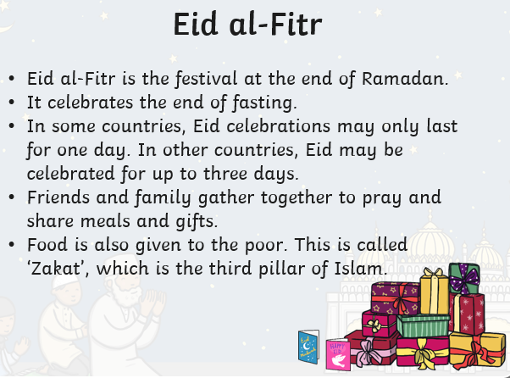

Look at these mehndi patterns that Muslims paint with henna on their hands during Eid. Draw around your hand and use a brown felt tip or brown paint with a cocktail stick to draw your own mehndi designs.
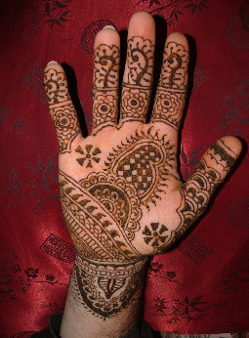
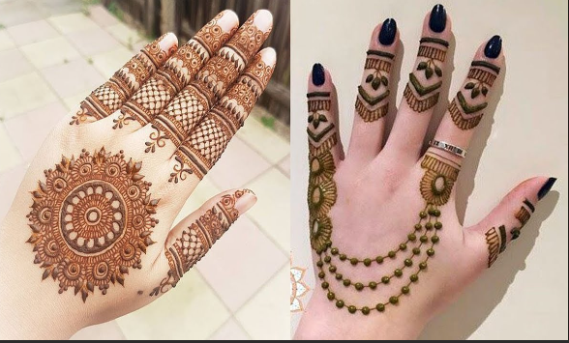
If you have the ingredients, you could make Eid cookies with an adult and share them with your family. In many Muslim cultures, it is tradition to make Eid cookies and share them with family and friends. This symbolises kindness, compassion and the importance of giving to others.
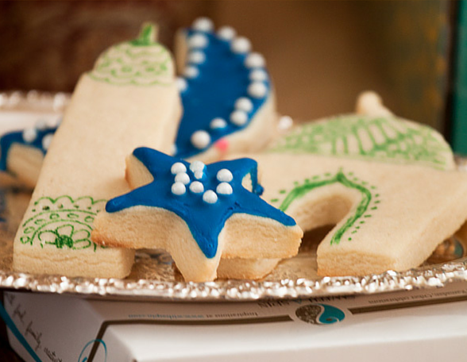
Eid cookies
Ingredients
75g butter
40g sugar
Tsp vanilla essence
Pinch of salt
150g plain flour.

Instructions
- Line a baking sheet with baking paper.
- Preheat oven to 180°c.
- In a bowl, cream butter and sugar until smooth. Beat in vanilla.
- Sift the flour and salt together.
- Add the dry ingredients to the creamed mixture, little by little at a time.
- Wet your hands and finish off kneading the dough by hand.
- Divide the dough into workable batches, roll out closer to under 1cm onto a lightly floured surface
- Cut out the cookie using your favourite cookie cutters.
- Bake about 7-9 minutes.
- Let cool on the baking sheet until firm enough to transfer to a cooling rack.
- Decorate!

