Class 2, Branscombe C of E Primary School

Dear Parents and Members of Class 2,
Thank you for the wonderful video you all helped to make for the staff. It was such a lovely surprise, though it did bring home how much I miss you all as I saw how much some of you have grown up in the past few months! I hope you enjoyed last week’s trip to Scandinavia and the Nordic Region. This week, in celebration of Bastille day on Tuesday, we are going to visit France, with some contributions sent in by Grace, from her work a couple of weeks ago. Well done Grace!
I would also like to draw your attention to a competition opportunity: one of the websites we have used over lockdown (kids-world-travel-guide.com) is running a writing competition. It’s their 5th annual essay competition with the theme ‘My Country’. Here is some information from their website:
‘Tell us about your experiences, insights and favourite tips about your happy place and let all know what makes your country so special! Be creative! And keep it positive, tell us about all the wonderful insights you have about your country or destination or travel experience.
Essay length: 300 - 400 words.
The essay may include the following topics:
- About my home country
- My favourite country in the world
- The country of my dreams
- The ideal country: If I was president/ king/ queen…
- Important facts about my country
- Customs and traditions in my country
- Landmarks in my country
- Holiday and travel experiences
The essay has to be submitted in English but may include words or phrases in a foreign language. Find out more at: https://www.kids-world-travel-guide.com/writing-competition.html
Closing date for entries is 1st November 2020 so plenty of time – what would you want to say about Devon and England/UK/Great Britain?
For more PE ideas, especially for a Monday afternoon when we would be working with Premier League, why not check out https://plprimarystars.com/home-learning

Happy learning! I’m looking forward to being with you again soon,

Miss Moss

The most important thing you can do to support your child’s learning whilst schools are closed is to ensure that they read every day and they continue to practise their number bonds and times tables.

Week beginning Monday 13th July 2020

Monday  13th July | Core activities |  |  | Suggestions for additional activities.
9.00 – 9.30 | Daily Dashboard:  Quelle est la date aujourd’hui?  C’est lundi le treize juillet 2020.  Can you write the number date in Roman numerals?  Why not visit Kids World Travel Guide News for an alternative news source – there’s videos and articles to choose from.  https://www.kwtgnews.com/  Click under the heading ‘News for Kids’, then select world, environment, science or culture. |  | Live Aid happened today in 1985, a massive concert attended by 75,000 people in London and 89,484 people in Philadelphia USA to raise money for Ethiopian famine. It was one of the largest-scale satellite link-ups and television broadcasts of all time; an estimated audience of 1.9 billion, across 150 nations, watched the live broadcast, nearly 40% of the world population! Here is the band Queen playing that day:  https://www.youtube.com/watch?v=TkFHYODzRTs
9.30-10.00 | Grammar – see Grammar and Spelling Resources |  |  | Use your spelling shed login to practise by playing spelling games.
10.00- 10.30 | Time for some physical activity. Why not try some ‘Throw Tennis’ (instructions below) and develop your throwing and catching skills?  Or why not try horizontal climbing? Learn more here: https://youtu.be/jSP-fWmk36A?list=PLYGRaluWWTojV3An2WEgsQ4qGFy_91jDL
10.30-11.30 | Maths – follow the links to find online lessons for each year group:  Year 3: https://classroom.thenational.academy/lessons/commutativity-between-multiplication-and-division  Year 4: https://classroom.thenational.academy/lessons/to-develop-strategies-to-plan-and-solve-problems  Year 5: https://classroom.thenational.academy/lessons/to-represent-an-interval-across-zero-on-a-number-line  Year 6: https://classroom.thenational.academy/lessons/solve-problems-involving-the-relative-sizes-of-two-quantities-part-1 |  |  |  |  | Remember to keep practising key facts such as times tables – a few minutes daily practice on Times Table Rock Stars can make a big difference to your confidence in Maths.
11.30-12.00 | Have a break and play a game or do another activity that you enjoy.
12.00- 1.00pm | Lunch break. Eat a healthy lunch and, if you are able, try to get outside for some fresh air!
1.00pm – 1.30pm | Reading – answer the questions on the sheet below, after visiting https://www.kids-world-travel-guide.com/france-facts.html  I’ve included an information page on Paris below and a labelled map in Additional Information if you can’t get online! | Read a chapter or two more in your latest Bug Club book. Don’t forget to click on the bugs to answer the comprehension questions.
1.30pm – 2.00pm | Mental Health Working together – teamwork  What does the word ‘team’ mean to you? Make a mind map/ though shower to record some of your ideas about what teams are, when they are important and what people need to know about good teamwork.  The word TEAM is an acronym for Together Everyone Achieves More. Do you agree with this statement? Is this true always, sometimes or never? Can you think of circumstances in which teamwork is/ isn’t helpful?  What makes a good team? Qualities of good teamwork might include things like: diversity, inclusion, encouraging, positivity, being organised, fairness, good communication, supportive, fun etc.  Why not record some of these words/ qualities and decorate them to make a ‘Great teamwork needs…’ poster. You could illustrate this further with pictures of different circumstances in which teamwork is valuable – either drawn by the children or printed from the computer.
2.00pm - 3.00pm | Theme – Geography – lets visit France’s capital city of Paris today!  What do you already know about Paris? Make a list!  Look at the photo slide collection in Additional Information France: for each photo can you add at least one observation to your list. What is it like in Paris?  Below are some clue cards – use them to complete sheet 1a, labelling the map.  Ext: Also included below are two average temperature charts – one for France and one for London. You could read the chart then answer the questions.  Let’s investigate:  London is built on the banks of the River Thames. Paris is built on the banks of the River Seine. Are all capital cities built on a river? Why/Why not? |  |  |  | France is made up of mostly flat plains and rolling hills in the North and West, whereas the South and East are mountainous. Find out some good basic facts about the geography of France here: https://www.schoolsofkingedwardvi.co.uk/ks2-geography-place-knowledge-2bii-france-country/

Here is a useful link to help you answer these questions. Answer these questions in your school book. https://www.kids-world-travel-guide.com/france-facts.html

- Who was the french political leader who was beaten at the Battle of Waterloo?
- What is the capital city of France?
- What is the name of a French bakery?
- Name two of the most famous painters in France.
- Name all of the countries that share a border with France.

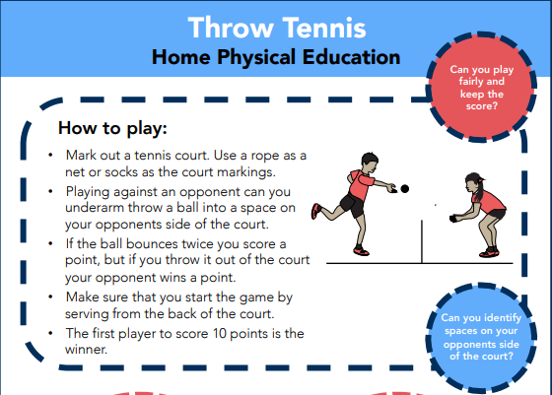
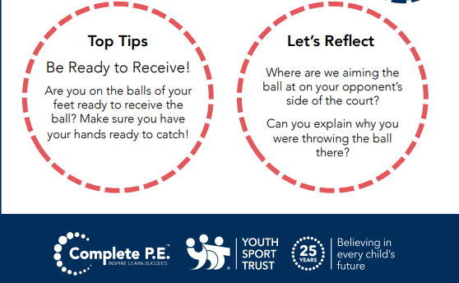
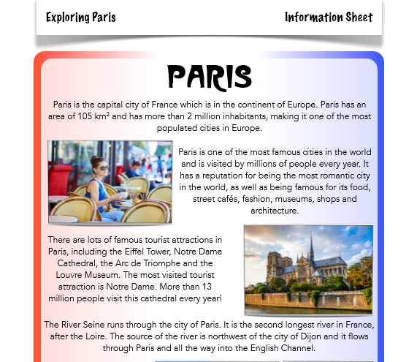
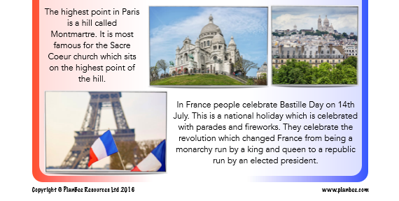

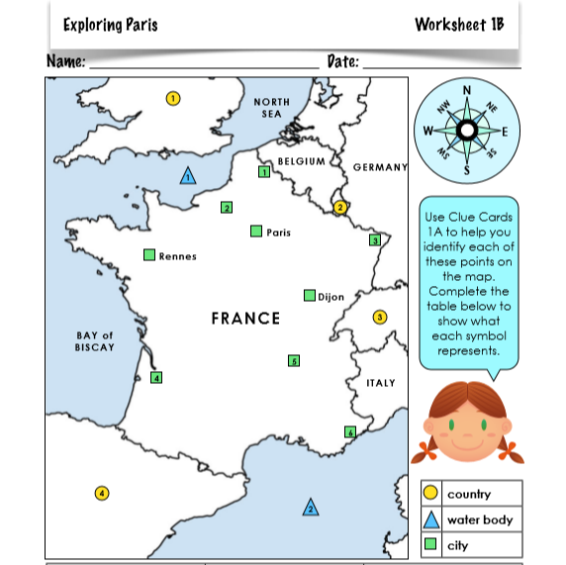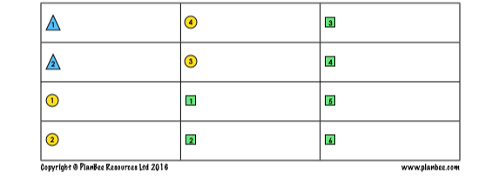
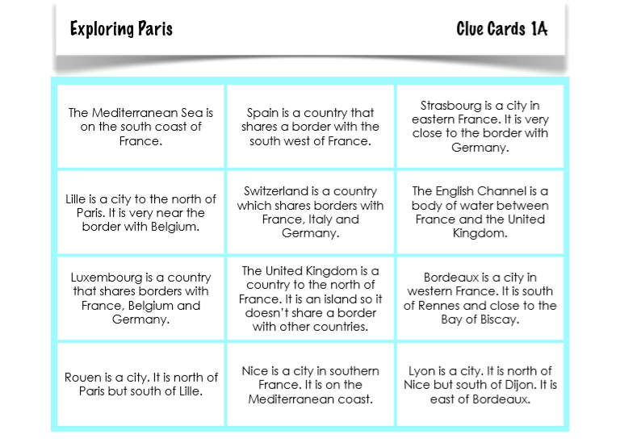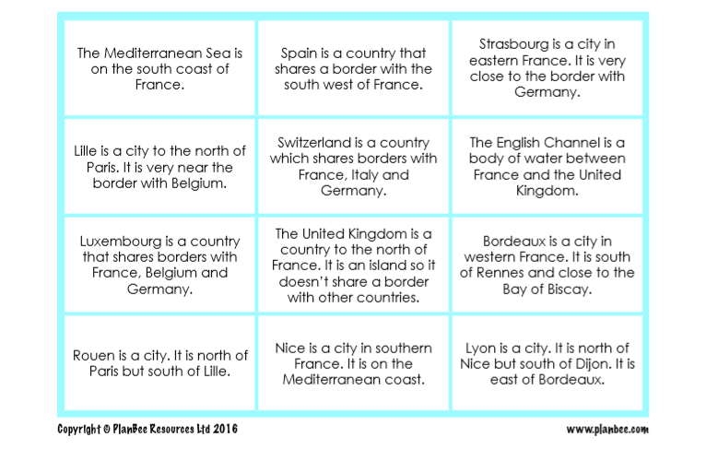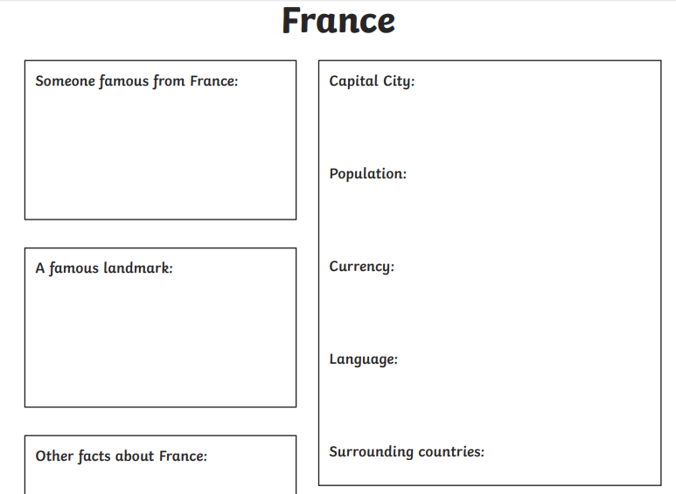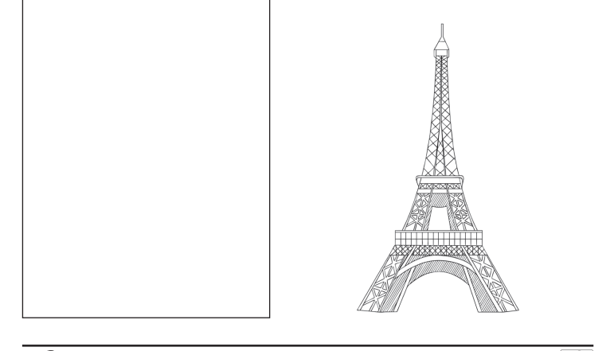
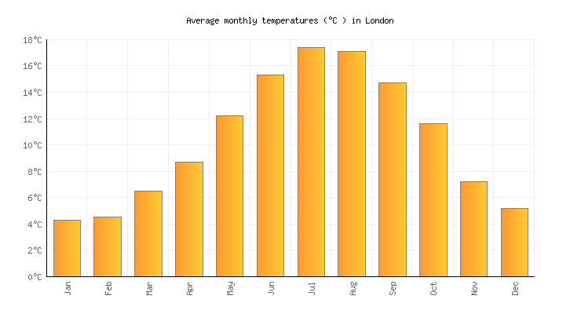

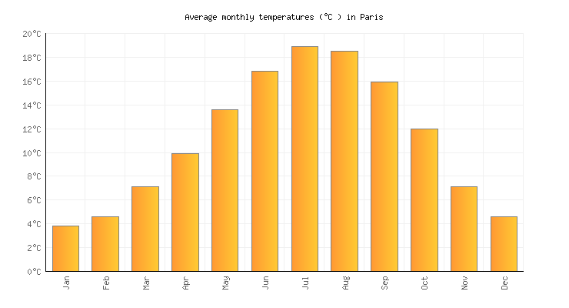

Questions
- What is the hottest month in Paris?
- What is the coldest month in Paris?
- What is the hottest month in London?
- What is the coldest month in London?
- Can you come up with a comparing question to answer using this data?

Tuesday 14th July | Core activities |  |  | Suggestions for additional activities.
9.00 – 9.30 | Daily Dashboard:  Quelle est la date aujourd’hui?  C'est le mardi le quatorze juillet 2020  Can you write the number date in Roman numerals?  What is happening in the world? Have a look at https://www.bbc.co.uk/newsround or https://www.dogonews.com/ to see what is going on in the world. Choose a news article or two to read.  Watch this report on Bastille Day in 2014  https://www.bbc.co.uk/newsround/28311898  “Vive le 14 juillet!” (“Long live the 14th of July!”) is the slogan of Bastille Day. |  |  |  | On this day in 1989, which was the 200th anniversary of the storming of the Bastille, there was great revelry and celebration, but 500 arrests.  http://news.bbc.co.uk/onthisday/hi/dates/stories/july/14/newsid_2503000/2503109.stm  Here’s a quick 1-minute video with the background to Bastille Day.  https://www.youtube.com/watch?v=FvTxpxZNmhg  We’ll learn more about the historical background this afternoon during theme time.
9.30-10.00 | Spelling – see Grammar and Spelling Resources |  |  | Use your spelling shed login to practise by playing spelling games.
10.00- 10.30 | Time for some physical activity.  Why not try out ‘KESSP PE at Home – Tennis’ or practise being light on your feet with ‘Wrong Way Right Way Race’– see the prompt sheets below.  Alternatively, try Hot Shot Slingshot here: https://www.ltl.org.uk/resources/hot-shots-with-slingshots/ for PE crossed with science and technology!
10.30-11.30 | Maths – follow the links to find online lessons for each year group:  Year 3: https://classroom.thenational.academy/lessons/use-known-multiplication-facts-to-derive-our-6-times-table  Year 4: https://classroom.thenational.academy/lessons/to-develop-strategies-to-plan-and-solve-problems-b2fcb2  Year 5: https://classroom.thenational.academy/lessons/to-explain-a-remainder-expressed-as-a-fraction-and-as-a-decimal  Year 6: https://classroom.thenational.academy/lessons/solve-problems-involving-the-relative-sizes-of-two-quantities-part-2 |  |  |  |  | Alternatively, you could go for a BBC Bitesize daily lessons today.
11.30-12.00 | Have a break and play a game or do another activity that you enjoy. | Stay connected – who could you make a phone call or send an email to to to keep in touch?
12.00- 1.00pm | Lunch break. Eat a healthy lunch and, if you are able, try to get outside for some fresh air!
1.00pm – | Reading/ Literacy time  Learn about Bastille Day from this article, found at https://kids.britannica.com/kids/article/Bastille-Day/352834 |  | Alternatively, read a few chapters of your book of the moment.
1.30pm -2.00pm | Mental Health Working together – teamwork  Watchhttps://www.bbc.co.uk/bitesize/clips/zyrvr82and https://www.bbc.co.uk/bitesize/clips/z39g9j6  Think about the issues encountered by the team and how they overcame them.  Write a list of instructions/ guidelines/ rules or a recipe for ‘How to work successfully in a team’, including the importance of listening, taking different roles, cooperating, patience with each other, being willing to try other people’s ideas, identifying and making use of the team’s skills etc.  (It may be helpful to watch the final video again and take notes of ideas that you can use in your guidelines.)
2.00pm – 3.00pm | Theme – History/Geography Literacy  Bastille Day  Learn about Bastille Day here:  https://www.euroclub-schools.org/bastille-day  Or you could read this article from the BBC- scroll half way down to find a video: https://www.bbc.co.uk/bitesize/articles/zrk6ncw  Or read the information provided below.  You could then write an essay of at least a paragraph, that explains the history of Bastille Day. Be sure to explain why it’s called Bastille Day. You could begin by writing about the problems the French people were having with the king.  Or you could design a Bastille Day greeting card. Make sure the card has at least two sentences about Day and contains appropriate illustrations and colours. For example, Bastille The entire card could use the colours of blue, red, and white, and the front could have a large French flag on it. The inside of the card could say, "Woohoo, freedom! Happy Bastille Day!".  Alternatively, you could pretend that you are living in France and you decide to throw a huge Bastille Day party on July 14. Create an invitation to your party that lists all of the fun activities you will be doing. Make your invitation as appealing as possible so people will come to your party! The invitation could ask everyone to wear blue, red, and white, and say that the party will end with night time fireworks.

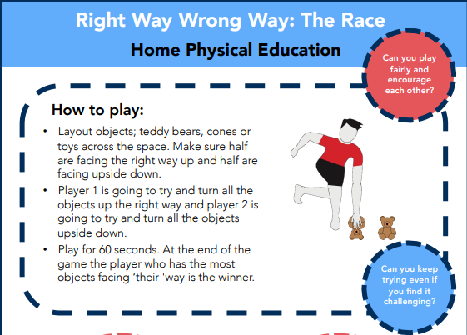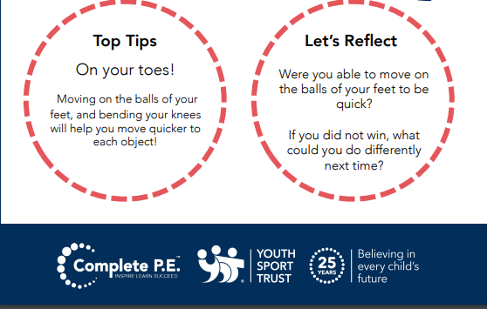
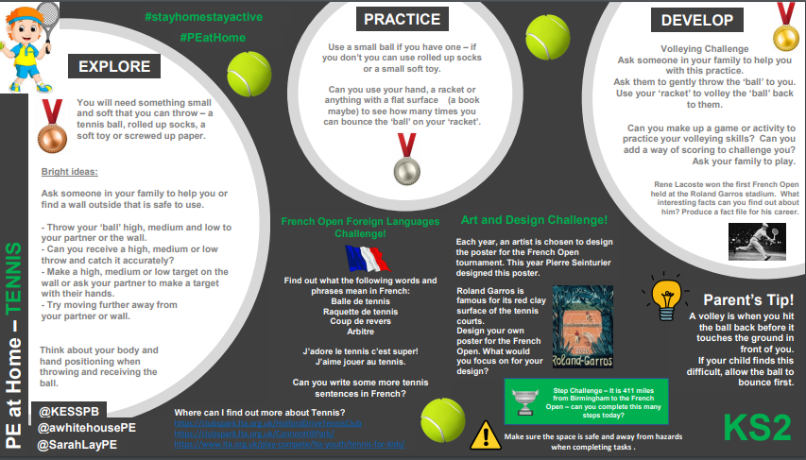
Do you like fireworks and stories about brave people fighting for more freedom? Then you will enjoy learning about an important holiday in France, Bastille Day!

Bastille Day: July 14
Marie stood outside with her family excitedly. This was always her favourite part of the July 14th celebrations. Finally, it was dark enough for fireworks. Marie and all the other French people around her look up and cheer when the first firework shoots across the sky. Marie grins up at her dad and says 'Happy Bastille Day!'

The Original Bastille Day
In 1789, France was getting ready for a revolution; the common people were tired of having a king who controlled everything. Throughout France, there were grumblings about how bad things were. Two big complaints were that the king had made the taxes very high to help pay for his debts, and there was not enough food for everyone. The people wanted a more democratic form of government, and they were ready to fight for it.
The French army was under the control of King Louis XVI, who did not want to give up his power to the people. Everyday people did not have any weapons, only pitchforks and rakes. The common people knew they could not fight the French army this way! So when they heard that there was gunpowder in the Bastille, an old prison in Paris, they decided to attack it.
On July 14, 1789, the common people overcame the guards at the Bastille prison and got the gunpowder. They also happened across some prisoners, so they set them free. Some members of the army even joined the rebels and helped them take the Bastille. The storming of the Bastille prison proved to everyone in France that the people were a serious force that must be listened to.
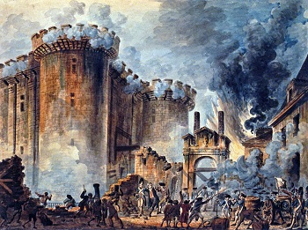
The attack on the Bastille

Bastille Day Traditions
Think back to your most recent Fourth of July celebration. Most likely, it was similar to how the French, like Marie, celebrate Bastille Day. Marie's family and friends gather together and wear the French flag's colours of blue, white and red. Marie and her family hang flags everywhere, too.

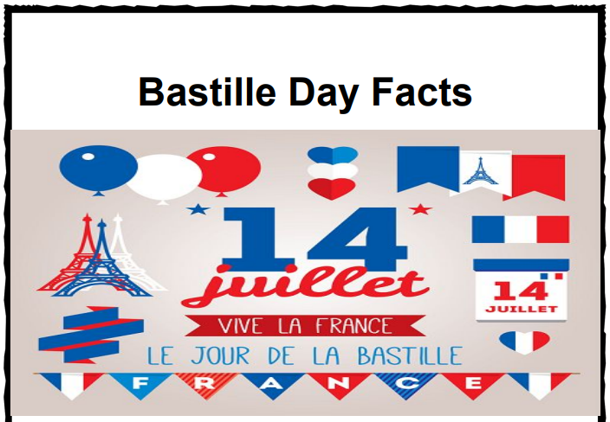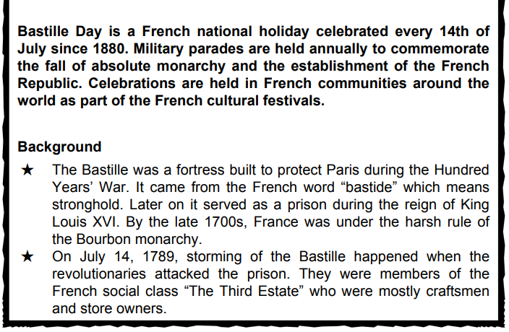

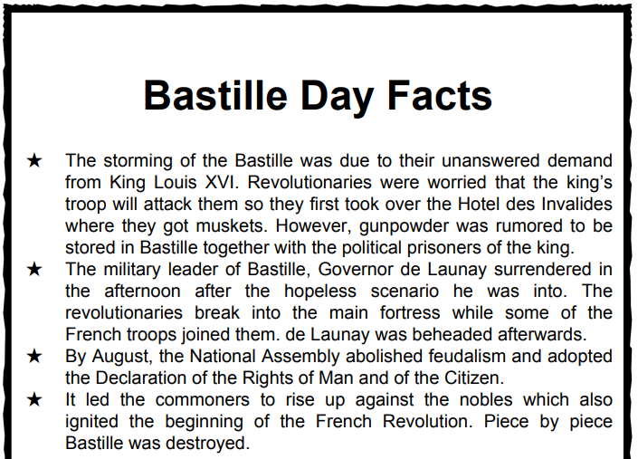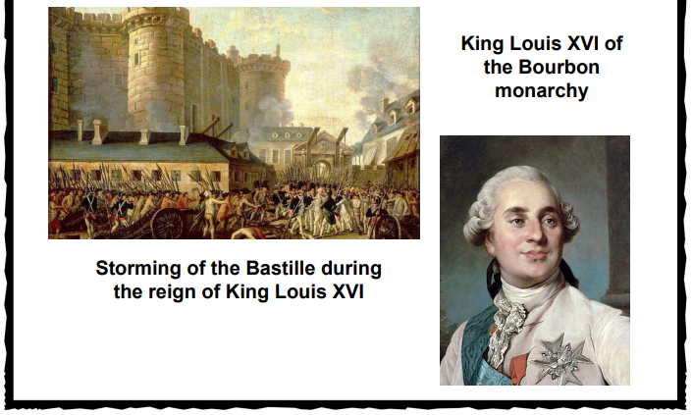

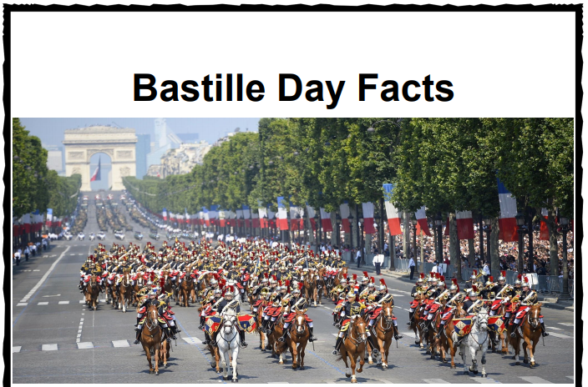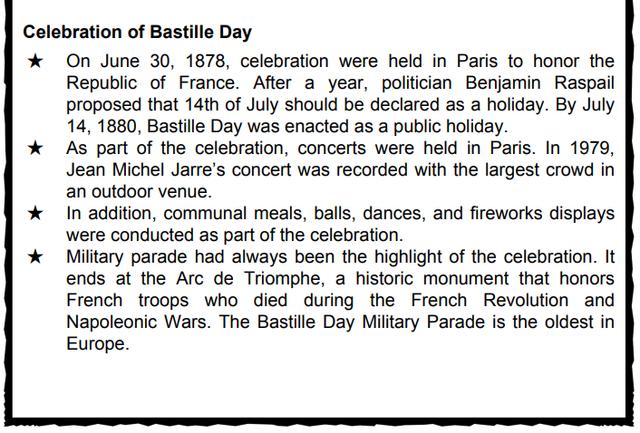

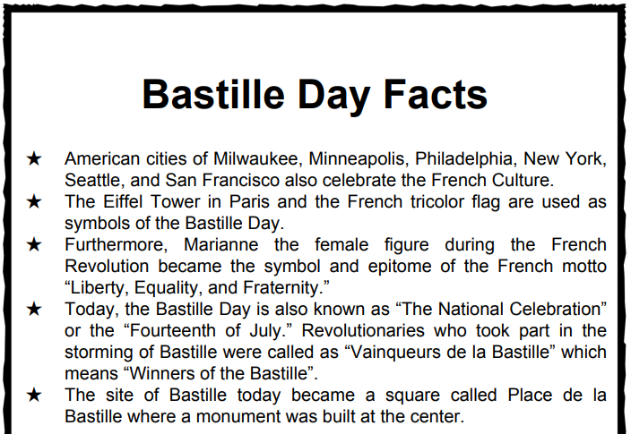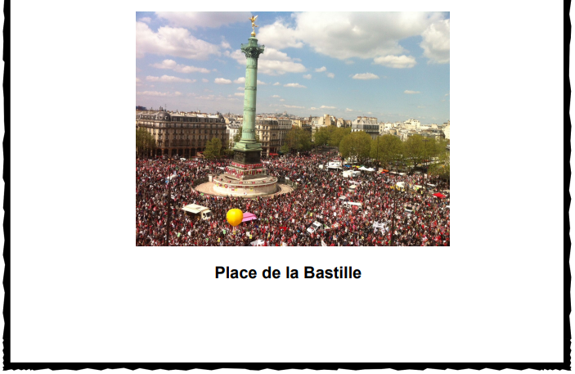

Wednesday 15th July | Core activities |  | Suggestions for additional activities.
9.00 – 9.30 | Daily Dashboard:  Quelle est la date aujourd’hui?  C’est mercredi le quinze juillet, 2020.  Can you write the number date in Roman numerals?  What is happening in the world? Have a look at https://www.bbc.co.uk/newsround or https://www.dogonews.com/ to see what is going on in the world. Choose a news article or two to read. |  | According to the legend of St Swithin, if it rains today it will be the start of 40 days of rain. Reminds me of Groundhog Day in USA. Look out of the window – is it raining today? You could use this site to investigate what weather we can expect over July and August!  https://www.metoffice.gov.uk/weather/forecast/gcj2x8gt4#?date=2020-07-15
9.30-10.00 | Grammar – see Grammar and Spelling Resources |  |  | Use your spelling shed login to practise by playing spelling games.
10.00- 10.30 | Time for some physical exercise –  Try out the three minute challenge below – no resources needed, just your energy and focus!  Or, if you are in the mood to dance, go online and find something on https://www.gonoodle.com/
10.30-11.30 | Maths – follow the links to find online lessons for each year group:  Year 3: https://classroom.thenational.academy/lessons/use-known-multiplication-facts-to-derive-our-8-times-table  Year 4: https://classroom.thenational.academy/lessons/to-develop-strategies-to-plan-and-solve-problems-a61888  Year 5: https://classroom.thenational.academy/lessons/to-interpret-remainders-appropriately-in-the-context-of-the-problem  Year 6: https://classroom.thenational.academy/lessons/ratio-problems-c42b16 |  |  |  |  |  | Alternatively, have you played any maths games recently? Keep your addition and subtraction skills sharp!
11.30-12.00 | Have a break and play a game or do another activity that you enjoy. | Eat well – how could you show your appreciation to the people who prepare your daily meals? Why not make a card to say thank you?
12.00- 1.00pm | Lunch break. Eat a healthy lunch and, if you are able, try to get outside for some fresh air!
1.00pm – 1.30pm | Reading time – Today, in 1815, French Emperor Napolean Bonaparte surrendered to Captain Maitland aboard the English ship Bellerophon. Learn more about Napolean here, then answer the questions found below today’s plan. https://kids.britannica.com/kids/article/Napoleon/353514 |  |  |  |  | Alternatively, catch a chapter or two of your personal reader. I miss chatting to you about your books and finding new titles and authors to read!
1.30pm-2.00pm | Mental Health  Dealing with conflict  What is meant by the word ‘conflict’? When have you come into conflict with others or witnessed conflict between other people?  People can respond to conflict in different ways. Some people behave a bit like hedgehogs, hiding away from conflict. We call this a passive response. It avoids getting into arguments but the conflict may never be resolved. Other people behave a bit more like a rhinoceros meeting the conflict head-on in an aggressive or defensive manner. This can actually make things worse! Ideally, we need to be assertive but not aggressive.  Look at the hedgehog vs rhino sheet below. How could you respond to conflict in an assertive, but not aggressive way? What animal might represent this kind of reaction?  Which virtues are needed to deal with conflict well? Can you identify one virtue you have and one virtue that you would like to develop further to deal with conflict more effectively?
1.30pm – 3.00pm | Theme – Art  Famous French artists include: Claude Monet, Peirre Auguste Renoir, Edgar Degas, Paul Cezanne  - Learn about famous French artists. Can you try to create some of your own art work in a similar style?  - Create a piece of art that is worthy of being displayed in the Louvre.  - Colour the French flag.  - Draw a picture of an artist's palette and label different colours using their French names.  - Create a shield, logo or poster that displays the French motto ‘Liberte, Egalite, Fraternite' (Liberty, Equality, Fraternity).  - Find out about the Lascaeux caves. Can you create your own versions of the cave paintings found there? |  |  |  | In Additional information you will find 3 of Monet’s paintings to cut up as jigsaws. To make it trickier, you could mix the pieces of all 3 jigsaws before building each one. Why not stick the jigsaw on a piece of paper, leaving out a couple of pieces. Then you can use your artistic skills to fill in the gaps.  If you want to learn more about France watch here:  https://www.youtube.com/watch?v=z89fac5Z250  Watch this video and then complete a writing task.  Write a diary entry or a letter with 3-4 paragraphs in the role as a traveller.  After that, you could write a longer non-fiction piece about life in France.  Here are some more websites you could look at for information.  https://kids.britannica.com/kids/article/France/345690  https://www.kids-world-travel-guide.com/france-facts.html  https://www.britannica.com/place/France
Reading Task
https://kids.britannica.com/kids/article/Napoleon/353514
Look at this website and then answer the questions.
- Who was Napoleon?
- Where was he born?
- When was he born?
- How old was he when he became an army officer?
- Where was he first sent to?
- Where was he when the French people overthrew their king?
- Where did he die?
- When did he die?
What happened to Napoleon after his surrender? Why do you think that decision was made? Do you agree or disagree it was a good decision?

I can describe different ways of responding to conflict. I can reflect on my own personality and responses.
Annotate the animals to explain the different responses to conflict represented by each animal:

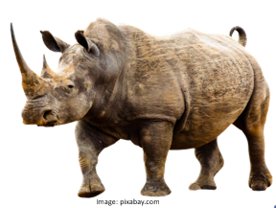

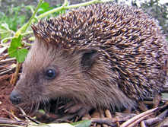

Which of these responses do you think you are more likely to have? Why?

Now describe a response that you think would be a more appropriate, assertive choice. You may wish to choose an animal to represent this behaviour.

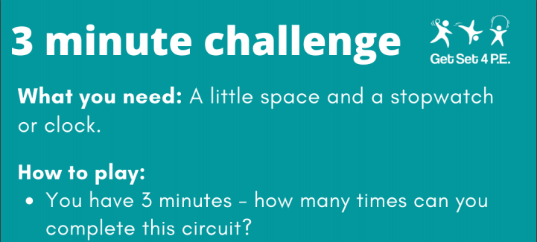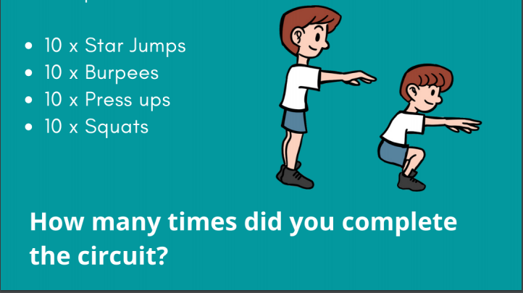

Thursday 16th July | Core activities |  |  |  | Suggestions for additional activities.
9.00 – 9.30 | Daily Dashboard:  Quelle est la date aujourd’hui?  C’est jeudi le seize juillet, 2020.  Can you write the number date in Roman numerals?  What is happening in the world? Have a look at https://www.bbc.co.uk/newsround or https://www.dogonews.com/ to see what is going on in the world. Choose a news article or two to read. |  |  | Apollo took off, heading for the moon, on this day in XXXX  http://news.bbc.co.uk/onthisday/hi/dates/stories/july/16/newsid_4091000/4091551.stm  Watch the historic moment here  https://www.youtube.com/watch?v=S3ufJ7lcr08
9.30-10.00 | Grammar – see Grammar and Spelling Resources |  | Use your spelling shed login to practise by playing spelling games.
10.00- 10.30 | Time for some physical activity.  Why not try ‘The Wheelie Bin Challenge’ – video here:  https://www.bbc.co.uk/sport/av/tennis/53243876  Or do the disco dance and maths challenge found on imoves, here: https://imoves.com/home-learning/1369  Alternatively, why not stretch your brain with one of these cross-curricular Maths investigations linked to sport? Get active while doing maths! More information here: https://nrich.maths.org/public/topic.php?ct=0&cl=1&dl%5B0%5D=1&dl%5B1%5D=1&dl%5B2%5D=1&group_id=48&cldcmpid=&code=-413#results:
10.30-11.30 | Maths – follow the links to find online lessons for each year group:  Year 3: https://classroom.thenational.academy/lessons/multiply-2-digit-numbers-by-6-using-the-partitioning-method  Year 4: https://classroom.thenational.academy/lessons/to-develop-strategies-to-plan-and-solve-problems-2350d9  Year 5: https://classroom.thenational.academy/lessons/to-calculate-the-mean-as-an-average  Year 6: https://classroom.thenational.academy/lessons/unequal-sharing
11.30-12.00 | Have a break and play a game or do another activity that you enjoy. | Care for others – what little job around the house could you do today to show care for someone in your family?
12.00- 1.00pm | Lunch break. Eat a healthy lunch and, if you are able, try to get outside for some fresh air!
1.00pm – 1.30pm | You might use this time to read some of the information shared about France and Paris.  How’s your personal book coming along? If you have a kindle or laptop, there are thousands of free books available on gutenburg.org – check it out. |  | Why not read some French literature, like the famous “The Three Musketeers” by Alexandre Dumas or “The Little Prince” by Antoine de Saint-Exupery? The three musketeers can be downloaded for free here: http://www.gutenberg.org/ebooks/1257
1.30pm – 2.00pm | Mental Health  Resolving Conflict  Watch ‘The Zax’ by Dr Seuss available on YouTube at: https://www.youtube.com/watch?v=ji4MUtCm8Hw - What is the conflict about? - What barriers are there to solving the conflict? - What virtues would ‘The Zax’ need to develop to solve the conflict? - What other barriers might there be to solving a conflict?  There are some other examples of conflicts at https://www.youtube.com/watch?v=EPQjUJFVFC4  https://www.youtube.com/watch?v=mXs9CplgxJI and https://www.youtube.com/watch?v=SeYD5QklmpA  What might the characters do that would escalate the conflict (ie. make it worse)? What could they do to de-escalate the conflict and make things better?  Look at the ‘Escalating and De-escalating’ activity sheet below for some ideas.  A good solution to a conflict is one that presents a ‘win-win’ solution or compromise. In order for conflicts to be solved, both participants need to feel like their concerns have been addressed and that a compromise has been reached. Look at the following dilemma:  Aleena is a keen footballer and attends football practice every week. Her mum says that, if her room isn’t tidied by 6pm, she can’t go. The coach says that, if she doesn’t go to practice, she won’t be picked for the match on Saturday. It is 6pm and Aleena hasn’t tidied her room.  What might be a win-win solution to this conflict?  Have a go at completing the ‘Friendship Issue- What to do?’ activity.
2.00pm - 3.00pm | Theme – virtual human geography.  Below is a sheet showing key tourist landmarks in Paris.  Today you will be using Google Maps (or similar) to explore some of these attractions for yourselves. Start with Place de la Concorde for an example. First type in a location or address into the search bar, use the +/- to zoom in and out, then convert to ‘street view’ by dragging and dropping the yellow man onto the blue dots or lines. Then look around! Can you find the tourist attraction? What else can you see nearby?  Worksheet 2B gives you addresses to look up and space to record 3 other things you can see on Streetview. |  |  |  |  | Look at the suggested itineraries on the sheet below – which would be the best sightseeing route? If you haven’t got Google map access, you can look at the map marked with the landmarks included below.  Art attack – choose one of the landmarks and draw or paint it!  D/T – Use plastic straws to create a model of the Eiffel Tower. Can you create a model of another famous French landmark?

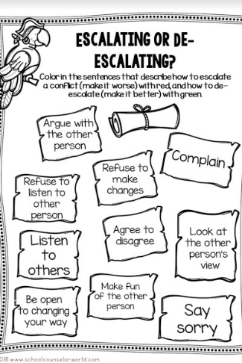

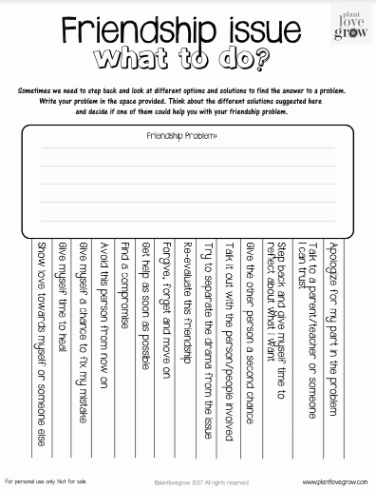

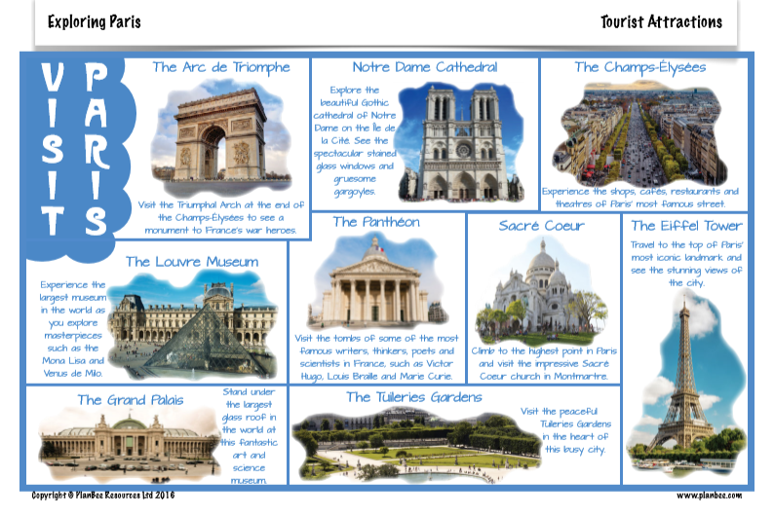
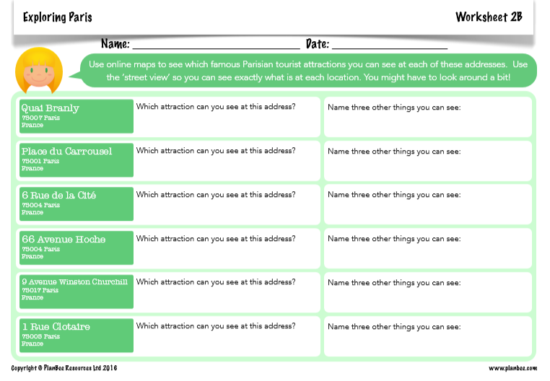

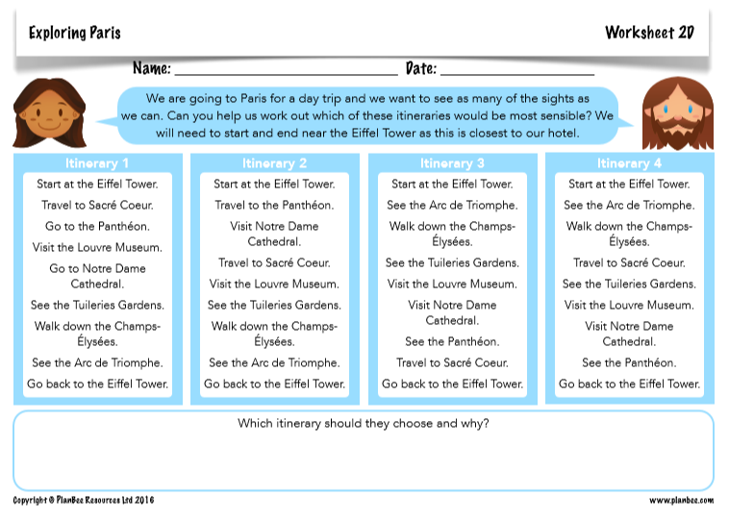

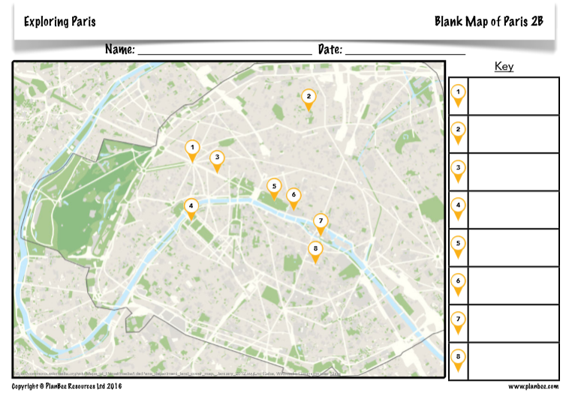

Friday 17th July | Core activities |  |  | Suggestions for additional activities.
9.00 – 9.30 | Daily Dashboard:  Quelle est la date aujourd’hui?  C’est vendredi le dix-sept juillet, 2020.  Can you write the number date in Roman numerals?  What is happening in the world? Have a look at https://www.bbc.co.uk/newsround or https://www.dogonews.com/ to see what is going on in the world. Choose a news article or two to read. |  |  | On this day in 1976, countries protested New Zealand’s rugby links with South Africa, due to apartheid. The opening ceremony of the 21st Olympic games in Montreal was marred by the withdrawal of 25 African countries. This issue was so important to them they boycotted the Olympics- an effective protest, or not?  http://news.bbc.co.uk/onthisday/hi/dates/stories/july/17/newsid_3555000/3555450.stm
9.30-10.00 | Grammar – see Grammar and Spelling Resources | Use your spelling shed login to practise by playing spelling games.
10.00- 10.30 | Time for some physical activity.  Why not try ‘Plank Goalie’? Rules are below – a great way to build your core strength, which helps with lots of sports, but also makes handwriting easier! Surprising but true!  I’ve also included an Outdoor & Adventurous Activity below from KESSP PE @ home.  Alternatively, you could do Daily Mile at Home https://thedailymile.co.uk/at-home/ or a Joe Wicks workout at https://www.youtube.com/user/thebodycoach1
10.30-11.30 | Maths – follow the links to find online lessons for each year group:  Year 3: https://classroom.thenational.academy/lessons/multiply-2-digit-numbers-by-8-using-the-partitioning-method  Year 4: https://classroom.thenational.academy/lessons/to-develop-strategies-to-plan-and-solve-problems-836571  Year 5: https://classroom.thenational.academy/lessons/to-add-three-sums-of-money-and-calculate-change  Year 6: https://classroom.thenational.academy/lessons/unequal-sharing-problems |  |  |  | Alternatively, you could try out a BBC Bitesize daily lesson.  Remember to keep practising key facts such as times tables – a few minutes daily practice on Times Table Rock Stars can make a big difference to your confidence in Maths.
11.30-11.45 | Have a break and play a game or do another activity that you enjoy. |  | Be proud of your very being! What have you done well this week? Why not award yourself a certificate!
11.45 – 12.00 | Why not join in with the act of Collective Worship that you will find on the school website.
12.00- 1.00pm | Lunch break. Eat a healthy lunch and, if you are able, try to get outside for some fresh air!
1.00pm – 1.30pm | Reading  How are you getting on with reading on Bug Club? Spend some time reading one of the books allocated to you and answer the comprehension questions by clicking on the bugs. |  |  | Alternatively, read a chapter or two of a novel. Pick out a few of your favourite sentences and consider what the author has done to make them have an impact on the reader. Share your thoughts with someone at home.
1.30pm – 2.00pm | Mental Health:  Mediation  Sometimes we can play a role in helping other people to resolve their conflicts and find a ‘win-win’ solution. This is called mediation. Look at the sheet below and complete the activities to find out more.
2.00pm - 3.00pm | Theme: Comparing Paris and London  Below are two information sheets about Paris and London, with information to compare. Read them through thinking about the similarities and differences between the two cities. There is more information about London Landmarks in Additional Information.  Choose from the activities below.  - Use the venn diagram to sort the sentences about London, Paris or both – there should be 4 statements in the middle for both!  - Sort the true or false statements about the cities (9 true statements).  - Literacy –Imagine you’ve been to London or Paris for the day – write a recount of your experiences. Choose one of the bookmarks below as a planning guide and make sure you include information you have learnt about the city.  Ext: why not use google maps streetview to investigate some of the tourist landmarks in London? |  |  | Maths link – compare the numerical data, such as area, population or elevation above sea level. Use the vocabulary of comparison – larger, smaller, higher lower, wetter, drier. Can you use your calculation skills to make your comparisons specific and accurate?  Art attack – choose one of the London landmarks and draw or paint it!  D/T –Can you create a model of a famous English landmark?
Hope you have had a great week and remember to stay safe in the sun!
4 more days of the school year to go!

)

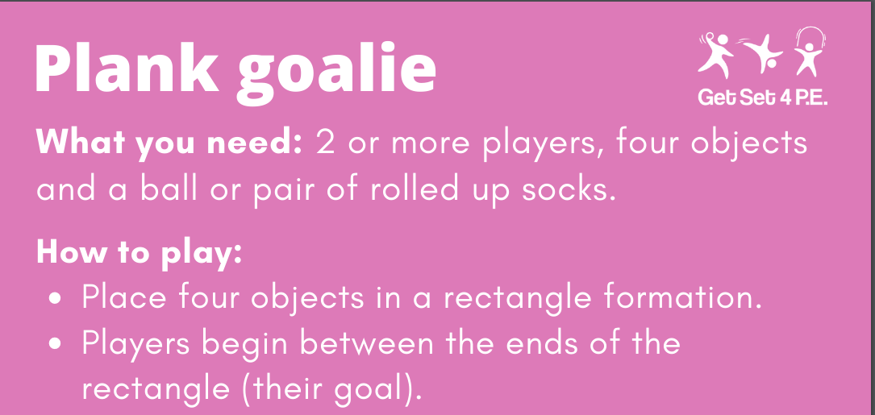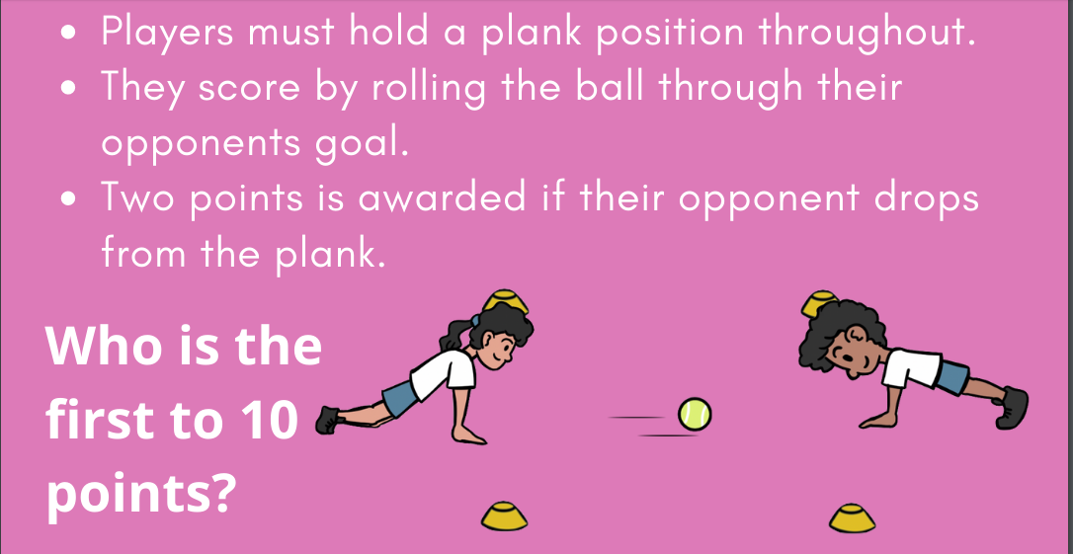

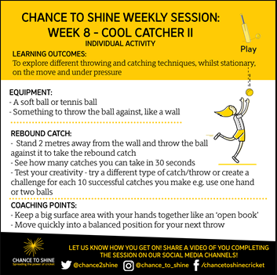

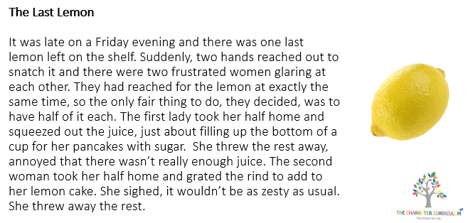
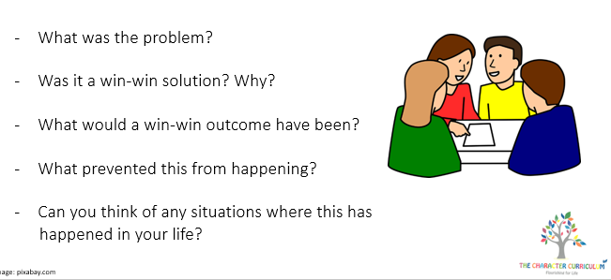
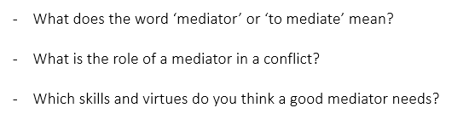
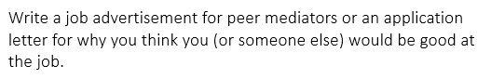
Mediation

Watch the videos at https://www.bbc.com/bitesize/clips/z6stsbk and https://www.bbc.co.uk/bitesize/clips/zvc3cdm to find out more. Is this a role you would be interested in taking on?
Task:

