Weeks beginning Monday 29th June/Monday 6th July – Home Learning in Class 1

Dear Parents and Children of Class 1,

Welcome to Summer Term B - Weeks 5 and 6 of your Home Learning! We hope you are all still doing well with the work that we have been setting?

All of the staff are certainly missing you all in school. Have a look at the website where Mrs Gray has put up some photos so that you can see what the children in school are doing. Maybe you could send them some photographs via email to the admin address so that they can see what you have been getting up to at home too.

Off we go with another tranche of learning: Here is another fortnight worth of work and a bank of resources for you to access. The children in school will be following this work as well, so let us know how you get on.

We have been able to track some super progress on Bug Club – well done! We will continue to focus on developing the children’s reading skills through continuing with your use of this resource. We have updated your reading books on here so there is plenty for you to be getting on with. You will also see that we have once again adapted some of our phonics planning to support the children in using their reading/phonics skills in creative writing episodes.

You may now be running out of space in the books that you were provided with. If this is the case and you would like a new one, please get in touch and we will arrange this.

Our photo for you this week is one of Mrs Bartlett taking part in our reading challenge! Here she is reading a book and her unusual/bizarre place is her childrens’ trampoline!

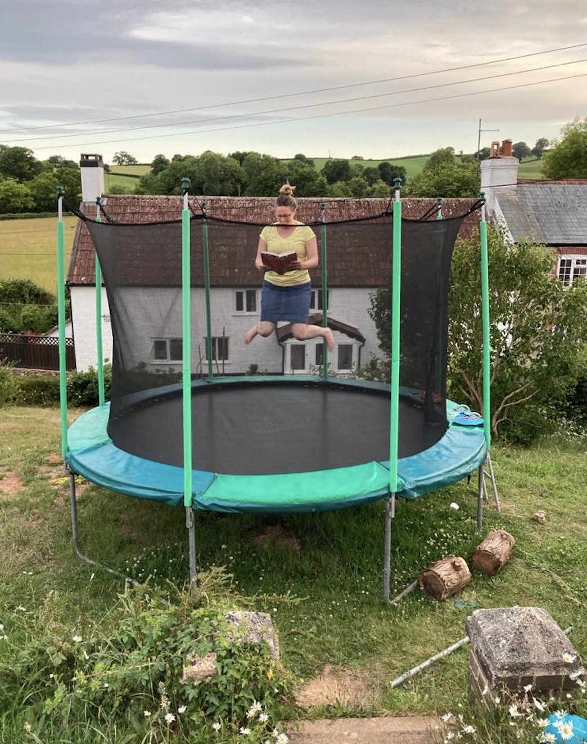

Missing you all… As always, keep reading a book that you enjoy and stay safe and well with your family,

Miss Harvey-Jones and Mrs Bartlett
EVERY DAY
- Phonics: Pre-school, Reception, Y1 and Y2. Reception, Y1 and Y2 pupils please see the table below for details/activities. Remember, you could also use Phonics Play to practise reading sounds and words and also practise sounding and blending skills with the games provided on here. Pre-school children will continue to benefit from spending some time to practise writing their name – ideally forename and surname (remembering the capital letters), so that they know how to spell it using correctly formed letters. They could also practise letter formation of the other letters of the alphabet. (See below for guidance). This does not have to be limited to using pencil and paper; the children might like to use water on the ground, write using their finger in sand or foam, or using paint for example.
- 20 minutes ‘Bug Club’ Reading (with comprehension ‘bug’ questions): Reception, Y1 and Y2. Bug Club books have been updated to suit your level – any issues please get in touch.
- Choose 5 spellings from your Home Learning Books, Common Exception Words list or High Frequency Words list to learn: Reception, Y1 and Y2. (See below for these word lists).
- 15 minutes ‘Spelling Shed’, ‘SPAG.com’ OR ‘Bug Club Grammar’ games (KS1 only).
- 15 minutes ‘Times Table Rockstars’ (KS1 only) OR to limit screen time you may wish to spend this time learning 2, 3, 5 and 10 times tables to be able to recall them at speed. Reception pupils would benefit from spending a little time counting in twos e.g. count some teddies or dolls in twos.
- 20 - 30 minutes Maths: Pre-school, Reception, Y1 and Y2. See table below for a 5 minute warm ups with your parents/game, then complete any tasks set if in Reception or KS1. KS1 pupils can also continue to work in their ‘Power Maths’ Practice Books should you wish. Pre-school children may enjoy watching the videos too or could access some of the websites attached on website to play some number and shape games.
- PE/Active Time: Pre-school, Reception, Y1 and Y2. Joe Wicks (The Body Coach) has daily workout videos on YouTube (go online with your grown ups) but you do not need to feel restricted to this – get some fresh air when walking the dog, using skills developed in out of school clubs such as football/ballet or exercising in the garden instead, if you can safely do so.
- We would like children to continue their Summer Term diary: Pre-school, Reception, Y1 and Y2. Write one or two sentences a day (labels/captions scribed or written with support if necessary for pre-school children) and draw a picture. The sentence might be about something they have done, something they have seen or even what the weather is like. Some examples might be: ‘It is sunny.’ ‘It is a flower.’ ‘I went to the park’. Sentences do not need to be spelt correctly but the children should use their phonic skills to attempt to write words. KS1 children could also use the Time Capsule sheets attached on a separate link to help with ideas.
- Please keep reading/sharing a book you enjoy with your family: Pre-school, Reception, Y1 and Y2. Try to keep a log together (one or two sentences) of what you have read that day. If you are reading a fiction book, what happened or what characters did you meet? If you are reading a non-fiction book perhaps you write down something that you have found out that you didn’t know before.

Monday | Phonics/Literacy  Preschool – see notes above.  Reception – Phase 4 revision: Practise GPCs and Phase 4 Tricky Words – You can continue to play ‘Flashcards’ using the previously attached resources and ‘Quickwrite Graphemes’ (say the sound on the flashcard ask your child to write it without them seeing it), or alternatively if any of the activities that have been set in weeks 1 and 2 were particularly successful in helping your child to learn their tricky words you could incorporate these for a change. Twinkl sheet - Page 1 - Phase 4 Home Learning Challenges.  Year 1 – Continue revision of all of the GPCs phase 2 – 5 with your child at a rapid pace (continue to use previously suggested activities) + complete assessment task below + work through ‘Talk for Creative Writing’ unit. This fortnight, your book is called ‘Pippety Skycap - A Tale of Mischief’. Enjoy this tale of mischief. There are some super activities to do each day. Try to do at least one each day if you can.  Year 2 - Continue revision of spelling all Common Exception Words using suggestions from Summer Term B Week 3 + complete assessment task below + work through ‘Talk for Creative Writing’ unit. This fortnight, your book is called ‘Superheros’. The three superheroes in this booklet are called Jo Awesome, Raja Extraordinary and Sammy Exceptional and they will guide you through the activities.  YEARS 1 AND 2 ASSESSMENT TASK:  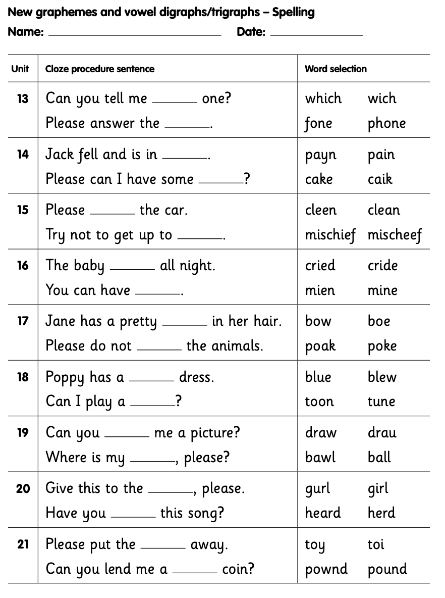  Maths  EYFS Maths Starter – Can you begin to learn your number bonds to 20? Practise these alongside your number bonds to 10.  EYFS - Access the White Rose Maths website for home learning (link below).  https://whiterosemaths.com/homelearning/early-years/  Complete Summer Term Week 8 (w/c 15th June) - Day 1: Princess Mirror-Belle (watch the video before following the links to complete suggested activities).  KS1 Maths Starter  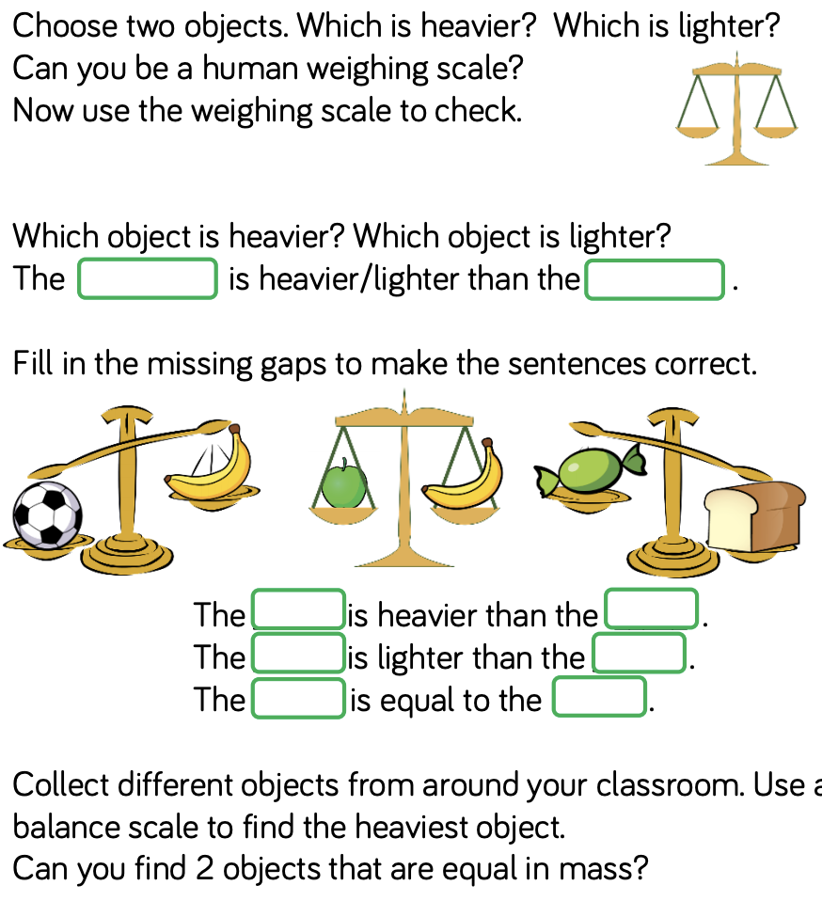  Y1 Access the White Rose Maths website for home learning (link below).  https://whiterosemaths.com/homelearning/year-1/  Complete Summer Term – Week 10 (w/c 29th June) Lesson 1 (watch the video before following the links to complete suggested activities).  Y2 Access the White Rose Maths website for home learning (link below).  https://whiterosemaths.com/homelearning/year-2/  Complete Summer Term – Week 10 (w/c 29th June) – Lesson 1 (watch the video before following the links to complete suggested activities).  KS1 - If you do have access to a printer and want to print the linked sheets that go with each lesson, you can do. If you do this, you do not have to do the Power Maths pages as well. If you do not have access to a printer, watch the White Rose video each day and then complete work in your Power Maths books.  Daily Project – TOPIC/HISTORY – Monday and Tuesday (complete over 2 days)  EYFS and KS1: Look at the pictures of forms of transport through the ages (see separate attached document). Can you place them in chronological order? Talk about how transport has changed over time – try to use historical vocabulary associated with the passing of time. Explain what visual clues they can spot and what they reveal Use books and the internet to find out a little more. Can you make a poster to share your learning?  Useful Links: http://www.gmts.co.uk/ and https://www.ltmuseum.co.uk/.
Tuesday | Phonics/Literacy  Preschool – see notes above.  Reception – Phase 4 revision: Practise GPCs and Phase 4 Tricky Words – You can continue to play ‘Flashcards’ using the previously attached resources and ‘Quickwrite Graphemes’ (say the sound on the flashcard ask your child to write it without them seeing it), or alternatively if any of the activities that have been set in weeks 1 and 2 were particularly successful in helping your child to learn their tricky words you could incorporate these for a change. Twinkl sheet - Page 2 - Phase 4 Home Learning Challenges.  Year 1 – Continue revision of all of the GPCs phase 2 – 5 with your child at a rapid pace (continue to use previously suggested activities) + complete assessment task below + work through ‘Talk for Creative Writing’ unit. This fortnight, your book is called ‘Pippety Skycap - A Tale of Mischief’. Enjoy this tale of mischief. There are some super activities to do each day. Try to do at least one each day if you can.  Year 2 - Continue revision of spelling all Common Exception Words using suggestions from Summer Term B Week 3 + complete assessment task below + work through ‘Talk for Creative Writing’ unit. This fortnight, your book is called ‘Superheros’. The three superheroes in this booklet are called Jo Awesome, Raja Extraordinary and Sammy Exceptional and they will guide you through the activities.  YEARS 1 AND 2 ASSESSMENT TASK:  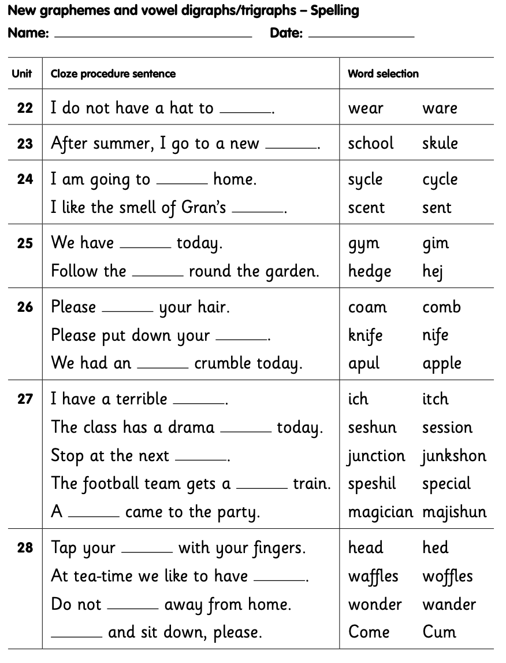  Maths  EYFS Maths Starter:  Pick an activity from the EYFS Maths Starters PowerPoint (attached in separate document on website).  EYFS - Access the White Rose Maths website for home learning (link below).  https://whiterosemaths.com/homelearning/early-years/  Complete Summer Term Week 8 (w/c 15th June) - Day 2: Princess Mirror-Belle (watch the video before following the links to complete suggested activities).  KS1 Maths Starter:  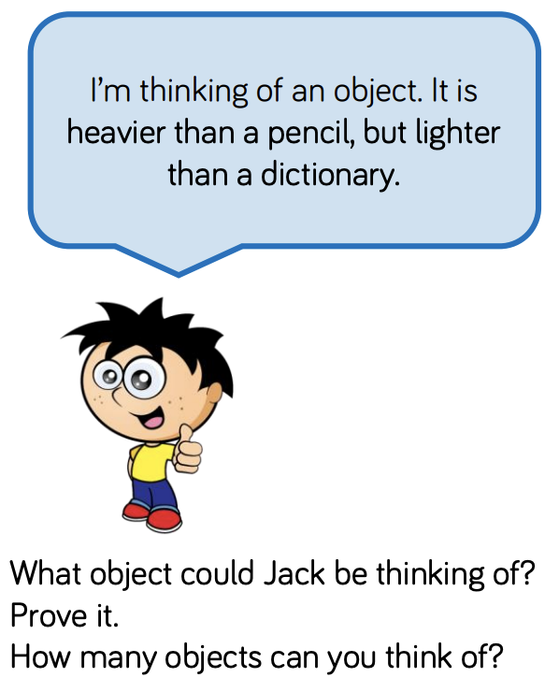  Y1 Access the White Rose Maths website for home learning (link below).  https://whiterosemaths.com/homelearning/year-1/  Complete Summer Term – Week 10 (w/c 29th June) Lesson 2 (watch the video before following the links to complete suggested activities).  Y2 Access the White Rose Maths website for home learning (link below).  https://whiterosemaths.com/homelearning/year-2/  Complete Summer Term – Week 10 (w/c 29th June) – Lesson 2 (watch the video before following the links to complete suggested activities).  KS1 - If you do have access to a printer and want to print the White Rose sheets that go with each lesson, you can do. If you do this, you do not have to do the Power Maths pages as well.  If you do not have access to a printer, watch the White Rose video each day and then complete the Power Maths books.  Daily Project – TOPIC/HISTORY – Monday and Tuesday (complete over 2 days)  EYFS and KS1: Look at the pictures of forms of transport through the ages (see separate attached document). Can you place them in chronological order? Talk about how transport has changed over time – try to use historical vocabulary associated with the passing of time. Explain what visual clues they can spot and what they reveal Use books and the internet to find out a little more. Can you make a poster to share your learning?  Useful Links: http://www.gmts.co.uk/ and https://www.ltmuseum.co.uk/.

Wednesday | Phonics/Literacy  Preschool – see notes above.  Reception – Phase 4 revision + Work through ‘Talk for Creative Writing’ unit: Practise GPCs and Phase 4 Tricky Words – You can continue to play ‘Flashcards’ using the previously attached resources and ‘Quickwrite Graphemes’ (say the sound on the flashcard ask your child to write it without them seeing it), or alternatively if any of the activities that have been set in weeks 1 and 2 were particularly successful in helping your child to learn their tricky words you could incorporate these for a change. Practise reading the following words:  stib blat brod twop slaf flem swip gluf clum frem  crup snig skap speg plon prin drog trub smat gred  Now move on to ‘Talk for Creative Writing’: Max’s Jungle Adventures. There are 11 little sections in this unit of work. Please try at least one section each day.  Year 1 – Continue revision of all of the GPCs phase 2 – 5 with your child at a rapid pace (continue to use previously suggested activities) + complete assessment task below + work through ‘Talk for Creative Writing’ unit. This fortnight, your book is called ‘Pippety Skycap - A Tale of Mischief’. Enjoy this tale of mischief. There are some super activities to do each day. Try to do at least one each day if you can.  Year 2 - Continue revision of spelling all Common Exception Words using suggestions from Summer Term B Week 3 + complete assessment task below + work through ‘Talk for Creative Writing’ unit. This fortnight, your book is called ‘Superheros’. The three superheroes in this booklet are called Jo Awesome, Raja Extraordinary and Sammy Exceptional and they will guide you through the activities.  YEARS 1 AND 2 ASSESSMENT TASK – Can you read the words in the grid below? Highlight any that you found tricky to practise further. You could also practise reading other words with this sound in. For example, if you found ‘boam’ difficult to read you could practise reading toast, float, foam, throat, boat etc. How many can you think of?  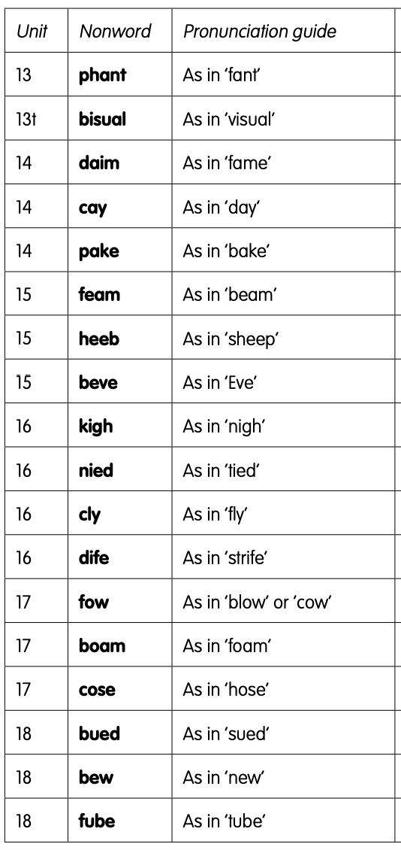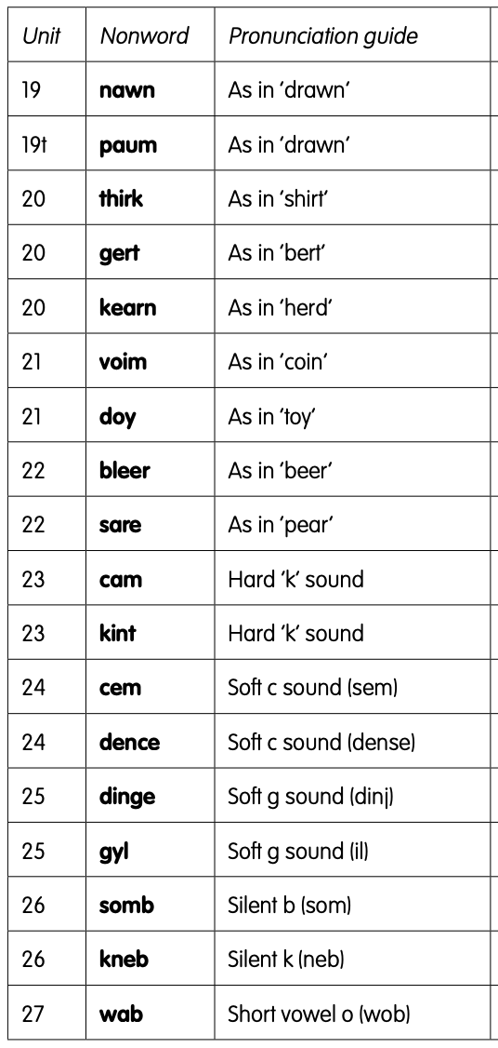  Maths  EYFS Maths Starter:  Pick an activity from the EYFS Maths Starters PowerPoint (attached in separate document on website).  EYFS - Access the White Rose Maths website for home learning (link below).  https://whiterosemaths.com/homelearning/early-years/  Complete Summer Term Week 8 (w/c 15th June) - Day 3: Princess Mirror-Belle (watch the video before following the links to complete suggested activities).  KS1 Maths Starter:  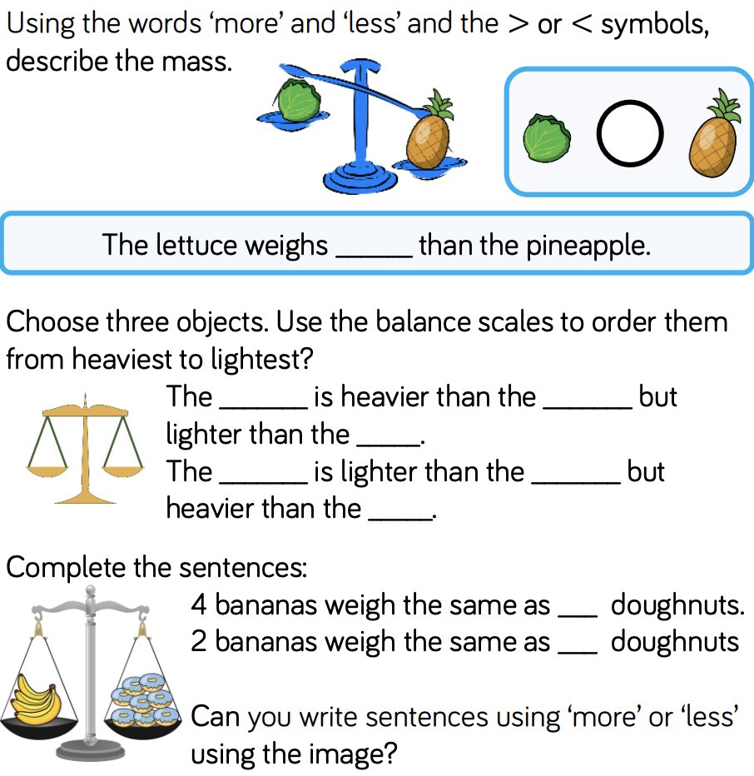  Y1 Access the White Rose Maths website for home learning (link below).  https://whiterosemaths.com/homelearning/year-1/  Complete Summer Term – Week 10 (w/c 29th June) Lesson 3 (watch the video before following the links to complete suggested activities).  Y2 Access the White Rose Maths website for home learning (link below).  https://whiterosemaths.com/homelearning/year-2/  Complete Summer Term – Week 10 (w/c 29th June) – Lesson 3 (watch the video before following the links to complete suggested activities).  KS1 - If you do have access to a printer and want to print the White Rose sheets that go with each lesson, you can do. If you do this, you do not have to do the Power Maths pages as well.  If you do not have access to a printer, watch the White Rose video each day and then complete the Power Maths books.  Daily Project – Mental Health/PSHE  EYFS and KS1: Continue with the next page of your ‘Family positivity and gratitude pack’ (see resources attached on the website from week 1).
Thursday | Phonics/Literacy  Preschool – see notes above.  Reception – Phase 4 revision + Work through ‘Talk for Creative Writing’ unit: Practise GPCs and Phase 4 Tricky Words – You can continue to play ‘Flashcards’ using the previously attached resources and ‘Quickwrite Graphemes’ (say the sound on the flashcard ask your child to write it without them seeing it), or alternatively if any of the activities that have been set in weeks 1 and 2 were particularly successful in helping your child to learn their tricky words you could incorporate these for a change. Practise reading the following words:  tond dist fent hong kump pask relt saft musp bink  tund dest fant ting kemp posk ralt suft mosp hink  Now move on to ‘Talk for Creative Writing’: Max’s Jungle Adventures. There are 11 little sections in this unit of work. Please try at least one section each day.  Year 1 – Continue revision of all of the GPCs phase 2 – 5 with your child at a rapid pace (continue to use previously suggested activities) + complete assessment task below + work through ‘Talk for Creative Writing’ unit. This fortnight, your book is called ‘Pippety Skycap - A Tale of Mischief’. Enjoy this tale of mischief. There are some super activities to do each day. Try to do at least one each day if you can.  Year 2 - Continue revision of spelling all Common Exception Words using suggestions from Summer Term B Week 3 + complete assessment task below + work through ‘Talk for Creative Writing’ unit. This fortnight, your book is called ‘Superheros’. The three superheroes in this booklet are called Jo Awesome, Raja Extraordinary and Sammy Exceptional and they will guide you through the activities.  YEARS 1 AND 2 ASSESSMENT TASK:  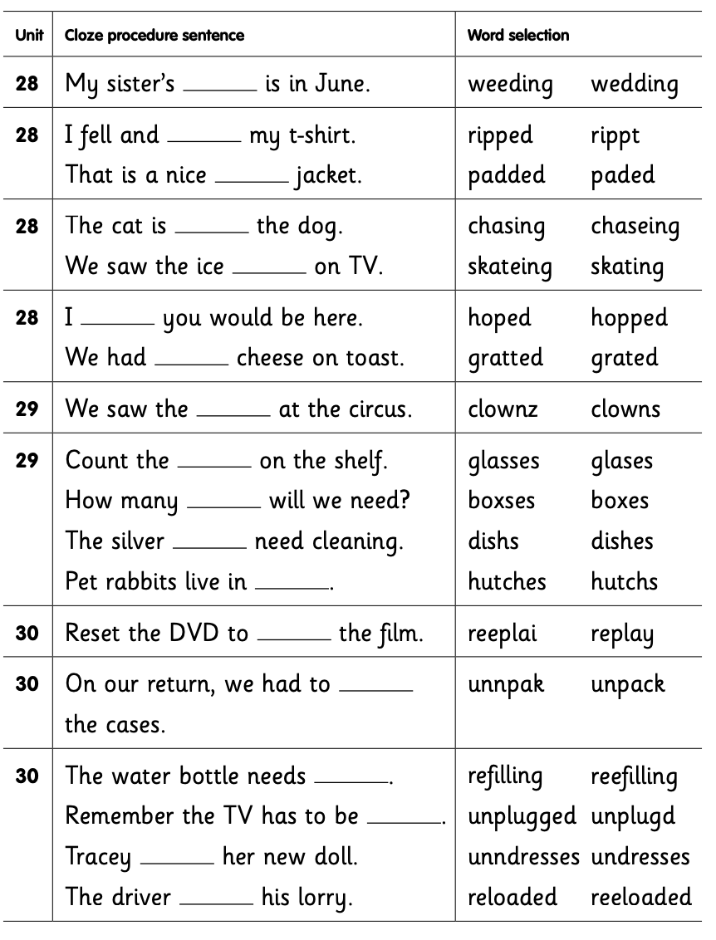  Maths  EYFS Maths Starter:  Pick an activity from the EYFS Maths Starters PowerPoint (attached in separate document on website).  EYFS - Access the White Rose Maths website for home learning (link below).  https://whiterosemaths.com/homelearning/early-years/  Complete Summer Term Week 8 (w/c 15th June) - Day 4: Princess Mirror-Belle (watch the video before following the links to complete suggested activities).  KS1 Maths Starter:  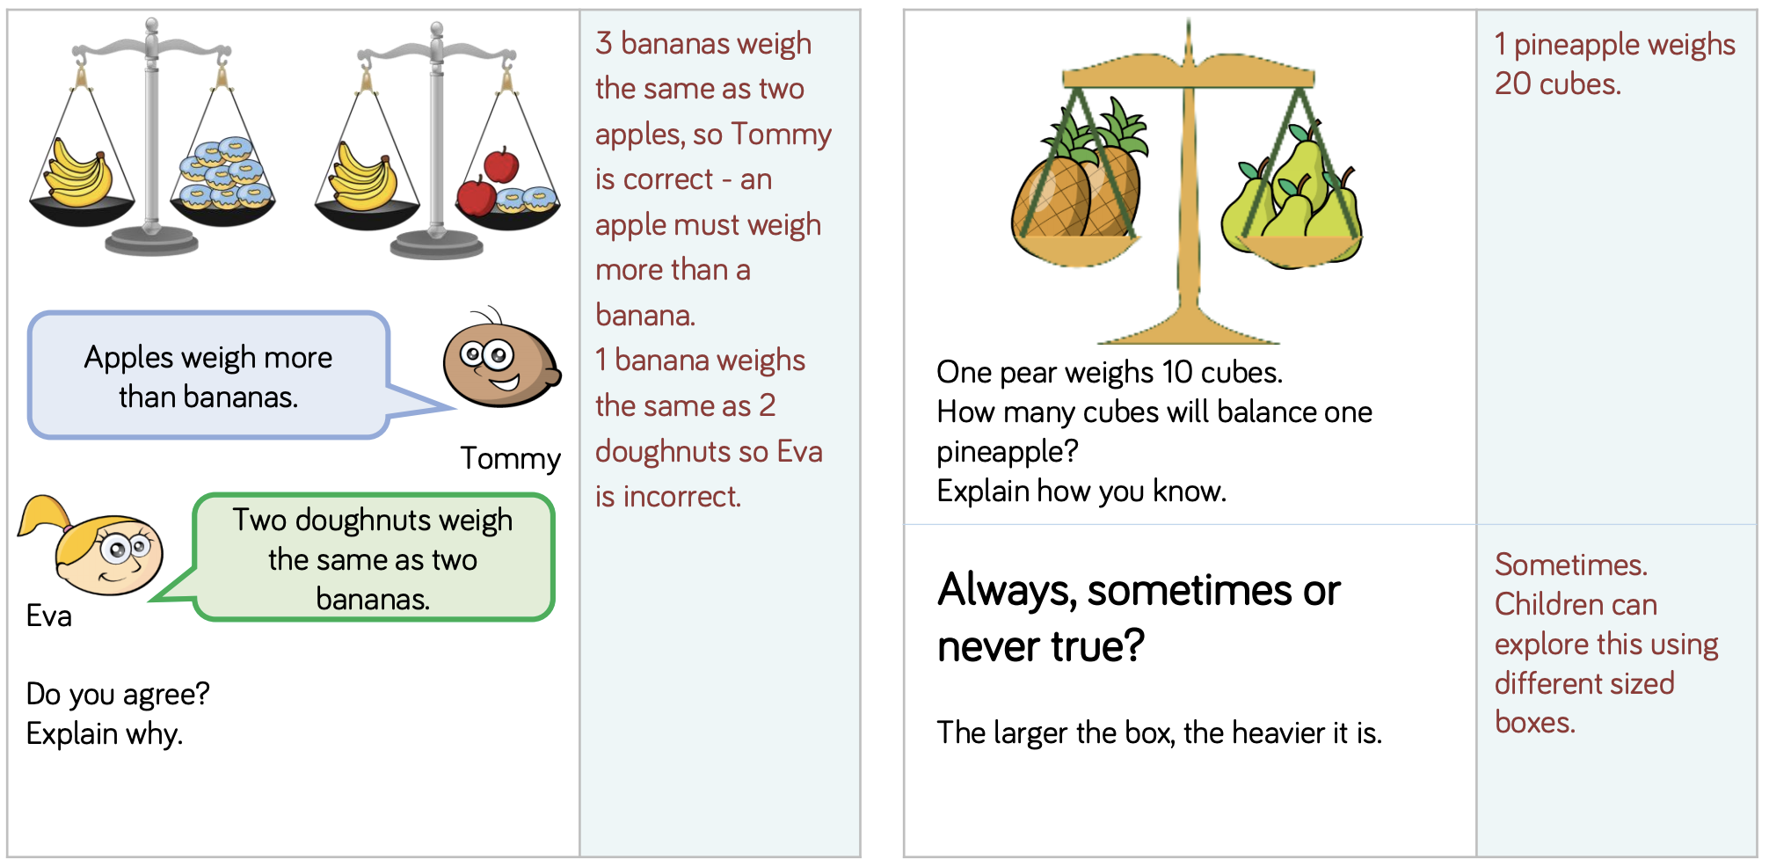  Y1 Access the White Rose Maths website for home learning (link below).  https://whiterosemaths.com/homelearning/year-1/  Complete Summer Term – Week 10 (w/c 29th June) Lesson 4 (watch the video before following the links to complete suggested activities).  Y2 Access the White Rose Maths website for home learning (link below).  https://whiterosemaths.com/homelearning/year-2/  Complete Summer Term – Week 10 (w/c 29th June) – Lesson 4 (watch the video before following the links to complete suggested activities).  KS1 - If you do have access to a printer and want to print the White Rose sheets that go with each lesson, you can do. If you do this, you do not have to do the Power Maths pages as well.  If you do not have access to a printer, watch the White Rose video each day and then complete the Power Maths books.  Daily Project – RE  EYFS and KS1: Find and follow the PowerPoint about Sikh Gurdwara (attached as a separate document on the website). There is also a labelling activity to complete at the bottom of this document.
Friday | Phonics/Literacy  Preschool – see notes above.  Reception – Phase 4 revision + Work through ‘Talk for Creative Writing’ unit: AS LAST WEEK Watch some of these videos to revise your phonemes https://www.bbc.co.uk/bitesize/topics/zvq9bdm. Have a look at the games on this website: http://www.letters-and-sounds.com/phase-4-games.html and have a go at some of them to practise your phonics. Practise reading the following words:  blapt slest crilk fromp spunt plasp stend spimp plont crupt  blamp slelt crint spind plusp frast stemp crind blosp plupt  Now move on to ‘Talk for Creative Writing’: Max’s Jungle Adventures. There are 11 little sections in this unit of work. Please try at least one section each day.  Year 1 – Continue revision of all of the GPCs phase 2 – 5 with your child at a rapid pace (continue to use previously suggested activities) + complete assessment task below + work through ‘Talk for Creative Writing’ unit. This fortnight, your book is called ‘Pippety Skycap - A Tale of Mischief’. Enjoy this tale of mischief. There are some super activities to do each day. Try to do at least one each day if you can.  Year 2 - Continue revision of spelling all Common Exception Words using suggestions from Summer Term B Week 3 + complete assessment task below + work through ‘Talk for Creative Writing’ unit. This fortnight, your book is called ‘Superheros’. The three superheroes in this booklet are called Jo Awesome, Raja Extraordinary and Sammy Exceptional and they will guide you through the activities.  YEARS 1 AND 2 ASSESSMENT TASK:  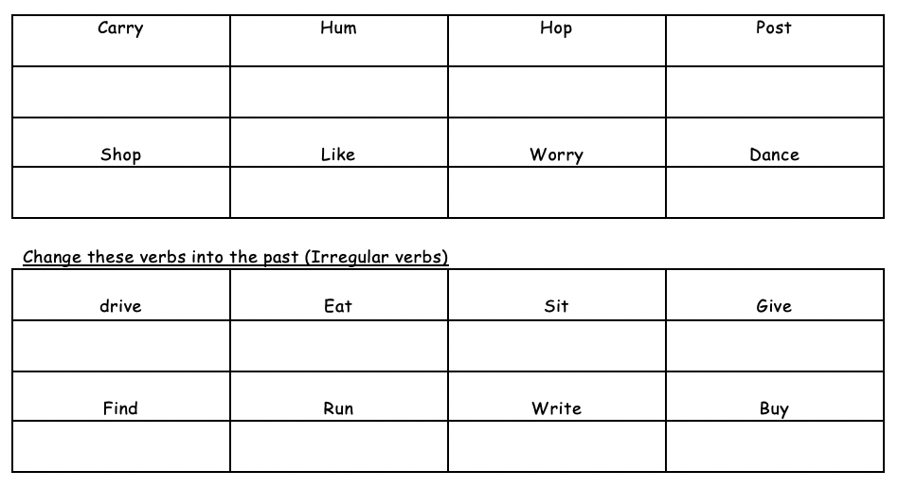  Maths  EYFS Maths Starter:  Pick an activity from the EYFS Maths Starters PowerPoint (attached in separate document on website).  EYFS - Access the White Rose Maths website for home learning (link below).  https://whiterosemaths.com/homelearning/early-years/  Complete Summer Term Week 8 (w/c 15th June) - Day 5: Princess Mirror-Belle (watch the video before following the links to complete suggested activities).  KS1 Maths Starter:  Today we would like you to spend some time practising your mental maths skills. This includes rapid recall of number bonds to 10 and 20, as well as counting in 2s, 3s, 5s and 10s.  Y1 Access the White Rose Maths website for home learning (link below).  https://whiterosemaths.com/homelearning/year-1/  Complete Summer Term – Week 10 (w/c 29th June) Lesson 5 (watch the video before following the links to complete suggested activities).  Y2 Access the White Rose Maths website for home learning (link below).  https://whiterosemaths.com/homelearning/year-2/  Complete Summer Term – Week 10 (w/c 29th June) – Lesson 5 (watch the video before following the links to complete suggested activities).  KS1 If you do have access to a printer and want to print the White Rose sheets that go with each lesson, you can do. If you do this, you do not have to do the Power Maths pages as well.  If you do not have access to a printer, watch the White Rose video each day and then complete the Power Maths books.  Daily Project – SPELLING  KS1 – See sheets attached below for revision and practise. (Please note that there is a sheet for this week and also one ready for next week).  Daily Project - Extra-Curricular Time (PE/ TOPIC/HISTORY/PSHE and MENTAL HEALTH)  EYFS and KS1 TASK 1 - Can you find out about some playground games from past generations? These might include hopscotch, hoops, blind man’s buff, hot potato, marbles and Simon says. Other table games, such as tiddlywinks, jacks and snap, were also popular. Investigate the rules of how to play and have a go at learning some of these.  EYFS and KS1 TASK 2 - Today you can have a look at managing worry. Use the link below to get to a One Decision video that will help you: https://us8.campaign-archive.com/?u=57437507f4a3aad76843b6d9e&amp;id=1696dc257d&amp;e=b9859c0018  Next, make a worry monster:  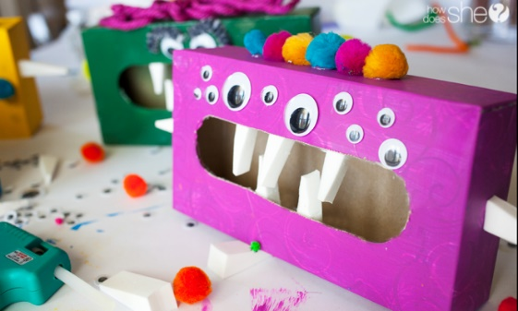  You can decide how you want your monster to manage your worries; you may choose to scribble your worries on paper and feed them to the monster and forget about them, or you may choose to write down your concerns and share them with a trusted adult.

Reception spellings
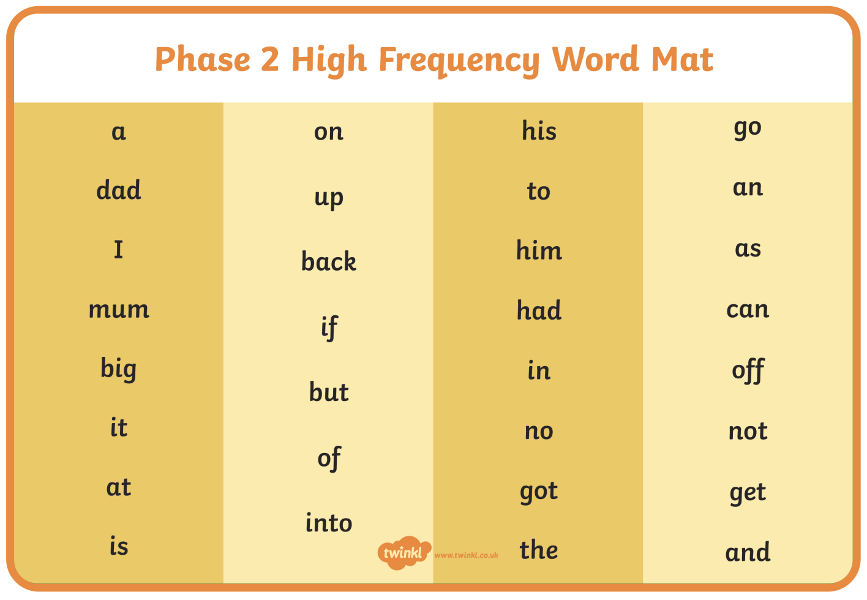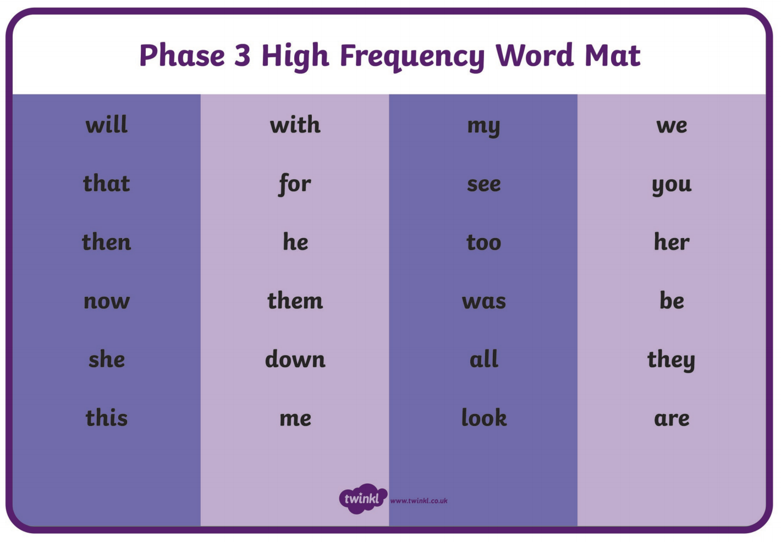

KS1 – Spellings
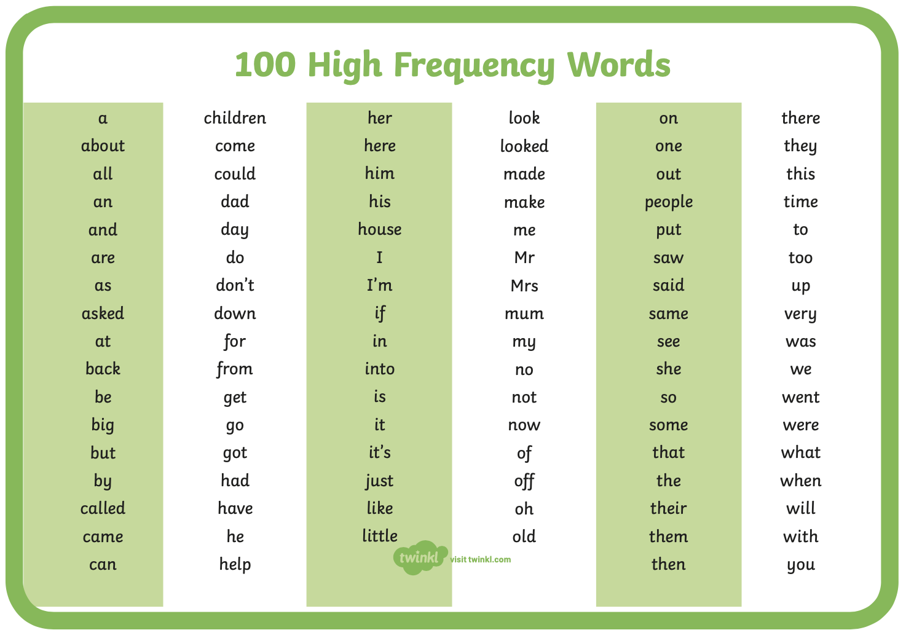
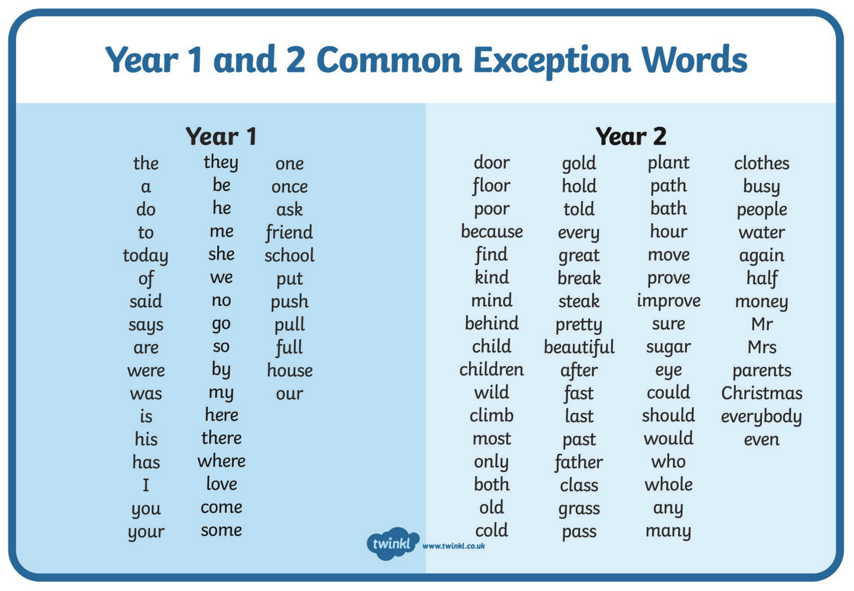
Pre-school Letter Formation Guidance
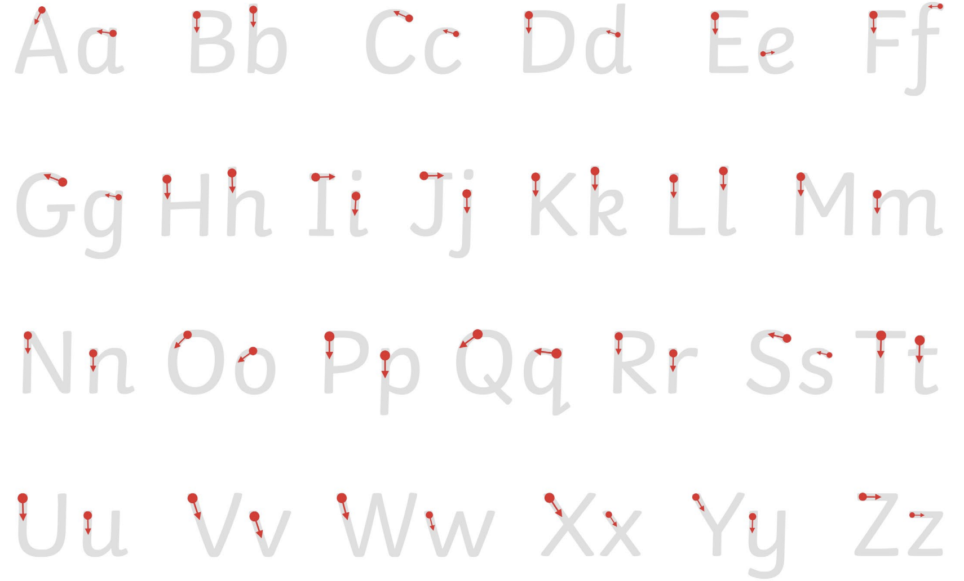
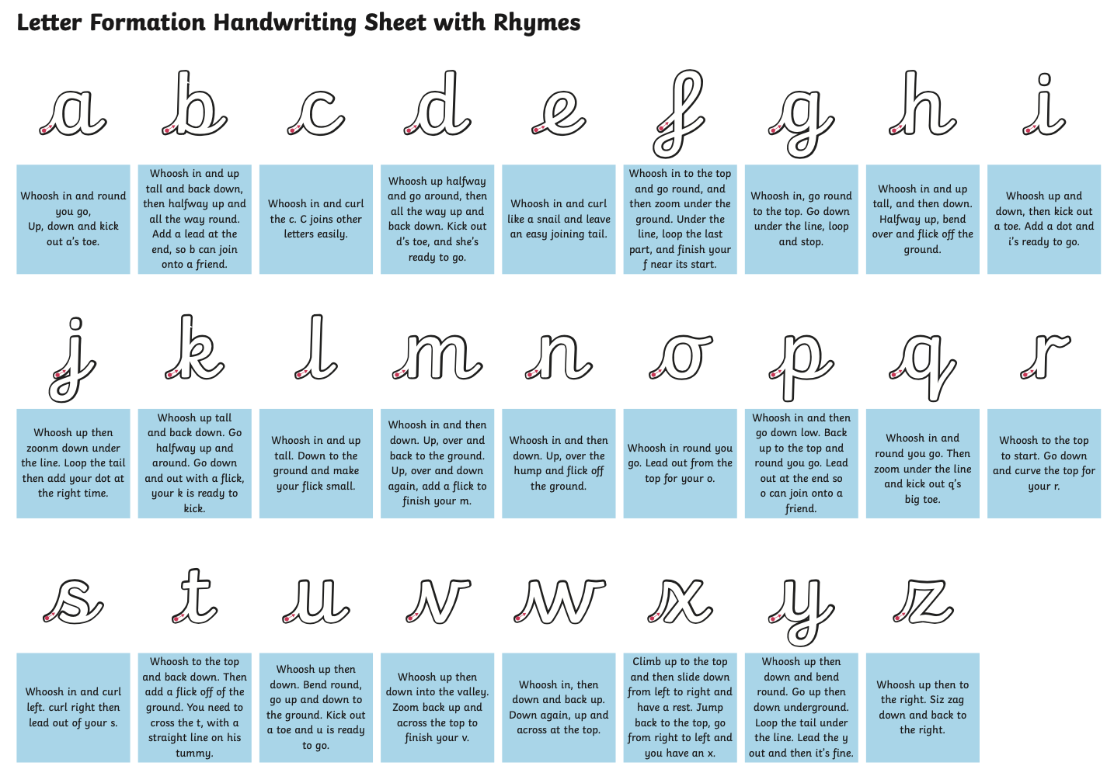

Monday | Phonics/Literacy – Continuing and completing work set last week.  Preschool – see notes above.  Reception – Phase 4 revision + complete task below + work through ‘Talk for Creative Writing’ unit: Practise GPCs and Phase 4 Tricky Words – You can continue to play ‘Flashcards’ using the previously attached resources and ‘Quickwrite Graphemes’ (say the sound on the flashcard ask your child to write it without them seeing it), or alternatively if any of the activities that have been set in weeks 1 and 2 were particularly successful in helping your child to learn their tricky words you could incorporate these for a change.  Complete the task:  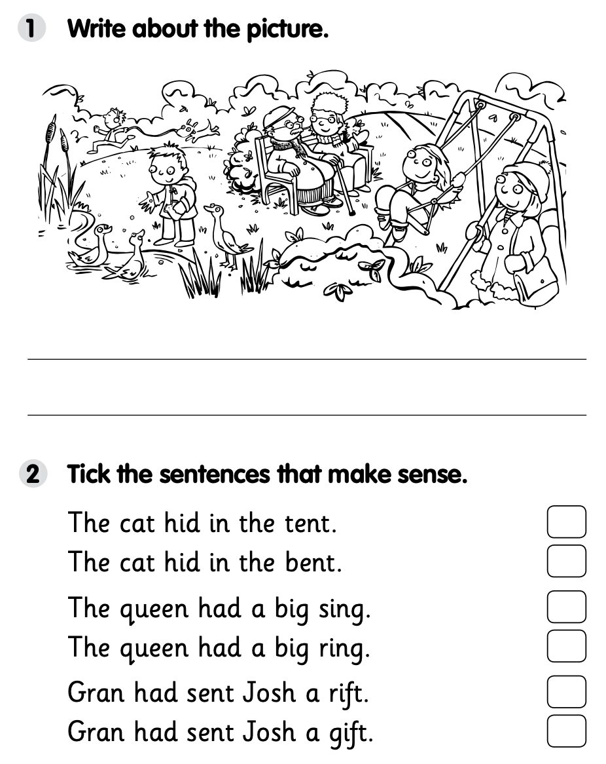  Now move on to ‘Talk for Creative Writing’: Max’s Jungle Adventures. There are 11 little sections in this unit of work. Please try at least one section each day.  Year 1 – Continue revision of all of the GPCs phase 2 – 5 with your child at a rapid pace (continue to use previously suggested activities) + complete task below + work through ‘Talk for Creative Writing’ unit. This fortnight, your book is called ‘Pippety Skycap - A Tale of Mischief’. Enjoy this tale of mischief. There are some super activities to do each day. Try to do at least one each day if you can.  Year 2 - Continue revision of spelling all Common Exception Words using suggestions from Summer Term B Week 3 + complete task below + work through ‘Talk for Creative Writing’ unit. This fortnight, your book is called ‘Superheros’. The three superheroes in this booklet are called Jo Awesome, Raja Extraordinary and Sammy Exceptional and they will guide you through the activities.  YEARS 1 AND 2 TASK:  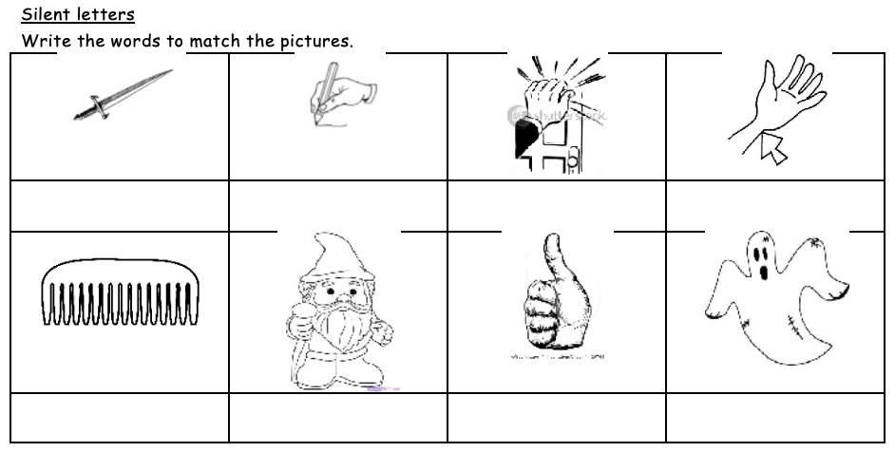  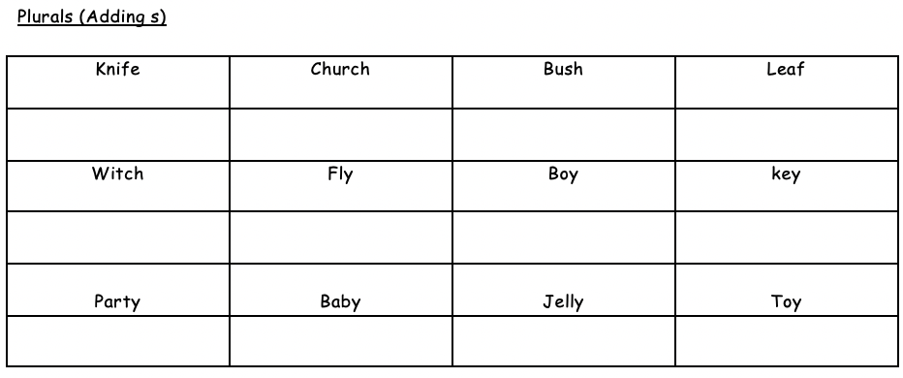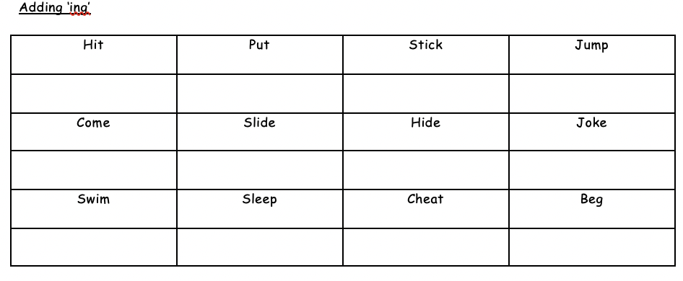  Maths  EYFS Maths Starter – Can you begin to learn your number bonds to 20? Practise these alongside your number bonds to 10. You could also pick an activity from the EYFS Maths Starters PowerPoint (attached in separate document on website).  EYFS - Access the White Rose Maths website for home learning (link below).  https://whiterosemaths.com/homelearning/early-years/  Complete Summer Term Week 9 (w/c 22nd June) - Day 1: Zog (watch the video before following the links to complete suggested activities).  KS1 Maths Starter  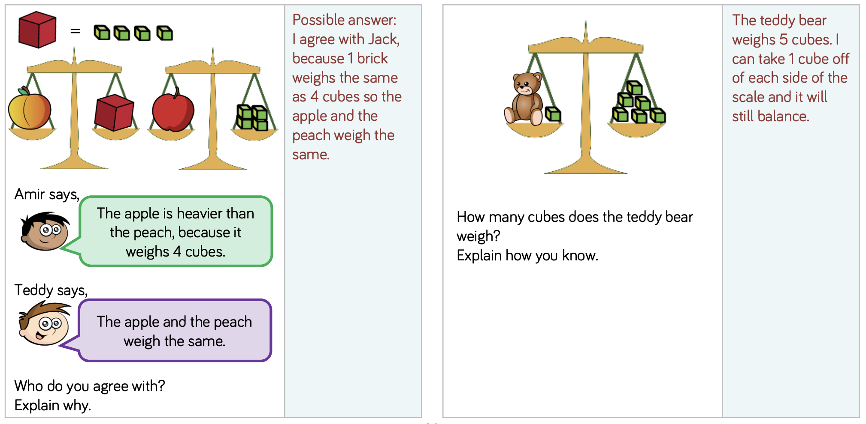  Y1 Access the White Rose Maths website for home learning (link below).  https://whiterosemaths.com/homelearning/year-1/  Complete Summer Term – Week 11 (w/c 6th July) Lesson 1 (watch the video before following the links to complete suggested activities).  Y2 Access the White Rose Maths website for home learning (link below).  https://whiterosemaths.com/homelearning/year-2/  Complete Summer Term – Week 11 (w/c 6th July) Lesson 1 (watch the video before following the links to complete suggested activities).  KS1 - If you do have access to a printer and want to print the White Rose sheets that go with each lesson, you can do. If you do this, you do not have to do the Power Maths pages as well.  If you do not have access to a printer, watch the White Rose video each day and then complete the Power Maths books.  Daily Project – PE/Mental Health/PSHE/RE  TASK 1 RE - EYFS and KS1: Find and follow the PowerPoint about Mandir (attached as a separate document on the website). There is also a labelling activity to complete at the bottom of this document.  TASK 2 – EYFS and KS1: Continue with the next page of your ‘Family positivity and gratitude pack’ (see resources attached on the website from week 1).
Tuesday | Phonics/Literacy – Continuing and completing work set last week.  Preschool – see notes above.  Reception – Phase 4 revision + complete task below + work through ‘Talk for Creative Writing’ unit: Practise GPCs and Phase 4 Tricky Words – You can continue to play ‘Flashcards’ using the previously attached resources and ‘Quickwrite Graphemes’ (say the sound on the flashcard ask your child to write it without them seeing it), or alternatively if any of the activities that have been set in weeks 1 and 2 were particularly successful in helping your child to learn their tricky words you could incorporate these for a change.  Complete the task:  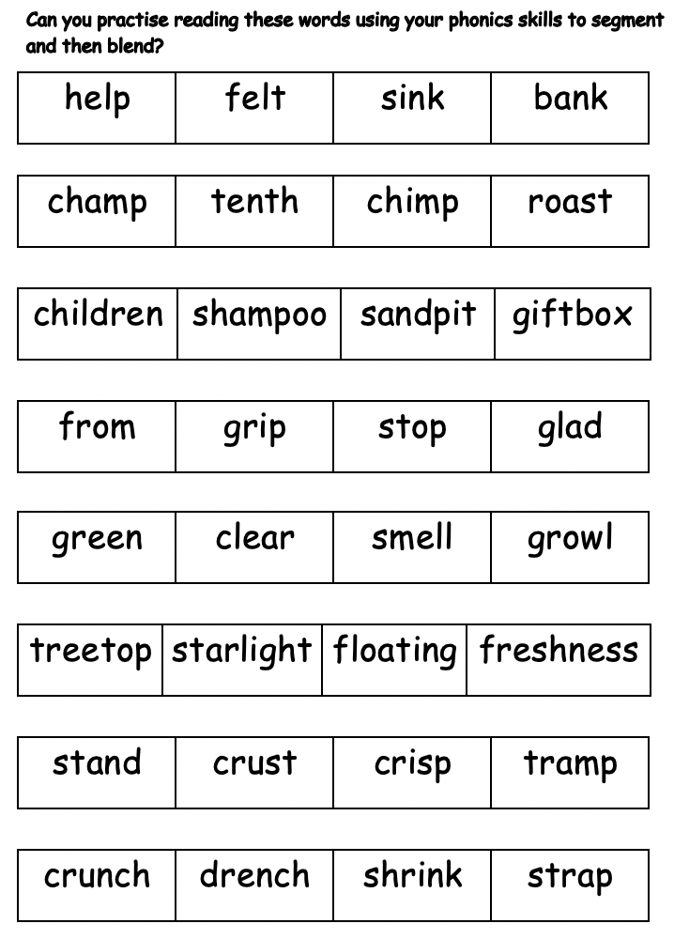  Now move on to ‘Talk for Creative Writing’: Max’s Jungle Adventures. There are 11 little sections in this unit of work. Please try at least one section each day.  Year 1 – Continue revision of all of the GPCs phase 2 – 5 with your child at a rapid pace (continue to use previously suggested activities) + complete task below + work through ‘Talk for Creative Writing’ unit. This fortnight, your book is called ‘Pippety Skycap - A Tale of Mischief’. Enjoy this tale of mischief. There are some super activities to do each day. Try to do at least one each day if you can.  Year 2 - Continue revision of spelling all Common Exception Words using suggestions from Summer Term B Week 3 + complete task below + work through ‘Talk for Creative Writing’ unit. This fortnight, your book is called ‘Superheros’. The three superheroes in this booklet are called Jo Awesome, Raja Extraordinary and Sammy Exceptional and they will guide you through the activities.  YEARS 1 AND 2 TASK:  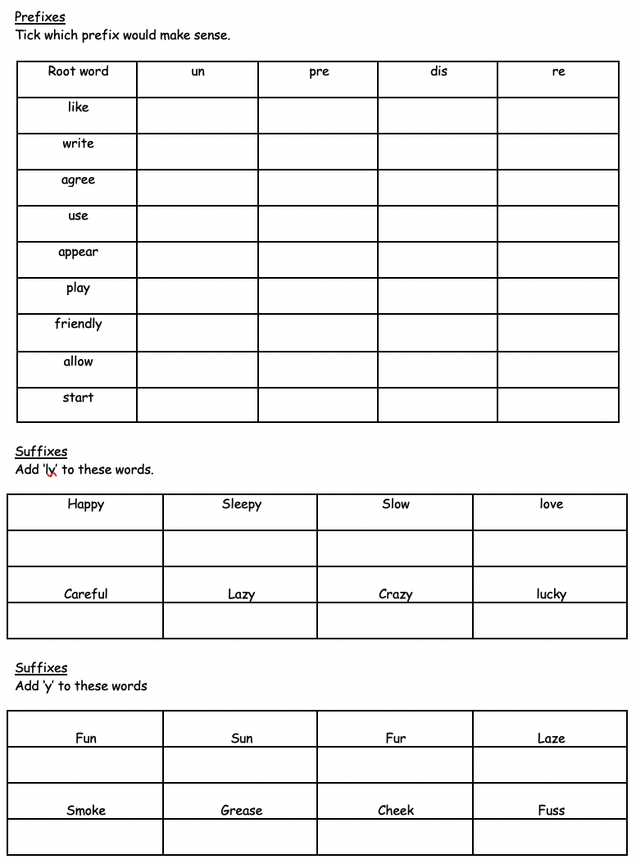  Maths  EYFS Maths Starter – Can you begin to learn your number bonds to 20? Practise these alongside your number bonds to 10. You could also pick an activity from the EYFS Maths Starters PowerPoint (attached in separate document on website).  EYFS - Access the White Rose Maths website for home learning (link below).  https://whiterosemaths.com/homelearning/early-years/  Complete Summer Term Week 9 (w/c 22nd June) - Day 2: Zog (watch the video before following the links to complete suggested activities).  KS1 Maths Starter:  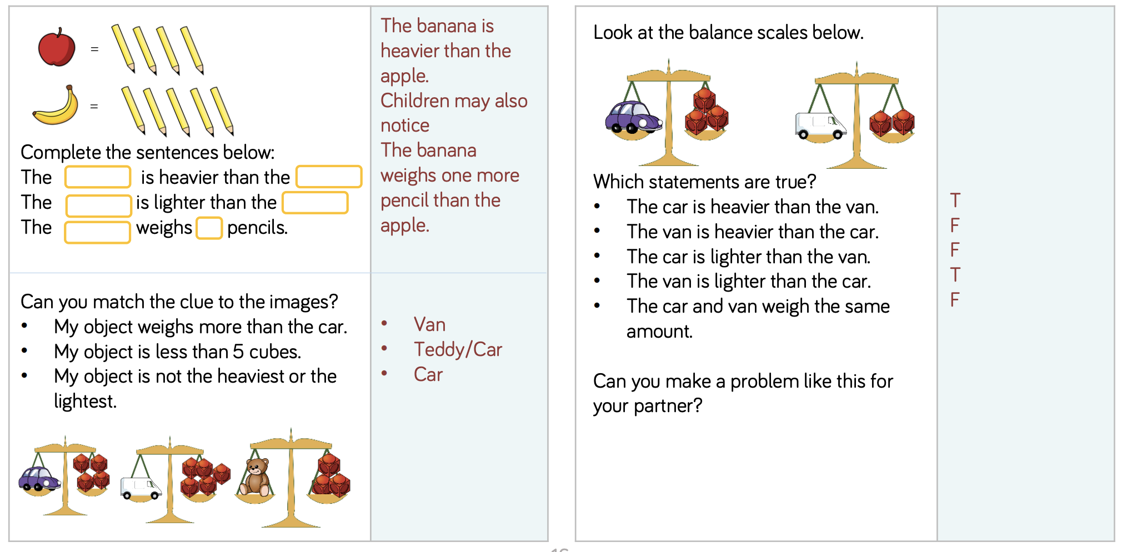  Y1 Access the White Rose Maths website for home learning (link below).  https://whiterosemaths.com/homelearning/year-1/  Complete Summer Term – Week 11 (w/c 6th July) Lesson 2 (watch the video before following the links to complete suggested activities).  Y2 Access the White Rose Maths website for home learning (link below).  https://whiterosemaths.com/homelearning/year-2/  Complete Summer Term – Week 11 (w/c 6th July) Lesson 2 (watch the video before following the links to complete suggested activities).  KS1 - If you do have access to a printer and want to print the White Rose sheets that go with each lesson, you can do. If you do this, you do not have to do the Power Maths pages as well.  If you do not have access to a printer, watch the White Rose video each day and then complete the Power Maths books.  Daily Project - EYFS and KS1 TOPIC  This week we would like you to spend some time on beginning to make a Memory Box in your ‘Daily Project’ time. A memory box is a special place for you to keep important and treasured memories. You can put in special things that belong to you, like an old toy, something you had as a baby, photographs, letters, drawings and other things that will remind you of precious and memorable times. What will you put in your special box?  Here are the first steps to take this week:  Step 1: You will need to decide how you will make your special memory box. You could use a shoebox and decorate it with lovely colours, papers and materials or perhaps a collage or decoupage of photos of you and your family!  Step 2: Pad the box on the inside using coloured tissue, foam or bubble wrap to make sure things don’t get broken. Maybe you could make some compartments for your objects?  Step 3: Make a list of all the things you would like to collect for your box. You will need to take your list home, so write it in your best handwriting so that grown ups can read it clearly. Have you included any sensory items? Perhaps a sachet of a favourite cream or soap that someone in your family uses? Maybe spray a perfume or aftershave onto a cloth or soft toy. Did you know that smell is a powerful way of triggering memories? How about including a favourite packet of sweets? You could eat one in years to come – that’s if they haven’t gone off by then. Yuk!

Wednesday | Phonics/Literacy – Continuing and completing work set last week.  Preschool – see notes above.  Reception – Phase 4 revision + complete task below + work through ‘Talk for Creative Writing’ unit: Practise GPCs and Phase 4 Tricky Words – You can continue to play ‘Flashcards’ using the previously attached resources and ‘Quickwrite Graphemes’ (say the sound on the flashcard ask your child to write it without them seeing it), or alternatively if any of the activities that have been set in weeks 1 and 2 were particularly successful in helping your child to learn their tricky words you could incorporate these for a change.  Complete the focus task – practise reading these words:  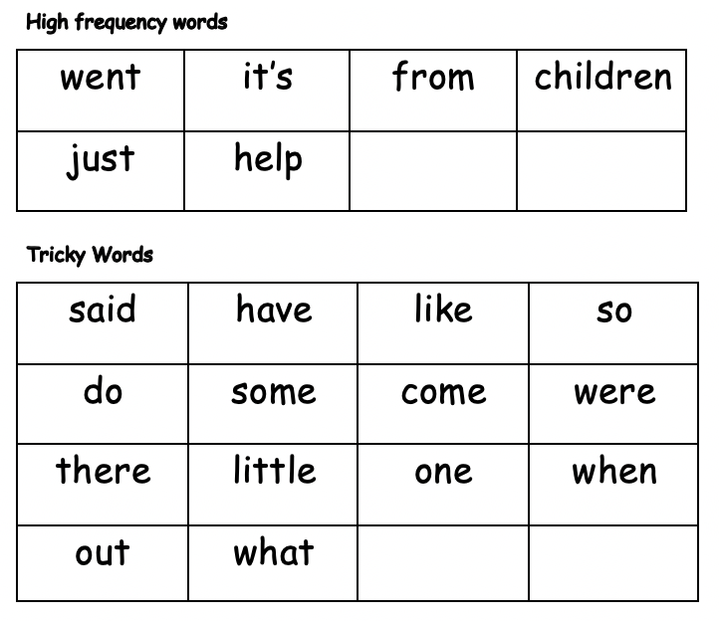  Now move on to ‘Talk for Creative Writing’: Max’s Jungle Adventures. There are 11 little sections in this unit of work. Please try at least one section each day.  Year 1 – Continue revision of all of the GPCs phase 2 – 5 with your child at a rapid pace (continue to use previously suggested activities) + complete task below + work through ‘Talk for Creative Writing’ unit. This fortnight, your book is called ‘Pippety Skycap - A Tale of Mischief’. Enjoy this tale of mischief. There are some super activities to do each day. Try to do at least one each day if you can.  Year 2 - Continue revision of spelling all Common Exception Words using suggestions from Summer Term B Week 3 + complete task below + work through ‘Talk for Creative Writing’ unit. This fortnight, your book is called ‘Superheros’. The three superheroes in this booklet are called Jo Awesome, Raja Extraordinary and Sammy Exceptional and they will guide you through the activities.  YEARS 1 AND 2 TASK:  Homophones  Circle the word which makes the sentence make sense.  The boy put shampoo on his (hare/hair).  Mum put some (flower/flour) in the cake mix.  James didn't have a very good (nights/knights) sleep.  Tony got chased by a large (bare/bear).  Lucy couldn't wait to (meet/meat) her friend.  Andrew (missed/mist) the bus.  The mouse got his (tale/tail) caught.  Glen has a long (wait/weight) for the bus.  The cat hurt its (pour/poor/paw).  The old man had no money, he was (pour/poor/paw).  "Could you (pour/poor/paw) the orange juice, please?"  Mark got a letter in the (mail/male).  Maths  EYFS Maths Starter – Can you begin to learn your number bonds to 20? Practise these alongside your number bonds to 10. You could also pick an activity from the EYFS Maths Starters PowerPoint (attached in separate document on website).  EYFS - Access the White Rose Maths website for home learning (link below).  https://whiterosemaths.com/homelearning/early-years/  Complete Summer Term Week 9 (w/c 22nd June) - Day 3: Zog (watch the video before following the links to complete suggested activities).  KS1 Maths Starter:  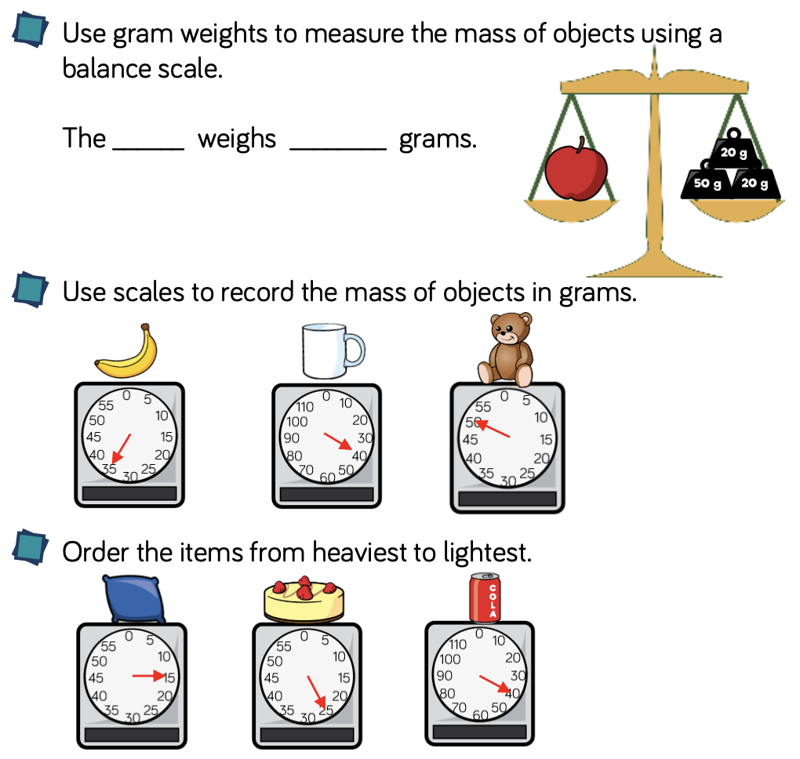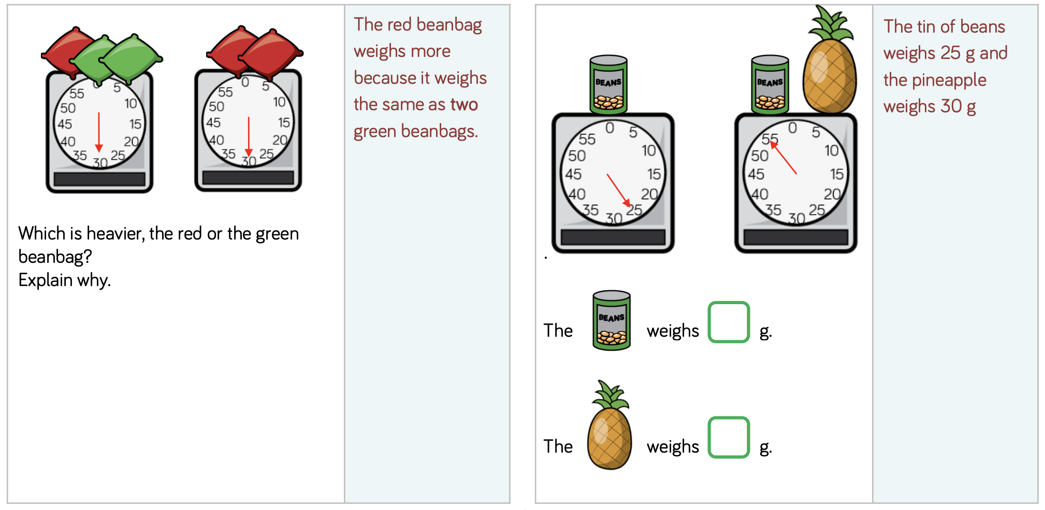  Y1 Access the White Rose Maths website for home learning (link below).  https://whiterosemaths.com/homelearning/year-1/  Complete Summer Term – Week 11 (w/c 6th July) Lesson 3 (watch the video before following the links to complete suggested activities).  Y2 Access the White Rose Maths website for home learning (link below).  https://whiterosemaths.com/homelearning/year-2/  Complete Summer Term – Week 11 (w/c 6th July) Lesson 3 (watch the video before following the links to complete suggested activities).  KS1 - If you do have access to a printer and want to print the White Rose sheets that go with each lesson, you can do. If you do this, you do not have to do the Power Maths pages as well.  If you do not have access to a printer, watch the White Rose video each day and then complete the Power Maths books.  Daily Project - EYFS and KS1  Use this time to do some more work on your Memory Box.  Here are the next two steps:  Step 4: Write messages on small cards to include in your box. Write about things you love and enjoy now so you can recall those things when you are older. You could start your messages with: I love…, I enjoy…, My best friend is…, My teacher is…  Step 5: Attach a small label or tag to each one of your items to remind you why it is important or special. Luggage labels are a good way of doing this!
Thursday | Phonics/Literacy – Continuing and completing work set last week.  Preschool – see notes above.  Reception – Phase 4 revision + complete task below + work through ‘Talk for Creative Writing’ unit: Practise GPCs and Phase 4 Tricky Words – You can continue to play ‘Flashcards’ using the previously attached resources and ‘Quickwrite Graphemes’ (say the sound on the flashcard ask your child to write it without them seeing it), or alternatively if any of the activities that have been set in weeks 1 and 2 were particularly successful in helping your child to learn their tricky words you could incorporate these for a change.  Complete the focus task:  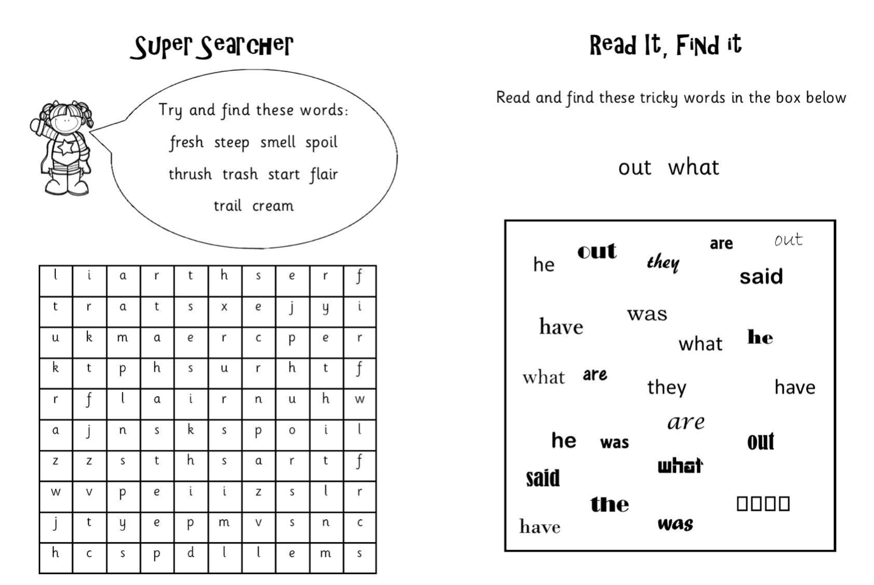  Now move on to ‘Talk for Creative Writing’: Max’s Jungle Adventures. There are 11 little sections in this unit of work. Please try at least one section each day.  Year 1 – Continue revision of all of the GPCs phase 2 – 5 with your child at a rapid pace (continue to use previously suggested activities) + complete task below + work through ‘Talk for Creative Writing’ unit. This fortnight, your book is called ‘Pippety Skycap - A Tale of Mischief’. Enjoy this tale of mischief. There are some super activities to do each day. Try to do at least one each day if you can.  Year 2 - Continue revision of spelling all Common Exception Words using suggestions from Summer Term B Week 3 + complete task below + work through ‘Talk for Creative Writing’ unit. This fortnight, your book is called ‘Superheros’. The three superheroes in this booklet are called Jo Awesome, Raja Extraordinary and Sammy Exceptional and they will guide you through the activities.  YEARS 1 AND 2 TASK:  Homophones  Correct the homophones in the text below.  Last knight when I looked up the sky was dark blew. I new I wood sea stars but eye was surprised buy there brightness. Who had maid them seam sew beautiful? I was shore they had bean maid millions of years ago, and I was court up in there beauty. I wanted to stair at them four ever, butt my piece was disturbed. Nun of this would bee forgotten but I knew it was to grate to last.  Maths  EYFS Maths Starter – Can you begin to learn your number bonds to 20? Practise these alongside your number bonds to 10. You could also pick an activity from the EYFS Maths Starters PowerPoint (attached in separate document on website).  EYFS - Access the White Rose Maths website for home learning (link below).  https://whiterosemaths.com/homelearning/early-years/  Complete Summer Term Week 9 (w/c 22nd June) - Day 4: Zog (watch the video before following the links to complete suggested activities).  KS1 Maths Starter:  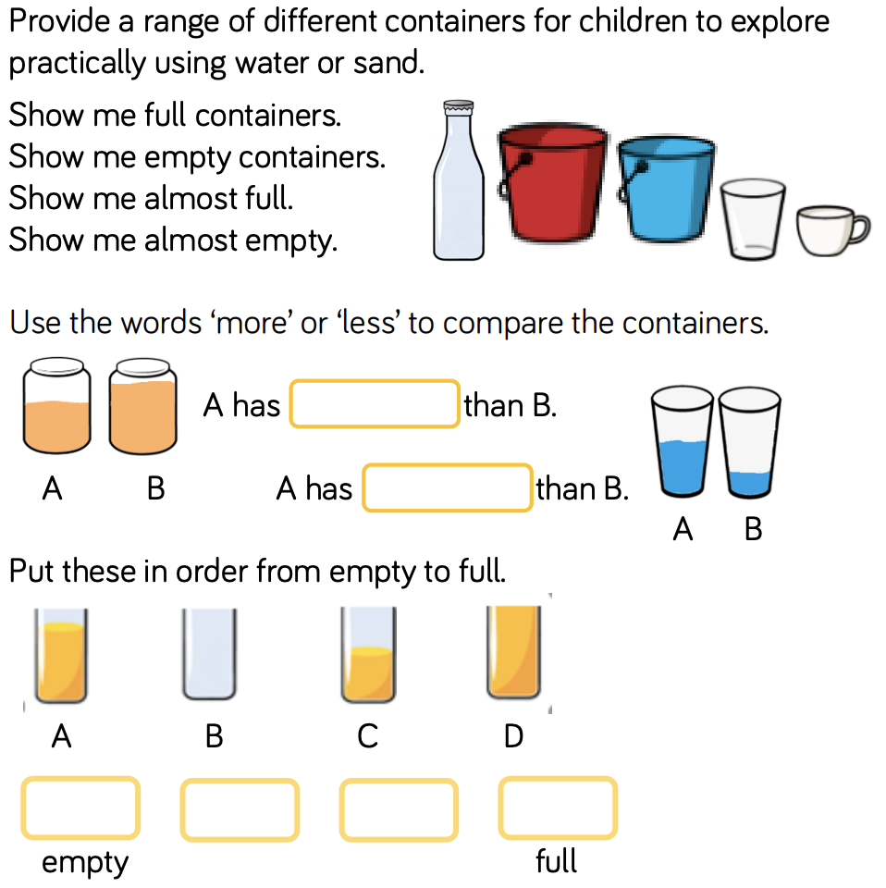  Y1 Access the White Rose Maths website for home learning (link below).  https://whiterosemaths.com/homelearning/year-1/  Complete Summer Term – Week 11 (w/c 6th July) Lesson 4 (watch the video before following the links to complete suggested activities).  Y2 Access the White Rose Maths website for home learning (link below).  https://whiterosemaths.com/homelearning/year-2/  Complete Summer Term – Week 11 (w/c 6th July) Lesson 4 (watch the video before following the links to complete suggested activities).  KS1 - If you do have access to a printer and want to print the White Rose sheets that go with each lesson, you can do. If you do this, you do not have to do the Power Maths pages as well.  If you do not have access to a printer, watch the White Rose video each day and then complete the Power Maths books.  Daily Project - EYFS and KS1  Use this time to do some more work on your Memory Box.  Finished your memory box? What is happening in the world? Have a look at https://www.bbc.co.uk/newsround or https://www.dogonews.com/ to see what is going on in the world. Choose a news article or two to read.
Friday | Phonics/Literacy – Continuing and completing work set last week.  Preschool – see notes above.  Reception – Phase 4 revision + complete task below + work through ‘Talk for Creative Writing’ unit: Practise GPCs and Phase 4 Tricky Words – You can continue to play ‘Flashcards’ using the previously attached resources and ‘Quickwrite Graphemes’ (say the sound on the flashcard ask your child to write it without them seeing it), or alternatively if any of the activities that have been set in weeks 1 and 2 were particularly successful in helping your child to learn their tricky words you could incorporate these for a change.  Complete the focus task – practise reading these words:  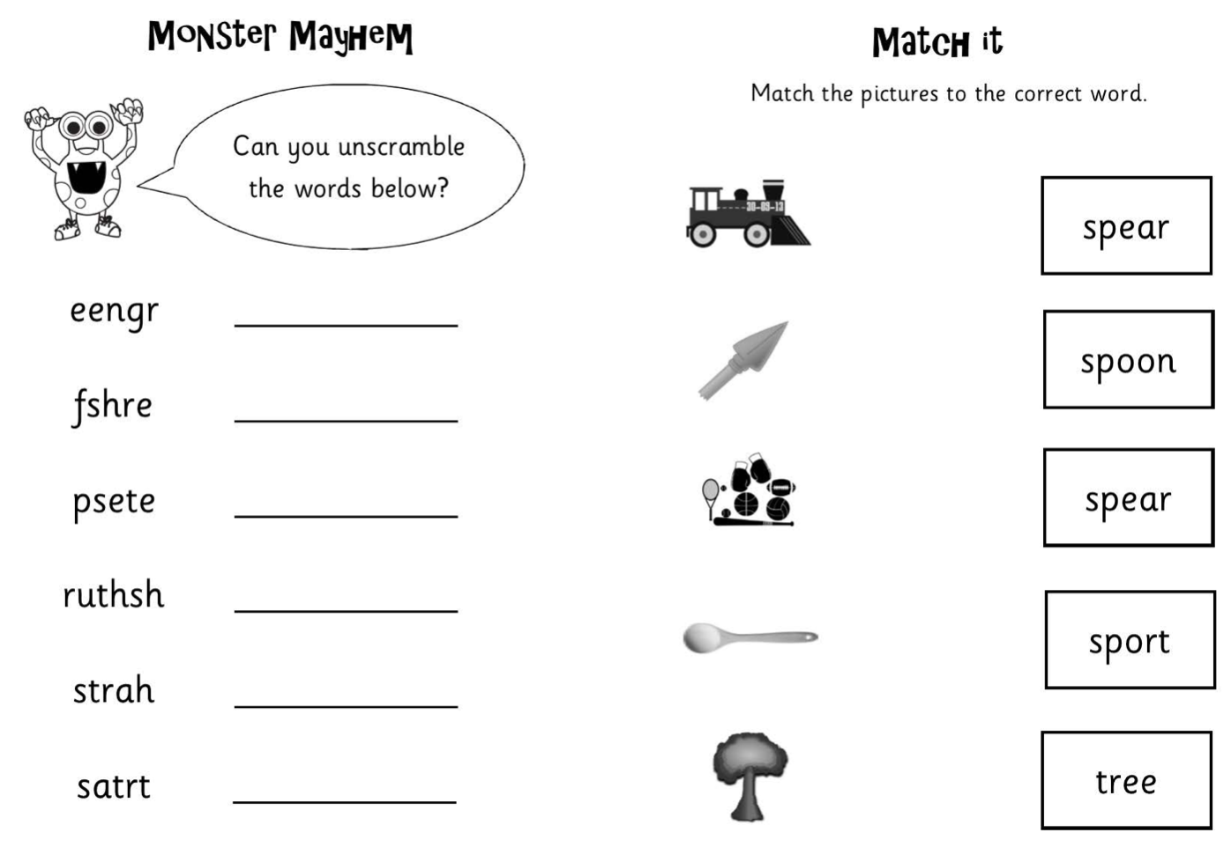  Now move on to ‘Talk for Creative Writing’: Max’s Jungle Adventures. There are 11 little sections in this unit of work. Please try at least one section each day.  Year 1 – Continue revision of all of the GPCs phase 2 – 5 with your child at a rapid pace (continue to use previously suggested activities) + complete task below + work through ‘Talk for Creative Writing’ unit. This fortnight, your book is called ‘Pippety Skycap - A Tale of Mischief’. Enjoy this tale of mischief. There are some super activities to do each day. Try to do at least one each day if you can.  Year 2 - Continue revision of spelling all Common Exception Words using suggestions from Summer Term B Week 3 + complete task below + work through ‘Talk for Creative Writing’ unit. This fortnight, your book is called ‘Superheros’. The three superheroes in this booklet are called Jo Awesome, Raja Extraordinary and Sammy Exceptional and they will guide you through the activities.  YEARS 1 AND 2 TASK:  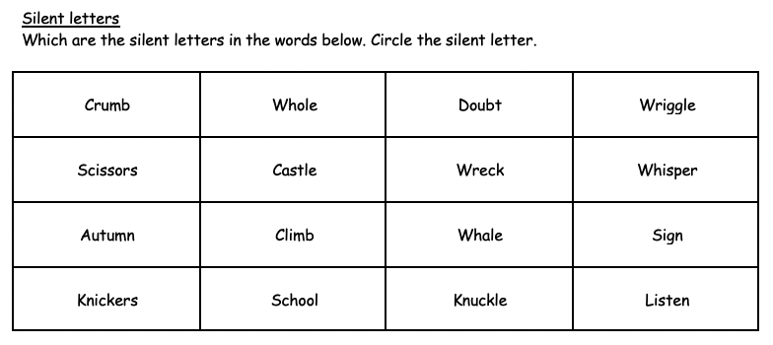  Maths  EYFS Maths Starter – Can you begin to learn your number bonds to 20? Practise these alongside your number bonds to 10. You could also pick an activity from the EYFS Maths Starters PowerPoint (attached in separate document on website).  EYFS - Access the White Rose Maths website for home learning (link below).  https://whiterosemaths.com/homelearning/early-years/  Complete Summer Term Week 9 (w/c 22nd June) - Day 5: Zog (watch the video before following the links to complete suggested activities).  KS1 Maths Starter:  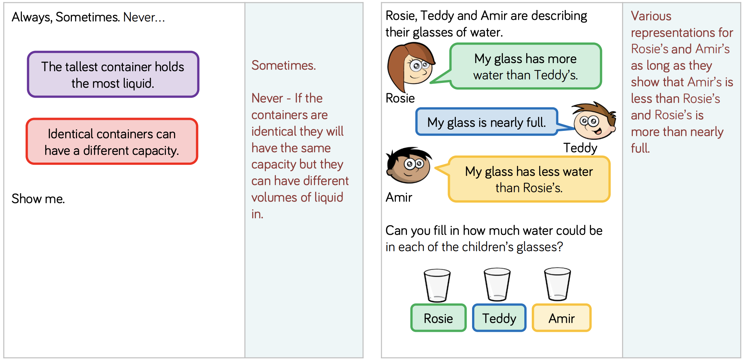  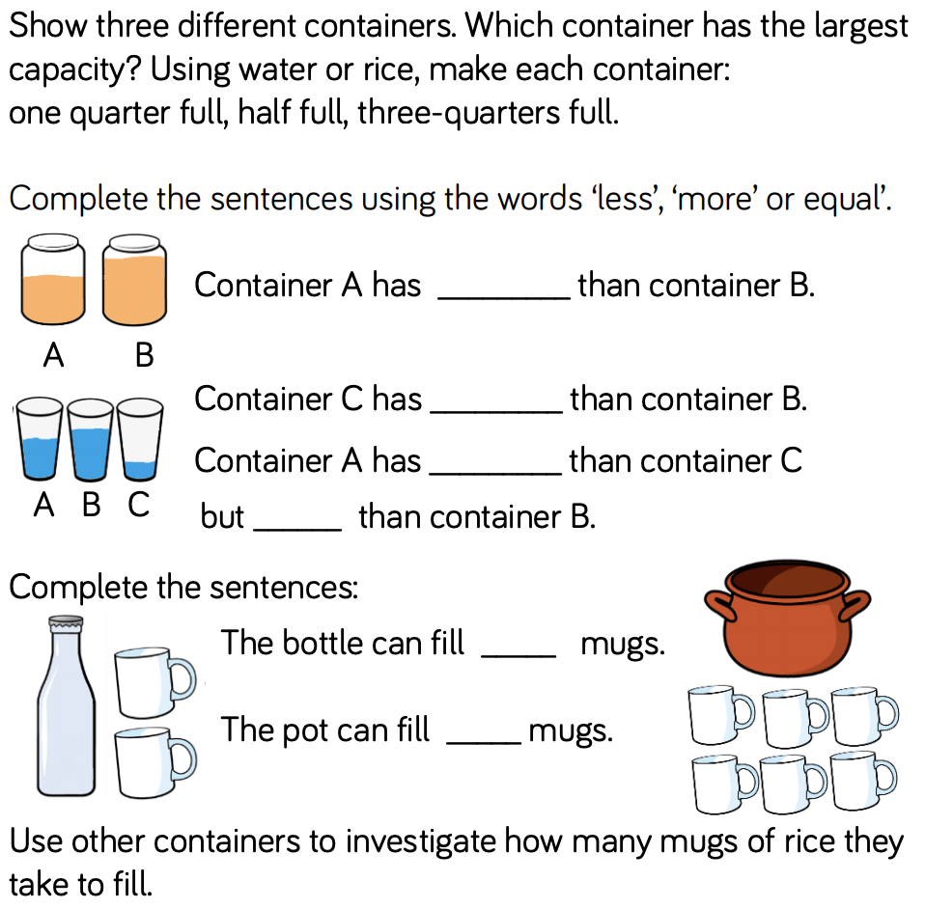  Y1 Access the White Rose Maths website for home learning (link below).  https://whiterosemaths.com/homelearning/year-1/  Complete Summer Term – Week 11 (w/c 6th July) Lesson 5 (watch the video before following the links to complete suggested activities).  Y2 Access the White Rose Maths website for home learning (link below).  https://whiterosemaths.com/homelearning/year-2/  Complete Summer Term – Week 11 (w/c 6th July) Lesson 5 (watch the video before following the links to complete suggested activities).  KS1 If you do have access to a printer and want to print the White Rose sheets that go with each lesson, you can do. If you do this, you do not have to do the Power Maths pages as well.  If you do not have access to a printer, watch the White Rose video each day and then complete the Power Maths books.  Daily Project – SPELLING  KS1 – See sheets attached below for revision and practise.  Daily Project – ALL: Extra-Curricular Time (PE/ PSHE/Mental Health/Mindfulness/Art)  Our focus this week is ‘Feelings and Emotions’, linked to our 10-a-day focus on talking about your feelings. Who could you talk to about how you have been feeling? Why not create a feelings ‘barometer’ so that you can communicate your feelings to your family without even needing to speak. You can download an emotions fan at https://www.elsa-support.co.uk/emotion-fans-with-synonyms/ or use the wheel below.  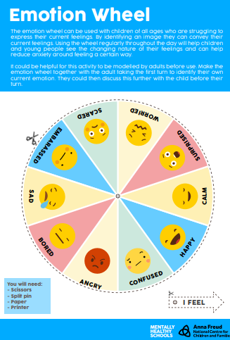  Write a list: what makes you feel happy…sad…angry…frustrated…bored…excited? When you feel sad, angry, worried or upset, what helps to calm you down? Write a list of strategies for keeping calm so that you can refer to it when you are next upset. Or make a collection of images that will help you to focus your thoughts on things that will help you feel calmer or happier.  CHALLENGE – ALL: Home Learning without a Screen  Fancy a challenge or just looking for something to do?  Here are some fun and meaningful ideas to choose from:  - How many different words can you make from the letters in this sentence, below? Grab a pencil and paper and write a list!  ‘Learning from home is fun’  - Thank a community hero. Think of someone that helps you in some way and write a short letter to thank them.  - Can you create your own secret code? You could use letters, numbers, pictures or something else! Can you get someone else to try and crack it?  - Start a nature diary. Look out of the window each day and keep note  of what you see. Birds, flowers, changes in the weather, what else?  - Use an old sock to create a puppet. Can you put on a puppet show for someone?  - Make a list of all the electrical items in each room of your home. Can you come up with any ideas to use less electricity?  - Do something kind for someone. Can you pay them a compliment, make them something or help them with a task?  - Can you create a story bag? Find a bag and collect items to go in it that relate to a well known story. If you can’t find an item, you could draw a picture to include.  - List making! Write a list of things that make you happy, things you’re grateful for or things you are good at.  - Design and make an obstacle course at home or in the garden. How fast can you complete it?  - Can you invent something new? Perhaps a gadget or something to help people? Draw a picture or write a description.  - Keep moving! Make up a dance routine to your favourite song.  - Write a song or rap about your favourite subject.  - Get sketching! Find a photograph or picture of a person, place or object and sketch it.  - Junk modelling! Collect and recycle materials such as yoghurt pots, toilet rolls and boxes and see what you can create with them.  - Draw a map of your local area and highlight interesting landmarks.  - Draw a view. Look out of your window and draw what you see.  - Get reading! What would you most like to learn about? Can you find out more about it in books? Perhaps you can find a new hobby?

Year One spellings  Week 5 | ir
This week please practise the ‘ir’ sound. Whirl and twirl.
read | copy | copy | Test yourself | or ?
girl
bird
shirt
first
thirsty
third
Year One spellings  Week 6 | aw
This week please practise the ‘aw’ sound. Yawn at dawn.
read | copy | copy | Test yourself | or ?
paw
claw
jaw
lawn
yawn
drawer

Year Two Spellings week 5
The ‘s’ sound spelt c before e, i and y. The soft ‘c’ sound.
Have a go at this crossword puzzle.
Practise the spelling games at https://spellingframe.co.uk/spelling-rule/81/4-The-s-sound-spelt-c-before-e-i-and-y
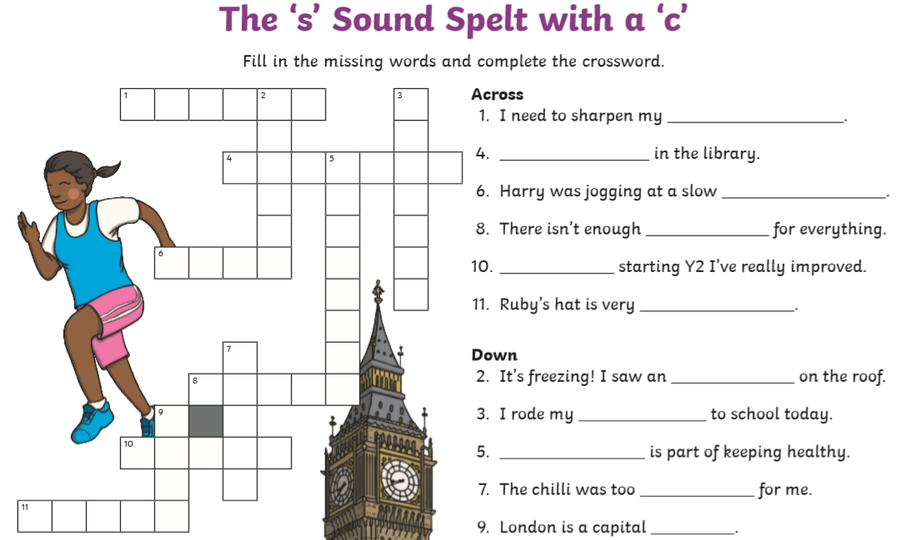

Year Two Spellings week 6
The ‘n’ sound spelt ‘kn’ and ‘gn’ at the beginning of words.

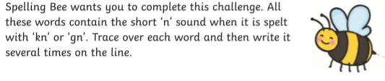

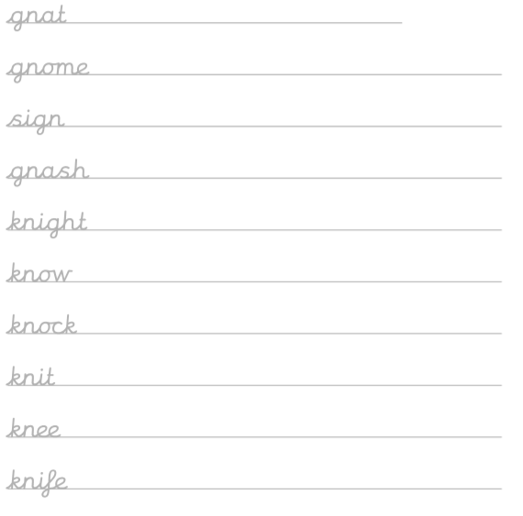 For an extra challenge, try the games and test on the spelling frame website.
https://spellingframe.co.uk/spelling-rule/82/5-The-n-sound-spelt-kn-and-less-often-gn

RE Week 5 Labels
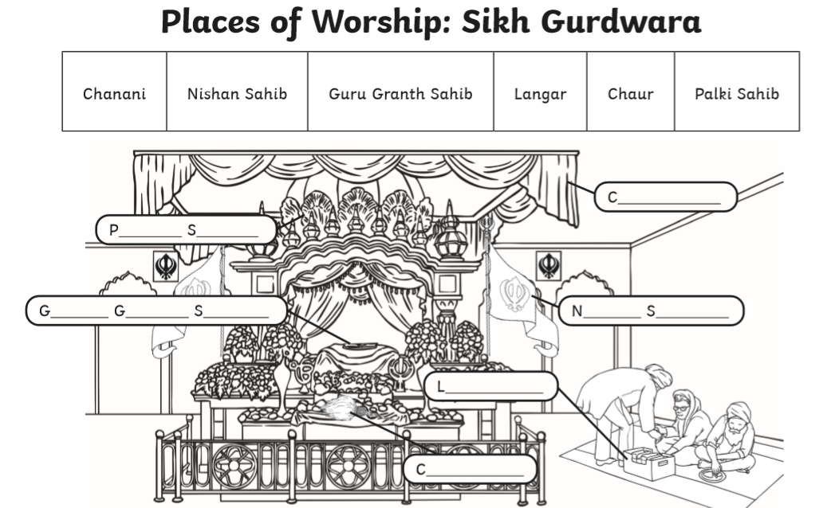
RE Week 6 Labels
