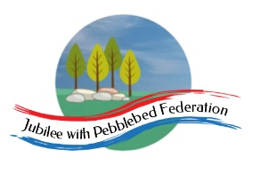

Class 2, Branscombe C of E Primary School

Dear Parents and Members of Class 2,

This week’s leg of our virtual world travels takes us to the continent of North America, focusing on the United States of America. We’ll look at the geographical features, human features and their culture and history, while also thinking about our own culture and British values.

Please be aware that we touch on the slave trade on Wednesday, and have provided some carefully chosen and checked links and activities that day, but we do not recommend allowing the children to research freely as they might encounter stories and images that could be disturbing to them. If the children are aware of the recent demonstrations around the world and campaigns for greater equality and justice, these lessons may provide some useful background and may prompt some interesting conversations!

We have also included particular Mental Health activities each day this week, that link to some of those we will be doing with the children in school. This week’s theme is ‘Love, Friendship and Belonging’ and the activities encourage the children to think about their friends and how they can care for others around them – even at a distance.

Again, if you wish to collect a set of these plans and resources from school, do let us know and we can print and leave a pack out for you.

(Scroll to the end of Friday’s plan for a sneak preview into the next part of our learning journey.)

Happy learning! Hope to see many of you again before too long,

Miss Moss

The most important thing you can do to support your child’s learning whilst schools are closed is to ensure that they read every day and they continue to practise their number bonds and times tables.

Don’t forget to keep using the accounts you have through our school to practise basic skills, such as reading, reading comprehension (Bug Club), Times tables (Times Table Rock Stars) and Spelling (Spelling Shed). I have set work on TTRS each week and I shall be checking these sites regularly to keep an eye on what you’re doing. Feel free to challenge me (Dot McRock) to a Rockslam competition!

Week beginning Monday 15th June

Monday  15th June | Core activities |  | Suggestions for additional activities.
9.00 – 9.30 | Daily Dashboard:  Quelle est la date aujourd’hui?  C’est lundi quinze juin 2020.  Can you write the number date in Roman numerals?  Smile Power Day is today. Feel the power. Give everyone you see a big, friendly, ‘I like you’ smile. You never know, your warm smile might just turn someone’s day around…for the good!  Love may make the world go round. But, a smile makes the world a happy place.  Did you know:You use more facial muscles to frown than to smile. So, smile - it’s easier!  This week we’re off to North America, with a particular focus on the United States of America. |  |  | Saturday was National Weed Your Garden Day. Did you do any weeding over the weekend? Sometimes a weed to one person is a beautiful flower to another.  Today is National Nature Photography Day. Why not go outside and see if you can capture a bee, a woodlouse or even a butterfly in a close up photo. If you use a phone, you can then edit it to crop the picture so the main focus is the bug. Perhaps you have birds nesting outside your house and you’ll see them flitting in and out to feed their hatchlings. Mrs Marsh says, “Sometimes I have slow worms, damsel flies and hedgehogs in my garden – I wonder if I’ll catch one today!”
9.30-10.00 | Grammar and spelling – see Grammar and Spelling resources |  | Use your spelling shed login to practise by playing spelling games.
10.00- 10.30 | Time for some PE –  A new challenge in the #DevonVirtualGames launches today. This week’s challenge is based on the game boccia but uses socks instead of balls,  so it is called –sock-ia! Have a look and join in at https://www.activedevon.org/wp-content/uploads/2020/06/Boccia-sockia-challenge-devon-virtual-games.pdf  Alternatively, here is a link to a golf rolling activity designed for home PE: https://www.youthsporttrust.org/sites/default/files/Home%20PE%20Golf%20Rolling.pdf  Or try another- ‘Climb the ladder’:  https://www.youthsporttrust.org/sites/default/files/Home%20PE%20Climb%20the%20Ladder.pdf  If you’ve done these recently, try a new one from Youth Sport Trust.
10.30-11.30 | Maths – Follow the links to the Oak National Academy Maths lessons  Year 3: https://classroom.thenational.academy/lessons/multiply-and-divide-by-10-and-100  Year 4: https://classroom.thenational.academy/lessons/measures-time-marathon-training  Year 5: https://classroom.thenational.academy/lessons/to-convert-miles-and-kilometres  Year 6: https://classroom.thenational.academy/lessons/to-generate-and-describe-linear-number-sequences |  |  |  | Don’t forget to keep logging on to Times Table Rock Stars to practise your times tables. A few minutes practice every day will soon improve your recall of key facts!
11.30-12.00 | Have a break and play a game or do another activity that you enjoy. | Keep active in mind and body – why not do a puzzle or other activity today that will help to stretch your brain and keep your mind active?
12.00- 1.00pm | Lunch break. Eat a healthy lunch and, if you are able, try to get outside for some fresh air!
1.00pm – 1.30pm | Reading - Complete the short reading comprehension below to find out more about Christopher Columbus who ‘discovered’ America in 1492. | Check out Honiton Library’s online Summer Reading Challenge here:  https://summerreadingchallenge.org.uk/  Join the silly squad!
1.30pm-2.00pm | Mental Health Stay connected… Talk about your feelings… Actively care for others  Some of you may remember the book we read, ‘Have you filled a bucket today?’. Follow the link to see the book being read by its author: https://www.youtube.com/watch?v=JEg38zCOMgk  Why not make a picture of a bucket or find a real bucket and start a collection of ideas for how to ‘fill someone else’s bucket’?
2.00pm – 3.00pm | Theme – Geography, History and British Values  Start by checking out the countries that make up North America – we will be focusing this week on the United States of America (USA) Did you know there are actually 23 countries in North America?  https://www.nationsonline.org/oneworld/america.htm  What do you think of when you think of the USA?  Look at the USA flag below:  What do you notice about the stars? How are they arranged? How many are there?  https://kids.kiddle.co/Flag_of_the_United_States  Now look at the map of the states here and below:  https://pixabay.com/vectors/usa-capitals-map-united-states-155594/  How many states are there? How many do you recognise?  The national anthem is called ‘The Star-spangled Banner’. Listen to it here:  www.youtube.com/  Find the words here:  https://kids.kiddle.co/The_Star-Spangled_Banner  Americans are very patriotic – this means they are proud of their country but also very proud of their states’ speciality too.  Want to know more about specific states? Check out this website: it’s bursting with easy-to-read information.  https://www.coolkidfacts.com/?s=north+america  We have our British Values and are patriotic too. I’ve put a reminder of the key values in additional activities to the right. Today, could you create a poster or information text explaining ‘What Makes Britain Great?’ |  | There are lots of videos on Youtube – type in USA flag and history for kids.  Link  Link  Find more information about the flag of the United States here on americanhistoryforkids.com  https://www.americanhistoryforkids.com/old-glory-story-flag/  Find lots of maps games related to North America here at:  https://online.seterra.com/en/l/nam  Or you can choose to use this interactive map, to begin to learn where different states are found. Which states are found in the south west of the map?  https://online.seterra.com/en/vgp/3003  Follow up your learning using the interactive map by completing the numbered map below. I’ve included the answers at the end.  Key British Values  - Democracy  - Rule of Law  - Freedom to believe/worship/choose/be an individual  - Tolerance of Others  Alternatively, instead of writing about British Values, you could instead record the information you find out about states such as North Dakota, California or Alaska. Decide which information is best explained as a paragraph and which is best shared through tables or charts. Do you have any family links to any states in the USA?

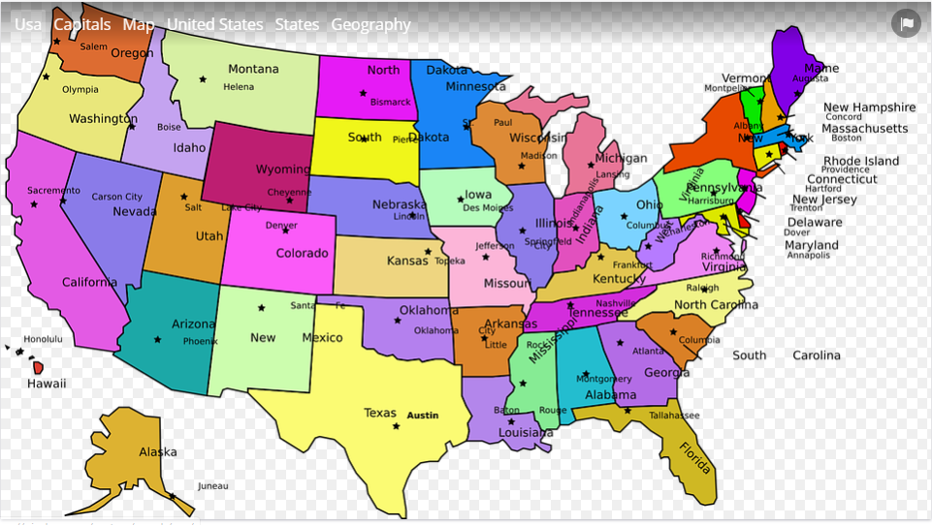

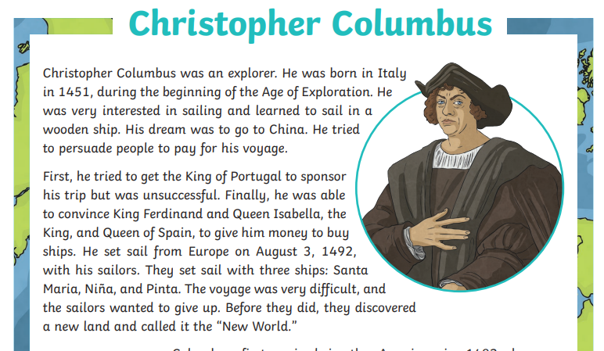
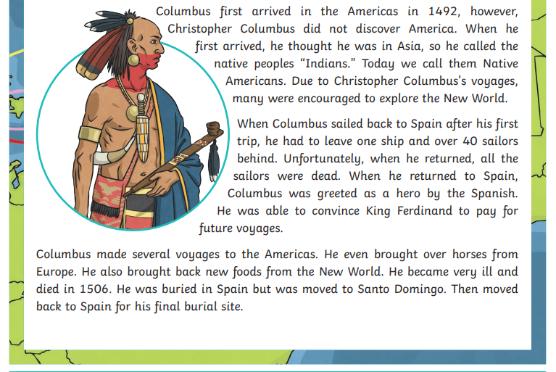
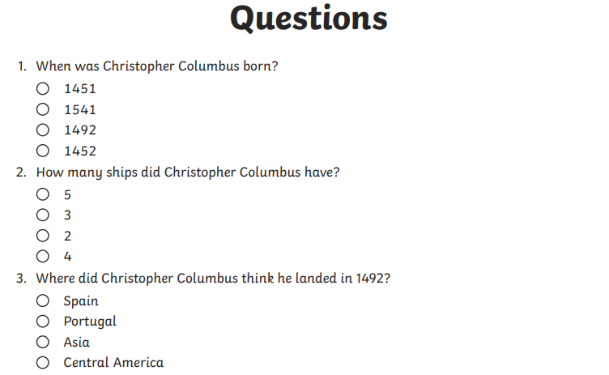
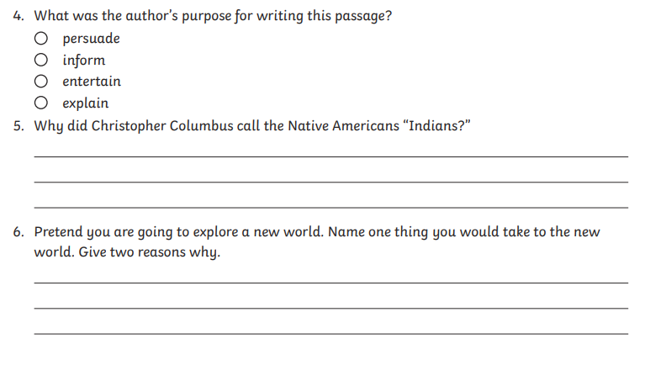

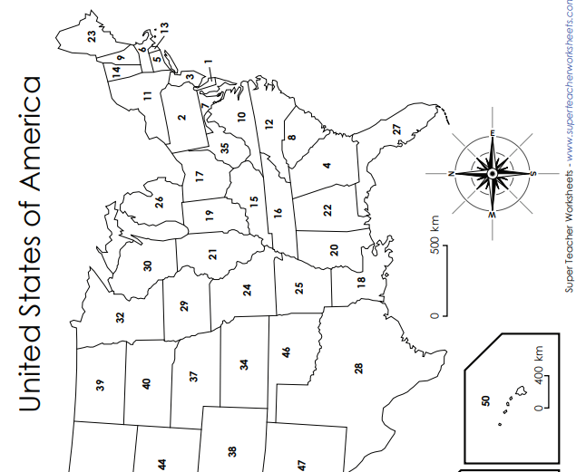
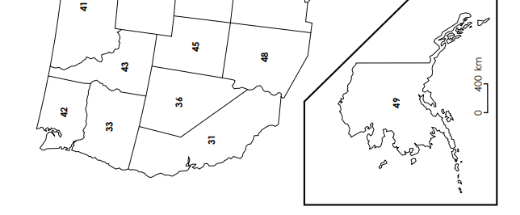

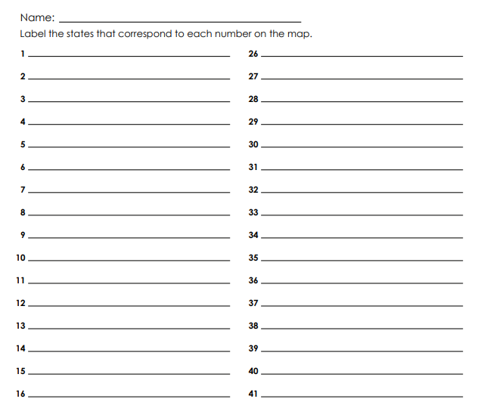
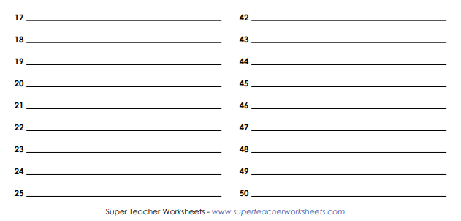

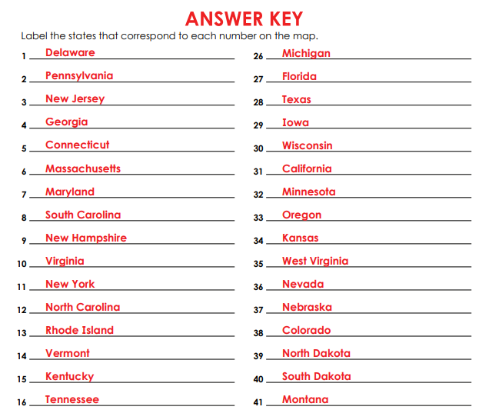
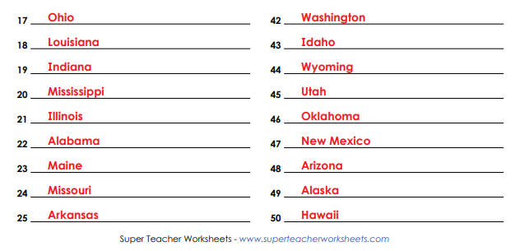

Tuesday  16th June | Core activities |  |  | Suggestions for additional activities.
9.00 – 9.30 | Daily Dashboard:  Quelle est la date aujourd’hui?  C’est mardi le dix-neuf mai 2020.  Can you write the number date in Roman numerals?  This year, 16th June is Fresh Veggies Day. Take a vow to eat healthy today (and everyday), with fresh veggies for every meal, and for snack, too. Better still, be a vegetarian for a day. Your body will like it.  Fresh vegetables are tasty, far better tasting than canned or frozen vegetables. They are also healthy and highly nutritious. This makes it easy to add fresh vegetables to the menu at every meal, and for snacking. This time of year, there are plenty of fresh vegetables at your local grocery store, or in your backyard vegetable garden.  What’s your favourite vegetable? |  |  |  |  | What is happening in the world? Have a look at https://www.bbc.co.uk/newsround or https://www.dogonews.com/ to see what is going on in the world. Choose a news article or two to read.  16th June
9.30-10.00 | Spelling – see additional Grammar and spelling resources |  | Use your spelling shed login to practise by playing spelling games.
10.00- 10.30 | Time for some Physical activity. How about an active game of Bingo?  https://www.yourschoolgames.com/sgo/south-east-devon/home-bingo-picture-template-record-sheet-1/
10.30-11.30 | Maths – Follow the links to the Oak National Academy Maths lessons  Year 3: https://classroom.thenational.academy/lessons/multiply-and-divide-by-1000  Year 4: https://classroom.thenational.academy/lessons/measures-money-the-price-of-stamps  Year 5: https://classroom.thenational.academy/lessons/to-convert-between-grams-and-kilograms  Year 6: https://classroom.thenational.academy/lessons/to-use-read-and-write-standard-units-of-length-mass-and-volume |  |  |  |  |  | Don’t forget your addition and subtraction facts! Play hit the button to practise number bonds, doubles, halves – there are also multiplication and division buttons. Good luck!  https://www.topmarks.co.uk/maths-games/hit-the-button
11.30-12.00 | Have a break and play a game or do another activity that you enjoy. | Ask for help – Is there something you have been finding confusing or difficult in your learning – or in life? Who could you talk to today to ask for help?
12.00- 1.00pm | Lunch break. Eat a healthy lunch and, if you are able, try to get outside for some fresh air!
1.00pm – 1.30pm | Reading – Abraham Lincoln is one of the most iconic presidents in American history. Known as "Honest Abe" because of his tendency to always do the right thing. He led the Civil War and abolished slavery in the United States, and gave one of the most influential speeches in American history, the Gettysburg Address. Find out more in the fact sheet below.
1.30pm -2.00 pm | Mental Health Stay connected… Talk about your feelings… Actively care for others  Friends can be different and friends can be the same! How are you different the same as your friend? What does same/different mean? Watch this song about friends that like some things the same and some things different.  https://sesamestreetincommunities.org/topics/caring/?activity=friends-can-different  Think about you and one or two of your friends. What is the same about you, your lives and situations? What is different? When is it good to be different and when is it difficult? What can you do to make it easier in those times? (eg. think about the things you have in common, remember to show empathy). Empathy is the ability to see things from someone else’s point of view. Why not make yourself some special empathy glasses to remind yourself to think about someone else’s point of view (see below for the template). This will help you with understanding some of the History learning this week.
2.00pm – 3.00pm | Theme/History of USA  This afternoon we will investigate some of the key historical events and periods in US history. From the beginning, when Native Americans lived on the land, through Colonial America, then The American Revolution, leading to The American Civil War, followed by Westward Expansion and The Great Depression then the Civil Rights Movement.  You can also look at history pre-1900s or history 1900s to present day on this site:  https://www.ducksters.com/history/  To find out more about the civil war specifically, that started because the Northern States wanted to abolish slavery, try here:  https://www.softschools.com/viewTimeline.action?id=8 |  |  |  | To find out more on American history this week, why not explore: https://www.americanhistoryforkids.com/  There’s a great article on Elizabeth Blackwell, the first female American doctor. https://www.americanhistoryforkids.com/elizabeth-blackwell/  Or try this interactive map, where you can choose to learn capital cities, physical features or states: https://online.seterra.com/en/vgp/3114  For lots of quick facts about the worlds most prosperous country, visit  https://www.theschoolrun.com/homework-help/the-united-states-of-america  How many maths facts can you record from this page?  Why not take some time to admire the photos in their gallery at the bottom of the page. Perhaps choose one of the iconic american scenes and draw it for yourself.

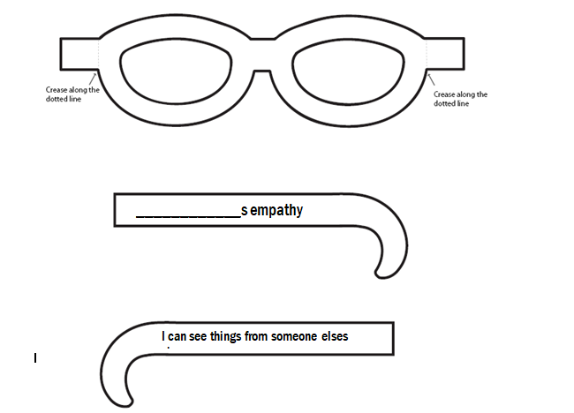

Wednesday  17th June | Core activities |  | Suggestions for additional activities.
9.00 – 9.30 | Daily Dashboard:  Quelle est la date aujourd’hui?  C’est mercredi le vingt mai, 2020.  Can you write the number date in Roman numerals?  What is happening in the world? Have a look at https://www.bbc.co.uk/newsround or https://www.dogonews.com/ to see what is going on in the world. Choose a news article or two.  Talk to someone at home about the world-wide protests happening at the moment, promoting Black Lives Matter.  Today we will be learning a little about the civil war between North and South and slavery – the history behind what is happening today. |  |  |  | Strategically created in the middle of National Fresh Fruits and Vegetable Month, Eat Your Vegetables Day is the perfect opportunity to re-introduce a healthy portion of vegetables into your diet. Maybe you could offer to help prepare the salad or vegetables for today’s meal?
9.30-10.00 | Grammar and spelling – see grammar and spelling resources
10.00- 10.30 | Time for some physical exercise - revisit the ’60 second challenges’ on the following web page, from keeping a balloon in the air for 60 seconds, to passing a ball (or cuddly toy) around your waist as many times as you can in 60 seconds, speed bouncing (2feet to 2feet jumps across a line) for 60 seconds or holding a plank position for as long as you can… Can you think of some other 60 second challenges?  https://www.youthsporttrust.org/60-second-physical-activity-challenges
10.30-11.30 | Maths – Follow the links to the Oak National Academy Maths lessons  Year 3: https://classroom.thenational.academy/lessons/measure-to-read-a-scale  Year 4: https://classroom.thenational.academy/lessons/measures-length-ribbon-riddle  Year 5: https://classroom.thenational.academy/lessons/to-convert-units-of-mass  Year 6: https://classroom.thenational.academy/lessons/to-convert-between-standard-units-of-length |  |  |  |  | How about a warm-up using Times Table Rock Stars or else play a Maths game to help practise core number facts?
11.30-12.00 | Have a break and play a game or do another activity that you enjoy. | Eat well –Check out the nutrients contained in your favourite snacks. Are they providing your body with useful nutrients, or do they contain excessive amounts of sugar, fat or salt? If so, why not research some healthy alternatives?
12.00- 1.00pm | Lunch break. Eat a healthy lunch and, if you are able, try to get outside for some fresh air!
1.00pm – 1.30pm | Reading – Abraham Lincoln is one of the most iconic presidents in American history. Known as "Honest Abe" because of his tendency to always do the right thing. He led the Civil War and abolished slavery in the United States, and gave one of the most influential speeches in American history, the Gettysburg Address. Find out more in the fact sheet below. An earlier famous president was George Washington, who brought an end to the American Revolution. His facts are also found below. |  |  |  |  |  | Read a chapter or two of your personal book.
1.30pm-2.00pm | Mental Health Stay connected… Talk about your feelings… Actively care for others  How about trying to send a hug to someone you care about in the mail – or by email?  Below is one way you could do it, but you might be able to think of another creative way!
2.00pm – 3.00pm | Theme/Civil War/Slavery/Underground Railway  Today we are going to find out more about the American Civil War, that resulted in North against South fighting to abolish slavery.  You may want to start by watching the following animation https://www.youtube.com/watch?v=IUfJCh7Rd_Q  And/or this video https://www.youtube.com/watch?v=kFTS0KXCRX8  These are produced specifically to explain some of the reasons for slavery in the USA and also the consequences, for children.  Start with this wordsearch (below- easy or hard) to build your vocabulary wordbank – do you know the meaning of all the words?  Next, look at the reasons some people gave to justify slavery. (Sheet of orange boxes below) Can you sort them into those about beliefs, those about money and those about religion?  Below is a quayside scene and a writing task where you can describe what you might see, hear, feel and smell.  Finally, there is an advert and some questions to answer, headed ‘A Piece of History’.  PLEASE DO NOT research this topic further – there are extrememly upsetting pictures and accounts freely available on the internet. We have found you safe sites and tasks for today. |  |  | Time to read – today there is a biography below based on a lady called Betsy Ross, who perhaps created the first american flag. Read her information then tell me what you think.  An important part of American history is black history. Many of the first black people that came to America were slaves and even those that were free were not treated fairly. However, many black people overcame that discrimination and contributed important achievements to history. Scroll through this timeline of Black History, including the Underground Railway, by clicking on the right arrow:  https://www.softschools.com/viewTimeline.action?id=37  If you want to further your geographical knowledge about USA, have a look at https://www.3dgeography.co.uk/usa-worksheets

Mail a Hug
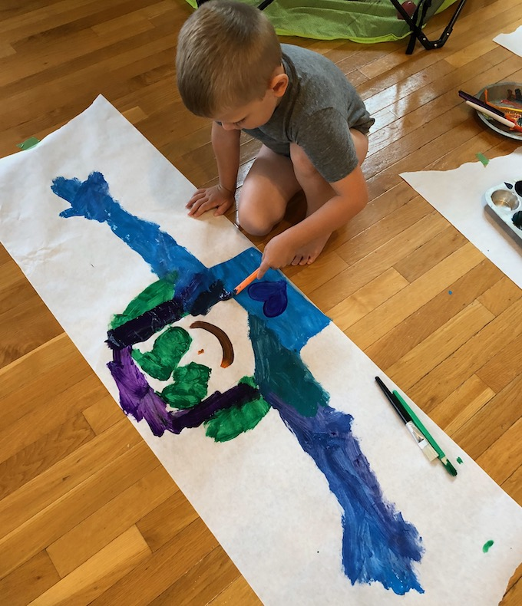
Here are your directions:
- Spread out a long sheet of butcher paper.
- Get someone to trace around your head, arms, and upper torso onto the paper.
- You can either cut it out now or decorate first and then cut. We used paint but markers or crayons would work just fine!
- Print or write out the message below to accompany the hug.
- Fold it all up, put in an envelope and mail!
Here’s a message you could send with your hug. You could write this out in your neatest handwriting to accompany your hug!
“I miss you when you’re far away.
I’d love to see you every day.
But since I can’t come over to play,
I’m mailing you a hug today.
So although it might be quite a sight,
wrap my arms around you tight.
Repeat daily to keep your smile bright,
until we get to reunite!”
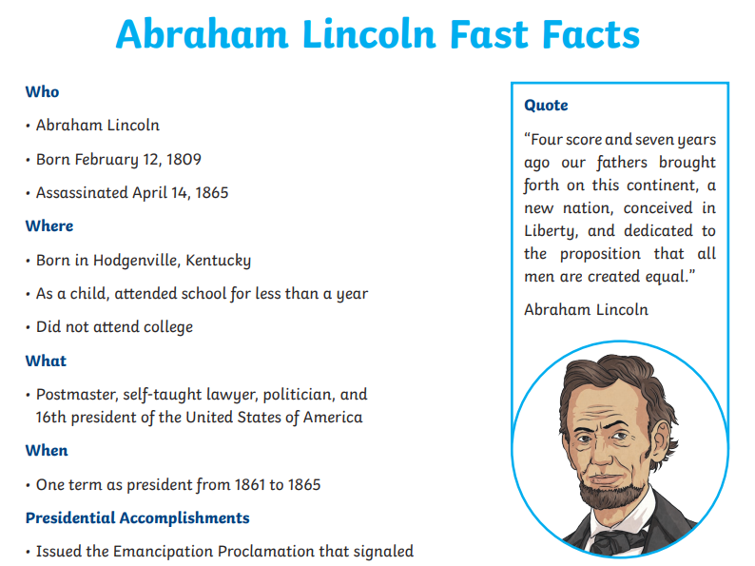
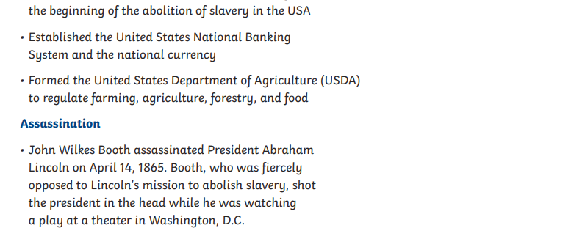

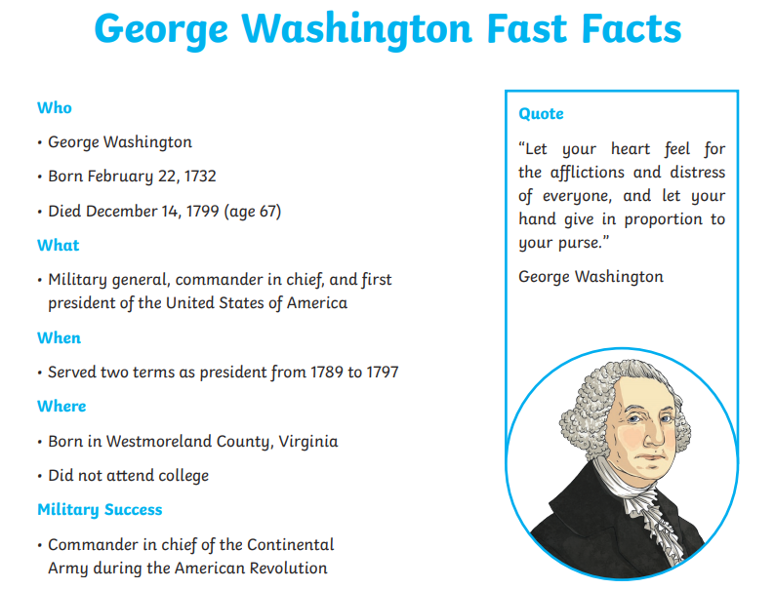

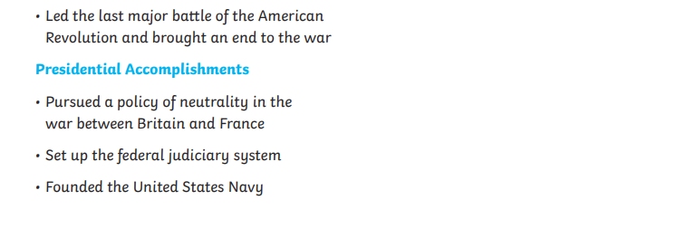

You could do further research on first President George Washington then record his four greatest achievements below (in full sentences please).

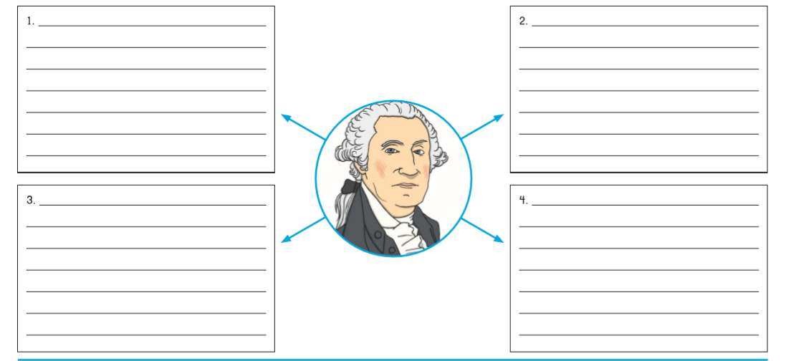

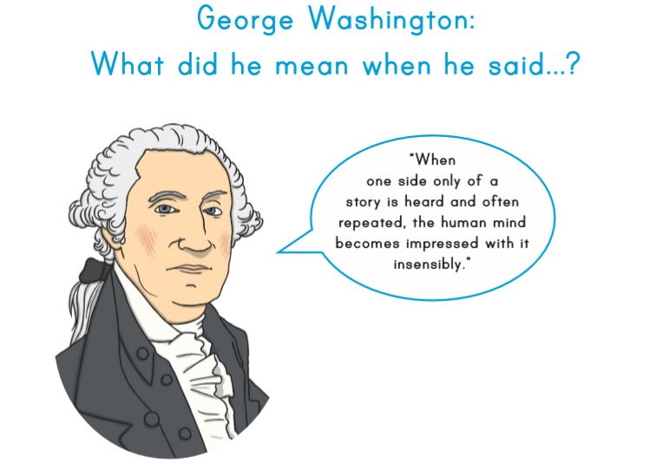

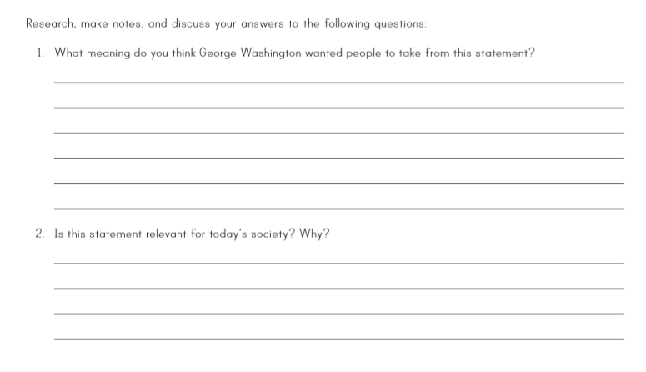

Easier wordsearch
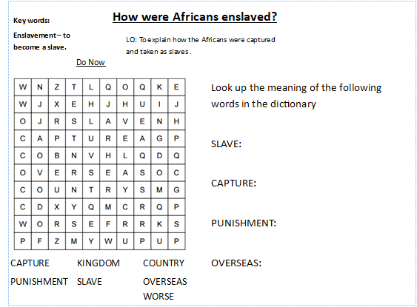

Harder wordsearch

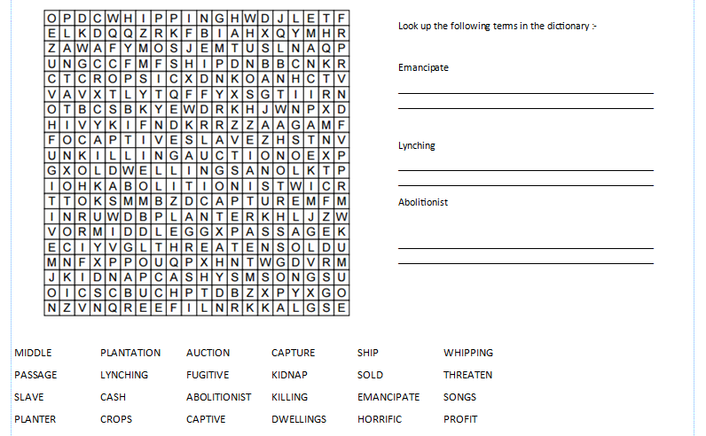

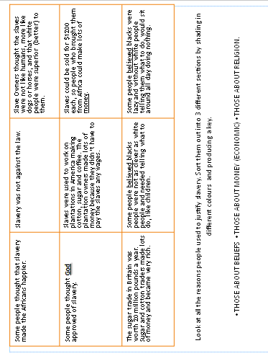

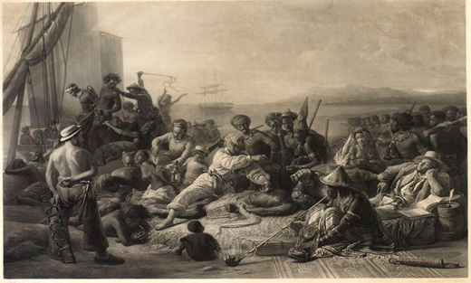
Above is the scene of a quayside on the West African coast.
Merchants are bringing enslaved people to sell to the crew of a European slave ship.
Your task is to imagine that you were one of the slaves (pupil A) or a merchant (pupil B) during this capture. Whilst sat waiting at this quayside describe what you may have been able to see, hear, smell and touch/feel.

Senses | Describe your experience using the image
See

Hear

Smell

Touch/ feel

Use these words to explain what is happening in this image.
The image A shows ……………………………………

……………………………………
They were chained like this because ……………………………………

……………………………………
The slaves were treated like this because ……………………………………

……………………………………
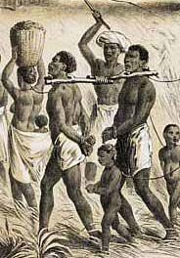

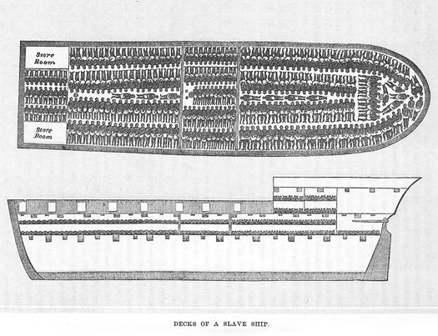
Use these words to explain what is happening in this image.
The image B shows ………………………………………………………………
They travelled like this because ……………………………………………………………………………………………
When the slaves travelled like this they were ………………………………………………………………

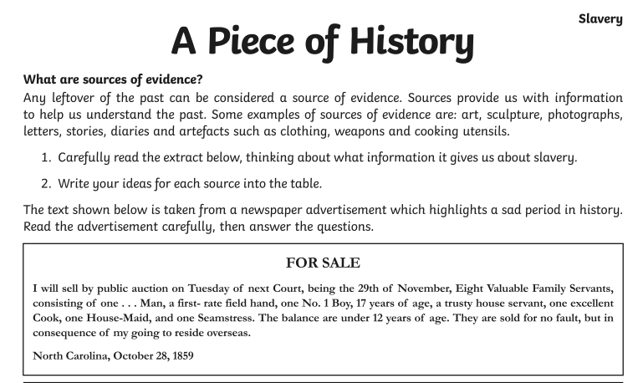
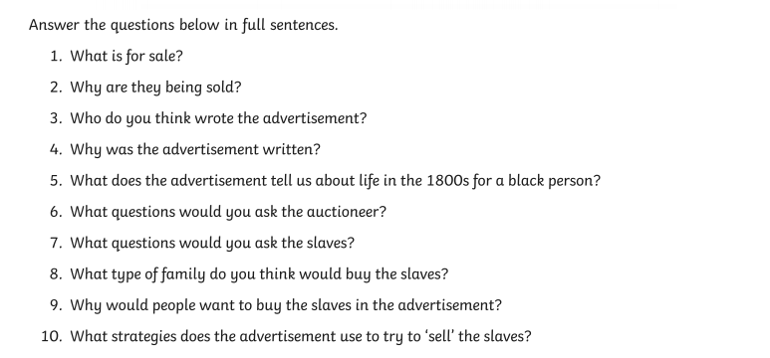

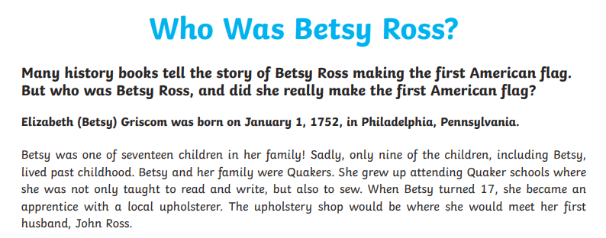
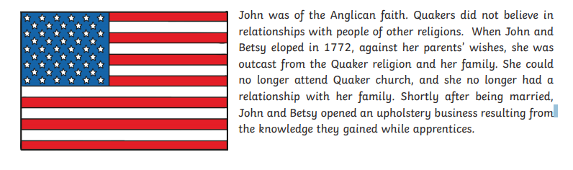
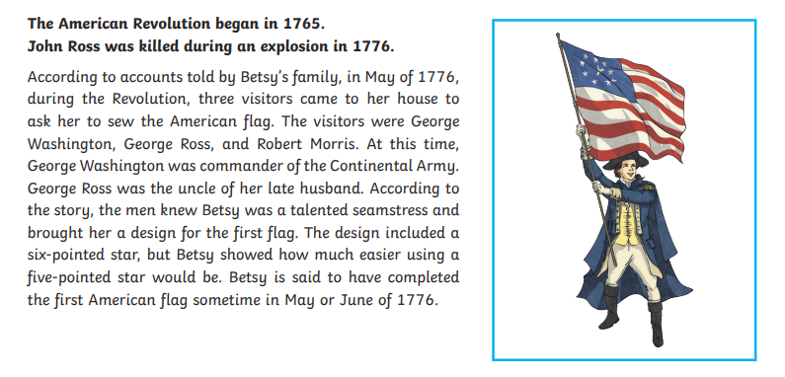
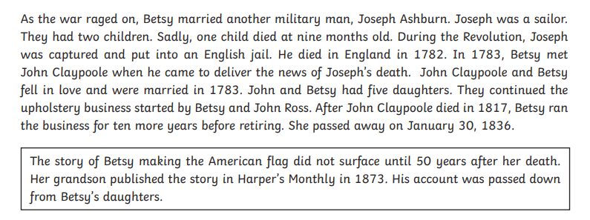
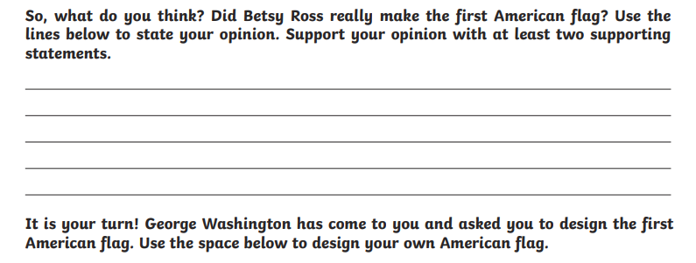

Thursday 18th June | Core activities |  |  |  | Suggestions for additional activities.
9.00 – 9.30 | Daily Dashboard:  Quelle est la date aujourd’hui?  C’est jeudi le vingt-et-un mai, 2020.  Can you write the number date in Roman numerals?  What is happening in the world? Have a look at https://www.bbc.co.uk/newsround or https://www.dogonews.com/ to see what is going on in the world. Choose a news article or two to read.  Key search term for today – civil rights. What news articles come up if you use this search term? |  | Today is International Picnic Day! The perfect day to go outdoors and have a picnic. It can be in a park, or right in your back garden.  Picnics date back to Medieval times, when outdoors feats were held to celebrate a successful hunt. Picnics really grew in popularity during the Victorian era in England.  What foods would you include in your ideal picnic? Why not draw the food and a whicker basket? Maybe you could include a rug to sit on?
9.30-10.00 | Grammar – see Grammar resources
10.00- 10.30 | Time for some physical activity. Here is a link to a ‘Race to 100’ game you can play with other members of your family: https://www.yourschoolgames.com/sgo/south-east-devon/race-to-100-activity-game/  Alternatively, you could play a game of ‘Treasure Chest’: Place 10 treasure items (eg. socks, shoes, small toys) at one end of the room (or garden), known as the treasure chest. Run and collect an item and return it back to the start as quickly as possible. How many items can you collect in 60 seconds? Can you race against someone else to see who can collect the most items?
10.30-11.30 | Maths – Follow the links to the Oak National Academy Maths lessons  Year 3: https://classroom.thenational.academy/lessons/measure-to-read-mass-on-a-scale  Year 4: https://classroom.thenational.academy/lessons/measures-money-coin-purse-challenge  Year 5: https://classroom.thenational.academy/lessons/to-convert-between-pounds-and-kilograms  Year 6: https://classroom.thenational.academy/lessons/to-solve-problems-involving-conversion-of-length |  |  |  | How about a warm-up using Times Table Rock Stars or else play a Maths game to help practise core number facts?  Why not visit https://nrich.maths.org/9803 and have a go at one of the Maths investigations there. Be warned – these will really make you think!
11.30-12.00 | Have a break and play a game or do another activity that you enjoy. | Care for others – what little job around the house could you do today to show care for someone in your family?
12.00- 1.00pm | Lunch break. Eat a healthy lunch and, if you are able, try to get outside for some fresh air! Something’s fishy. That’s because today is International Sushi Day. Sushi was created in Japan, where it is a well-known type of Japanese cuisine. Did you taste some on your trip to Japan? We did in school! This event was first proclaimed in 2009.
1.00pm- 1.30pm | Time to Read: Rosa Parks was an African-American civil rights activist, whom the United States Congress called "the first lady of civil rights", and "the mother of the freedom movement". This timeline outlines the major events that happened during the lifetime of Rosa Parks.  https://www.softschools.com/viewTimeline.action?id=7  Answer questions about her below. |  |  | Why not re-read an old favourite? Why do you like it?
1.30pm- 2.00pm | Mental Health Stay connected… Talk about your feelings… Actively care for others  Make a little treasure box and use it to begin a collection of all the little things people do and say that make you feel loved and special. Then, on days when you feel lonely or sad, you can get out your treasure box and look through these to remember how loved and special you are. Below is a template for a little treasure box made of card.
2.00pm – 3.00pm | Topic/Civil Rights  Initial Task: write a persuasive speech about recent events in America and across the world, following Floyd George’s death.  The definition and history of civil rights can be found here:  https://www.ducksters.com/history/civil_rights/  An important leader in the civil rights movement was Martin Luther King. Hear and read his famous ‘I have a dream’ speech here:  https://www.americanrhetoric.com/speeches/mlkihaveadream.htm  To learn more about his life and achievements, visit https://www.natgeokids.com/uk/discover/history/general-history/martin-luther-king-facts/  Also, duckster.com or historyfacts.net also have lots of information about this very special man. Choose your favourite website from the last few weeks!  (https://www.historyforkids.net/martin-luther-king.html is an easier read for Y3 and includes information about Rosa Parks)  There is a printable version of the timeline of the civil rights movement below. |  |  | What do you think are important rights children should have today? Make a list of five.  Are there any countries where children do not have these rights? Read more about The UN Convention on the Rights of the Child at:  https://www.unicef.org.uk/child-rights-partners/wp-content/uploads/sites/3/2016/08/CRC_summary_leaflet_Child_Rights_Partners_web_final.pdf  Read this article about other important young activists who wanted to change the world. https://www.biography.com/news/african-american-youth-civil-rights-movement

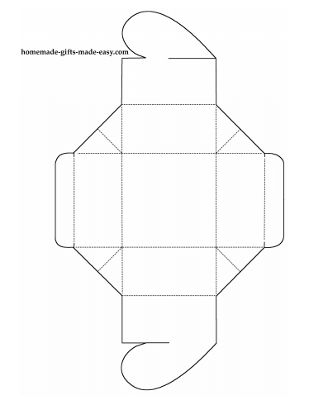

Step 1
Cut along all the solid lines, then score along the dashed lines using a butter-knife and ruler. Scoring helps the paper fold more easily in the next steps.
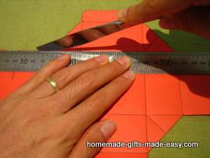

Step 2
Fold up the sides of the box to make it into this shape:
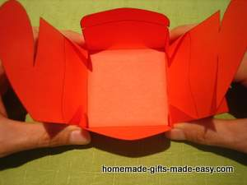

Step 3
Slot the two heart-halves together like this:
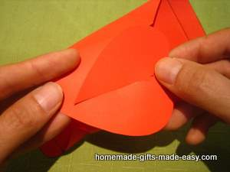

Step 4
Fold in the top and bottom flaps to close:
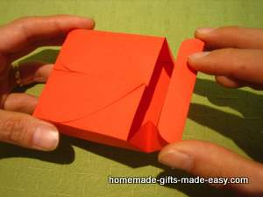

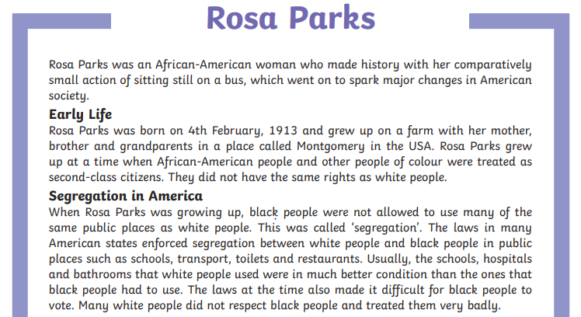
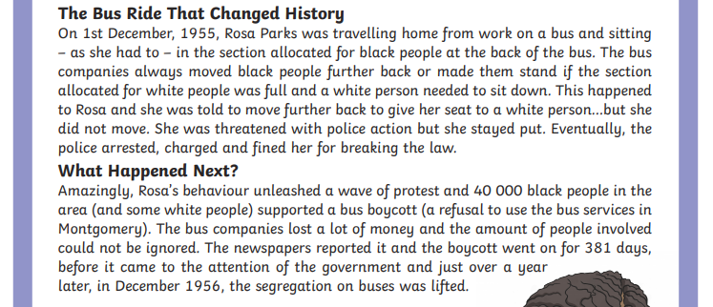
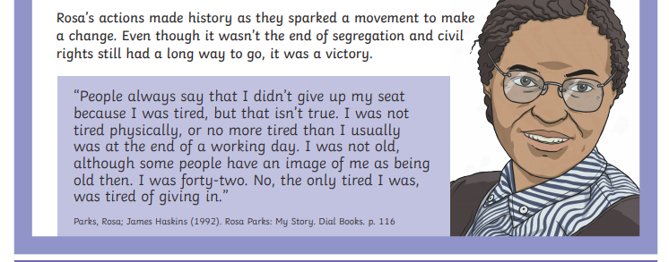

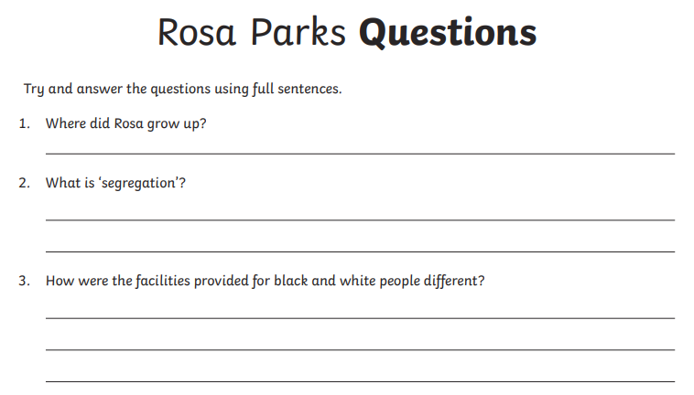
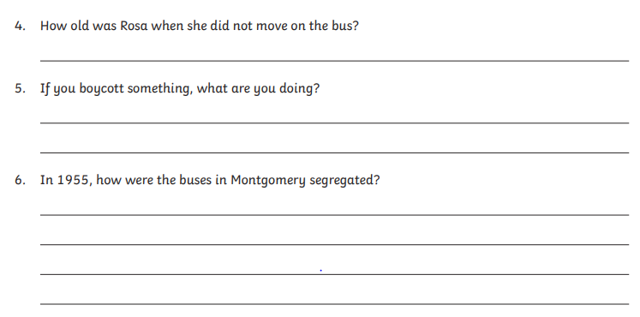
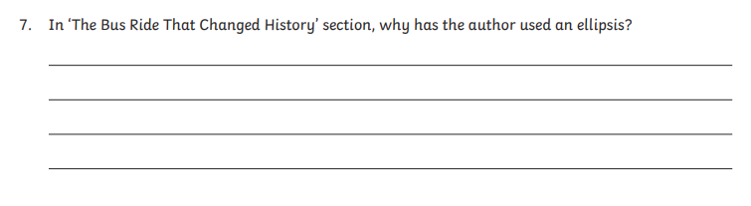
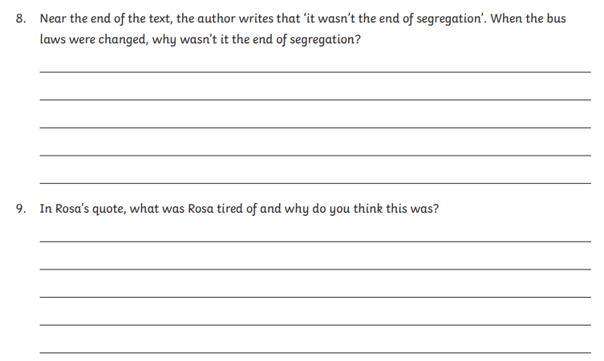
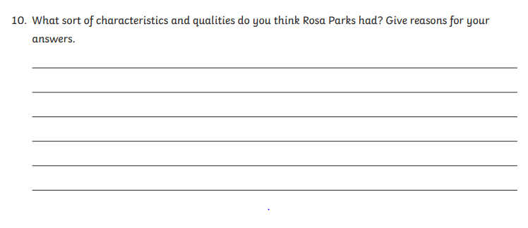

Historical Background to The Civil Rights Movement:
- Since the first slaves arrived from Africa in 1619, there was a tremendous need for the protection and enforcement of a person’s civil rights.
In 1808, Congress banned the importation of slaves from Africa.
- In 1863, President Lincoln issued the Emancipation Proclamation, declaring “that all persons held as slaves” within the Confederate states “are, and henceforward shall be free.”

Rise Of The Civil Rights Movement:
- On May 17, 1954, the United States Supreme Court in Brown v. Board of Education of Topeka, Kansas, declared that racial segregation in schools was unconstitutional. It overturned the Plessy v. Ferguson doctrine of “separate but equal.”
- On December 1, 1955, Rosa Parks refused to give up her seat at the front of the “colored section” of a bus to a white passenger.
- In response to her arrest, Montgomery’s black community launched a successful year-long bus boycott. It was led by Martin Luther King, Jr., and Montgomery’s buses were desegregated on Dec. 21, 1956. A series of movements followed starting in the mid 1950s until the late 1960s.
- By 1957, The Southern Christian Leadership Conference (SCLC), a civil rights group, was established by Martin Luther King, Jr., Charles K. Steele, and Fred L. Shuttlesworth. Dr.
- King became its founding president. He encourage all African Americans to exercise their
civil rights.
- Later that year, the Civil Rights Act was passed, ensuring that all African Americans can exercise their right to vote. Despite this, the admission of nine black students at the Little Rock Central High School was rejected by opposing white people. Known as the 1957 Little Nine Rock crisis, it was resolved by President Dwight Eisenhower when he enforced the integration.
- In 1961, black and white Freedom Riders started to ride buses to test whether there was integration.
- By 1964, civil activist Fannie Lou Hamer became one of the leaders of the Freedom Summer Campaign, which gathered as many African Americans in Mississippi to register and vote.
- On August 28, 1963, the March on Washington for Jobs and Freedom is attended by about 250,000 people, the largest demonstration ever seen in the nation’s capital. Dr. King delivered his famous “I Have a Dream” speech. The march built momentum for civil rights legislation.
- Martin Luther King, Jr. was arrested and jailed during anti-segregation protests in Birmingham, Al. He wrote “Letter from Birmingham Jail”, which advocated non-violent civil disobedience.
- When Dr. King met with President John F. Kennedy, Kennedy urged Congress to pass the Civil Rights Bill that prohibited segregation and discrimination based on race, nationality or gender.
- On November 22, 1963, President JFK was assassinated during his motorcade in Dallas.The bill was not signed into law.
- During the administration of President Lyndon B. Johnson, the Civil Rights Act of 1964 was passed. It banned discrimination and segregation. Furthermore, the right of minorities to vote was stated.
- On February 21, 1965, Malcolm X, former follower of Elijah Muhammad, leader of the Nation of Islam in the United States, was assassinated after establishing the Organization of
Afro-American Unity.
- The Organization of Afro-American Unity advocated that racism was the greatest enemy of African Americans. It was believed that members of the Nation of Islam shot Malcolm X dead.
- On March 7, 1965, the first Selma Freedom March was organized by John Lewis. The demonstration ended with violence and came to be known as “Bloody Sunday.”
- On August 6, 1965, the Voting Rights Act was signed into law. The law enabled the protection of African Americans’ right to vote and the prohibition of literacy tests in the process.
- Race riots occurred from 1965 until 1967. On August 11, 1965, the Watts Riots erupted in Los Angeles. It was followed by the Newark Riots and Detroit Riots.
- In 1966, Bobby Seale and Huey P. Newton founded the Black Panther, which aimed to liberalized African-Americans through violent revolution.
- On April 4, 1968, Dr. Martin Luther King, Jr. was assassinated by James Earl Ray at Lorraine Motel in Memphis, Tennessee. Violent riots broke out in many cities in the United States after his death.
- In November 2009, Barack Obama, an African-American Senator from Illinois, was elected as the 44th President of the United States.
- On February 2, 2009, Eric Holder was elected in a vote of 75 to 21 as the first African-American Attorney General of the United States.

Friday 19th June | Core activities |  | Suggestions for additional activities.
9.00 – 9.30 | Daily Dashboard:  Quelle est la date aujourd’hui?  C’est vendredi le vingt-deux mai, 2020.  Can you write the number date in Roman numerals?  What is happening in the world? Have a look at https://www.bbc.co.uk/newsround or https://www.dogonews.com/ to see what is going on in the world. Choose a news article or two to read.  date |  | ‘World Sauntering Day’ is a day to saunter here and there, wherever you go. You can spend your life walking, jogging or being dragged through life. But, life is far more enjoyable if you saunter through it. It’s doubly true if you saunter with a friend or loved one.  Sauntering is a form of strolling. Sauntering is very casual, yet stylish, form of movement from Point A to Point B.  So why not go for a saunter around your house today?
9.30-10.00 | Grammar – see resources
10.00- 10.30 | Time for some physical activity. Why not have a look at https://thedailymile.co.uk/at-home/ for some fun challenges to try while going for a ‘daily mile’ walk or run.
10.30-11.30 | Maths – Follow the links to the Oak National Academy Maths lessons  Year 3: https://classroom.thenational.academy/lessons/measure-to-compare-mass  Year 4: https://classroom.thenational.academy/lessons/measures-mixed-measure-problems  Year 5: https://classroom.thenational.academy/lessons/to-apply-measures-and-conversions-in-context  Year 6: https://classroom.thenational.academy/lessons/to-calculate-the-area-of-parallelograms-and-triangles |  |  |  | Why not try a BBC Supermovers Maths video to help warm up your Maths brain while getting in a bit of movement?  https://www.bbc.co.uk/teach/supermovers/ks2-maths-collection/z7frpg8
11.30-11.45 | Have a break and play a game or do another activity that you enjoy. | Be proud of your very being! What have you done well this week? Why not award yourself another certificate!
11.45 – 12.00 | Why not join in with the act of Collective Worship that you will find on the school website. Take time to think about how you can use your own creativity to make life a little brighter or easier for someone else.
12.00- 1.00pm | Lunch break. Eat a healthy lunch and, if you are able, try to get outside for some fresh air!
1.00pm – 1.30pm | Reading - |  |  | You could read another chapter of your current book.
1.30pm – 2.00pm | Mental Health Stay connected… Talk about your feelings… Actively care for others  We have all seen posters that contain inspirational messages. Why not make a poster of your own inspiring message about love, kindness and friendship to brighten your home and inspire your family – and yourself? Here are a few examples:  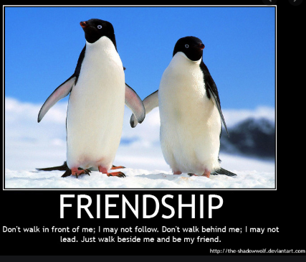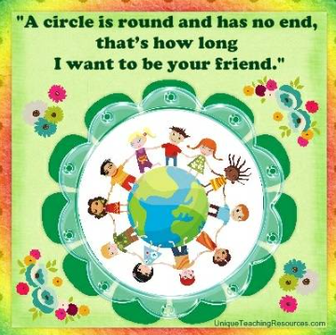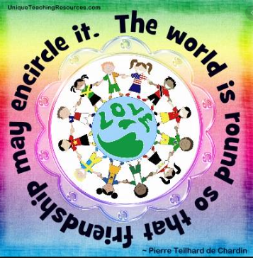
1.30pm – 3.00pm | Theme/Art (pencil, feltpens, paints, pastels, collage)  This afternoon, could you create a piece of art that shows what you have learnt about human rights this week? What do you think about human rights in the past compared to in the present? What do you hope human rights will look like in the future?  It could be a picture, a painting, a sculpture… it’s up to you!  Alternatively, you could make a poster that shares your knowledge about American history. |  |  | If you want to write rather than draw, feel free to put together a powerpoint, a non-chronological report or a poster focusing on an area that has interested you this week.
And so, that concludes our trip around North America. Where was your favourite place? Which state are you now expert on? Next week we’ll be asking you to create a learning journey related to a country of your choice as your project for the week, then we’ll visit Australia, culminating in the final weeks with visits to the countries you suggest, incorporating your ideas. Is there a country that immediately jumps to mind for you? One that you’ve passed over the last few months and thought ‘I’d like to know more’?
Have a great weekend!

