Task 1: Can you unscramble the following words to reveal six special places
Special Places
- hrcuhc | ___________________ | - qseumo | ___________________
- geasoynug | ___________________ | - mtelep | ___________________
- rwaguadr | ___________________ | - nardmi | ___________________

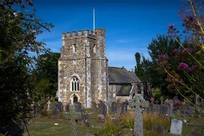
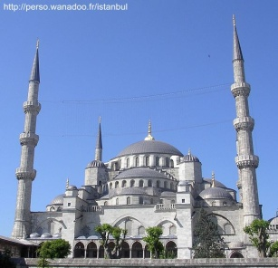
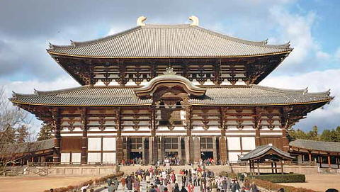
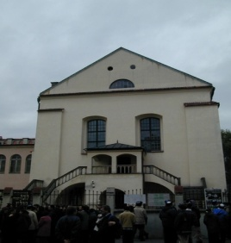
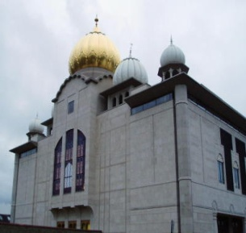
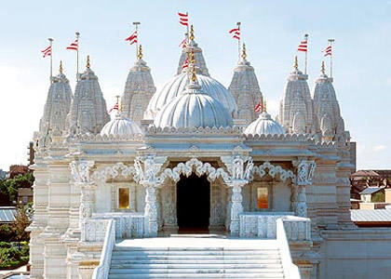
- _____________________________________________________________________________________________________________________________
- _____________________________________________________________________________________________________________________________
- _____________________________________________________________________________________________________________________________
- _____________________________________________________________________________________________________________________________
- _____________________________________________________________________________________________________________________________
- _____________________________________________________________________________________________________________________________
Task 2: Can you label each building and remember the name of the people who worship there? in each place?
Discussion: What is worship?
- ________________________________
- ________________________________
- ________________________________
- ________________________________
- ________________________________
- ________________________________
- ________________________________
- ________________________________
- ________________________________
- ________________________________
Task 3: What happens in these special places? In the space provided, make a list of all the things you can think of, which might happen.
Worship
Definition:

__________________________________________________________________________________________________

